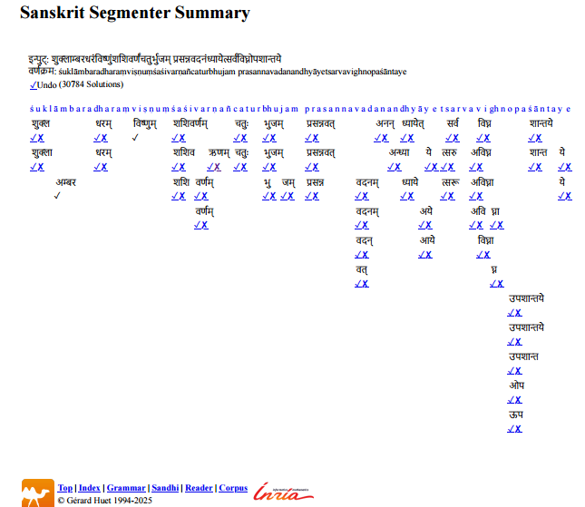
Fig. 1. illustrates the segmentation lattice produced by the Sanskrit Heritage Segmenter (INRIA) for a single Sanskrit verse, highlighting the combinatorial explosion of grammatically valid sandhi resolutions. Image © Gérard Huet, INRIA Sanskrit Heritage Platform

