# 

# WE

**(Women Entrepreneur)**



# Embrace the Challenge! And Thrive as Entrepreneurs!

# Coming together is a beginning!!Keeping together is process!!Working together is success!!

**Project Team Members:**

1. **Sudharsheini.E (Team Leader)**
2. **Divya Ganapathy.S.P**
3. **Sugadhaa.S**
4. **Lakshmi Kumari.C.H**

# 1.0 DOCUMENT PURPOSE

This project will help the women who want to become an entrepreneur. Women entrepreneur may be defined as a woman or group of women who initiate, organize, and run a business enterprise. The project keeps track of the sponsors and women entrepreneur’s details. It also takes care of the product details that they are going to sell.

The Scope of the project takes care of the details of each and every group of women’s who is going to start the business and their product. These details help the common people to contact and get the product .The details of Sponsors helps the household women to start a business.

This project includes modules such as

1. User Log in and Signup
2. Sponsor’s Registration
3. Team’s Registration
4. Product Updates
5. Search for Product

# 2.0 Module Use case

**2.1 User Log in and Signup**

In User Login and signup module, the User Login page is to access the website. If user hasn’t registered, he/she will go to Signup page to create a new account by providing the required detail like,

* User name
* Password
* Confirm Password
* Mobile Number
* Email-id
* Address

After creating the account, the user will Login to the webpage.

**2.2 Sponsor’s Registration**

This module contains a sponsor form , which are the documents that sponsors will fill out. It includes the details about the sponsor, like

* Sponsor’s name
* Date of Birth
* Age
* Occupation
* contact number
* Aadhar id
* Amount
* Card Holder
* Card Number
* Expiry Date
* CVC

which they are going to sponsor.

**2.3 Team’s Registration**

This module contains a new employee registration form, where they fill the form which has fields like ,

* Team Name
* Executive Name
* Date of Birth
* Age
* Aadhar Id
* Father\Spouse Name
* Contact Number
* Alternative Number
* Account Number
* IFSC Code

The team where they want to join and work. So, based on these details if the team requires any employee they can hire.

**2.4 Search for Sponsor**

Here the existing team can search for the sponsor’s who are interested to sponsor money for their work and they can contact that particular sponsor to discuss about this further. This helps the team to enhance their business.

**2.5 Product Updates**

This module has the form where the existing team updates about their product in the website. This helps them to sell their products. It has fields like,

* Team Id
* Product Name
* Product Description
* Stock
* Mobile Number
* E-mail Id

**2.6 Search for Product**

This module helps the general user to search for the product and get the details of the product details to purchase it. It shows the following:

* Product Name
* Product Description
* Stock
* Mobile Number
* E-mail Id
* Rating

**2.7 About us**

This module contains the general information about the webpage that helps the users to understand the motto, objective, vision and mission of the website.

**2.8 Contact us**

This module allows the visitor to contact the website admin for the feedback .This contains fields like:

* User Name
* Feedback Rating
* Comments

**2.9 Log out**

This module ends the session, if the current user wishes to end the login session. After that, it navigates to login page.

# 3.0 Design and Implementation Constraints

**3.1 Database:** The system shall use the MS SQL Server Database, which is open source and free.

**3.2 Operating System:** The Development environment shall be Windows10

**3.3 Web-Based:** The system shall be a Web-based application ASP.Net

**4.0 Define module & Functionality:**

The system functions can be described as follows:

* **Registration:** When the user enters the page, they have to register to visit the website. The Sponsor has a separate registration in Sponsor’s tab and the women’s have separate registration to join as team and get the sponsorship in sponsor’s tab.
* **Login:** When Email Id and password is matched it allows the user to dashboard or else it denies the user to enter into website.
* **Product:** When a common user visits the website, they can see the product and its description. If they like the product, they can contact the respective team using the contact details provided by them to purchase.

**5.0 System Analysis**

System analysis is the first and foremost step performed in developing the software to solve a particular problem. In the analysis part, a software developer examines the requirements. Carrying out preliminary investigation identifies these requirements

* Analysis consists of two sub phases:

1. Planning
2. Requirement definition

During planning phase, cost estimates and work schedules will be planned. Requirement definition is a specification that describes the processing environment, the required software functions, performance constraints (Size, Speed, Machine Configuration) and exception handling.

**6.0 Schema Diagram:**

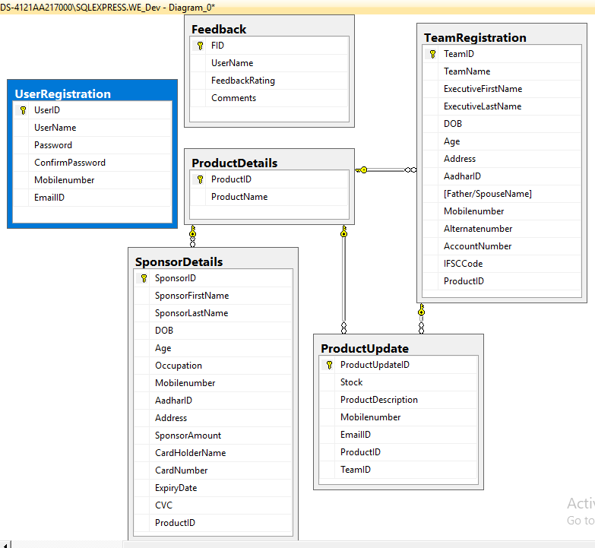

**7.0 Use Case Diagram**

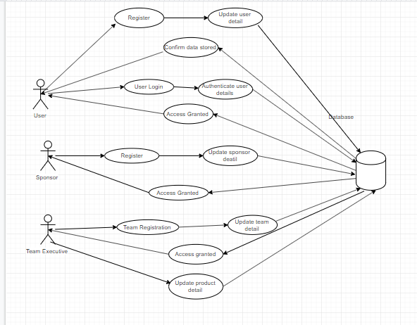

**8.0 Class Diagram**

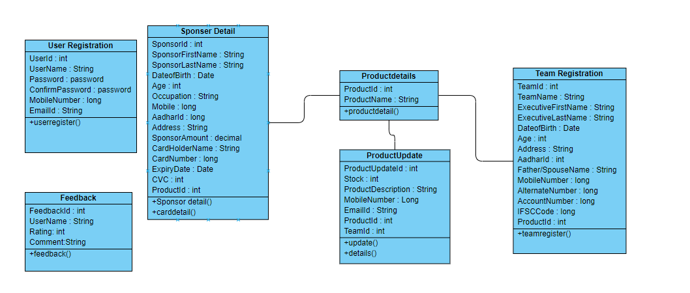

**9.0 Sequence Diagram**

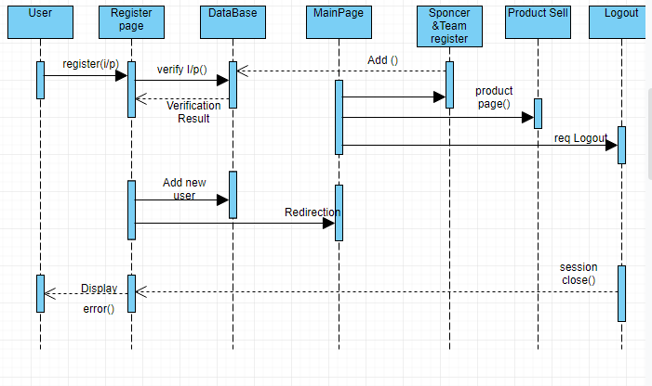

**10.0 Technical:**

1. HTML 5

2. CSS

3. BOOTSTRAP v4

4. AJAX

5. JQUERY

6. SQL

7. MVC

8. Validation

9. Session

**11.0 Role for Team Members:**

**Sudharsheini and Divya** **Designed User Login and Registeration Page. And also created Sql database and stored procedure.**

**Sugadhaa and Divya** **Designed About Us Page.**

**Sugadhaa Designed Sponsor Registration and Product detail Page. And created Sql database for Sponsor Registration and stored procedure.**

**Divya Designed Feedback and Product Page. And created Sql database for feedback,product and stored procedure**.

**Lakshmi Designed Team Registration and Sponsorship Page. And created Sql database for Team Registration and stored procedure**.

**Sudharsheini integrated all the pages and Designed the Master Layout Page.**

**12.0 Conclusion**

WE (Women entrepreneur) provides a required platform for entrepreneurship, development, marketing support, membership opportunities etc. And this platform is connecting employees with sponsors can help in the professional growth of the women. The sponsors are can play the main role in this Women entrepreneurship are encouraging them towards reach their goals.

Women were denied a lot of opportunities and they missed out on a lot of things that would have changed their lives. However, they deserve equal opportunities for **education, in their careers, in the society**, and so much more.

The empowerment of women is a very important task that every one of us should undertake. This is because empowering women is equal to empowering the whole community and generations to come. There are many ways in which we can empower girls and women and the task does not solely lay with the government but with everyone in the society.