wwCollections in Java

**Collections in java** is a framework that provides an architecture to store and manipulate the group of objects.

All the operations that you perform on a data such as searching, sorting, insertion, manipulation, deletion etc. can be performed by Java Collections.

Java Collection simply means a single unit of objects. Java Collection framework provides many interfaces (Set, List, Queue, Deque etc.) and classes (ArrayList, Vector, LinkedList, PriorityQueue, HashSet, LinkedHashSet, TreeSet etc).

#### What is Collection in java

Collection represents a single unit of objects i.e. a group.

#### What is framework in java

* provides readymade architecture.
* represents set of classes and interface.
* is optional.

#### What is Collection framework

Collection framework represents a unified architecture for storing and manipulating group of objects. It has:

1. Interfaces and its implementations i.e. classes
2. Algorithm

### Hierarchy of Collection Framework

Let us see the hierarchy of collection framework.The **java.util** package contains all the classes and interfaces for Collection framework.

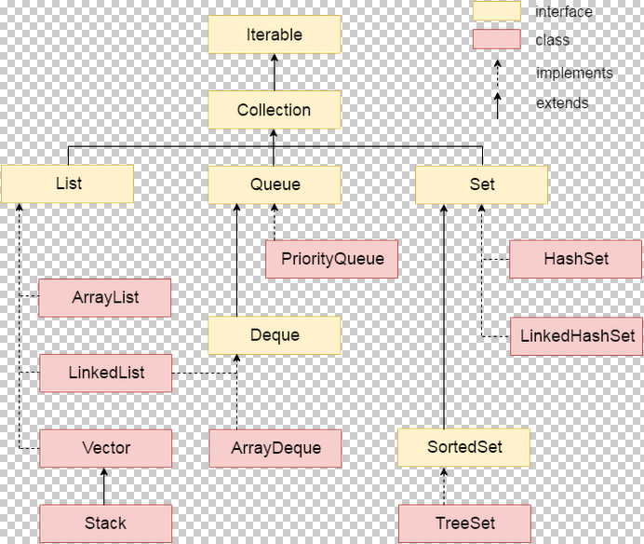

### Iterator interface

|  |
| --- |
| Iterator interface provides the facility of iterating the elements in forward direction only. |

#### Methods of Iterator interface

There are only three methods in the Iterator interface. They are:

|  |  |  |
| --- | --- | --- |
| **No.** | **Method** | **Description** |
| 1 | public boolean hasNext() | It returns true if iterator has more elements. |
| 2 | public Object next() | It returns the element and moves the cursor pointer to the next element. |
| 3 | public void remove() | It removes the last elements returned by the iterator. It is rarely used. |

# Java ArrayList class

Java ArrayList class uses a dynamic array for storing the elements. It inherits AbstractList class and implements List interface.

The important points about Java ArrayList class are:

* Java ArrayList class can contain duplicate elements.
* Java ArrayList class maintains insertion order.
* Java ArrayList class is non synchronized.
* Java ArrayList allows random access because array works at the index basis.
* In Java ArrayList class, manipulation is slow because a lot of shifting needs to be occurred if any element is removed from the array list.

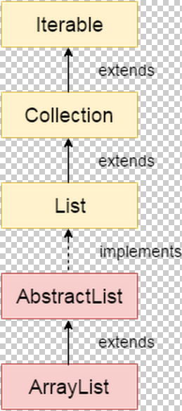

### Hierarchy of ArrayList class

As shown in above diagram, Java ArrayList class extends AbstractList class which implements List interface. The List interface extends Collection and Iterable interfaces in hierarchical order.

### ArrayList class declaration

Let's see the declaration for java.util.ArrayList class.

**public** **class** ArrayList<E> **extends** AbstractList<E> **implements** List<E>, RandomAccess, Cloneable, Serializable

### Java Non-generic Vs Generic Collection

Java collection framework was non-generic before JDK 1.5. Since 1.5, it is generic.

Java new generic collection allows you to have only one type of object in collection. Now it is type safe so typecasting is not required at run time.

Let's see the old non-generic example of creating java collection.

1. ArrayList al=**new** ArrayList();//creating old non-generic arraylist

Let's see the new generic example of creating java collection.

1. ArrayList<String> al=**new** ArrayList<String>();//creating new generic arraylist

In generic collection, we specify the type in angular braces. Now ArrayList is forced to have only specified type of objects in it. If you try to add another type of object, it gives *compile time error*.

### Two ways to iterate the elements of collection in java

There are two ways to traverse collection elements:

1. By Iterator interface.
2. By for-each loop.

# Java LinkedList class

Java LinkedList class uses doubly linked list to store the elements. It provides a linked-list data structure. It inherits the AbstractList class and implements List and Deque interfaces.

The important points about Java LinkedList are:

* Java LinkedList class can contain duplicate elements.
* Java LinkedList class maintains insertion order.
* Java LinkedList class is non synchronized.
* In Java LinkedList class, manipulation is fast because no shifting needs to be occurred.
* Java LinkedList class can be used as list, stack or queue.

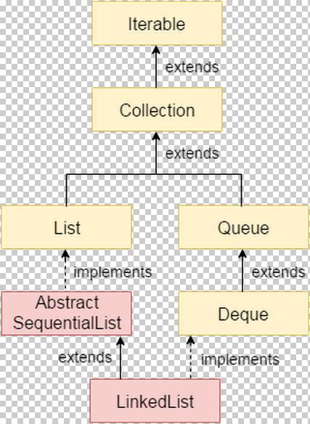

### Hierarchy of LinkedList class

As shown in above diagram, Java LinkedList class extends AbstractSequentialList class and implements List and Deque interfaces.

### Doubly Linked List

In case of doubly linked list, we can add or remove elements from both side.

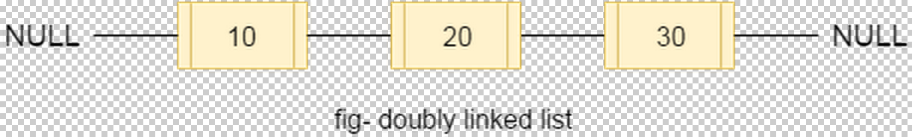

### LinkedList class declaration

Let's see the declaration for java.util.LinkedList class.

**public** **class** LinkedList<E> **extends** AbstractSequentialList<E> **implements** List<E>, Deque<E>, Cloneable, Serializable

Difference between ArrayList and LinkedList

ArrayList and LinkedList both implements List interface and maintains insertion order. Both are non synchronized classes.

But there are many differences between ArrayList and LinkedList classes that are given below.

|  |  |
| --- | --- |
| **ArrayList** | **LinkedList** |
| 1) ArrayList internally uses **dynamic array** to store the elements. | LinkedList internally uses **doubly linked list** to store the elements. |
| 2) Manipulation with ArrayList is **slow** because it internally uses array. If any element is removed from the array, all the bits are shifted in memory. | Manipulation with LinkedList is **faster** than ArrayList because it uses doubly linked list so no bit shifting is required in memory. |
| 3) ArrayList class can **act as a list** only because it implements List only. | LinkedList class can **act as a list and queue** both because it implements List and Deque interfaces. |
| 4) ArrayList is **better for storing and accessing** data. | LinkedList is **better for manipulating** data. |

# Java List Interface

List Interface is the subinterface of Collection.It contains methods to insert and delete elements in index basis.It is a factory of ListIterator interface.

### List Interface declaration

**public** **interface** List<E> **extends** Collection<E>

## Java ListIterator Interface

ListIterator Interface is used to traverse the element in backward and forward direction.

### ListIterator Interface declaration

1. **public** **interface** ListIterator<E> **extends** Iterator<E>

# Java HashSet class

Java HashSet class is used to create a collection that uses a hash table for storage. It inherits the AbstractSet class and implements Set interface.

The important points about Java HashSet class are:

* HashSet stores the elements by using a mechanism called **hashing.**
* HashSet contains unique elements only.

## Difference between List and Set

List can contain duplicate elements whereas Set contains unique elements only.

# 

### Hierarchy of HashSet class

The HashSet class extends AbstractSet class which implements Set interface. The Set interface inherits Collection and Iterable interfaces in hierarchical order.

### HashSet class declaration

Let's see the declaration for java.util.HashSet class.

**public** **class** HashSet<E> **extends** AbstractSet<E> **implements** Set<E>, Cloneable, Serializable

# Java HashSet class

Java HashSet class is used to create a collection that uses a hash table for storage. It inherits the AbstractSet class and implements Set interface.

The important points about Java HashSet class are:

* HashSet stores the elements by using a mechanism called **hashing.**
* HashSet contains unique elements only.

## Difference between List and Set

List can contain duplicate elements whereas Set contains unique elements only.

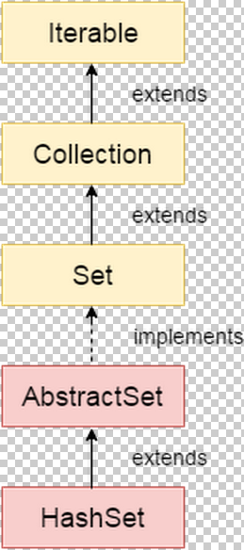

### Hierarchy of HashSet class

The HashSet class extends AbstractSet class which implements Set interface. The Set interface inherits Collection and Iterable interfaces in hierarchical order.

### HashSet class declaration

Let's see the declaration for java.util.HashSet class.

**public** **class** HashSet<E> **extends** AbstractSet<E> **implements** Set<E>, Cloneable, Serializable