In the given program, when an object to **My_Calculation** class is created, a copy of the contents of the superclass is made within it. That is why, using the object of the subclass you can access the members of a superclass.

The Superclass reference variable can hold the subclass object, but using that variable you can access only the members of the superclass, so to access the members of both classes it is recommended to always create reference variable to the subclass.

If you consider the above program, you can instantiate the class as given below. But using the superclass reference variable ( **cal** in this case) you cannot call the method **multiplication()**, which belongs to the subclass My_Calculation.

Calculation cal = new My_Calculation();

demo.addition(a, b);

demo.Subtraction(a, b);

**Note** − A subclass inherits all the members (fields, methods, and nested classes) from its superclass. Constructors are not members, so they are not inherited by subclasses, but the constructor of the superclass can be invoked from the subclass.

The super keyword

The **super** keyword is similar to **this** keyword. Following are the scenarios where the super keyword is used.

* It is used to **differentiate the members** of superclass from the members of subclass, if they have same names.
* It is used to **invoke the superclass** constructor from subclass.

Differentiating the Members

If a class is inheriting the properties of another class. And if the members of the superclass have the names same as the sub class, to differentiate these variables we use super keyword as shown below.

super.variable

super.method();

Sample Code

This section provides you a program that demonstrates the usage of the **super** keyword.

In the given program, you have two classes namely *Sub_class* and *Super_class*, both have a method named display() with different implementations, and a variable named num with different values. We are invoking display() method of both classes and printing the value of the variable num of both classes. Here you can observe that we have used super keyword to differentiate the members of superclass from subclass.

IS-A Relationship

IS-A is a way of saying: This object is a type of that object. Let us see how the **extends** keyword is used to achieve inheritance.

public class Animal {

}

public class Mammal extends Animal {

}

public class Reptile extends Animal {

}

public class Dog extends Mammal {

}

Now, based on the above example, in Object-Oriented terms, the following are true −

* Animal is the superclass of Mammal class.
* Animal is the superclass of Reptile class.
* Mammal and Reptile are subclasses of Animal class.
* Dog is the subclass of both Mammal and Animal classes.

Now, if we consider the IS-A relationship, we can say −

* Mammal IS-A Animal
* Reptile IS-A Animal
* Dog IS-A Mammal
* Hence: Dog IS-A Animal as well

With the use of the extends keyword, the subclasses will be able to inherit all the properties of the superclass except for the private properties of the superclass.

We can assure that Mammal is actually an Animal with the use of the instance operator.

**Example**

[Live Demo](http://tpcg.io/ubo9f0)

class Animal {

}

class Mammal extends Animal {

}

class Reptile extends Animal {

}

public class Dog extends Mammal {

public static void main(String args[]) {

Animal a = new Animal();

Mammal m = new Mammal();

Dog d = new Dog();

System.out.println(m instanceof Animal);

System.out.println(d instanceof Mammal);

System.out.println(d instanceof Animal);

}

}

This will produce the following result −

**Output**

true

true

true

Since we have a good understanding of the **extends** keyword, let us look into how the **implements** keyword is used to get the IS-A relationship.

Generally, the **implements** keyword is used with classes to inherit the properties of an interface. Interfaces can never be extended by a class.

**Example**

public interface Animal {

}

public class Mammal implements Animal {

}

public class Dog extends Mammal {

}

The instanceof Keyword

Let us use the **instanceof** operator to check determine whether Mammal is actually an Animal, and dog is actually an Animal.

**Example**

[Live Demo](http://tpcg.io/8kk8Bm)

interface Animal{}

class Mammal implements Animal{}

public class Dog extends Mammal {

public static void main(String args[]) {

Mammal m = new Mammal();

Dog d = new Dog();

System.out.println(m instanceof Animal);

System.out.println(d instanceof Mammal);

System.out.println(d instanceof Animal);

}

}

This will produce the following result −

**Output**

true

true

true

HAS-A relationship

These relationships are mainly based on the usage. This determines whether a certain class **HAS-A** certain thing. This relationship helps to reduce duplication of code as well as bugs.

Lets look into an example −

**Example**

public class Vehicle{}

public class Speed{}

public class Van extends Vehicle {

private Speed sp;

}

This shows that class Van HAS-A Speed. By having a separate class for Speed, we do not have to put the entire code that belongs to speed inside the Van class, which makes it possible to reuse the Speed class in multiple applications.

In Object-Oriented feature, the users do not need to bother about which object is doing the real work. To achieve this, the Van class hides the implementation details from the users of the Van class. So, basically what happens is the users would ask the Van class to do a certain action and the Van class will either do the work by itself or ask another class to perform the action.

Types of Inheritance

There are various types of inheritance as demonstrated below.

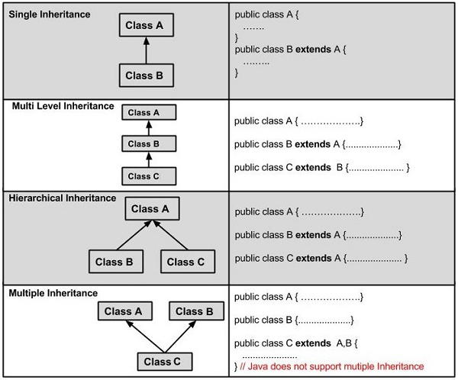

A very important fact to remember is that Java does not support multiple inheritance. This means that a class cannot extend more than one class. Therefore following is illegal −

**Example**

public class extends Animal, Mammal{}

However, a class can implement one or more interfaces, which has helped Java get rid of the impossibility of multiple inheritance.