Java Package

A **java package** is a group of similar types of classes, interfaces and sub-packages.

Package in java can be categorized in two form, built-in package and user-defined package.

There are many built-in packages such as java, lang, awt, javax, swing, net, io, util, sql etc.

Here, we will have the detailed learning of creating and using user-defined packages.

## Advantage of Java Package

1) Java package is used to categorize the classes and interfaces so that they can be easily maintained.

2) Java package provides access protection.

3) Java package removes naming collision.

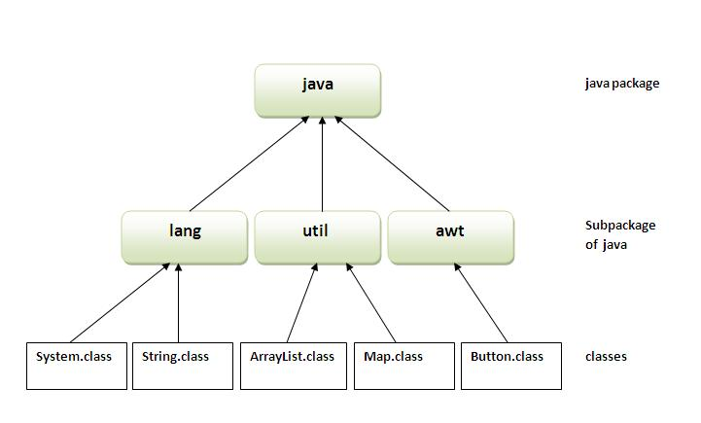

## How to compile java package

If you are not using any IDE, you need to follow the **syntax** given below:

1. javac -d directory javafilename

For **example**

1. javac -d . Simple.java

The -d switch specifies the destination where to put the generated class file. You can use any directory name like /home (in case of Linux), d:/abc (in case of windows) etc. If you want to keep the package within the same directory, you can use . (dot).

## How to run java package program

You need to use fully qualified name e.g. mypack.Simple etc to run the class.

|  |
| --- |
| **To Compile:** javac -d . Simple.java |
| **To Run:** java mypack.Simple |

Output:Welcome to package

|  |
| --- |
| The -d is a switch that tells the compiler where to put the class file i.e. it represents destination. The . represents the current folder |

## How to access package from another package?

There are three ways to access the package from outside the package.

1. import package.*;
2. import package.classname;
3. fully qualified name.

#### Note: Sequence of the program must be package then import then class.

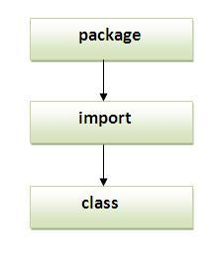

## Subpackage in java

Package inside the package is called the **subpackage**. It should be created **to categorize the package further**.

Let's take an example, Sun Microsystem has definded a package named java that contains many classes like System, String, Reader, Writer, Socket etc. These classes represent a particular group e.g. Reader and Writer classes are for Input/Output operation, Socket and ServerSocket classes are for networking etc and so on. So, Sun has subcategorized the java package into subpackages such as lang, net, io etc. and put the Input/Output related classes in io package, Server and ServerSocket classes in net packages and so on.

#### The standard of defining package is domain.company.package e.g. com.javatpoint.bean or org.sssit.dao.

## How to send the class file to another directory or drive?

There is a scenario, I want to put the class file of A.java source file in classes folder of c: drive. For example:

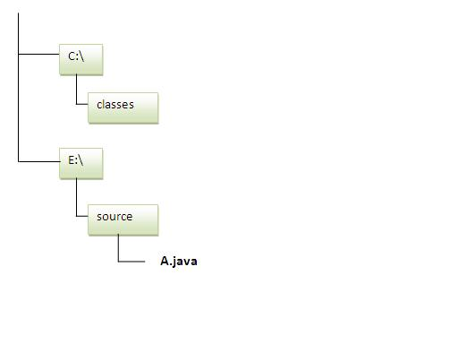

### Another way to run this program by -classpath switch of java:

The -classpath switch can be used with javac and java tool.

To run this program from e:\source directory, you can use -classpath switch of java that tells where to look for class file. For example:

**e:\sources> java -classpath c:\classes mypack.Simple**

Output:Welcome to package

### Ways to load the class files or jar files

|  |
| --- |
| There are two ways to load the class files temporary and permanent. |

* Temporary
  + By setting the classpath in the command prompt
  + By -classpath switch
* Permanent
  + By setting the classpath in the environment variables
  + By creating the jar file, that contains all the class files, and copying the jar file in the jre/lib/ext folder.

#### Rule: There can be only one public class in a java source file and it must be saved by the public class name.

### How to put two public classes in a package?

|  |
| --- |
| If you want to put two public classes in a package, have two java source files containing one public class, but keep the package name same. For example: |

1. //save as A.java
3. **package** javatpoint;
4. **public** **class** A{}
5. //save as B.java
7. **package** javatpoint;
8. **public** **class** B{}

### What is static import feature of Java5?

|  |
| --- |
| Click [Static Import](https://www.javatpoint.com/static-import-in-java) feature of Java5. |

### What about package class?

|  |
| --- |
| Click for [Package class](https://www.javatpoint.com/package-class) |

# Access Modifiers in java

There are two types of modifiers in java: **access modifiers** and **non-access modifiers**.

The access modifiers in java specifies accessibility (scope) of a data member, method, constructor or class.

There are 4 types of java access modifiers:

1. private
2. default
3. protected
4. public

There are many non-access modifiers such as static, abstract, synchronized, native, volatile, transient etc. Here, we will learn access modifiers.

### 1) private access modifier

|  |
| --- |
| The private access modifier is accessible only within class. |

### Simple example of private access modifier

|  |
| --- |
| In this example, we have created two classes A and Simple. A class contains private data member and private method. We are accessing these private members from outside the class, so there is compile time error. |

1. **class** A{
2. **private** **int** data=40;
3. **private** **void** msg(){System.out.println("Hello java");}
4. }
6. **public** **class** Simple{
7. **public** **static** **void** main(String args[]){
8. A obj=**new** A();
9. System.out.println(obj.data);//Compile Time Error
10. obj.msg();//Compile Time Error
11. }
12. }

### Role of Private Constructor

|  |
| --- |
| If you make any class constructor private, you cannot create the instance of that class from outside the class. For example: |

1. **class** A{
2. **private** A(){}//private constructor
3. **void** msg(){System.out.println("Hello java");}
4. }
5. **public** **class** Simple{
6. **public** **static** **void** main(String args[]){
7. A obj=**new** A();//Compile Time Error
8. }
9. }

#### Note: A class cannot be private or protected except nested class.

### 2) default access modifier

|  |
| --- |
| If you don't use any modifier, it is treated as **default** bydefault. The default modifier is accessible only within package. |

### Example of default access modifier

|  |
| --- |
| In this example, we have created two packages pack and mypack. We are accessing the A class from outside its package, since A class is not public, so it cannot be accessed from outside the package. |

1. //save by A.java
2. **package** pack;
3. **class** A{
4. **void** msg(){System.out.println("Hello");}
5. }
6. //save by B.java
7. **package** mypack;
8. **import** pack.*;
9. **class** B{
10. **public** **static** **void** main(String args[]){
11. A obj = **new** A();//Compile Time Error
12. obj.msg();//Compile Time Error
13. }
14. }

In the above example, the scope of class A and its method msg() is default so it cannot be accessed from outside the package.

### 3) protected access modifier

The **protected access modifier** is accessible within package and outside the package but through inheritance only.

The protected access modifier can be applied on the data member, method and constructor. It can't be applied on the class.

### Example of protected access modifier

In this example, we have created the two packages pack and mypack. The A class of pack package is public, so can be accessed from outside the package. But msg method of this package is declared as protected, so it can be accessed from outside the class only through inheritance.

1. //save by A.java
2. **package** pack;
3. **public** **class** A{
4. **protected** **void** msg(){System.out.println("Hello");}
5. }
6. //save by B.java
7. **package** mypack;
8. **import** pack.*;
10. **class** B **extends** A{
11. **public** **static** **void** main(String args[]){
12. B obj = **new** B();
13. obj.msg();
14. }
15. }

Output:Hello

### 4) public access modifier

|  |
| --- |
| The **public access modifier** is accessible everywhere. It has the widest scope among all other modifiers. |

### Example of public access modifier

1. //save by A.java
3. **package** pack;
4. **public** **class** A{
5. **public** **void** msg(){System.out.println("Hello");}
6. }
7. //save by B.java
9. **package** mypack;
10. **import** pack.*;
12. **class** B{
13. **public** **static** **void** main(String args[]){
14. A obj = **new** A();
15. obj.msg();
16. }
17. }

Output:Hello

### Understanding all java access modifiers

Let's understand the access modifiers by a simple table.

|  |  |  |  |  |
| --- | --- | --- | --- | --- |
| **Access Modifier** | **within class** | **within package** | **outside package by subclass only** | **outside package** |
| **Private** | Y | N | N | N |
| **Default** | Y | Y | N | N |
| **Protected** | Y | Y | Y | N |
| **Public** | Y | Y | Y | Y |

### Java access modifiers with method overriding

If you are overriding any method, overridden method (i.e. declared in subclass) must not be more restrictive.

1. **class** A{
2. **protected** **void** msg(){System.out.println("Hello java");}
3. }
5. **public** **class** Simple **extends** A{
6. **void** msg(){System.out.println("Hello java");}//C.T.Error
7. **public** **static** **void** main(String args[]){
8. Simple obj=**new** Simple();
9. obj.msg();
10. }
11. }

|  |
| --- |
| The default modifier is more restrictive than protected. That is why there is compile time error. |