This article discusses the best way of incorporating React into a Java web application. The JavaReact sample project is a full featured React development environment that allows Java developers to stay with their familiar Maven build tool.

Using React
React is a Javascript library for creating HTML interfaces using view components. In its most basic form React can be used by simply including React.js in your page and writing components in a Javascript file. But a lot more power and flexibility is gained by using a complete React development environment. For this article, a complete React development environment has the following features:
- Components are written in multiple JXS files which are compiled and merged into just a couple of Javascript files
- Minified Javascript files are produced when packaging for production
- Hot Module Reloading is active when running in development so changes are reflected in the web browser immediately without refreshing
- External Javascript libraries are included from npm and packaged into a single include file
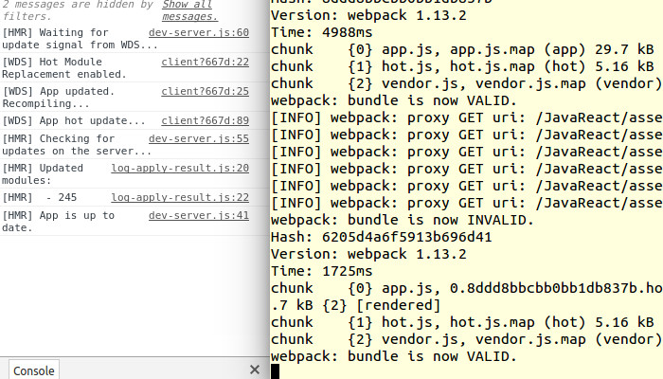

Javascript Build Process
Although the ultimate goal is to run everything from Maven, compiling and packaging the React files will use standard Javascript tools. Node is the Javascript runtime environment and is equivalent to the JRE for Java while NPM is the Node Package Manager responsible for downloading and installing Javascript libraries much like Maven handles Java dependencies. Webpack is a Javascript application that is responsible for compiling and packaging web related resources into the final files that can be included into web pages; and the webpack-dev-server is a similar application that hosts the files and changes from its own server for hot reloading of resources.
To use all of these Javascript tools automatically from within Maven, the frontend-maven-plugin from eirslett is defined in the pom.xml file.
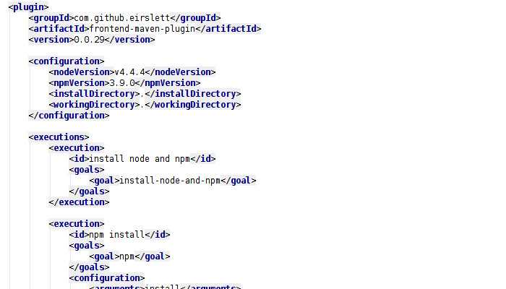

This plugin will download Node and NPM into the node directory of the Java project. The plugin will then use NPM to download all of the Javascript libraries defined in the project.json file (including Webpack) into the node_modules directory. This same plugin can also run Webpack and build the final resource files as defined in the webpack.config.js file. At this point the build process would be complete - but without Hot Module Reloading.

Hot Module Reloading
To enable hot reloading several things need to change when running in development. Instead of using the frontend-maven-plugin to run Webpack, the gmaven-plugin is used to run a simple Groovy script. This Groovy script checks for jetty:run as a Maven argument and instead of running webpack, it runs the webpack-dev-server.
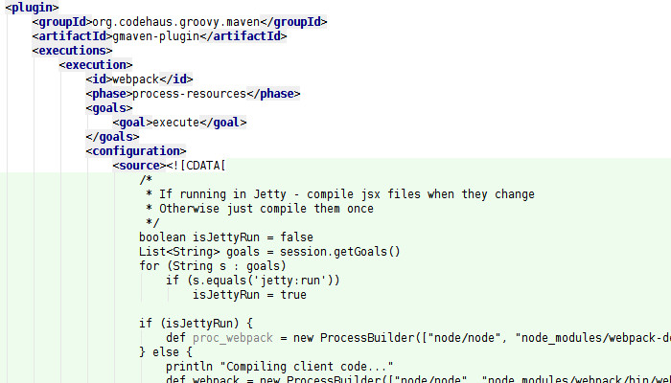

The key to all of this working from within Maven is to launch an external process while Jetty starts up yet have that process still integrated into the Maven build cycle. To accomplish this the Groovy script launches webpack-dev-server as an external process with its IO tied to the parent process IO. It is also started with the --stdin argument which tells the webpack-dev-server to shutdown when stdin closes. This allows Maven to continue its process and start up Jetty to server the web application. All output from the webpack-dev-server will be combined with the standard Maven output and when Maven shuts down the webpack-dev-server will also shut down.
The second change for hot reloading is to have all of the web resources be automatically served from the webpack-dev-server instead of the webapp directory without changing the web page source or the web.xml file. When packaging for production, the webpack.config.js file is configured to output resource files directly to webapp/assets under the Maven build output directory. For development, Jetty is configured with an overrideWebXml file that adds a servlet on top of the existing web.xml configuration. The servlet routs all /assets/* requests to the webpack-dev-server.
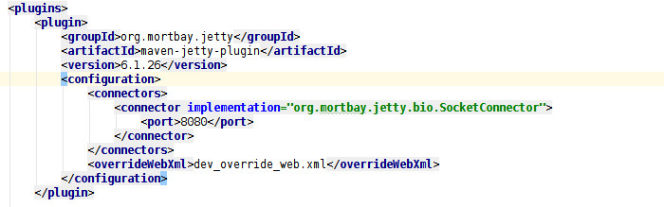

The last change is in the webpack.config.js file. When the -p flag is detected, modules are added to the configuration to minimize Javascript and extract CSS into a separate file. When not compiling for production, the configuration is changed to include entry points and loaders for Hot Module Reloading.

Final Solution
At this point the production web application can be built by running "mvn package" and in development the application can be run complete with Hot Module Reloading by using "mvn jetty:run".
The complete solution can be found at GitHub

