题目：
- 猜数页面，猜错猜对及输入不正确的情况分别处理，后台随机生成一个0-100的数，让用户猜。最多猜五次，每次猜完后要对用户提示“猜大了”或“猜小了”，如果相等，提示“猜对了，游戏结束！”
2.将第二章实训题的第二题，登录页面，提交用户名、密码，若用户名不为空字符串且长度在6-8位间，密码不为，空长度为6位，则登录成功，显示“***（用户名）登录成功！”，否则显示“***登录失败”。

核心代码：
1.<!DOCTYPE html>
<html>
<head>
<meta charset="UTF-8">
<title></title>
</head>
<script type="text/javascript" src="js/bootstrap.js" ></script>
<script type="text/javascript" src="js/jquery-1.8.3.min.js" ></script>
<script type="text/javascript" src="js/bootstrap.min.js" ></script>
<script>
var s=parseInt(100*Math.random());;
var cishu=0;
$(function()
{
$("#caicai").click(function(){
var a=$("#cai").val();
if(a==s&&cishu<=5)
{alert("猜对了");}
else if(cishu>5)
alert("已猜超过5次");
else if(a>s)
{
alert("猜大了");
cishu++;
}
else
{
alert("猜小了");
cishu++;}
})
})
</script>
<body>
<input type="text" id="cai" />
<input type="button" id="caicai" value="确定" />
</body>
</html>
2.
<%@ page language="java" import="java.util.*" pageEncoding="utf-8"%>
<%
String path = request.getContextPath();
String basePath = request.getScheme()+"://"+request.getServerName()+":"+request.getServerPort()+path+"/";
%>

<!DOCTYPE HTML PUBLIC "-//W3C//DTD HTML 4.01 Transitional//EN">
<html>
<head>
<base href="<%=basePath%>">

<title>My JSP 'register.jsp' starting page</title>

<meta http-equiv="pragma" content="no-cache">
<meta http-equiv="cache-control" content="no-cache">
<meta http-equiv="expires" content="0">
<meta http-equiv="keywords" content="keyword1,keyword2,keyword3">
<meta http-equiv="description" content="This is my page">
<!--
<link rel="stylesheet" type="text/css" href="styles.css">
-->

</head>

<body>
<form method="post" action="check.do">
用户名<input type="text" name="name"><br>
密码<input type="password" name="password"><br>
<input type="submit" value="登陆">

</form>
</body>
</html>
package a1;

import java.io.IOException;

import java.io.PrintWriter;
import javax.servlet.ServletException;
import javax.servlet.http.HttpServlet;
import javax.servlet.http.HttpServletRequest;
import javax.servlet.http.HttpServletResponse;

@SuppressWarnings({ "serial", "unused" })
public class check extends HttpServlet {

/**
* Constructor of the object.
*/
public check() {
super();
}

/**
* Destruction of the servlet. <br>
*/
public void destroy() {
super.destroy(); // Just puts "destroy" string in log
// Put your code here
}

/**
* The doGet method of the servlet. <br>
*
* This method is called when a form has its tag value method equals to get.
*
* @param request the request send by the client to the server
* @param response the response send by the server to the client
* @throws ServletException if an error occurred
* @throws IOException if an error occurred
*/
public void doGet(HttpServletRequest request, HttpServletResponse response)
throws ServletException, IOException {

doPost(request,response);

}
/**
* The doPost method of the servlet. <br>
*
* This method is called when a form has its tag value method equals to post.
*
* @param request the request send by the client to the server
* @param response the response send by the server to the client
* @throws ServletException if an error occurred
* @throws IOException if an error occurred
*/
public void doPost(HttpServletRequest request, HttpServletResponse response)
throws ServletException, IOException {
String name=request.getParameter("name");
String pwd=request.getParameter("password");
int a=name.length();
int b=pwd.length();
if(a>5&&a<9&&b!=0)
{
request.getRequestDispatcher("/success.jsp").forward(request,response);
}
else
{
response.sendRedirect("/WEB04172210/succeed.jsp");
}
}

/**
* Initialization of the servlet. <br>
*
* @throws ServletException if an error occurs
*/
public void init() throws ServletException {
// Put your code here
}

}<%@ page pageEncoding="utf-8"%>\
<html>
<head>
<meta http-equiv="Content-Type" content="text/html"; charset="utf-8">
</head>
<body>
<font>
<% request.setCharacterEncoding("utf-8");
String yourname=request.getParameter("name");
out.println(yourname+"登陆成功");

%>

</font>
</body>
</html><%@ page pageEncoding="utf-8"%>\
<html>
<head>
<meta http-equiv="Content-Type" content="text/html"; charset="utf-8">
</head>
<body>
<font>
<% request.setCharacterEncoding("utf-8");
String yourname=request.getParameter("name");
out.println(yourname+"登陆失败");

%>

</font>
</body>
</html>
结果截图：
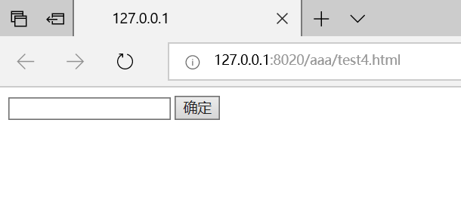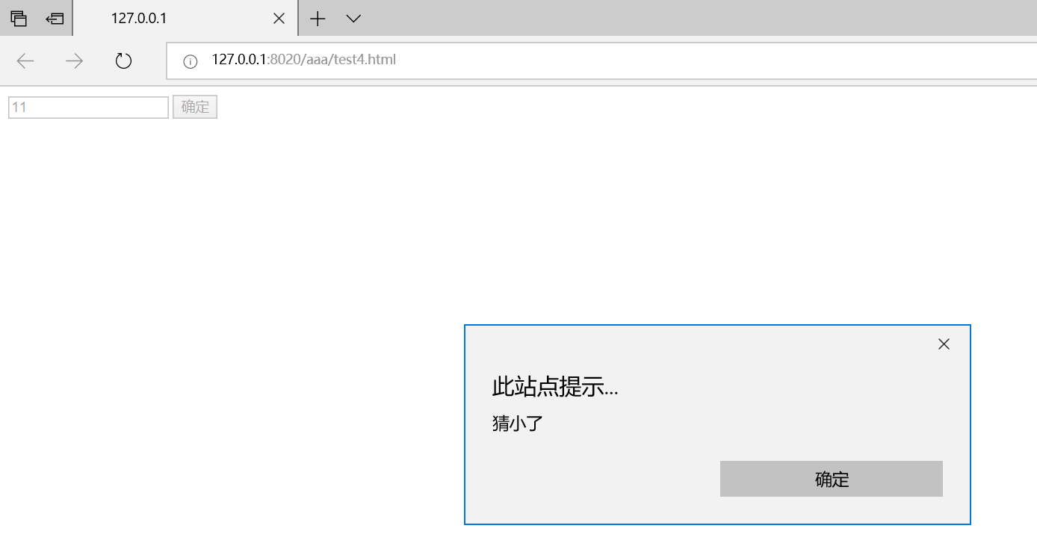2.
