Java Web开发

实验五
作业报告

学院 | 计算机
所在系班级 | 2017软件工程系10班
学号姓名 | 04172212 林杰
指导教师 | 郭晓燕
完成时间 | 2019年4月10号
实验目标：

1、理解会话的原理和HttpSession会话期；

2、掌握如何使用URL重写；

3、掌握如何使用HttpSession会话管理
实验内容：
- 练习老师在理论课上演示的购物车实例，理解购物功能如何实现，理解如何利用session对象保存购物信息，如何设计封装数据类。（请参考“第四章会话管理课上的购物车实例代码.docx”文档）；
如果上课听懂了购物车的原理或者部分理解，可以参考我的实例完成第2题，此题可忽略不写。
- 第四章课后练习3购物车，实现一个购物车应用程序，可以购物，显示购物数量并查看购物车内容。（此题模版test4E，提供给大家参考。）
提示：采购此书做成超链接，并用URL重写带关键信息
  - Shopping.view?bookID=‘0001’，其中0001是你选中图书对应的ID号，每点击一次就在相应的购书数量上加一，并返回当前的选购页面。
  - 除了要保存图书的ID号、书名，还要保存购书数量，所以session对象保存的信息需要考虑清楚，最好是一个对象数组或列表。
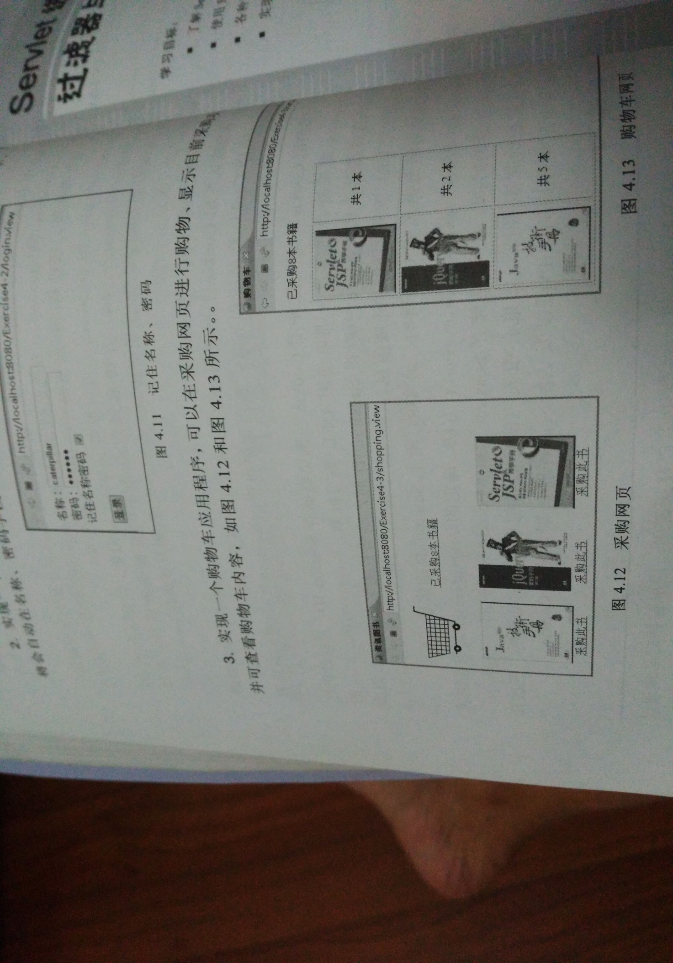
购物车的效果图
- 对第三章动态验证码程序实现动态验证。（选做）
提示：在生成动态验证码的同时将其放入HttpSession对象中，在网页上提取出来进行比对。
- 分析与设计

关键源码（部分）
Shopping.jsp
<%@ page language="java" import="java.util.*" pageEncoding="UTF-8"%>
<%@ page language="java" import="cc.homebook.Book" %>
<%
String path = request.getContextPath();
String basePath = request.getScheme()+"://"+request.getServerName()+":"+request.getServerPort()+path+"/";
%>

<!DOCTYPE HTML PUBLIC "-//W3C//DTD HTML 4.01 Transitional//EN">
<html>
<head>
<base href="<%=basePath%>">

<title>My JSP 'Shopping.jsp' starting page</title>

<meta http-equiv="pragma" content="no-cache">
<meta http-equiv="cache-control" content="no-cache">
<meta http-equiv="expires" content="0">
<meta http-equiv="keywords" content="keyword1,keyword2,keyword3">
<meta http-equiv="description" content="This is my page">
<!--
<link rel="stylesheet" type="text/css" href="styles.css">
-->

</head>

<%
if(session.getAttribute("books")==null)
{
Book[] books=new Book[4];
books[0]=new Book("001","三国演义","images/01.jpg",0);
books[1]=new Book("002","水浒传","images/02.jpg",0);
books[2]=new Book("003","西游记","images/03.jpg",0);
books[3]=new Book("004","红楼梦","images/04.jpg",0);
session.setAttribute("books",books);
session.setAttribute("total", 0);
}

%>
<body>
<%
Book[] books=(Book[])session.getAttribute("books");
int total=(Integer)session.getAttribute("total");
%>
<img style="width:150px;height:200px" src="images/05.jpg">
<a href="index.jsp">当前已经采购<%=total %>本书籍</a>
<form action="bookcount" methor="post" name=form>
<%
if(books!=null)
{
for(Book book:books)
{%>
<div style="float:left">
<img style="width:150px;height:200px" src="<%=book.getImg() %>">
<a href="count.do?id=<%=book.getBookID() %>">采购此书</a>
</div>

<%
}
}

%>

</form>
</body>
</html>
CountServlet
package cc.homebook;

import java.io.IOException;
import java.io.PrintWriter;

import javax.servlet.ServletException;
import javax.servlet.annotation.WebServlet;
import javax.servlet.http.HttpServlet;
import javax.servlet.http.HttpServletRequest;
import javax.servlet.http.HttpServletResponse;
import javax.servlet.http.HttpSession;
@WebServlet("/count.do")
public class CountServlet extends HttpServlet {

public CountServlet() {
super();
}

public void destroy() {
super.destroy(); // Just puts "destroy" string in log
// Put your code here
}

public void doGet(HttpServletRequest request, HttpServletResponse response)
throws ServletException, IOException {

doPost(request,response);
}

public void doPost(HttpServletRequest request, HttpServletResponse response)
throws ServletException, IOException {
request.setCharacterEncoding("UTF-8");
response.setContentType("text/html;charset=UTF-8");
HttpSession session=request.getSession();
Book[] books=(Book[])session.getAttribute("books");
int total=(Integer)session.getAttribute("total");
session.setAttribute("total", total+1);
if(books!=null)
{
for(Book book:books)
{
if(book.getBookID().equals(request.getParameter("id")))
{
book.setSum(book.getSum()+1);
}
}

}
request.getRequestDispatcher("Shopping.jsp").forward(request, response);
}

/**
* Initialization of the servlet. <br>
*
* @throws ServletException if an error occurs
*/
public void init() throws ServletException {
// Put your code here
}

}

Index.jsp
<%@ page language="java" import="java.util.*" pageEncoding="UTF-8"%>
<%@ page language="java" import="cc.homebook.Book" %>
<%
String path = request.getContextPath();
String basePath = request.getScheme()+"://"+request.getServerName()+":"+request.getServerPort()+path+"/";
%>

<!DOCTYPE HTML PUBLIC "-//W3C//DTD HTML 4.01 Transitional//EN">
<html>
<head>
<base href="<%=basePath%>">

<title>My JSP 'index.jsp' starting page</title>

<meta http-equiv="pragma" content="no-cache">
<meta http-equiv="cache-control" content="no-cache">
<meta http-equiv="expires" content="0">
<meta http-equiv="keywords" content="keyword1,keyword2,keyword3">
<meta http-equiv="description" content="This is my page">
<!--
<link rel="stylesheet" type="text/css" href="styles.css">
-->

</head>

<body>
<%
Book[] books=(Book[])session.getAttribute("books");
int total=(Integer)session.getAttribute("total");
%>
<p>已采购<%=total%>本书籍</p>
<a href="Shopping.jsp">返回继续采购</a>
<%if(books!=null){ %>
<table>
<%for(Book book:books) {%>
<tr>
<td><img style="width:150px;height:200px" src="<%=book.getImg() %>"></td>
<td>共<%=book.getSum()%>本</td>
</tr>
<%}%>
</table>
<%}%>
</body>
</html>
Book
package cc.homebook;

public class Book {

private String BookID;
private String BookName;
private String img;
private double BookPrice;
private int sum;
public Book()
{

}
public Book(String BookID,String BookName,String img,int sum)
{
this.BookID=BookID;
this.BookName=BookName;
this.img=img;
this.sum=sum;
}

public String getBookID() {
return BookID;
}
public void setBookID(String bookID) {
BookID = bookID;
}
public String getBookName() {
return BookName;
}
public void setBookName(String bookName) {
BookName = bookName;
}
public String getImg() {
return img;
}
public void setImg(String img) {
this.img = img;
}
public int getSum() {
return sum;
}
public void setSum(int sum) {
this.sum = sum;
}
public double getBookPrice() {
return BookPrice;
}
public void setBookPrice(double bookPrice) {
BookPrice = bookPrice;
}

}
- 运行效果图

