public class Hello extends HttpServlet {

@Override

protected void doPost(HttpServletRequest req, HttpServletResponse resp) throws ServletException, IOException {

resp.setContentType("text/html;charset=UTF-8");

PrintWriter out = resp.getWriter();

out.print("<html><body>");

out.print("<h2>你好，欢迎各位软工的同学,<br>");

out.print("</body><html>");

}

@Override

protected void doGet(HttpServletRequest req, HttpServletResponse resp) throws ServletException, IOException {

doPost(req, resp);

}

protected void doPost(HttpServletRequest req, HttpServletResponse resp) throws ServletException, IOException {

String user = req.getParameter("user");

String welcimeInfo = "Welocome You" + user + "同学";

resp.setContentType("text/html;charset=UTF-8");

PrintWriter out = resp.getWriter();

out.print("<html><HEAD><TITLE>欢迎页面</HEAD></TITLE>");

out.print("<h2>"+ welcimeInfo + "<br>");

out.print("</body><html>");

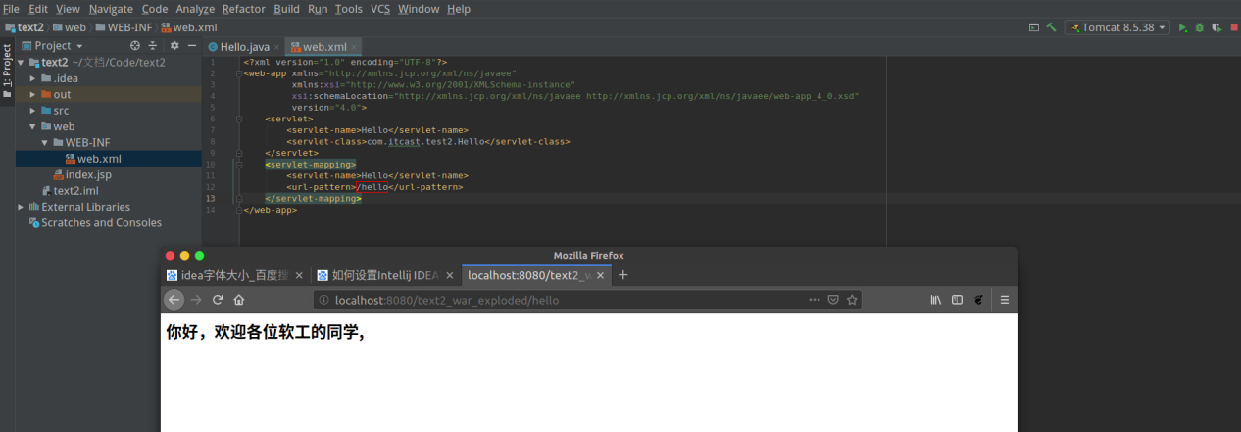

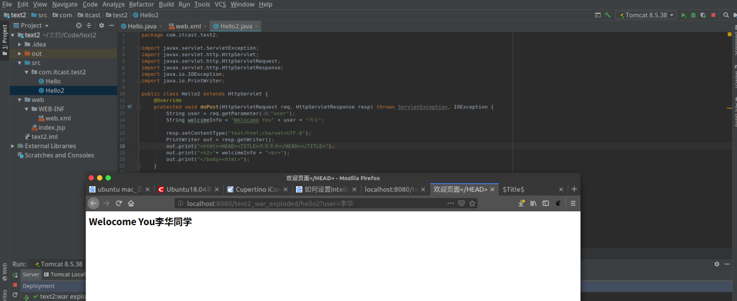

public class Register extends HttpServlet {

@Override

protected void doPost(HttpServletRequest req, HttpServletResponse resp) throws ServletException, IOException {

req.setCharacterEncoding("UTF-8");

String username = req.getParameter("user");

if (username != null && username.length() > 0){

req.getRequestDispatcher("success").forward(req, resp);

}else {

resp.sendRedirect("fail.html");

}

}

public class Success extends HttpServlet {

@Override

protected void doPost(HttpServletRequest req, HttpServletResponse resp) throws ServletException, IOException {

req.setCharacterEncoding("UTF-8");

String username = req.getParameter("user");

String email = req.getParameter("email");

resp.setContentType("text/html;charset=UTF-8");

PrintWriter out = resp.getWriter();

out.print("<html><body>");

out.print("<h2>你好!" + username + ",你的邮箱是:" + email + "<br>");

out.print("</body><html>");

}

