public class Hello extends HttpServlet {  
 @Override  
 protected void doPost(HttpServletRequest req, HttpServletResponse resp) throws ServletException, IOException {  
 resp.setContentType("text/html;charset=UTF-8");  
 PrintWriter out = resp.getWriter();  
 out.print("<html><body>");  
 out.print("<h2>你好，欢迎各位软工的同学,<br>");  
 out.print("</body><html>");  
  
 }  
  
 @Override  
 protected void doGet(HttpServletRequest req, HttpServletResponse resp) throws ServletException, IOException {  
 doPost(req, resp);  
 }

使用post提交因为这样提交.设置中文比较方便

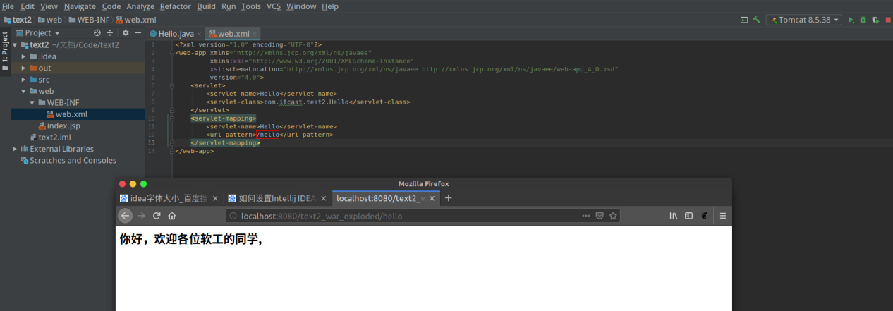

protected void doPost(HttpServletRequest req, HttpServletResponse resp) throws ServletException, IOException {  
 String user = req.getParameter("user");  
 String welcimeInfo = "Welocome You" + user + "同学";  
  
 resp.setContentType("text/html;charset=UTF-8");  
 PrintWriter out = resp.getWriter();  
 out.print("<html><HEAD><TITLE>欢迎页面</HEAD></TITLE>");  
 out.print("<h2>"+ welcimeInfo + "<br>");  
 out.print("</body><html>");

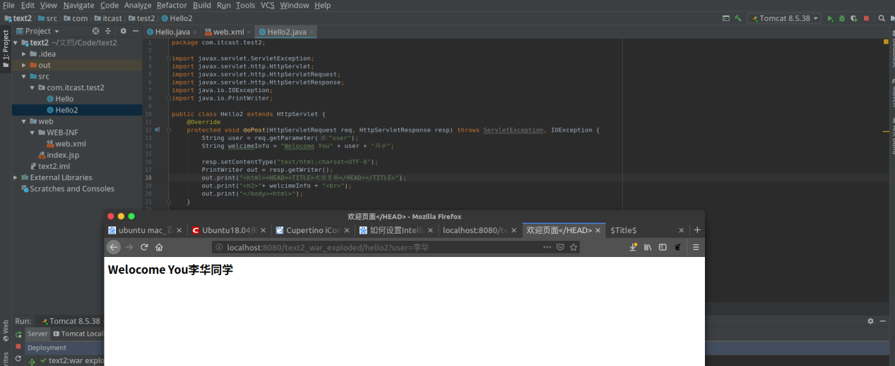

public class Register extends HttpServlet {  
 @Override  
 protected void doPost(HttpServletRequest req, HttpServletResponse resp) throws ServletException, IOException {  
 req.setCharacterEncoding("UTF-8");  
 String username = req.getParameter("user");  
 if (username != null && username.length() > 0){  
 req.getRequestDispatcher("success").forward(req, resp);  
 }else {  
 resp.sendRedirect("fail.html");  
 }  
 }

public class Success extends HttpServlet {  
 @Override  
 protected void doPost(HttpServletRequest req, HttpServletResponse resp) throws ServletException, IOException {  
 req.setCharacterEncoding("UTF-8");  
 String username = req.getParameter("user");  
 String email = req.getParameter("email");  
  
 resp.setContentType("text/html;charset=UTF-8");  
 PrintWriter out = resp.getWriter();  
 out.print("<html><body>");  
 out.print("<h2>你好!" + username + ",你的邮箱是:" + email + "<br>");  
 out.print("</body><html>");  
 }

