**一．**/*

* To change this license header, choose License Headers in Project Properties.

* To change this template file, choose Tools | Templates

* and open the template in the editor.

*/

package ch2;

import java.io.IOException;

import java.io.PrintWriter;

import javax.servlet.ServletException;

import javax.servlet.annotation.WebServlet;

import javax.servlet.http.HttpServlet;

import javax.servlet.http.HttpServletRequest;

import javax.servlet.http.HttpServletResponse;

/**

*

* @author Administrator

*/

@WebServlet("/test2/hello.view")

public class ex1 extends HttpServlet {

/**

* Processes requests for both HTTP <code>GET</code> and <code>POST</code>

* methods.

*

* @param request servlet request

* @param response servlet response

* @throws ServletException if a servlet-specific error occurs

* @throws IOException if an I/O error occurs

*/

// <editor-fold defaultstate="collapsed" desc="HttpServlet methods. Click on the + sign on the left to edit the code.">

/**

* Handles the HTTP <code>GET</code> method.

*

* @param request servlet request

* @param response servlet response

* @throws ServletException if a servlet-specific error occurs

* @throws IOException if an I/O error occurs

*/

@Override

protected void doGet(HttpServletRequest request, HttpServletResponse response)

throws ServletException, IOException {

//processRequest(request, response);

response.setContentType("text/html;charset=UTF-8");

try (PrintWriter out = response.getWriter()) {

/* TODO output your page here. You may use following sample code. */

String user = request.getParameter("user");

out.println("<!DOCTYPE html>");

out.println("<html>");

out.println("<head>");

out.println("<title>欢迎界面</title>");

out.println("</head>");

out.println("<body>");

out.println("<h1>hello! " + user + "</h1>");

out.println("</body>");

out.println("</html>");

}

}

/**

* Handles the HTTP <code>POST</code> method.

*

* @param request servlet request

* @param response servlet response

* @throws ServletException if a servlet-specific error occurs

* @throws IOException if an I/O error occurs

*/

@Override

protected void doPost(HttpServletRequest request, HttpServletResponse response)

throws ServletException, IOException {

//processRequest(request, response);

}

/**

* Returns a short description of the servlet.

*

* @return a String containing servlet description

*/

@Override

public String getServletInfo() {

return "Short description";

}// </editor-fold>

}

**1.**

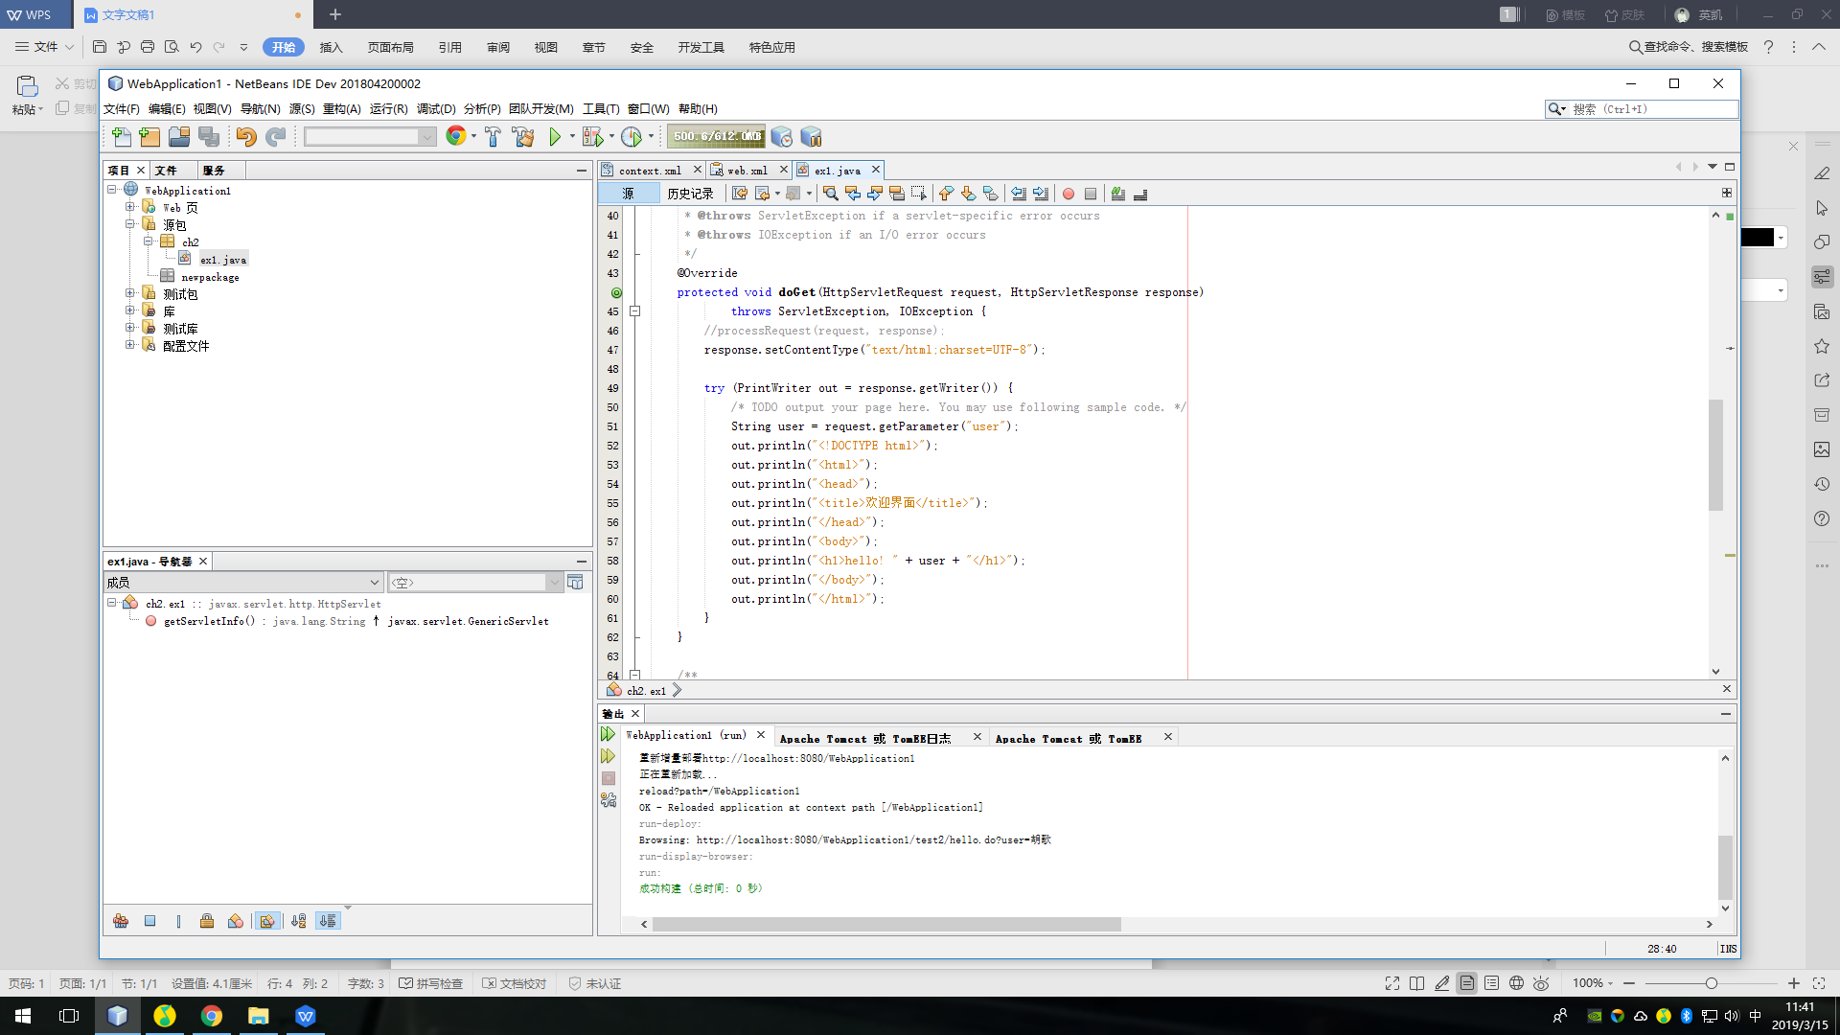

**文件法**

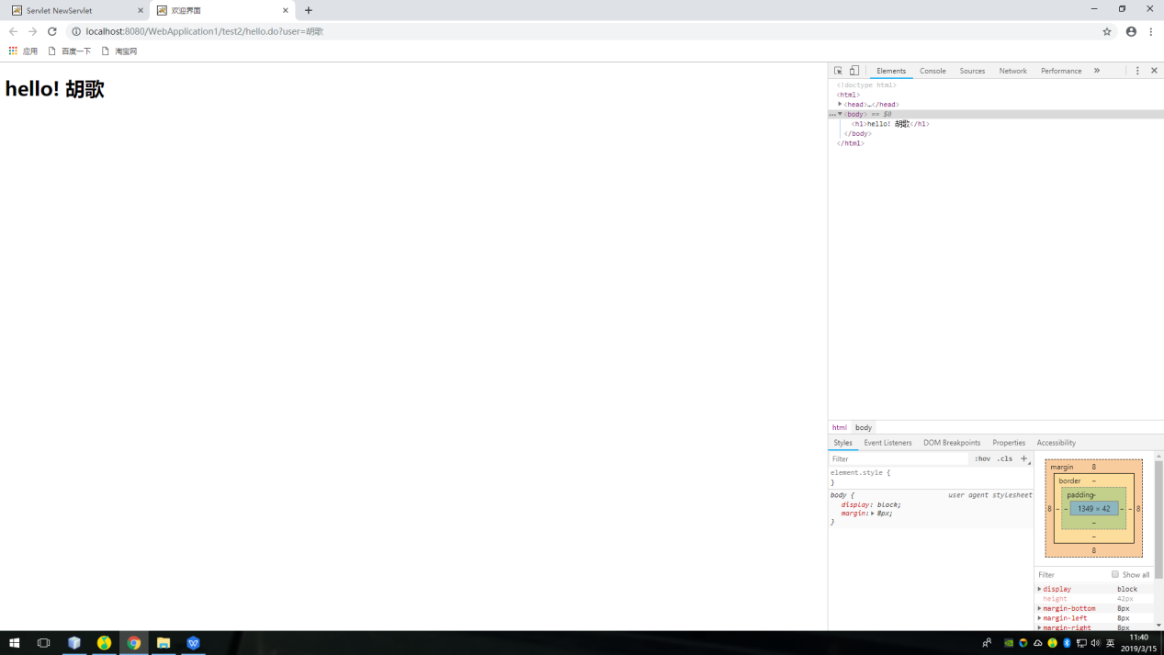

**注释法**

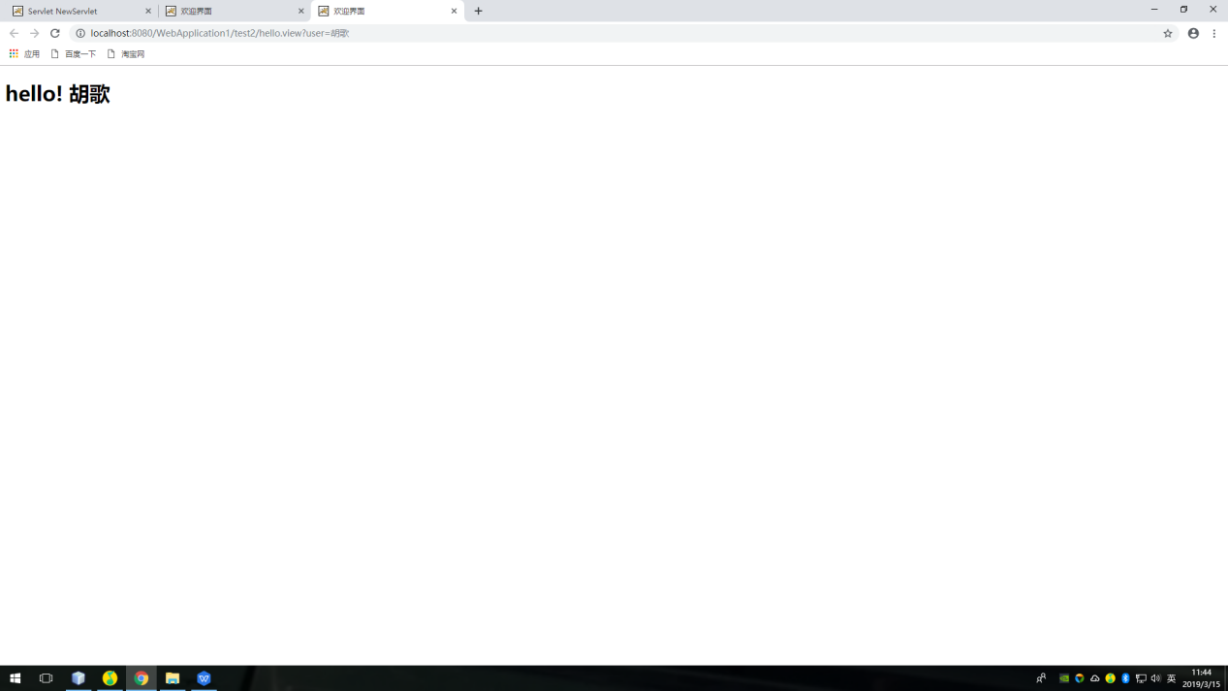

二．

<?xml version="1.0" encoding="UTF-8"?>

<web-app version="3.1" xmlns="http://xmlns.jcp.org/xml/ns/javaee" xmlns:xsi="http://www.w3.org/2001/XMLSchema-instance" xsi:schemaLocation="http://xmlns.jcp.org/xml/ns/javaee http://xmlns.jcp.org/xml/ns/javaee/web-app_3_1.xsd">

<servlet>

<servlet-name>ex1</servlet-name>

<servlet-class>ch2.ex1</servlet-class>

</servlet>

<servlet>

<servlet-name>ex2</servlet-name>

<servlet-class>ch2.ex2</servlet-class>

</servlet>

<servlet-mapping>

<servlet-name>ex1</servlet-name>

<url-pattern>/test2/hello.do</url-pattern>

</servlet-mapping>

<servlet-mapping>

<servlet-name>ex2</servlet-name>

<url-pattern>/test2/ex2</url-pattern>

</servlet-mapping>

<session-config>

<session-timeout>

30

</session-timeout>

</session-config>

</web-app>

/*

* To change this license header, choose License Headers in Project Properties.

* To change this template file, choose Tools | Templates

* and open the template in the editor.

*/

package ch2;

import java.io.IOException;

import java.io.PrintWriter;

import javax.servlet.ServletException;

import javax.servlet.http.HttpServlet;

import javax.servlet.http.HttpServletRequest;

import javax.servlet.http.HttpServletResponse;

/**

*

* @author Administrator

*/

public class ex2 extends HttpServlet {

/**

* Processes requests for both HTTP <code>GET</code> and <code>POST</code>

* methods.

*

* @param request servlet request

* @param response servlet response

* @throws ServletException if a servlet-specific error occurs

* @throws IOException if an I/O error occurs

*/

// <editor-fold defaultstate="collapsed" desc="HttpServlet methods. Click on the + sign on the left to edit the code.">

/**

* Handles the HTTP <code>GET</code> method.

*

* @param request servlet request

* @param response servlet response

* @throws ServletException if a servlet-specific error occurs

* @throws IOException if an I/O error occurs

*/

@Override

protected void doGet(HttpServletRequest request, HttpServletResponse response)

throws ServletException, IOException {

response.setContentType("text/html;charset=UTF-8");

String user= request.getParameter("user");

String welcomeINFO = "Welcome you"+user+"同学";

PrintWriter out = response.getWriter();

out.println();

out.println("<html>");

out.println("<head>");

out.println("<title>第二题</title>");

out.println("</head>");

out.println("<body>");

out.println(welcomeINFO);

out.println("</body>");

out.println("</html>");

}

/**

* Handles the HTTP <code>POST</code> method.

*

* @param request servlet request

* @param response servlet response

* @throws ServletException if a servlet-specific error occurs

* @throws IOException if an I/O error occurs

*/

@Override

protected void doPost(HttpServletRequest request, HttpServletResponse response)

throws ServletException, IOException {

}

/**

* Returns a short description of the servlet.

*

* @return a String containing servlet description

*/

@Override

public String getServletInfo() {

return "Short description";

}// </editor-fold>

}

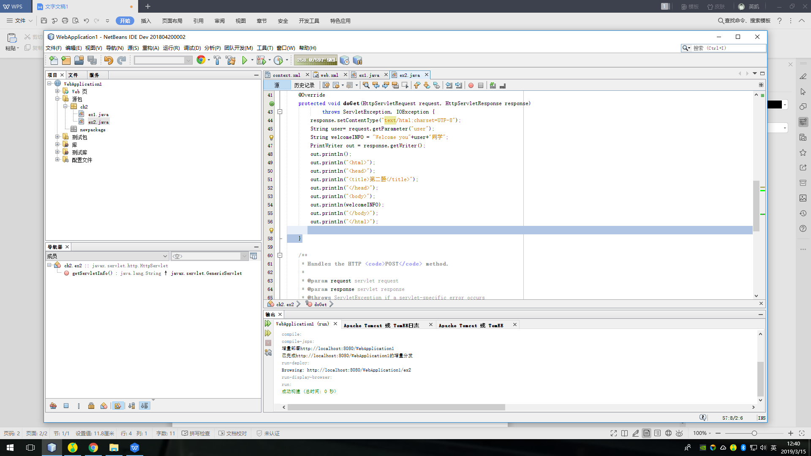

1. 把get请求的变量user赋值给user
2. 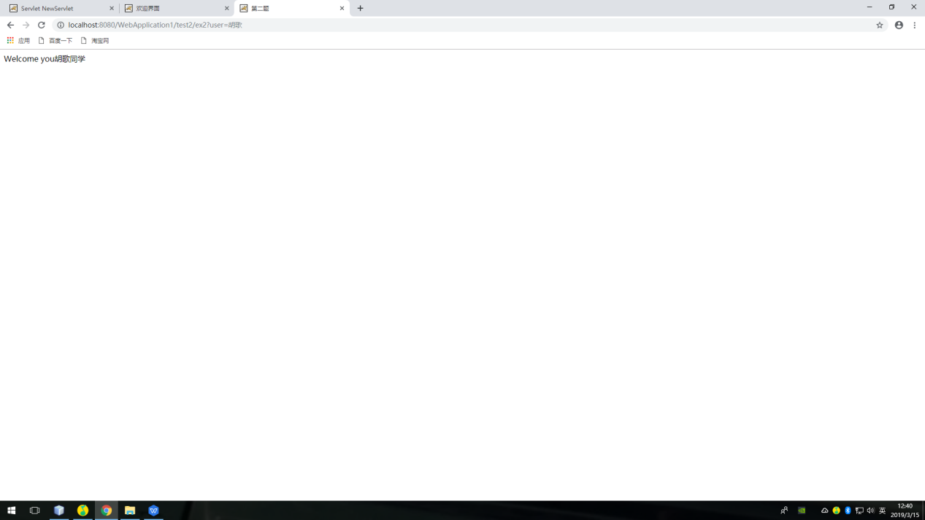

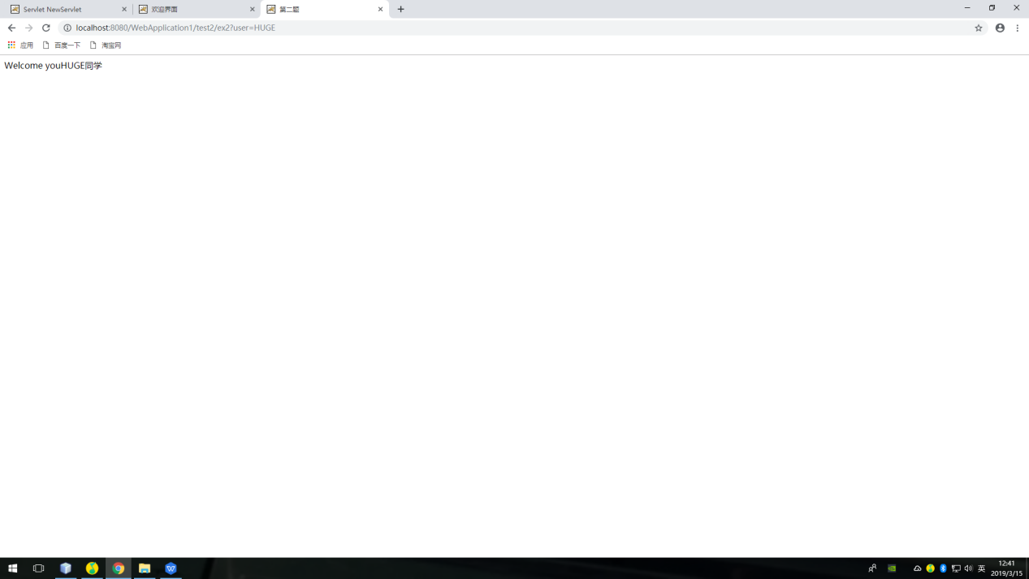

因为两次user的值不一样

3

