**Java Web开发**

**实验二**

**作业报告**

|  |  |
| --- | --- |
| 学 院 | 计算机 |
| 所在系 班 级 | 2017软件工程系11班 |
| 学 号 姓 名 | 04172016黄恺 |
| 指 导 教 师 | 郭晓燕 |
| 完 成 时 间 | 2019年3月11- |

# 实验题目

新建项目，练习教材上相关例子Hello.java文件，P29。并练习如何在Tomcat服务器上发布该文件

# 分析与设计

1.注释法直接加@webService

2.直接配置web.xml

# 关键源码（部分）

web.xml

<?xml version="1.0" encoding="UTF-8"?>  
<web-app xmlns="http://xmlns.jcp.org/xml/ns/javaee"  
 xmlns:xsi="http://www.w3.org/2001/XMLSchema-instance"  
 xsi:schemaLocation="http://xmlns.jcp.org/xml/ns/javaee http://xmlns.jcp.org/xml/ns/javaee/web-app_4_0.xsd"  
 version="4.0">  
 <servlet>  
 <servlet-name>HelloServlet</servlet-name>  
 <servlet-class>HelloServlet</servlet-class>  
 </servlet>  
 <servlet-mapping>  
 <servlet-name>HelloServlet</servlet-name>  
 <url-pattern>/hk</url-pattern>  
 </servlet-mapping>  
  
   
</web-app>

# 运行效果图

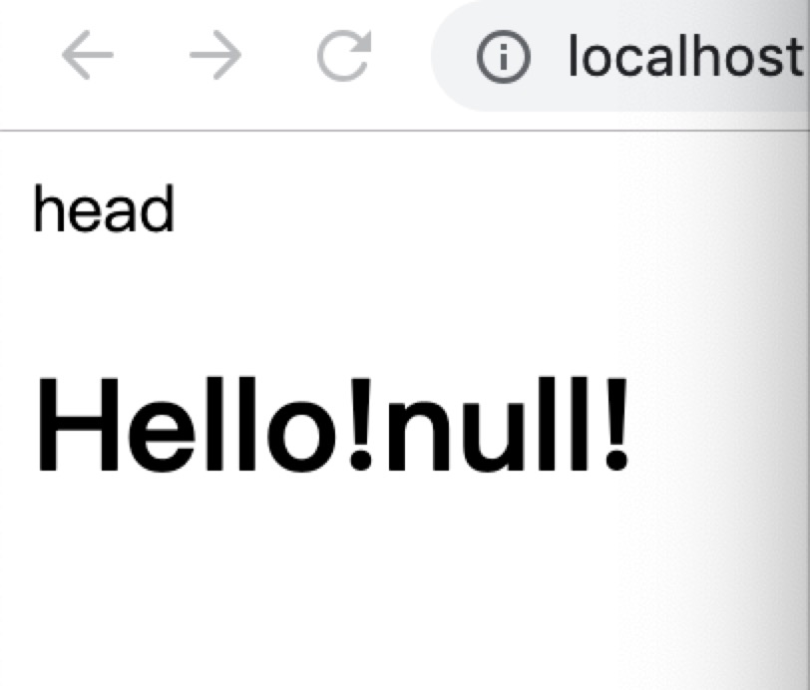

# 收获与问题

两种url的设置方法

# 题目二

**题目：**请编写WelcomeYou.java文件，代码内容如下图，

1） 图中第25行是何意思？

回答：接受页面提交的参数

2)修改网址参数获取同学相应的姓名：

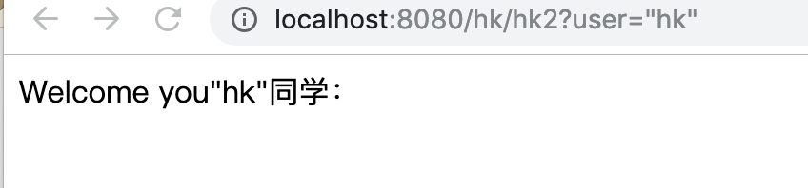

**题目三：自己设计邮箱注册**

**效果图：**

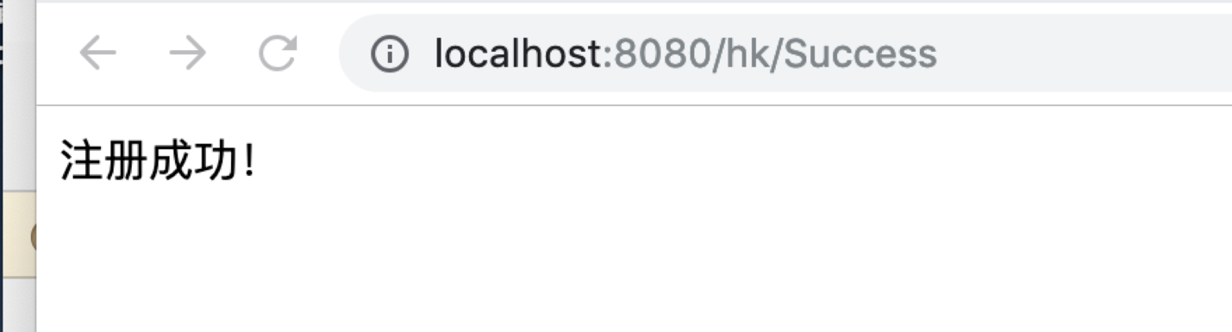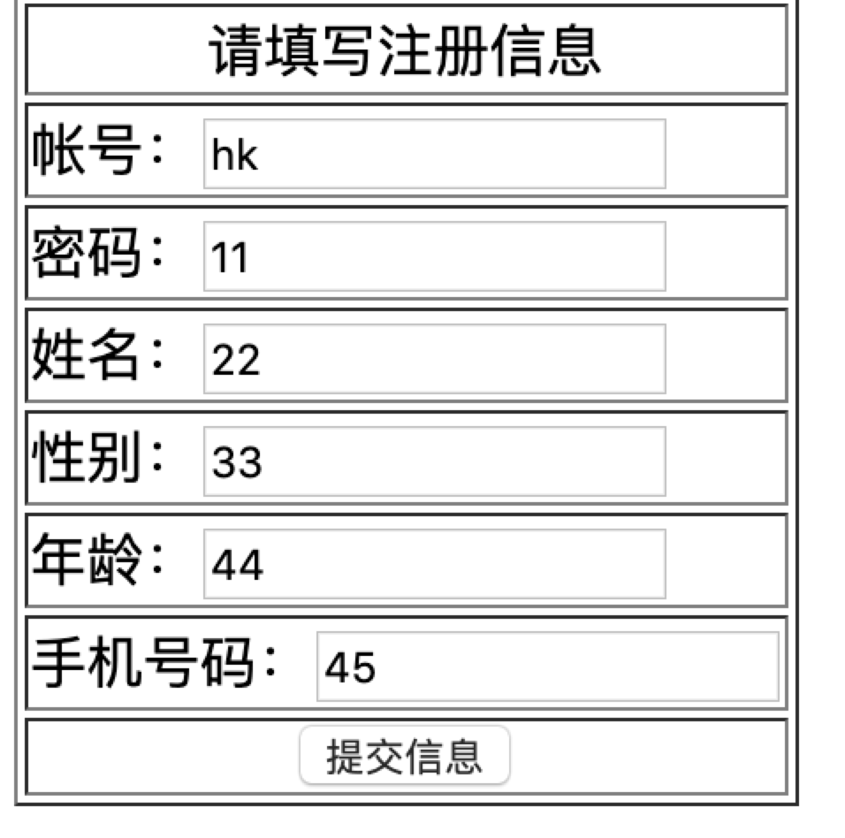

**代码如下**

**文件1:**

<%@ page language="java" contentType="text/html; charset=UTF-8"  
  
pageEncoding="UTF-8"%>  
  
<html>  
  
<head>  
  
 <meta http-equiv="Content-Type" content="text/html; charset=UTF-8">  
  
 <title>Insert title here</title>  
  
</head>  
  
<body>  
  
<form action="Success" method="post">  
  
 <table align="center" border="1" weight="200" height="200">  
  
 <tr align="center"><td>请填写注册信息</td></tr>  
 <tr><td>帐号：<input type="text" name="zh"></td></tr>  
 <tr><td>密码：<input type="text" name="mima"></td></tr>  
 <tr><td>姓名：<input type="text" name="xingming"></td></tr>  
  
 <tr><td>性别：<input type="text" name="sex"></td></tr>  
  
 <tr><td>年龄：<input type="text" name="age"></td></tr>  
  
 <tr><td>手机号码：<input type="text" name="num"></td></tr>  
  
 <tr align="center"><td><input type="submit" value="提交信息"></td></tr>  
  
 </table>  
  
</form>  
  
</body>  
  
</html>

**文件2**

import java.io.IOException;  
 import javax.servlet.ServletException;  
 import javax.servlet.http.HttpServlet;  
 import javax.servlet.http.HttpServletRequest;  
 import javax.servlet.http.HttpServletResponse;  
  
public class Success extends HttpServlet {  
 private static final long *serialVersionUID* = 1L;  
  
 public Success() {  
 super();  
  
 }  
 protected void doGet(HttpServletRequest request, HttpServletResponse response) throws ServletException, IOException {  
 response.setContentType("text/html");  
 response.setCharacterEncoding("UTF-8");  
 String z=request.getParameter("zh");  
 String m=request.getParameter("mima");  
 String nm=request.getParameter("xingming");  
 String s=request.getParameter("sex");  
 String a=request.getParameter("age");  
 String n=request.getParameter("num");  
 if(nm!=""&&s!=""&&a!=""&&n!=""&&z!=""&&m!="")  
 {  
 response.getWriter().write("注册成功！");  
  
 }  
 else  
 {  
 response.getWriter().write("请3秒后重新填写资料！");  
 response.setHeader("refresh", "3;URL=zhuceye.jsp");  
 }  
 //response.getWriter().append("Served at: ").append(request.getContextPath());  
 }  
  
  
 protected void doPost(HttpServletRequest request, HttpServletResponse response) throws ServletException, IOException {  
  
 doGet(request, response);  
 }  
  
}

**web.xml**

<?xml version="1.0" encoding="UTF-8"?>  
<web-app xmlns="http://xmlns.jcp.org/xml/ns/javaee"  
 xmlns:xsi="http://www.w3.org/2001/XMLSchema-instance"  
 xsi:schemaLocation="http://xmlns.jcp.org/xml/ns/javaee http://xmlns.jcp.org/xml/ns/javaee/web-app_4_0.xsd"  
 version="4.0">  
 <servlet>  
 <servlet-name>HelloServlet</servlet-name>  
 <servlet-class>HelloServlet</servlet-class>  
 </servlet>  
 <servlet-mapping>  
 <servlet-name>HelloServlet</servlet-name>  
 <url-pattern>/hk</url-pattern>  
 </servlet-mapping>  
 <servlet>  
 <servlet-name>WelcomeYou</servlet-name>  
 <servlet-class>WelcomeYou</servlet-class>  
 </servlet>  
 <servlet-mapping>  
 <servlet-name>WelcomeYou</servlet-name>  
 <url-pattern>/hk2</url-pattern>  
 </servlet-mapping>  
 <servlet>  
 <servlet-name>Success</servlet-name>  
 <servlet-class>Success</servlet-class>  
 </servlet>  
 <servlet-mapping>  
 <servlet-name>Success</servlet-name>  
 <url-pattern>/Success</url-pattern>  
 </servlet-mapping>  
  
   
</web-app>