第一题：

**package** cc.openhome;

**import** java.io.IOException;

**import** java.io.PrintWriter;

**import** javax.servlet.ServletException;

**import** javax.servlet.annotation.WebServlet;

**import** javax.servlet.http.HttpServlet;

**import** javax.servlet.http.HttpServletRequest;

**import** javax.servlet.http.HttpServletResponse;

@SuppressWarnings("serial")

@WebServlet("/hello.view")

**public** **class** HelloServlet **extends** HttpServlet {

@Override

**protected** **void** doGet(HttpServletRequest request, HttpServletResponse response) **throws** ServletException, IOException {

// **TODO** Auto-generated method stub

response.setContentType("text/html;charset=UTF-8");

PrintWriter out = response.getWriter();

String name = request.getParameter("name");

out.println("<html>");

out.println("<head>");

out.println("<title>Hello Servlet</title>");

out.println("</head>");

out.println("<body>");

out.println("<h1> 您好，欢迎各位软件工程专业的学生。 hello,"+ name + "!</h1>");

out.println("</body>");

out.println("</html>");

out.close();

}

**protected** **void** doPost(HttpServletRequest request, HttpServletResponse response) **throws** ServletException, IOException {

doGet(request,response);

}

}

***配置法截图：***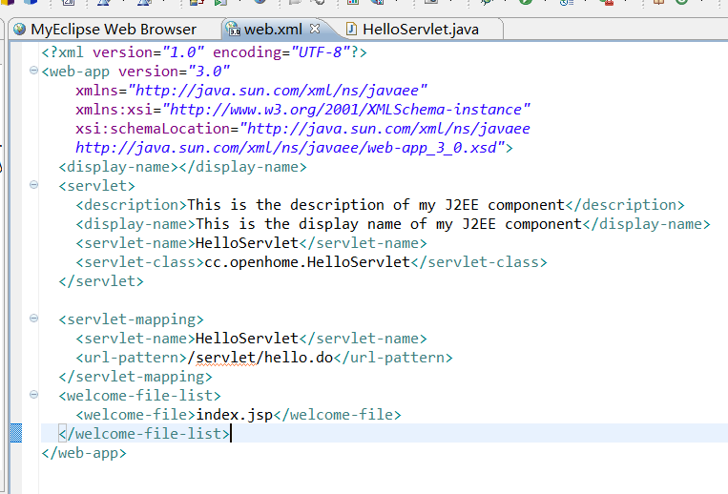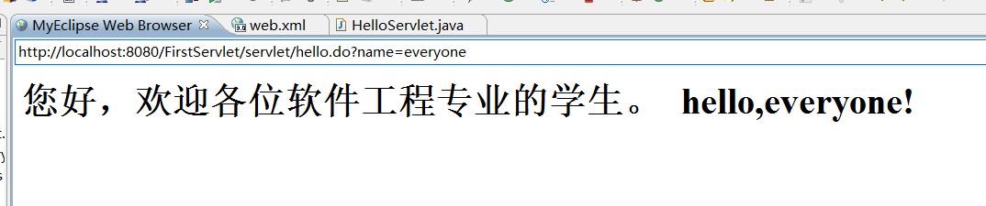

***注释法截图：***

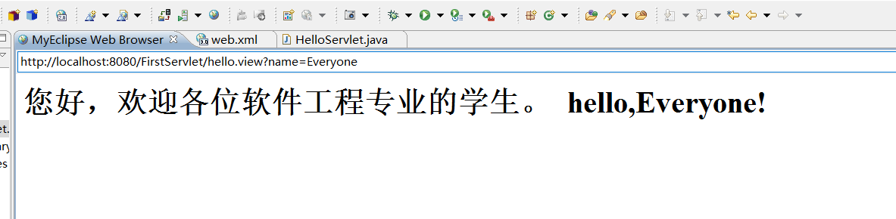

P39

package cc.openhome;

import java.io.*;

import javax.servlet.*;

import javax.servlet.annotation.*;

import javax.servlet.http.*;

@WebServlet("/servlet/*")

public class PathServlet extends HttpServlet {

@Override

protected void doGet(HttpServletRequest req, HttpServletResponse resp) throws ServletException, IOException {

PrintWriter out = resp.getWriter();

out.println("<html>");

out.println("<head>");

out.println("<title>Servlet Pattern</title>");

out.println("</head>");

out.println("<body>");

out.println(req.getRequestURI()+ "</br>");

out.println(req.getContextPath()+"<br>");

out.println(req.getServletPath()+"<br>");

out.println(req.getPathInfo());

out.println("<body>");

out.println("</html>");

out.close();

}

}

***截图：***

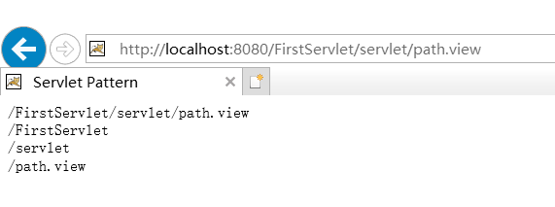

第二题：

（1）定义一个String类型的变量user，用request.getParameter（）方法来接受用post个get方法传递过来的参数

代码：

**package** cc.openhome;

**import** java.io.IOException;

**import** java.io.PrintWriter;

**import** javax.servlet.ServletException;

**import** javax.servlet.annotation.WebServlet;

**import** javax.servlet.http.HttpServlet;

**import** javax.servlet.http.HttpServletRequest;

**import** javax.servlet.http.HttpServletResponse;

**public** **class** WelcomeYou **extends** HttpServlet {

**protected** **void** doGet(HttpServletRequest request, HttpServletResponse response) **throws** ServletException, IOException {

// **TODO** Auto-generated method stub

String user=request.getParameter("user");

String welcomeInfo="Welcome You "+user+"同学!";

response.setContentType("text/html;charset=GB2312");

PrintWriter out = response.getWriter();

out.println("<HTML>");

out.println("<HEAD><TITLE>欢迎页面</TITLE></HEAD>");

out.println("<title>Hello Servlet</title>");

out.println("<BODY>");

out.println(welcomeInfo);

out.println("</BODY>");

out.println("</HTML>");

out.flush();

out.close();

}

**protected** **void** doPost(HttpServletRequest request, HttpServletResponse response) **throws** ServletException, IOException {

doGet(request,response);

}

}

***截图：***

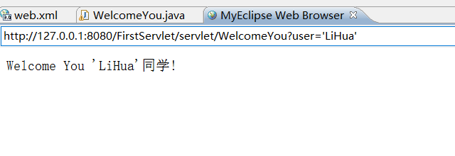

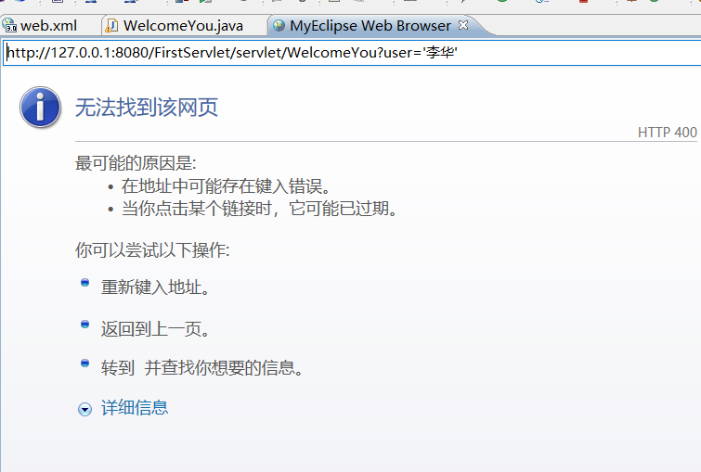

第三题：

代码：Register

<%@ page contentType=*"text/html;charset=utf-8"* %>

<HTML><BODY bgcolor=*cyan*><Font size=*8*>

<FORM action=*"success.jsp"* method=*post* name=*form*>

<P>用户注册:

<BR>新用户名:<INPUT type=*"text"* name=*"name"* value=*""*></BR>

<BR>密码:<INPUT type=*"text"* name=*"R"* value=*""* >

</BR>

<INPUT TYPE=*"submit"* value=*"提交"* name=*"submit"*>

</FORM>

</FONT></BODY></HTML>

代码：Success.jsp

<%@ page contentType=*"text/html; charset=utf-8"*%>

<HTML><BODY bgcolor=*aliceblue*>

<Font size=*8*> <a href=*"Register.jsp"*>回到首页</a>

<% request.setCharacterEncoding("utf-8");

String yourName=request.getParameter("name");

String secretMess=request.getParameter("secret");

out.println("恭喜你，创建成功！用户名:"+yourName+"</P>");

%>

</FONT></BODY></HTML>

***截图：***

