package cc.openhome;

import java.io.IOException;

import java.io.PrintWriter;

import javax.servlet.ServletException;

import javax.servlet.annotation.WebServlet;

import javax.servlet.http.HttpServlet;

import javax.servlet.http.HttpServletRequest;

import javax.servlet.http.HttpServletResponse;

@SuppressWarnings("serial")

@WebServlet("/hello.view")

public class lhq05170612 extends HttpServlet {

@Override

protected void doGet(HttpServletRequest request, HttpServletResponse response) throws ServletException, IOException {

// TODO Auto-generated method stub

response.setContentType("text/html;charset=UTF-8");

PrintWriter out = response.getWriter();

String name = request.getParameter("name");

out.println("<html>");

out.println("<head>");

out.println("<title>Hello Servlet</title>");

out.println("</head>");

out.println("<body>");

out.println("<h1> 您好，欢迎各位软件工程专业的学生。 hello,"+ name + "!</h1>");

out.println("</body>");

out.println("</html>");

out.close();

}

protected void doPost(HttpServletRequest request, HttpServletResponse response) throws ServletException, IOException {

doGet(request,response);

}

}

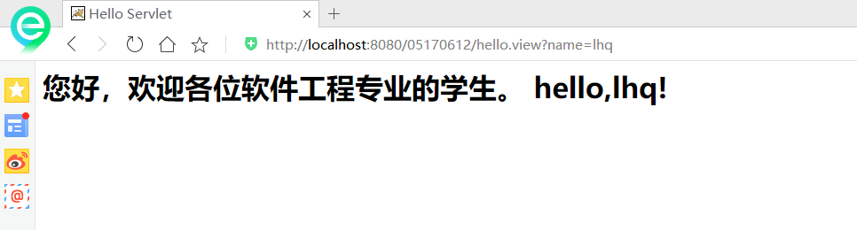

**package** ex2;

**import** java.io.IOException;

**import** java.io.PrintWriter;

**import** javax.servlet.ServletException;

**import** javax.servlet.annotation.WebServlet;

**import** javax.servlet.http.HttpServlet;

**import** javax.servlet.http.HttpServletRequest;

**import** javax.servlet.http.HttpServletResponse;

@SuppressWarnings("serial")

@WebServlet("/aavvccss.d")

**public** **class** lhq05170612 **extends** HttpServlet {

@Override

**protected** **void** doGet(HttpServletRequest request, HttpServletResponse response) **throws** ServletException, IOException {

// **TODO** Auto-generated method stub

response.setContentType("text/html;charset=UTF-8");

PrintWriter out = response.getWriter();

String name = request.getParameter("name");

out.println("<html>");

out.println("<head>");

out.println("<title>Hello Servlet</title>");

out.println("</head>");

out.println("<body>");

out.println("<h1> 您好，欢迎各位软件工程专业的学生。 hello,"+ name + "!</h1>");

out.println("</body>");

out.println("</html>");

out.close();

}

**protected** **void** doPost(HttpServletRequest request, HttpServletResponse response) **throws** ServletException, IOException {

doGet(request,response);

}

}