* 将第二章实训题的第二题，登录页面，提交用户名、密码，若用户名不为空字符串且长度在6-8位间，密码不为，空长度为6位，则登录成功，显示“***（用户名）登录成功！”，否则显示“***登录失败”。

相关代码：

Login.html

<!DOCTYPE html>

<html>

<head>

<title>登录界面</title>

<meta http-equiv=*"keywords"* content=*"keyword1,keyword2,keyword3"*>

<meta http-equiv=*"description"* content=*"this is my page"*>

<meta http-equiv=*"content-type"* content=*"text/html; charset=UTF-8"*>

<!--<link rel="stylesheet" type="text/css" href="./styles.css">-->

</head>

<body>

<form method = *'post'* action = *'register.do'*>

用户名：<input type = *'text'* name = *'username'* size = *'25'* maxlength = *'20'*><br/><br/>

密码：<input type = *'password'* name = *'password'* size = *'25'* maxlength = *'20'*><br/><br/>

<input type=*"submit"* value=*"提交"* name = *"submit"*>

</form>

</body>

</html>

Register.java

package cc.makeachange;

import java.io.IOException;

import java.io.PrintWriter;

import javax.servlet.ServletException;

import javax.servlet.annotation.WebServlet;

import javax.servlet.http.HttpServlet;

import javax.servlet.http.HttpServletRequest;

import javax.servlet.http.HttpServletResponse;

@WebServlet("/register.do")

public class Register extends HttpServlet {

private final String SUCCESS_VIEW = "success.view";

private final String ERROR_VIEW = "Fail.jsp";

public Register() {

super();

}

/**

* Destruction of the servlet. <br>

*/

public void destroy() {

super.destroy(); // Just puts "destroy" string in log

// Put your code here

}

public void doGet(HttpServletRequest request, HttpServletResponse response)

throws ServletException, IOException {

response.setContentType("text/html");

PrintWriter out = response.getWriter();

out.println("<!DOCTYPE HTML PUBLIC \"-//W3C//DTD HTML 4.01 Transitional//EN\">");

out.println("<HTML>");

out.println(" <HEAD><TITLE>A Servlet</TITLE></HEAD>");

out.println(" <BODY>");

out.print(" This is ");

out.print(this.getClass());

out.println(", using the GET method");

out.println(" </BODY>");

out.println("</HTML>");

out.flush();

out.close();

}

/**

* The doPost method of the servlet. <br>

*

* This method is called when a form has its tag value method equals to post.

*

* @param request the request send by the client to the server

* @param response the response send by the server to the client

* @throws ServletException if an error occurred

* @throws IOException if an error occurred

*/

public void doPost(HttpServletRequest request, HttpServletResponse response)

throws ServletException, IOException {

response.setContentType("text/html;charset=GB2313");

String username = request.getParameter("username");

String password = request.getParameter("password");

if(username.equals("caterpillar")&&password.equals("123456")){

request.getRequestDispatcher(SUCCESS_VIEW).forward(request, response);

}else{

response.sendRedirect(ERROR_VIEW);

}

}

Success.java

package cc.makeachange;

import java.io.IOException;

import java.io.PrintWriter;

import javax.servlet.ServletException;

import javax.servlet.annotation.WebServlet;

import javax.servlet.http.HttpServlet;

import javax.servlet.http.HttpServletRequest;

import javax.servlet.http.HttpServletResponse;

@WebServlet("/success.view")

public class Success extends HttpServlet {

public void doGet(HttpServletRequest request, HttpServletResponse response)

throws ServletException, IOException {

response.setContentType("text/html");

PrintWriter out = response.getWriter();

out.println("<!DOCTYPE HTML PUBLIC \"-//W3C//DTD HTML 4.01 Transitional//EN\">");

out.println("<HTML>");

out.println(" <HEAD><TITLE>A Servlet</TITLE></HEAD>");

out.println(" <BODY>");

out.print(" This is ");

out.print(this.getClass());

out.println(", using the GET method");

out.println(" </BODY>");

out.println("</HTML>");

out.flush();

out.close();

}

/**

* The doPost method of the servlet. <br>

*

* This method is called when a form has its tag value method equals to post.

*

* @param request the request send by the client to the server

* @param response the response send by the server to the client

* @throws ServletException if an error occurred

* @throws IOException if an error occurred

*/

public void doPost(HttpServletRequest request, HttpServletResponse response)

throws ServletException, IOException {

response.setContentType("text/html;charset=GB2312");

PrintWriter out = response.getWriter();

out.println("<HTML>");

out.println(" <HEAD><TITLE>登陆成功</TITLE></HEAD>");

out.println(" <BODY>");

out.print("<h2>亲爱的 "+request.getParameter("username")+" 恭喜你登陆成功！！</h2>");

out.println(" </BODY>");

out.println("</HTML>");

out.flush();

out.close();

}

/**

* Initialization of the servlet. <br>

*

* @throws ServletException if an error occurs

*/

public void init() throws ServletException {

// Put your code here

}

}

Fail.jsp

<%@ page language=*"java"* import=*"java.util.*"* pageEncoding=*"utf-8"*%>

<%

String path = request.getContextPath();

String basePath = request.getScheme()+"://"+request.getServerName()+":"+request.getServerPort()+path+"/";

%>

<!DOCTYPE HTML PUBLIC "-//W3C//DTD HTML 4.01 Transitional//EN">

<html>

<head>

<base href=*"*<%=basePath%>*"*>

<title>登陆失败</title>

<meta http-equiv=*"pragma"* content=*"no-cache"*>

<meta http-equiv=*"cache-control"* content=*"no-cache"*>

<meta http-equiv=*"expires"* content=*"0"*>

<meta http-equiv=*"keywords"* content=*"keyword1,keyword2,keyword3"*>

<meta http-equiv=*"description"* content=*"This is my page"*>

<!--

<link rel="stylesheet" type="text/css" href="styles.css">

-->

</head>

<body>

<fond size = *16*>

<a href=*"index.jsp"*>回到首页</a><br/><br/>

<h2>登陆失败 ！！<br></h2>

</body>

</html>

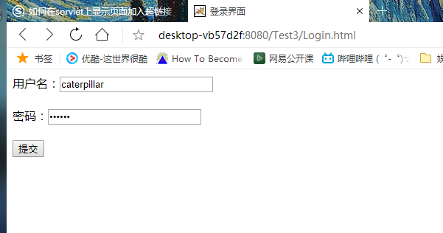

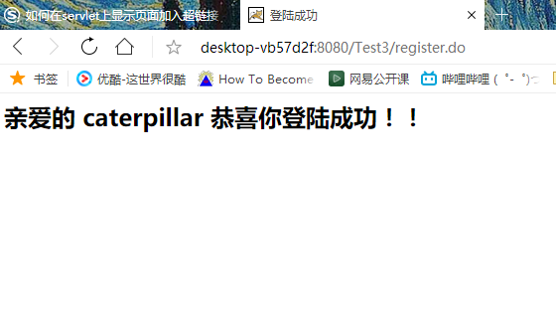

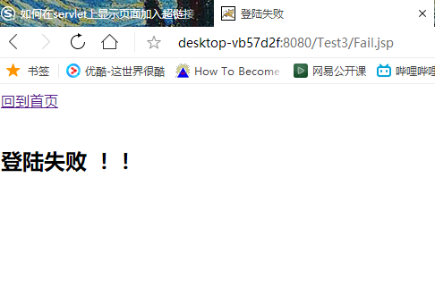

若用户名不为空字符串且长度在6-8位间，密码不为，空长度为6位，则登录成功，显示“***（用户名）登录成功！”，否则显示“***登录失败”。

关键代码：

**if**(username!=**null**&&username.length()>=6&&username.length()<=8&&password!=**null**&&password.length()==6){

request.getRequestDispatcher(SUCCESS_VIEW).forward(request, response);

}**else**{

response.sendRedirect(ERROR_VIEW);

}

效果：

