<%@ page language=*"java"* contentType=*"text/html; charset=UTF-8"*

pageEncoding=*"UTF-8"*%>

<!DOCTYPE html>

<html>

<head>

<meta charset=*"UTF-8"*>

<title>Insert title here</title>

</head>

<body>

<form action=*"../Login.do"* mothod=*post* name=*form*>

<Font size=*8*>

<BR>用户名:<INPUT type=*"text"*name=*"username"*>

<BR>密码:<INPUT type=*"password"* name=*"pwd"*>

<p><INPUT TYPE=*"hidden"* value=*"这是隐藏信息"* name=*"secret"*>

<INPUT TYPE=*"submit"* value=*"登录"* name=*"submit"*>

<INPUT TYPE=*"reset"* value=*"取消"* name=*"reset"*>

</FONT>

</body>

</html>

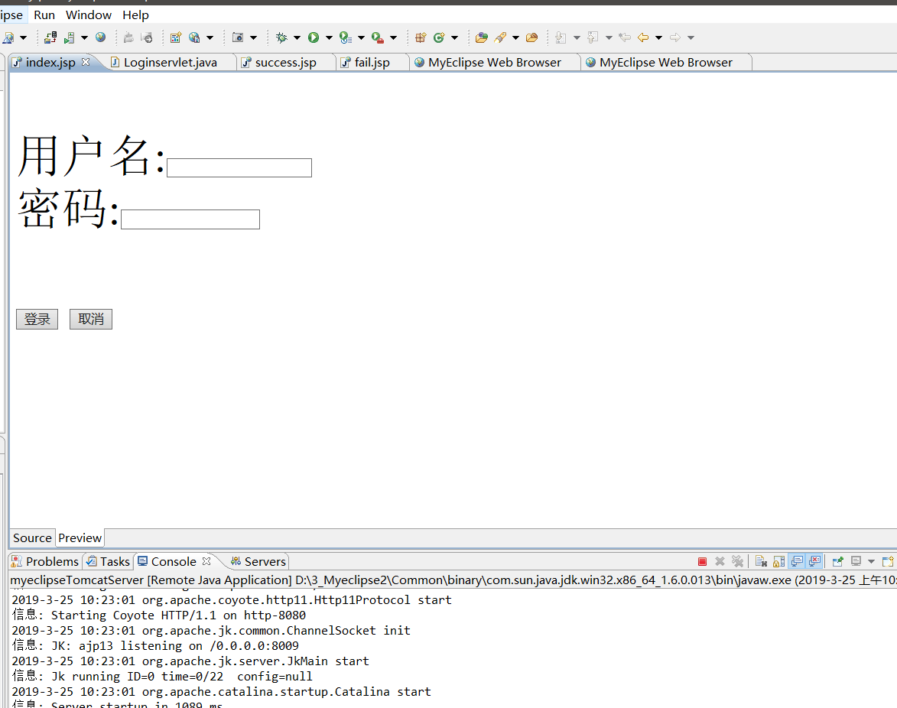

package ch3;

import java.io.IOException;

import javax.servlet.ServletException;

import javax.servlet.annotation.WebServlet;

import javax.servlet.http.HttpServlet;

import javax.servlet.http.HttpServletRequest;

import javax.servlet.http.HttpServletResponse;

@WebServlet(name = "Loginservlet", urlPatterns = { "/Login.do" })

public class Loginservlet extends HttpServlet {

/\*\*

\*

\*/

private static final long serialVersionUID = 1L;

String success="/ch3/success.jsp";

String fail="/ch3/fail.jsp";

protected void doPost(HttpServletRequest request, HttpServletResponse response) throws ServletException, IOException {

// TODO Auto-generated method stub

request.setCharacterEncoding("utf-8");

String name=request.getParameter("username");

String pwd=request.getParameter("pwd");

if(name.equals("03170723")&&(pwd.equals("03170723"))) {

response.sendRedirect(success);

}else if((name.equals("")||(name.length()>8)||(name.length()<6))){

response.sendRedirect(fail);

}else if((pwd.equals("")||(pwd.length()!=6))) {

response.sendRedirect(fail);

}

}

protected void doGet(HttpServletRequest request, HttpServletResponse response) throws ServletException, IOException {

// TODO Auto-generated method stub

doPost(request,response);

}

}