实验内容：

1. 将实验三的三题进行改写，在Servlet控制器中获取信息，验证后根据具体情况跳转到对应页面，成功请求转发到成功页面，否则重定向跳转到失败页面（可将动态验证码添加在页面上）

* 登录页面，提交用户名、密码及身份

改写一：支持中文，确保两种表单提交方式（get、post）都支持中文，另外对程序的空对象情况进行处理。

改写二：比如登录页面除了之前的用户名、密码另外再加上所在专业（计算机、软件工程及网络工程，单选框或下拉列表框皆可），登录成功后根据身份进行跳转，进入对应的页面，页面需显示****专业学号姓名。登录失败转向失败页面，并进行报错！

相关代码：

Login.html

<!DOCTYPE html>

<html>

<head>

<title>登录界面</title>

<meta http-equiv=*"keywords"* content=*"keyword1,keyword2,keyword3"*>

<meta http-equiv=*"description"* content=*"this is my page"*>

<meta http-equiv=*"content-type"* content=*"text/html; charset=UTF-8"*>

<!--<link rel="stylesheet" type="text/css" href="./styles.css">-->

</head>

<body>

<form method = *'post'* action = *'register.do'*>

用户名：<input type = *'text'* name = *'username'* size = *'25'* maxlength = *'20'*><br/><br/>

密码：<input type = *'password'* name = *'password'* size = *'25'* maxlength = *'20'*><br/><br/>

专业：

<select name=*"zhuanye"*>

<option value=*"软件工程"*>软件工程</option>

<option value=*"网络工程"*>网络工程</option>

<option value=*"计算机科学与技术"*>计算机科学与技术</option>

<option value=*"TEST"*>TEST</option>

</select>

<input type=*"submit"* value=*"提交"* name = *"submit"*>

</form>

</body>

</html>

Register.java

package cc.makeachange;

import java.io.IOException;

import java.io.PrintWriter;

import javax.servlet.ServletException;

import javax.servlet.annotation.WebServlet;

import javax.servlet.http.HttpServlet;

import javax.servlet.http.HttpServletRequest;

import javax.servlet.http.HttpServletResponse;

@WebServlet("/register.do")

public class Register extends HttpServlet {

private final String SUCCESS_VIEW = "success.view";

private final String ERROR_VIEW = "Fail.jsp";

public Register() {

super();

}

/**

* Destruction of the servlet. <br>

*/

public void destroy() {

super.destroy(); // Just puts "destroy" string in log

// Put your code here

}

public void doGet(HttpServletRequest request, HttpServletResponse response)

throws ServletException, IOException {

response.setContentType("text/html");

PrintWriter out = response.getWriter();

out.println("<!DOCTYPE HTML PUBLIC \"-//W3C//DTD HTML 4.01 Transitional//EN\">");

out.println("<HTML>");

out.println(" <HEAD><TITLE>A Servlet</TITLE></HEAD>");

out.println(" <BODY>");

out.print(" This is ");

out.print(this.getClass());

out.println(", using the GET method");

out.println(" </BODY>");

out.println("</HTML>");

out.flush();

out.close();

}

/**

* The doPost method of the servlet. <br>

*

* This method is called when a form has its tag value method equals to post.

*

* @param request the request send by the client to the server

* @param response the response send by the server to the client

* @throws ServletException if an error occurred

* @throws IOException if an error occurred

*/

public void doPost(HttpServletRequest request, HttpServletResponse response)

throws ServletException, IOException {

response.setContentType("text/html;charset=GB2313");

String username = request.getParameter("username");

String password = request.getParameter("password");

String major = request.getParameter("zhuanye");

request.setAttribute("key", major);

if(username.equals("caterpillar")&&password.equals("123456")){

request.getRequestDispatcher(SUCCESS_VIEW).forward(request, response);

}else{

response.sendRedirect(ERROR_VIEW);

}

}

Success.jsp

<%@ page contentType =*"text/html; charset=utf-8"*%>

<HTML>

<body bgcolor = *cyan*>

<Font size=*8*><a href=*"index.jsp"*>回到首页</a>

<% request.setCharacterEncoding("utf-8");

String yourName = request.getParameter("username");

String yourMajor = (String)request.getAttribute("key");

out.println("<p>专业："+yourMajor+"</p>");

out.println("<p>姓名："+yourName+"</p>");

out.println("<p>恭喜你登陆成功！</p>");

%>

</Font>

</body>

</HTML>

Fail.jsp

<%@ page language=*"java"* import=*"java.util.*"* pageEncoding=*"utf-8"*%>

<%

String path = request.getContextPath();

String basePath = request.getScheme()+"://"+request.getServerName()+":"+request.getServerPort()+path+"/";

%>

<!DOCTYPE HTML PUBLIC "-//W3C//DTD HTML 4.01 Transitional//EN">

<html>

<head>

<base href=*"*<%=basePath%>*"*>

<title>登陆失败</title>

<meta http-equiv=*"pragma"* content=*"no-cache"*>

<meta http-equiv=*"cache-control"* content=*"no-cache"*>

<meta http-equiv=*"expires"* content=*"0"*>

<meta http-equiv=*"keywords"* content=*"keyword1,keyword2,keyword3"*>

<meta http-equiv=*"description"* content=*"This is my page"*>

<!--

<link rel="stylesheet" type="text/css" href="styles.css">

-->

</head>

<body>

<fond size = *16*>

<a href=*"index.jsp"*>回到首页</a><br/><br/>

<h2>登陆失败 ！！<br></h2>

</body>

</html>

效果：

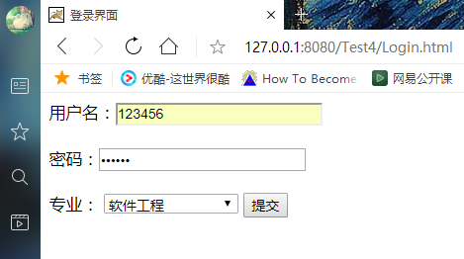

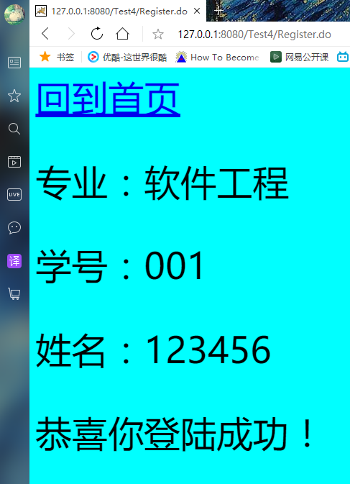

失败案例：

