**Java Web开发**

**实验四**

**作业报告**

|  |  |
| --- | --- |
| 学 院 | 计算机 |
| 所在系 班 级 | 2017软件工程系09班 |
| 学 号 姓 名 | 04172124周泳雅 |
| 指 导 教 师 | 罗永升 |
| 完 成 时 间 | 2019年4月- |

# 实验题目

1. 将实验三的三题进行改写，在Servlet控制器中获取信息，验证后根据具体情况跳转到对应页面，成功请求转发到成功页面，否则重定向跳转到失败页面（可将动态验证码添加在页面上）

* 登录页面，提交用户名、密码及身份

改写一：支持中文，确保两种表单提交方式（get、post）都支持中文，另外对程序的空对象情况进行处理。

改写二：比如登录页面除了之前的用户名、密码另外再加上所在专业（计算机、软件工程及网络工程，单选框或下拉列表框皆可），登录成功后根据身份进行跳转，进入对应的页面，页面需显示****专业学号姓名。登录失败转向失败页面，并进行报错！

# 分析与设计

设计了register.html/check.java/success.jsp/fail.jsp

# 关键源码（部分）

register.html

<body>

<form action=*"check.do"* method=*"post"*>

<lable>请输入您的邮箱账号： <lable>

<input type=*"email"* name=*"usersEmail"* id=*"usersEmail"*><br/>

<lable>请输入您的昵称： <lable>

<input type=*"name"* name=*"usersName"* id=*"usersName"*><br/>

<lable>请输入您的密码： <lable>

<input type=*"password"* name=*"usersPsw1"* id=*"usersPsw1"*><br/>

<lable>请确认您的密码： <lable>

<input type=*"password"* name=*"usersPsw2"* id=*"usersPsw2"*><br/>

<lable>选择性别:<INPUT type=*"radio"* name=*"R"* value=*"女"* checked=*"default"*>男

<INPUT type=*"radio"* name=*"R"* value=*"男"*>女<br>

<lable>选择您的专业:

<input type=*"checkbox"* name=*"major"* value=*"网络工程"* >网络工程

<input type=*"checkbox"* name=*"major"* value=*"软件工程"* >软件工程

<input type=*"checkbox"* name=*"major"* value=*"计算机科学与技术"* >计算机科学与技术

<input type=*"checkbox"* name=*"major"* value=*"信息与管理"* >信息与管理

</BR>

<input type=*"submit"* onclick="myFuncition" value=*"提交"*>

</form>

</body>

Check.java

**public** **class** check **extends** HttpServlet {

/**

* Constructor of the object.

*/

**public** check() {

**super**();

}

/**

* Destruction of the servlet. <br>

*/

**public** **void** destroy() {

**super**.destroy(); // Just puts "destroy" string in log

// Put your code here

}

/**

* The doGet method of the servlet. <br>

*

* This method is called when a form has its tag value method equals to get.

*

* **@param** request the request send by the client to the server

* **@param** response the response send by the server to the client

* **@throws** ServletException if an error occurred

* **@throws** IOException if an error occurred

*/

**public** **void** doGet(HttpServletRequest request, HttpServletResponse response)

**throws** ServletException, IOException {

**this**.doPost(request,response);

}

/**

* The doPost method of the servlet. <br>

*

* This method is called when a form has its tag value method equals to post.

*

* **@param** request the request send by the client to the server

* **@param** response the response send by the server to the client

* **@throws** ServletException if an error occurred

* **@throws** IOException if an error occurred

*/

**public** **void** doPost(HttpServletRequest request, HttpServletResponse response)

**throws** ServletException, IOException {

response.setContentType("text/html");

request.setCharacterEncoding("UTF-8");

String name =request.getParameter("usersName");

String email =request.getParameter("usersEmail");

String usersPsw1 =request.getParameter("usersPsw1");

String major[]=request.getParameterValues("major");

String yourSex=request.getParameter("R");

response.setContentType("text/html");

**if**(name.length()>=6&&name.length()<=8&&usersPsw1.length()==6)

{

request.setAttribute("Name", name);

request.setAttribute("email", email);

request.setAttribute("major", major);

request.setAttribute("R", yourSex);

request.getRequestDispatcher("success.jsp").forward(request, response);

}

**else**

{

response.sendRedirect("fail.jsp");

}

}

**public** **void** init() **throws** ServletException {

// Put your code here

}

}

Success.jsp

<head>

<base href=*"*<%=basePath%>*"*>

<title>My JSP 'success.jsp' starting page</title>

<meta http-equiv=*"pragma"* content=*"no-cache"*>

<meta http-equiv=*"cache-control"* content=*"no-cache"*>

<meta http-equiv=*"expires"* content=*"0"*>

<meta http-equiv=*"keywords"* content=*"keyword1,keyword2,keyword3"*>

<meta http-equiv=*"description"* content=*"This is my page"*>

<!--

<link rel="stylesheet" type="text/css" href="styles.css">

-->

</head>

<body>

<%

String email =(String)request.getAttribute("email");

String[] major =request.getParameterValues("major");

String yourSex =(String)request.getAttribute("R");

String yourName =(String)request.getAttribute("Name");

out.println("开心，恭喜你！你的邮箱是："+email);

out.println("你的昵称为："+ yourName);

out.println("你的性别是:"+yourSex);

out.print("你的专业是：");

**if**(major==**null**)

{

out.print("都不是");

}

**else**

{ **for**(**int** k=0;k<major.length;k++)

{

out.println(" "+major[k]);

}

}

%>

</body>

</html>

Fail.jsp

<%@ page language=*"java"* import=*"java.util.*"* pageEncoding=*"UTF-8"*%>

<%

String path = request.getContextPath();

String basePath = request.getScheme()+"://"+request.getServerName()+":"+request.getServerPort()+path+"/";

request.setCharacterEncoding("UTF-8");

response.setContentType("text/html; charset=UTF-8");

%>

<!DOCTYPE HTML PUBLIC "-//W3C//DTD HTML 4.01 Transitional//EN">

<html>

<head>

<title>My JSP 'fail.jsp' starting page</title>

<meta http-equiv=*"pragma"* content=*"no-cache"*>

<meta http-equiv=*"cache-control"* content=*"no-cache"*>

<meta http-equiv=*"expires"* content=*"0"*>

<meta http-equiv=*"keywords"* content=*"keyword1,keyword2,keyword3"*>

<meta http-equiv=*"description"* content=*"This is my page"*>

<!--

<link rel="stylesheet" type="text/css" href="styles.css">

-->

</head>

<body>

注册失败，请检测是否规范注册： <br>

1.用户名不为空，且长度位6~8位<br>

2.密码不为空，且长度为6位数

</body>

</html>

# 运行效果图

登录页面

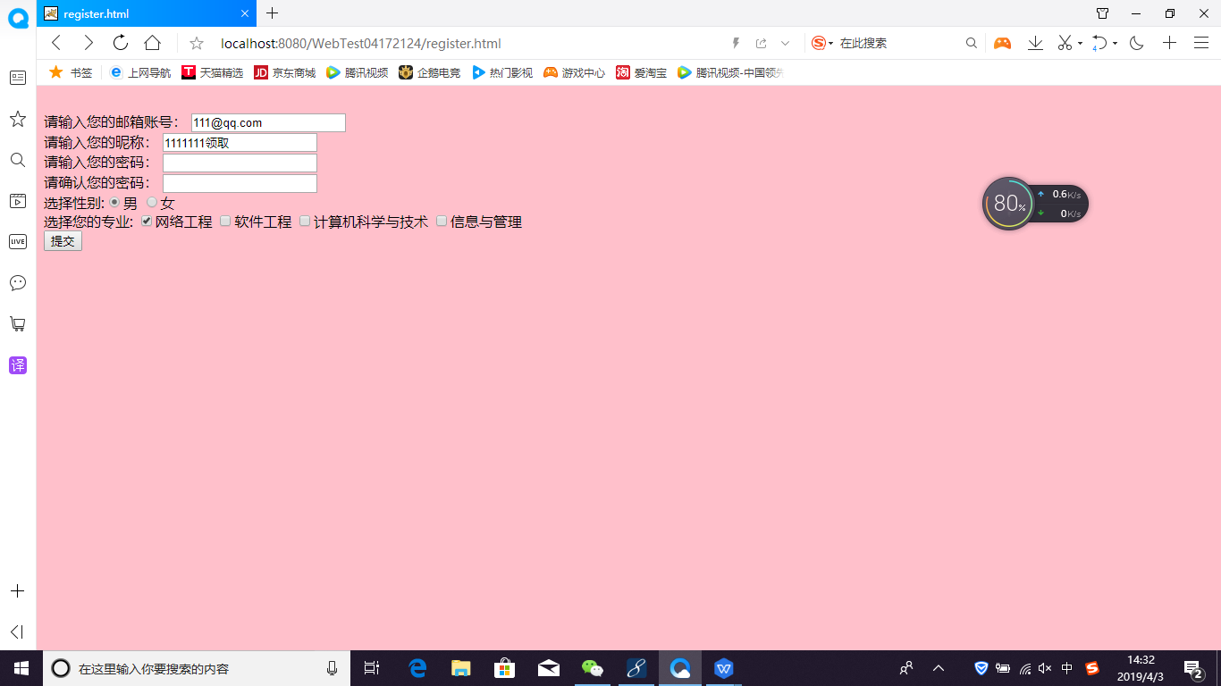

格式错误（注册失败）页面

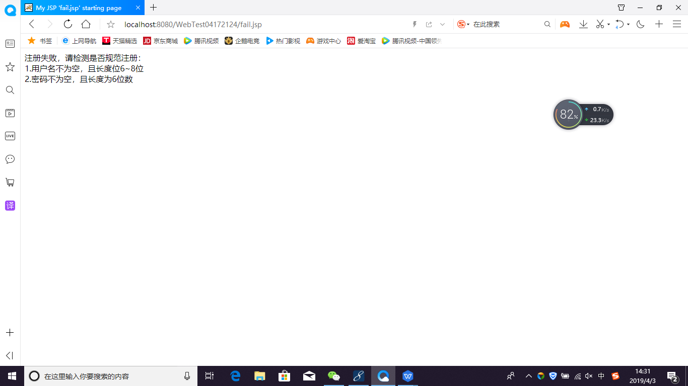

成功注册页面

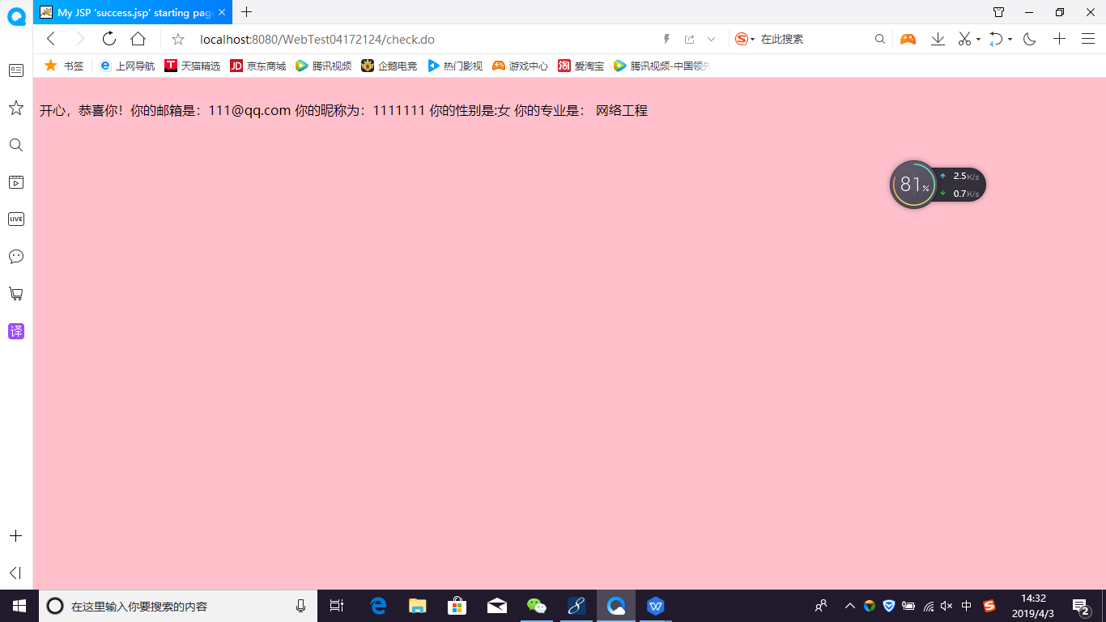

# 收获与问题

开始把check页面用jsp设置，后来改成了servlet。通过老师和同学的帮助了解了servlet路径的问题（在web.xml那里把servlet路径删掉再输入@WebServlet("/check.do")）check.java的路径才成功修改