**Java Web开发**

**实验五**

**作业报告**

|  |  |
| --- | --- |
| 学 院 | 计算机 |
| 所在系 班 级 | 2017软件工程系九班 |
| 学 号 姓 名 | 03170509 卢增伟 |
| 指 导 教 师 | 郭晓燕 |
| 完 成 时 间 | 2019年4月-5 |

# 实验题目

实现一个购物车应用程序，可以购物，显示购物数量并查看购物车内容

# 分析与设计

设计四个文件（两个类）来实现购物车的应用程序，Book.java:数据类，用来保存图书的基本信息（ID、书名、价格）和购书信息（购书数量）。Shopping.jsp:购书页面，通过此页面用户选购图书。ShoppingServlet.java **:** 取到用户所点击的ID号（即书号），同时从Session对象中将图书数组取出来。在图书数组中进行遍历，找到和用户点击ID号相同的那本图书，将其购买数量+1，同时将总本数+1，最后将更新好的图书数组和总本数放回session对象中，对应的key不变。**cart.jsp:**从Session对象中取出图书数组，对其进行遍历，凡图书购买本数大于0的图书，将其基本信息显示在页面上。

# 关键源码（部分）

1.( Book.java)

**package** cc1;

**public** **class** Book {

**private** String id;

**private** String bookname;

**private** String img;

**private** **double** price;

**private** **int** count;

**public** Book(String id, String bookname, String img, **double** price,**int** count) {

**super**();

**this**.id = id;

**this**.bookname = bookname;

**this**.img = img;

**this**.price = price;

**this**.count = count;

}

**public** String getId() {

**return** id;

}

**public** **void** setId(String id) {

**this**.id = id;

}

**public** String getBookname() {

**return** bookname;

}

**public** **void** setBookname(String bookname) {

**this**.bookname = bookname;

}

**public** String getImg() {

**return** img;

}

**public** **void** setImg(String img) {

**this**.img = img;

}

**public** **double** getPrice() {

**return** price;

}

**public** **void** setPrice(**double** price) {

**this**.price = price;

}

**public** **int** getCount() {

**return** count;

}

**public** **void** setCount(**int** count) {

**this**.count = count;

}

}

2.( Shopping.jsp)

<%@ page import= *"cc1.Book"* import=*'java.io.PrintWriter'* %>

<%@ page language=*"java"* contentType=*"text/html; charset=UTF-8"*

pageEncoding=*"UTF-8"*%>

<%@ taglib uri=*"http://java.sun.com/jsp/jstl/core"* prefix=*"c"*%>

<!DOCTYPE html PUBLIC "-//W3C//DTD HTML 4.01 Transitional//EN" "http://www.w3.org/TR/html4/loose.dtd">

<html>

<%

**if**(session.getAttribute("BookList")==**null**){

Book[] BookList = **new** Book[3];

BookList[0] = **new** Book("01","Java技术手册","img\\jishu.jpg",17.5,0);

BookList[1] = **new** Book("02","毛概","img\\maogai.jpg",16.0,0);

BookList[2] = **new** Book("03","jsp网站设计","img\\jsp.jpg",15.0,0);

session.setAttribute("BookList",BookList);

session.setAttribute("sum",0);

}

%>

<body>

<img src=*"*${pageContext.request.contextPath}*//img\\cart.jpg"*>

<a href=*'cart.jsp'*>已采购<%=session.getAttribute("sum")%>本</a>

<br>

<table border=*'1'*>

<c:forEach var=*"book"* items=*"*${BookList}*"*>

<tr>

<td><img src =*"*${pageContext.request.contextPath}*//*${book.getImg()}*"*></td>

<td><a href=*'shopping.view?id=*${book.getId()}*'*>采购此书</a></td>

</tr>

</c:forEach>

</table>

</body>

</html>

3.( ShoppingServlet.java)

**package** cc1;

**import** java.io.IOException;

**import** javax.servlet.ServletException;

**import** javax.servlet.annotation.WebServlet;

**import** javax.servlet.http.HttpServlet;

**import** javax.servlet.http.HttpServletRequest;

**import** javax.servlet.http.HttpServletResponse;

**import** javax.servlet.http.HttpSession;

**import** cc1.Book;

@WebServlet("/shopping.view")

**public** **class** ShoppingServlet **extends** HttpServlet {

**public** **void** doGet(HttpServletRequest request, HttpServletResponse response)

**throws** ServletException, IOException {

request.setCharacterEncoding("UTF-8");

HttpSession session=request.getSession();

String id =request.getParameter("id");

**int** sum=(Integer) request.getSession().getAttribute("sum");

Book[] BookList = (Book[])request.getSession().getAttribute("BookList");

**for**(Book book:BookList){

**int** count = 0;

**if**(id.equals(book.getId())){

sum=sum+1;

count =book.getCount()+1;

book.setCount(count);

}

}

request.getSession().setAttribute("sum",sum);

request.getSession().setAttribute("BookList", BookList);

request.getRequestDispatcher("Shopping.jsp").forward(request, response);

}

}

4.(cart.jsp)

<%@ page import= *"cc1.Book"* import=*'java.io.PrintWriter'* %>

<%@ page language=*"java"* contentType=*"text/html; charset=UTF-8"*

pageEncoding=*"UTF-8"*%>

<%@ taglib uri=*"http://java.sun.com/jsp/jstl/core"* prefix=*"c"*%>

<!DOCTYPE html PUBLIC "-//W3C//DTD HTML 4.01 Transitional//EN" "http://www.w3.org/TR/html4/loose.dtd">

<html>

<%

**if**(session.getAttribute("BookList")==**null**){

Book[] BookList = **new** Book[3];

BookList[0] = **new** Book("01","Java技术手册","img\\jishu.jpg",17.5,0);

BookList[1] = **new** Book("02","毛概","img\\maogai.jpg",16.0,0);

BookList[2] = **new** Book("03","jsp网站设计","img\\jsp.jpg",15.0,0);

session.setAttribute("BookList",BookList);

session.setAttribute("sum",0);

}

%>

<body>

<img src=*"*${pageContext.request.contextPath}*//img\\cart.jpg"*>

<a href=*'Shopping.jsp'*>已采购<%=session.getAttribute("sum")%>本</a>

<br>

<table border=*'1'*>

<c:forEach var=*"book"* items=*"*${BookList}*"*>

<tr>

<td><img src =*"*${pageContext.request.contextPath}*//*${book.getImg()}*"*></td>

<td>共采购${book.getCount()}本</td>

</tr>

</c:forEach>

</table>

</body>

</html>

# 运行效果图

1. 购物界面

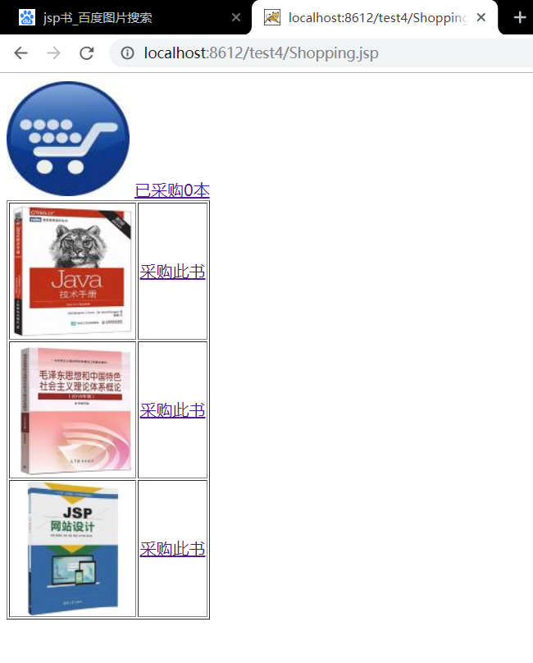

2.购物车界面

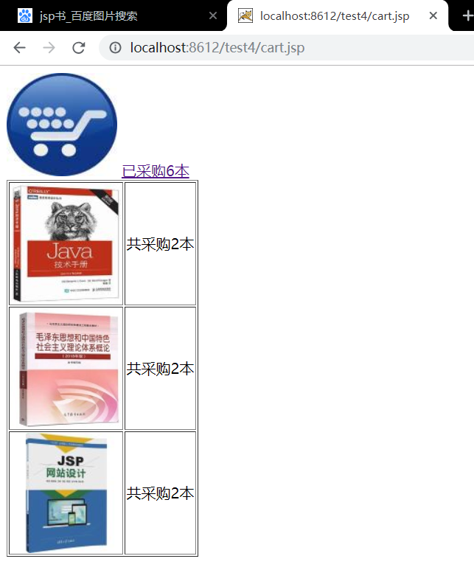

# 收获与问题

进一步理解会话的原理和HttpSession会话期，希望能更加熟练使用URL重写，掌握如何使用HttpSession会话管理；希望以后的学习能更加专注细心，学好专业基础知识。