**Java Web开发**

**实验五**

**作业报告**

|  |  |
| --- | --- |
| 学 院 | 计算机 |
| 所在系 班 级 | 2017软件工程系9班 |
| 学 号 姓 名 | 苟俊杰 |
| 指 导 教 师 | 郭晓燕 |
| 完 成 时 间 | 2019年4月 |

# 实验题目

1、练习老师在理论课上演示的购物车实例，理解购物功能如何实现，理解如何利用session对象保存购物信息，如何设计封装数据类。（请参考“第四章会话管理课上的购物车实例代码.docx”文档）；

如果上课听懂了购物车的原理或者部分理解，可以参考我的实例完成第2题，此题可忽略不写。

2、第四章课后练习3购物车，实现一个购物车应用程序，可以购物，显示购物数量并查看购物车内容。（此题模版test4E，提供给大家参考。）

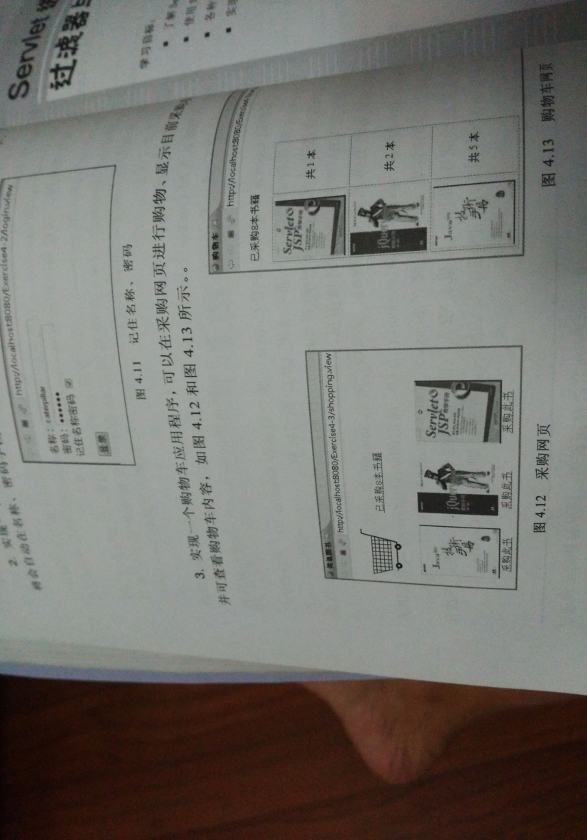

# 分析与设计

此题需设计5个程序完成

首先需要一个login.jsp实现用户的登陆（用户输入密码，账号）

<body bgcolor = *pink*><font size = *7*>

<% request.setCharacterEncoding("UTF-8"); %>

<h1>欢迎光临本商城</h1>

<p>请输入用户名进行登录

<form action = *"LoginVerify.do"* method = *post* name = *form*>

用户名<input type = *"text"* name = *"name"*><br>

密码 <input type = *"text"* name = *"password"*><br>

<input type = *"submit"* value = *"登录"* name = *sumbit*>

<%

String ID = (String)session.getId();

String name = (String)session.getAttribute("customerName");

%>

</form>

</font>

然后login.jsp表单会自动跳转到LoginVerify.java的servlet程序，进行用户的账号和密码的判断处理，并分别赋给他们一个属性，再根据判断的结果：登陆成功则跳转到饮品选购页面，失败则重新登陆。

@WebServlet("/LoginVerify.do")

**public** **class** LoginVerify **extends** HttpServlet {

**protected** **void** doGet(HttpServletRequest request, HttpServletResponse response) **throws** ServletException, IOException {

// **TODO** Auto-generated method stub

doPost(request, response);

}

**protected** **void** doPost(HttpServletRequest request, HttpServletResponse response)

**throws** ServletException, IOException {

// **TODO** Auto-generated method stub

request.setCharacterEncoding("UTF-8");

HttpSession session = request.getSession();

String name = request.getParameter("name");

String password = request.getParameter("password");

**if**(name != **null** && password != **null**)

{

session.setAttribute("customerName", name);

Chart[] chart = initChart();

session.setAttribute("chart", chart);

request.getRequestDispatcher("drink.jsp").

forward(request, response);

}

**else** {

response.sendRedirect("login.jsp");

}

}

**public** Chart[] initChart() {

Chart[] charts = **new** Chart[4];

charts[0] = **new** Chart("0001","柠檬茶", "img/0001.jpg", 2.5);

charts[1] = **new** Chart("0002","一点点", "img/0002.jpg", 13.0);

charts[2] = **new** Chart("0003","奈雪的茶", "img/0003.jpg", 29.0);

charts[3] = **new** Chart("0004","COCO", "img/0004.jpg", 15.0);

**return** charts;

}

}

登陆成功后跳转到drink.jsp页面，实现用户的商品选购

<body bgcolor = *cyan*><font size = *5*>

<% request.setCharacterEncoding("UTF-8"); %>

ID号<%= (String)session.getId() %><br>

<%

String name = (String)session.getAttribute("customerName");

Chart[] charts = (Chart[])session.getAttribute("chart");

%>

欢迎您，<%= name %>

<p>这里是冰柜，请选择您要购买的饮品：<br>

<form action = *"drinkCount.do"* method = *post* name = *form*>

<img src=*"img/shoppingCar.jpg"* height = *"40px"* width = *"40px"*>

<br>

<p>输入购买的数量

<table border = *"1"*>

<tr>

<%

**if**(charts != **null**){

**for**(Chart chart:charts){

%><br>

<input type = *"checkbox"* name = *"choice"* value = <%=chart.getProductID()%>>

<%=chart.getProductName() %>

<%=chart.getProductPrice() %>

<%}

}

%>

</tr>

<tr>

<td><img src = *"img/0001.jpg"* height = *"100px"* width = *"100px"*></td>

<td><img src = *"img/0002.jpg"* height = *"100px"* width = *"100px"*></td>

<td><img src = *"img/0003.jpg"* height = *"100px"* width = *"100px"*></td>

<td><img src = *"img/0004.jpg"* height = *"100px"* width = *"100px"*></td>

</tr>

<input type = *"submit"* value = *"提交"* name = *"submit"*>

</body>

</html>

另需定义一个Chart类包，用于定义饮品的基本信息（ID号，名字，图片，价格）。并用get和set构造方法

**public** **class** Chart {

String productID; //商品ID号

String productName; //商品名字

String productImg; //商品图片

**float** productPrice; //商品价格

**int** shopNum; //购买商品数量

**public** Chart(String id, String name, String img, **double** price){

**this**.productID = id;

**this**.productName = name;

**this**.productImg = img;

**this**.productPrice = (**float**)price;

**this**.shopNum = 0;

}

**public** String getProductID(){

**return** productID;

}

**public** **void** setProductID(String productID){

**this**.productID = productID;

}

**public** String getProductName(){

**return** productName;

}

**public** **void** setProductName(String productName){

**this**.productName = productName;

}

**public** String getProductImg() {

**return** productImg;

}

**public** **void** setProductImg(String productImg) {

**this**.productImg = productImg;

}

**public** **float** getProductPrice(){

**return** productPrice;

}

**public** **void** setProductPrice(**float** productPrice){

**this**.productPrice = productPrice;

}

**public** **int** getShopNum(){

**return** shopNum;

}

**public** **void** setShopNum(**int** shopNum){

**this**.shopNum = shopNum;

}

}

最后需要一个drinkCount.java供用户进行结算，或者继续选购商品或者重新登陆。

@WebServlet("/drinkCount.do")

**public** **class** drinkCount **extends** HttpServlet {

**private** **static** **final** **long** ***serialVersionUID*** = 1L;

**protected** **void** doGet(HttpServletRequest request, HttpServletResponse response)

**throws** ServletException, IOException {

// **TODO** Auto-generated method stub

doPost(request, response);

}

**protected** **void** doPost(HttpServletRequest request, HttpServletResponse response)

**throws** ServletException, IOException {

response.setContentType("text/html;charset = UTF-8");

request.setCharacterEncoding("UTF-8");

HttpSession session = request.getSession();

String id, name = "";

**float** price = 0, totalPrice = 0, num = 0;

Chart[] chartS = (Chart[])session.getAttribute("chart");

String prods[] = request.getParameterValues("choice");

**if**(prods != **null**)

{

**for**(**int** k = 0; k < prods.length; k++)

{

id = prods[k];

**for**(**int** i = 0; i < chartS.length; i++)

{

**if**(id.equals(chartS[i].getProductID()))

{

chartS[i].setShopNum(chartS[i].getShopNum() + 1);

**break**;

}

}

}

}

printChart(request, response);

}

**private** **void** printChart(HttpServletRequest request, HttpServletResponse response)

**throws** IOException {

HttpSession session = request.getSession();

PrintWriter out = response.getWriter();

**int** num = 0;

**float** totalPrice = 0;

out.println("<html><body><font size = 8>");

out.println("<p>这里是结账处,您的姓名以及选择的商品; ");

out.println("<br>您的姓名: " + (String)session.getAttribute("customerName"));

Chart[] chartS = (Chart[])session.getAttribute("chart");

**for**(**int** i = 0; i < chartS.length; i++)

{

**if**(chartS[i].getShopNum() > 0) {

out.println("<br>商品: " + chartS[i].getProductName() + "\t" + "价格 "

+ chartS[i].getProductPrice() + "\t" + "件数" + chartS[i].getShopNum());

num = num + chartS[i].getShopNum();

totalPrice = totalPrice + (chartS[i].getProductPrice() * chartS[i].getShopNum());

}

}

out.println("<p>商品总件数" + num + "\t" + "商品总价格" + totalPrice);

out.println("<p>点击超链接，继续选购商品。");

out.println("<a href = drink.jsp> 欢迎去drink.jsp！</a>");

out.println("<p>点击超链接，连接到login.jsp的页面，去修改姓名。");

out.println("<a href = login.jsp> 欢迎去login.jsp！ </a>");

out.println("</font></body></html>");

}

}

# 运行效果图

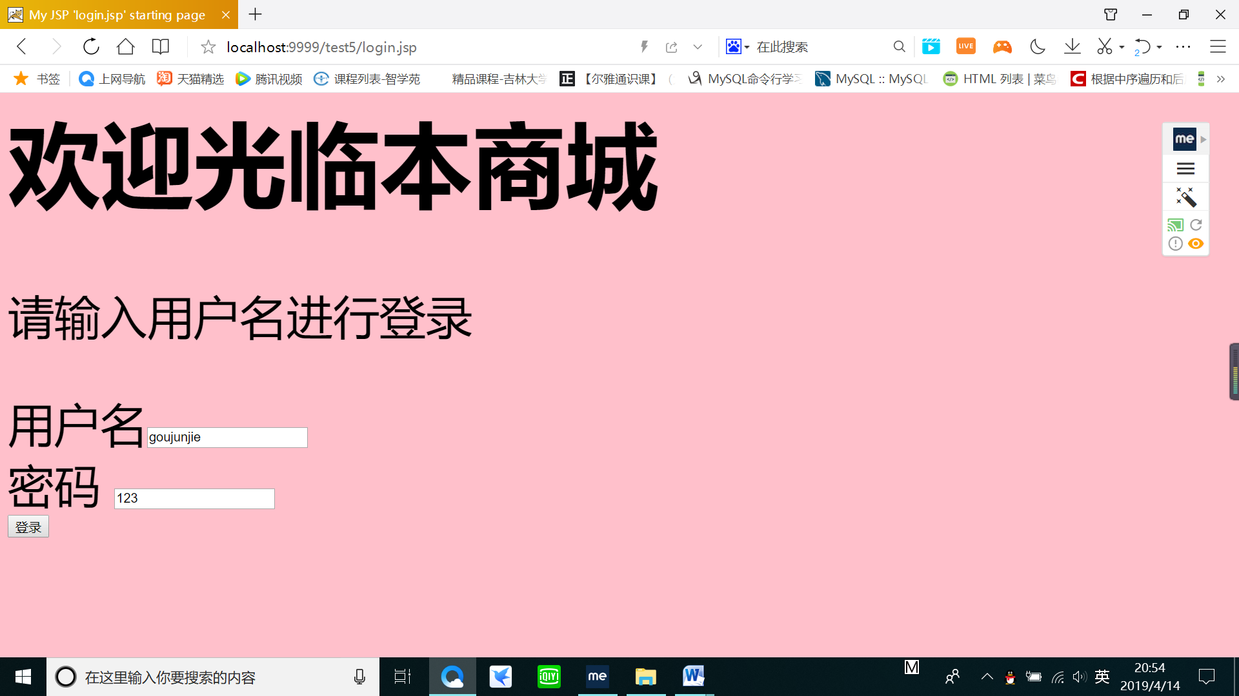

上图为登陆页面，首先用于用户的信息登陆

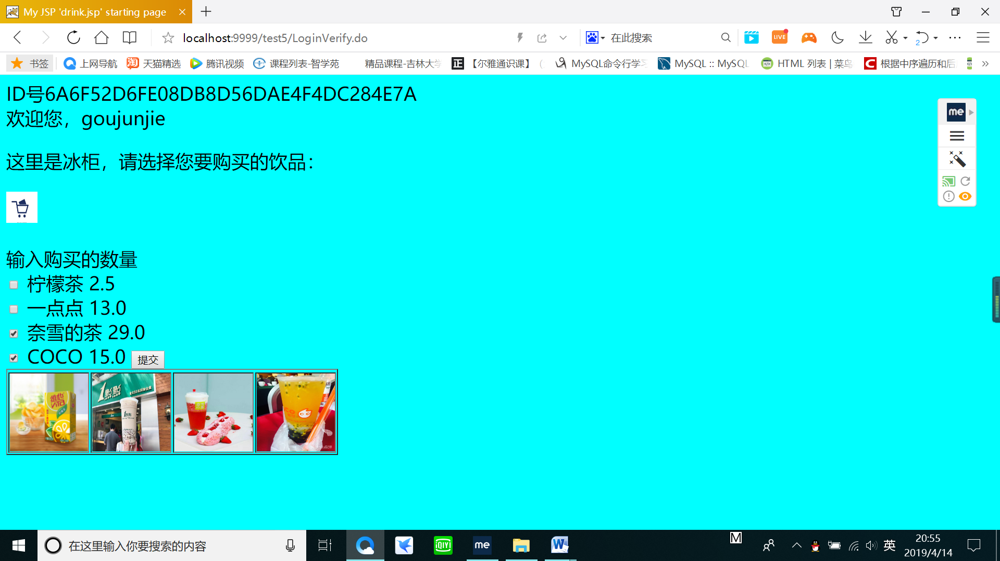

上图为登陆成功后跳转到选购页面。分别显示了登陆号的ID号，和商品的基本信息。

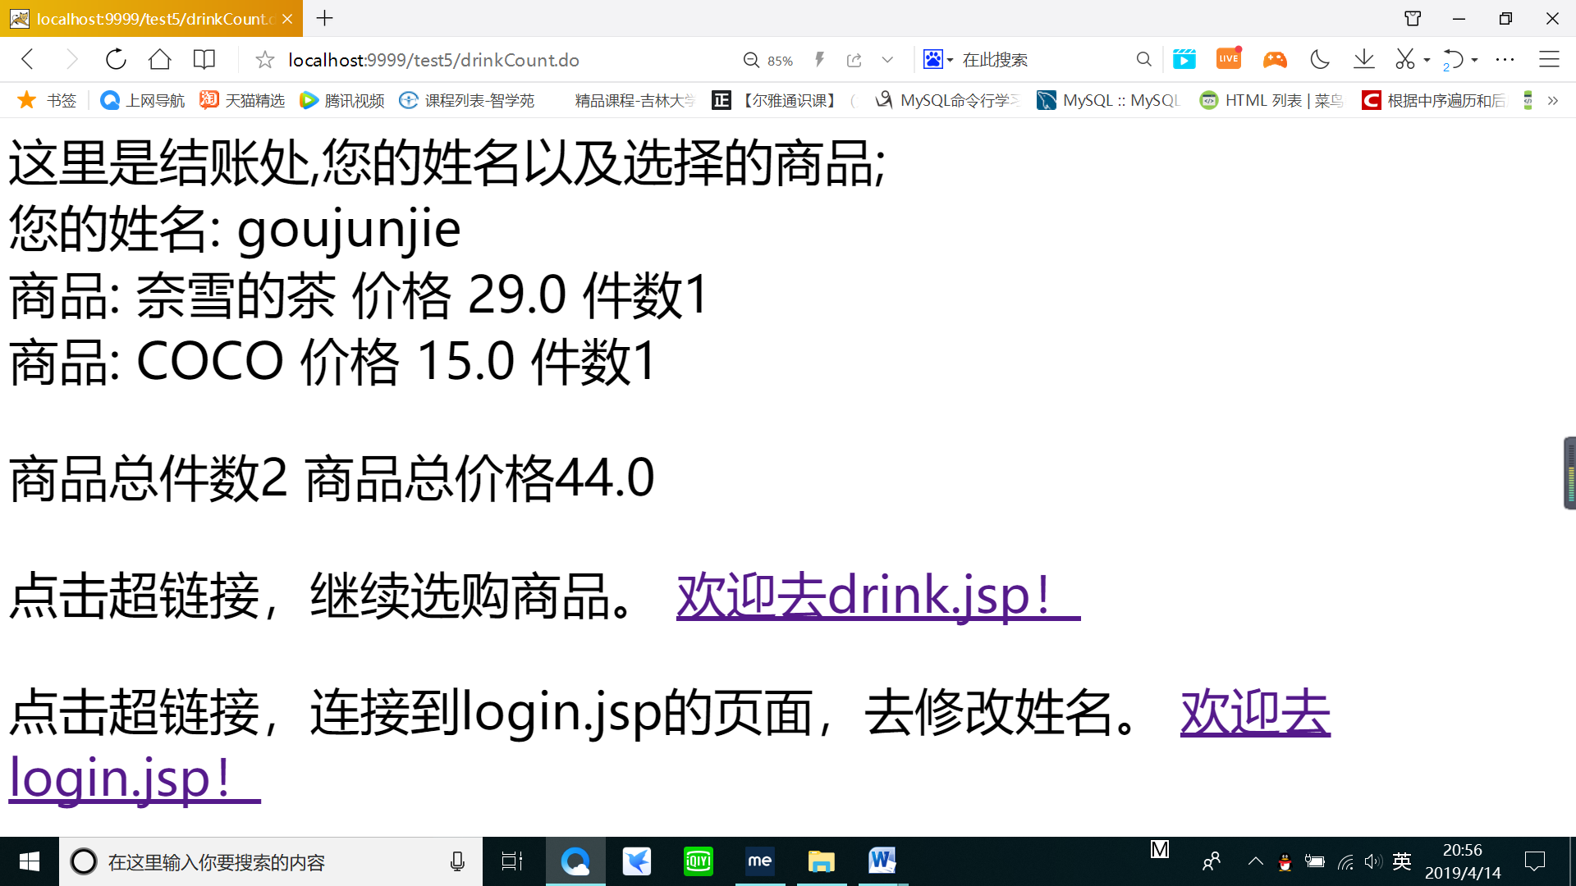

选购完后提交订单，进行商品的结算。并可选择跳转到drink.jsp继续选购或者login.jsp重新登陆。

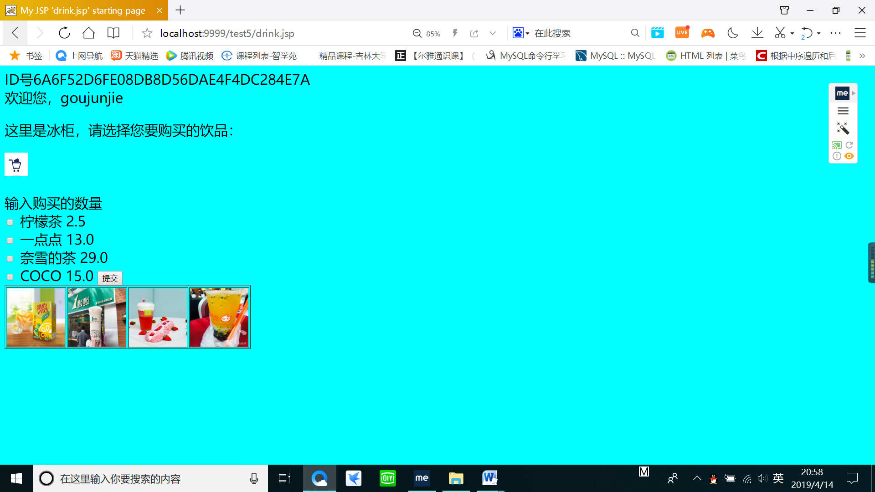

点击drink.jsp重新选购商品

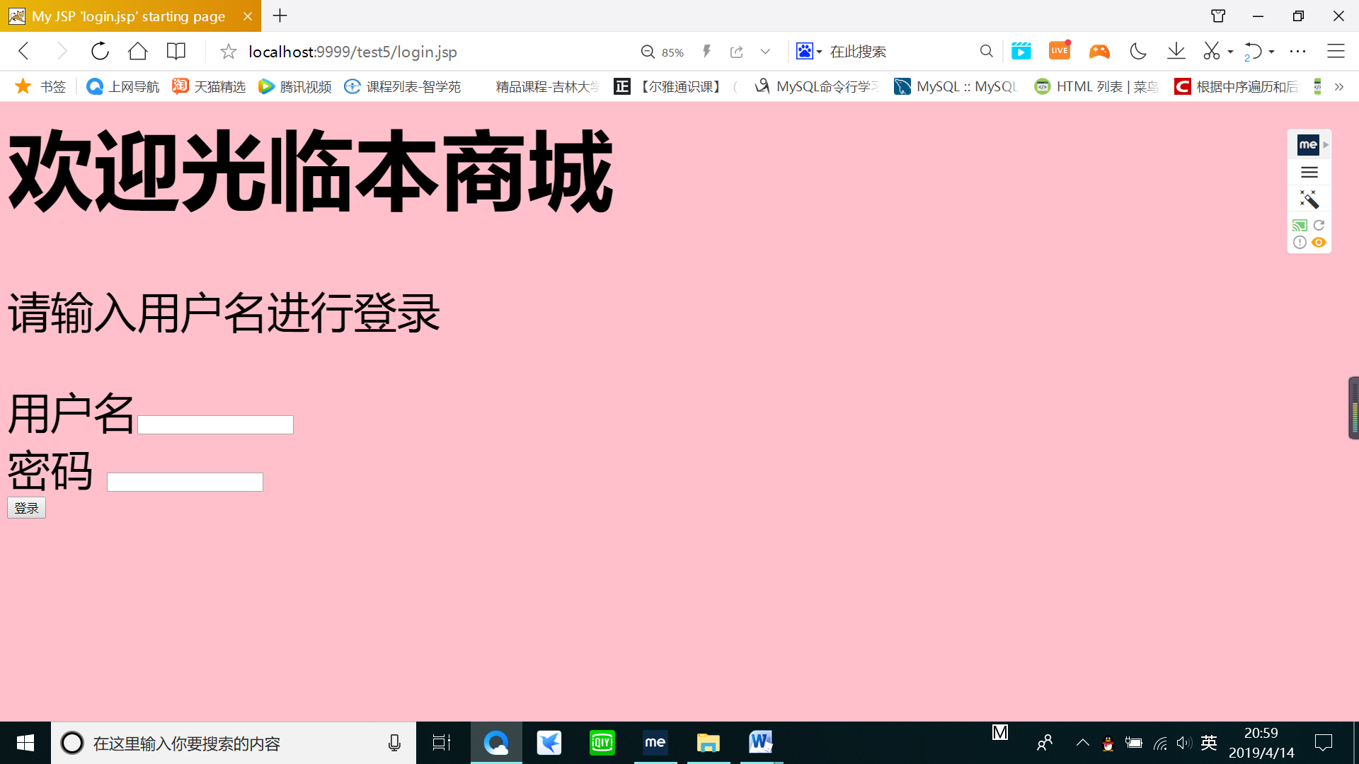点击login.jsp后重新登陆。

# 收获与问题

首先先要理解老师提供的参考代码的意思，学会掌握session对象保存信息，并利用setAttribute和getAttribute方法设置和获得属性。