**Java Web开发**

**实验五**

**作业报告**

|  |  |
| --- | --- |
| 学 院 | 计算机 |
| 所在系 班 级 | 2017软件工程9班 |
| 学 号 姓 名 | 03171519林宏钊 |
| 指 导 教 师 | 郭晓燕 |
| 完 成 时 间 | 2018年4月10日 |

# 实验题目

* 1. 第四章课后练习3购物车，实现一个购物车应用程序，可以购物，显示购物数量并查看购物车内容。（此题模版test4E，提供给大家参考。）

提示：采购此书做成超链接，并用URL重写带关键信息

* 1. Shopping.view?bookID=‘0001’，其中0001是你选中图书对应的ID号，每点击一次就在相应的购书数量上加一，并返回当前的选购页面。
  2. 除了要保存图书的ID号、书名，还要保存购书数量，所以session对象保存的信息需要考虑清楚，最好是一个对象数组或列表。

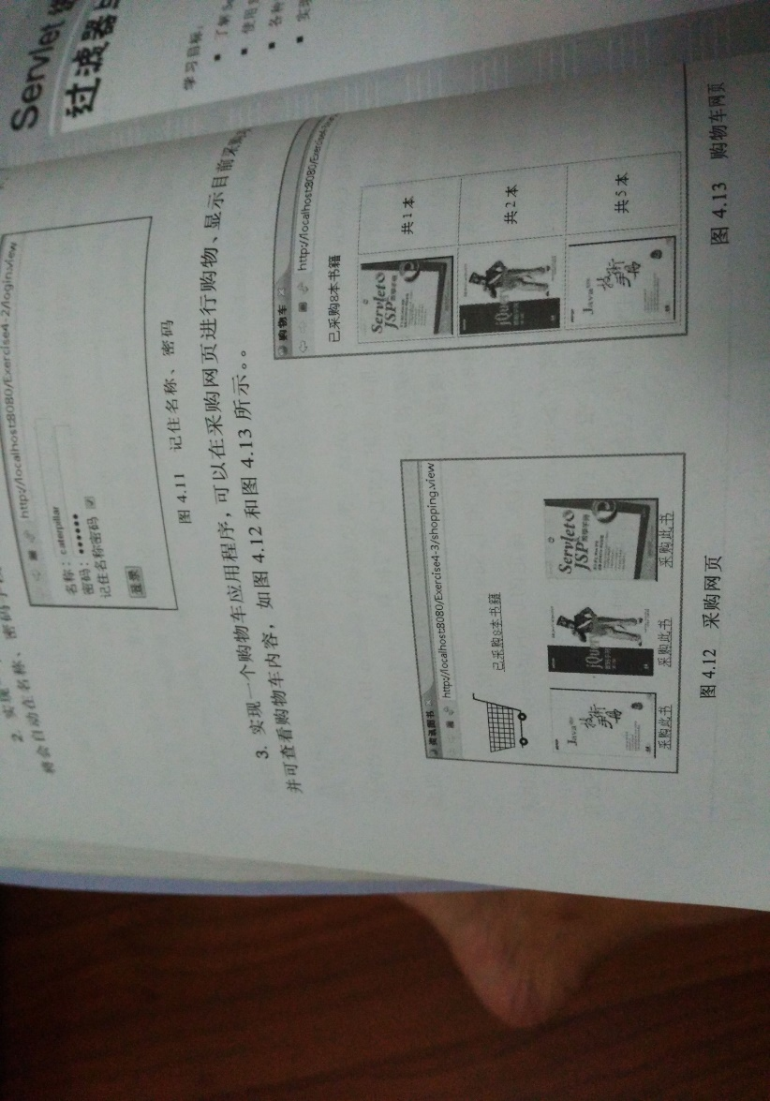

购物车的效果图

# 分析与设计

根据题目要求，计划设计几个文件来完成实验，每个文件的名字、作用。如果是类，要求写出类的变量和方法

# 关键源码（部分）

|  |
| --- |
| Book.java  **package** cc.openhome;  **public** **class** Book {  String productID;  String productName;  String productImg;  **double** productPrice;  **int** BookNum;  **double** productCount;    **public** Book(String id,String name,String img,**double** price,**int** num,**double** count) {  **this**.productID=id;  **this**.productName=name;  **this**.productImg=img;  **this**.productPrice=price;  **this**.BookNum=num;  **this**.productCount=count;  }    **public** String getProductID() {  **return** productID;  }  **public** **void** setProductID(String productID) {  **this**.productID=productID;  }  **public** String getProductName() {  **return** productName;  }  **public** **void** setProductName(String productName) {  **this**.productName=productName;  }  **public** String getproductImg() {  **return** productImg;  }  **public** **void** setproductImg(String productImg) {  **this**.productImg=productImg;  }  **public** **double** getproductPrice() {  **return** productPrice;  }  **public** **void** setproductPrice(**double** productPrice) {  **this**.productPrice=productPrice;  }  **public** **int** getBookNum() {  **return** BookNum;  }  **public** **void** setBookNum(**int** BookNum) {  **this**.BookNum=BookNum;  }  **public** **double** getproductCount() {  **ret**urn productCount;  }  **public** **void** setproductCount(**dou**ble productCount) {  **t**his.productCount=productCount;  }  } |

|  |
| --- |
| Shopping.jsp  <%@ page import=*"cc.openhome.*"* contentType=*"text/html;charset=utf-8"*%>  <!DOCTYPE HTML PUBLIC "-//W3C//DTD HTML 3.01 Transitional//EN">  <html>  <%  **if** (request.getSession().getAttribute("bookList")==**null**) {  Book [] BookList = **new** Book[5];  BookList[0] = **new** Book("10101","Java","10101.jpg",54.85,0,0.0);  BookList[1] = **new** Book("10102","Java","10102.jpg",45.66,0,0.0);  BookList[2] = **new** Book("10103","Java","10103.jpg",36.50,0,0.0);  BookList[3] = **new** Book("10104","Java","10104.jpg",48.90,0,0.0);  BookList[4] = **new** Book("10105","Java","10105.jpg",25.50,0,0.0);    request.getSession().setAttribute("bookList",BookList);  request.getSession().setAttribute("sum", 0);  }  %>  <body>  <img src=*"cart.png"* height=*"70px"* width=*"220px"*>    <a href=*"/WebTest_03171519/cart.view"*>已采购<%=request.getSession().getAttribute("sum") %>本书籍</a><br>  <br>  <table frame=*"void"* border=*"1"* cellspacing=*"8"* cellpadding=*"0"*>  <tr align=*center*>  <%  Book[] BookList=(Book[])request.getSession().getAttribute("bookList");  **for**(Book book:BookList) {  out.println("<td><img src="+book.getproductImg()+" height='220px' width='220px'><br>");  out.println("<small>价格：</small>"+book.getproductPrice()+"<small>元<small><br>");  out.println("<a href=/WebTest_03171519/shopping.view?id="+book.getProductID()+">采购此书</a>");  out.println("</td>");    }  %>  </tr>  </table>  </body>  </html> |

|  |
| --- |
| ShoppingServlet.java  package cc.openhome;  import java.io.IOException;  import java.io.PrintWriter;  import javax.servlet.ServletException;  import javax.servlet.annotation.WebServlet;  import javax.servlet.http.HttpServlet;  import javax.servlet.http.HttpServletRequest;  import javax.servlet.http.HttpServletResponse;  @WebServlet(urlPatterns= {"/shopping.view"})  public class ShoppingServlet extends HttpServlet {  public void doGet(HttpServletRequest request, HttpServletResponse response) throws ServletException, IOException {    response.setContentType("text/html;charset=UTF-8");  PrintWriter out = response.getWriter();  String id = request.getParameter("id");  Book[] BookList=(Book[])request.getSession().getAttribute("bookList");  int sum=(int)request.getSession().getAttribute("sum");    for(Book book:BookList) {  if(book.getProductID().equals(id)) {  book.setBookNum(book.getBookNum()+1);  book.setproductCount(book.getBookNum()*book.getproductPrice());  ++sum;  }  }  request.getSession().setAttribute("bookList", BookList);  request.getSession().setAttribute("sum", sum);  request.getRequestDispatcher("/Shopping.jsp").forward(request, response);    }  public void doPost(HttpServletRequest request, HttpServletResponse response) throws ServletException, IOException {  doGet(request,response);  }  } |

|  |
| --- |
| CarServlet.java  package cc.openhome;  import java.io.IOException;  import java.io.PrintWriter;  import javax.servlet.ServletException;  import javax.servlet.annotation.WebServlet;  import javax.servlet.http.HttpServlet;  import javax.servlet.http.HttpServletRequest;  import javax.servlet.http.HttpServletResponse;  @WebServlet(urlPatterns= {"/cart.view"})  public class CarServlet extends HttpServlet {  public void doGet(HttpServletRequest request, HttpServletResponse response) throws ServletException, IOException {  response.setContentType("text/html;charset=UTF-8");  PrintWriter out = response.getWriter();  Book[] BookList=(Book[])request.getSession().getAttribute("bookList");  out.println("<!DOCTYPE HTML PUBLIC \"-//W3C//DTD HTML 3.01 Transitional//EN\">");  out.println("<HTML>");  out.println(" <HEAD><TITLE>购物车</TITLE>");      out.println("<style type=\"text/css\">");  out.println(" .price,.num,.count,.work{width: 12%;}");  out.println(".choice{width: 5%;}");  out.println(".name{text-align: left;}");  out.println("td,th{border:none;/*这个是单元格，不给他要边框*/text-align:center;}");  out.println("</style>");  out.println("</head>");  out.println(" <BODY>");  out.println(" <form>");  out.println("已采购"+request.getSession().getAttribute("sum")+"本书籍");  out.println("<table border=\"1\" width=1200px align=\"center\">");  out.println("<thead><tr><th class=\"choice\"><input type=\"checkbox\" id=checkAll onclick=\"checkAll(this)\"/>全选</th>");  out.println("<th class=\"name1\" text-align=center;>书籍详细</th>");  out.println("<th class=\"price\">单价</th>");  out.println("<th class=\"num\">数量</th>");  out.println("<th class=\"count\">金额</th>");  out.println("<th class=\"work\">操作</th>");  out.println("</tr></thead></table><br>");    for(Book book:BookList) {  if(book.getBookNum()>0) {  out.println("<table border=\"1\" width=1200px align=\"center\">");  out.println("<td class=\"choice\"><input type=\"checkbox\" name=checkOne></td>");  out.println("<td class=\"name\"><img src="+book.getproductImg()+" height='220px' width='220px'></td>");  out.println("<td class=\"price\">"+book.getproductPrice()+"</td>");  out.println("<td class=\"num\">"+book.getBookNum()+"本</td>");  out.println("<td class=\"count\">"+book.getproductCount()+"元</td>");  out.println("<td class=\"work\">删除</td>");      out.println("</tr></table></br>");  }  }  out.println("<script>function checkAll(checkAll){");  out.println("var arr=document.getElementsByName('checkOne');");  out.println("var checkAll=document.getElementById('checkAll');");  out.println("for(i in arr){arr[i].checked=checkAll.checked;}}");  out.println("</script>");      out.println(" </form>");  out.println(" </BODY>");  out.println("</HTML>");  }  public void doPost(HttpServletRequest request, HttpServletResponse response) throws ServletException, IOException {    doGet(request,response);  }  } |

# 运行效果图

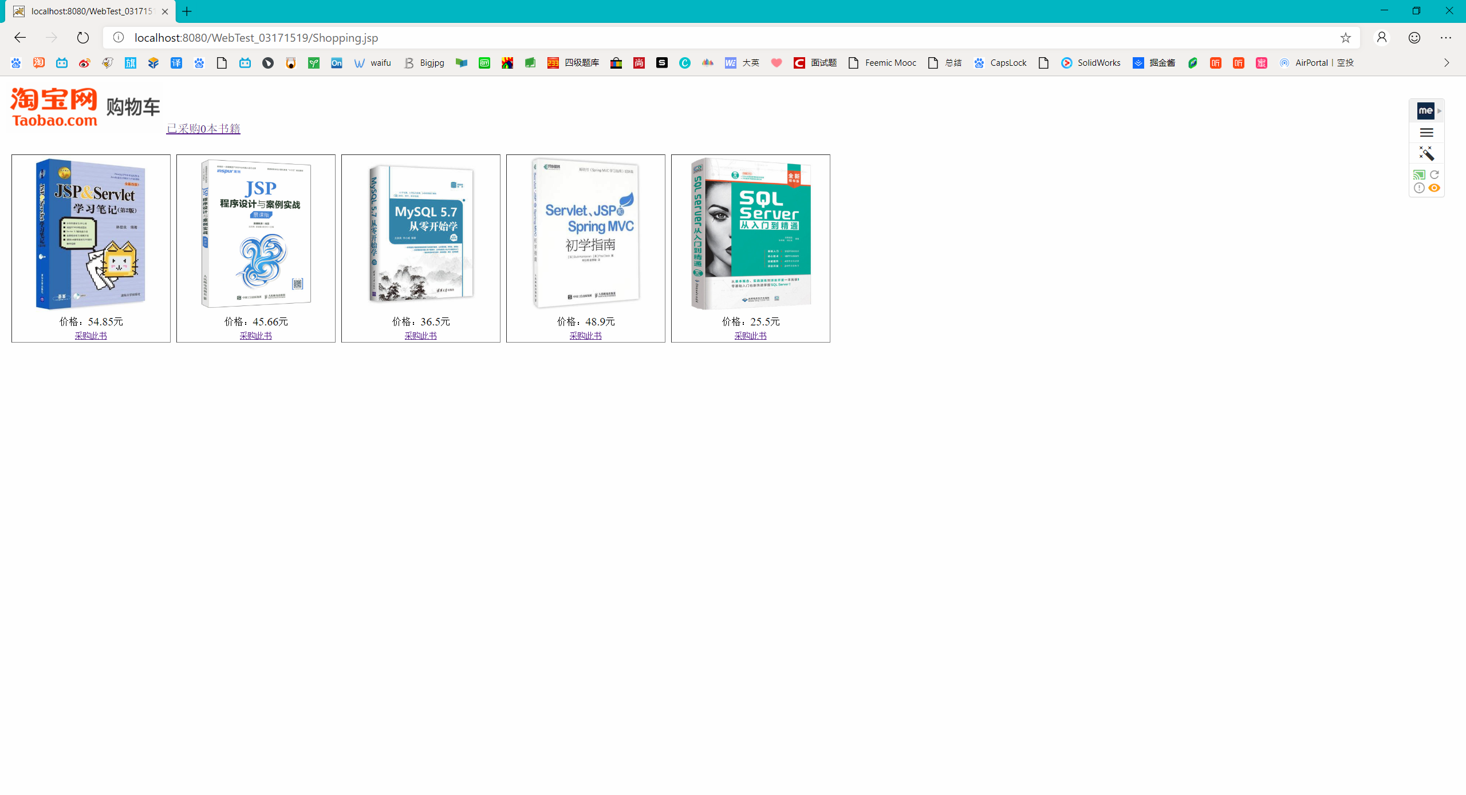

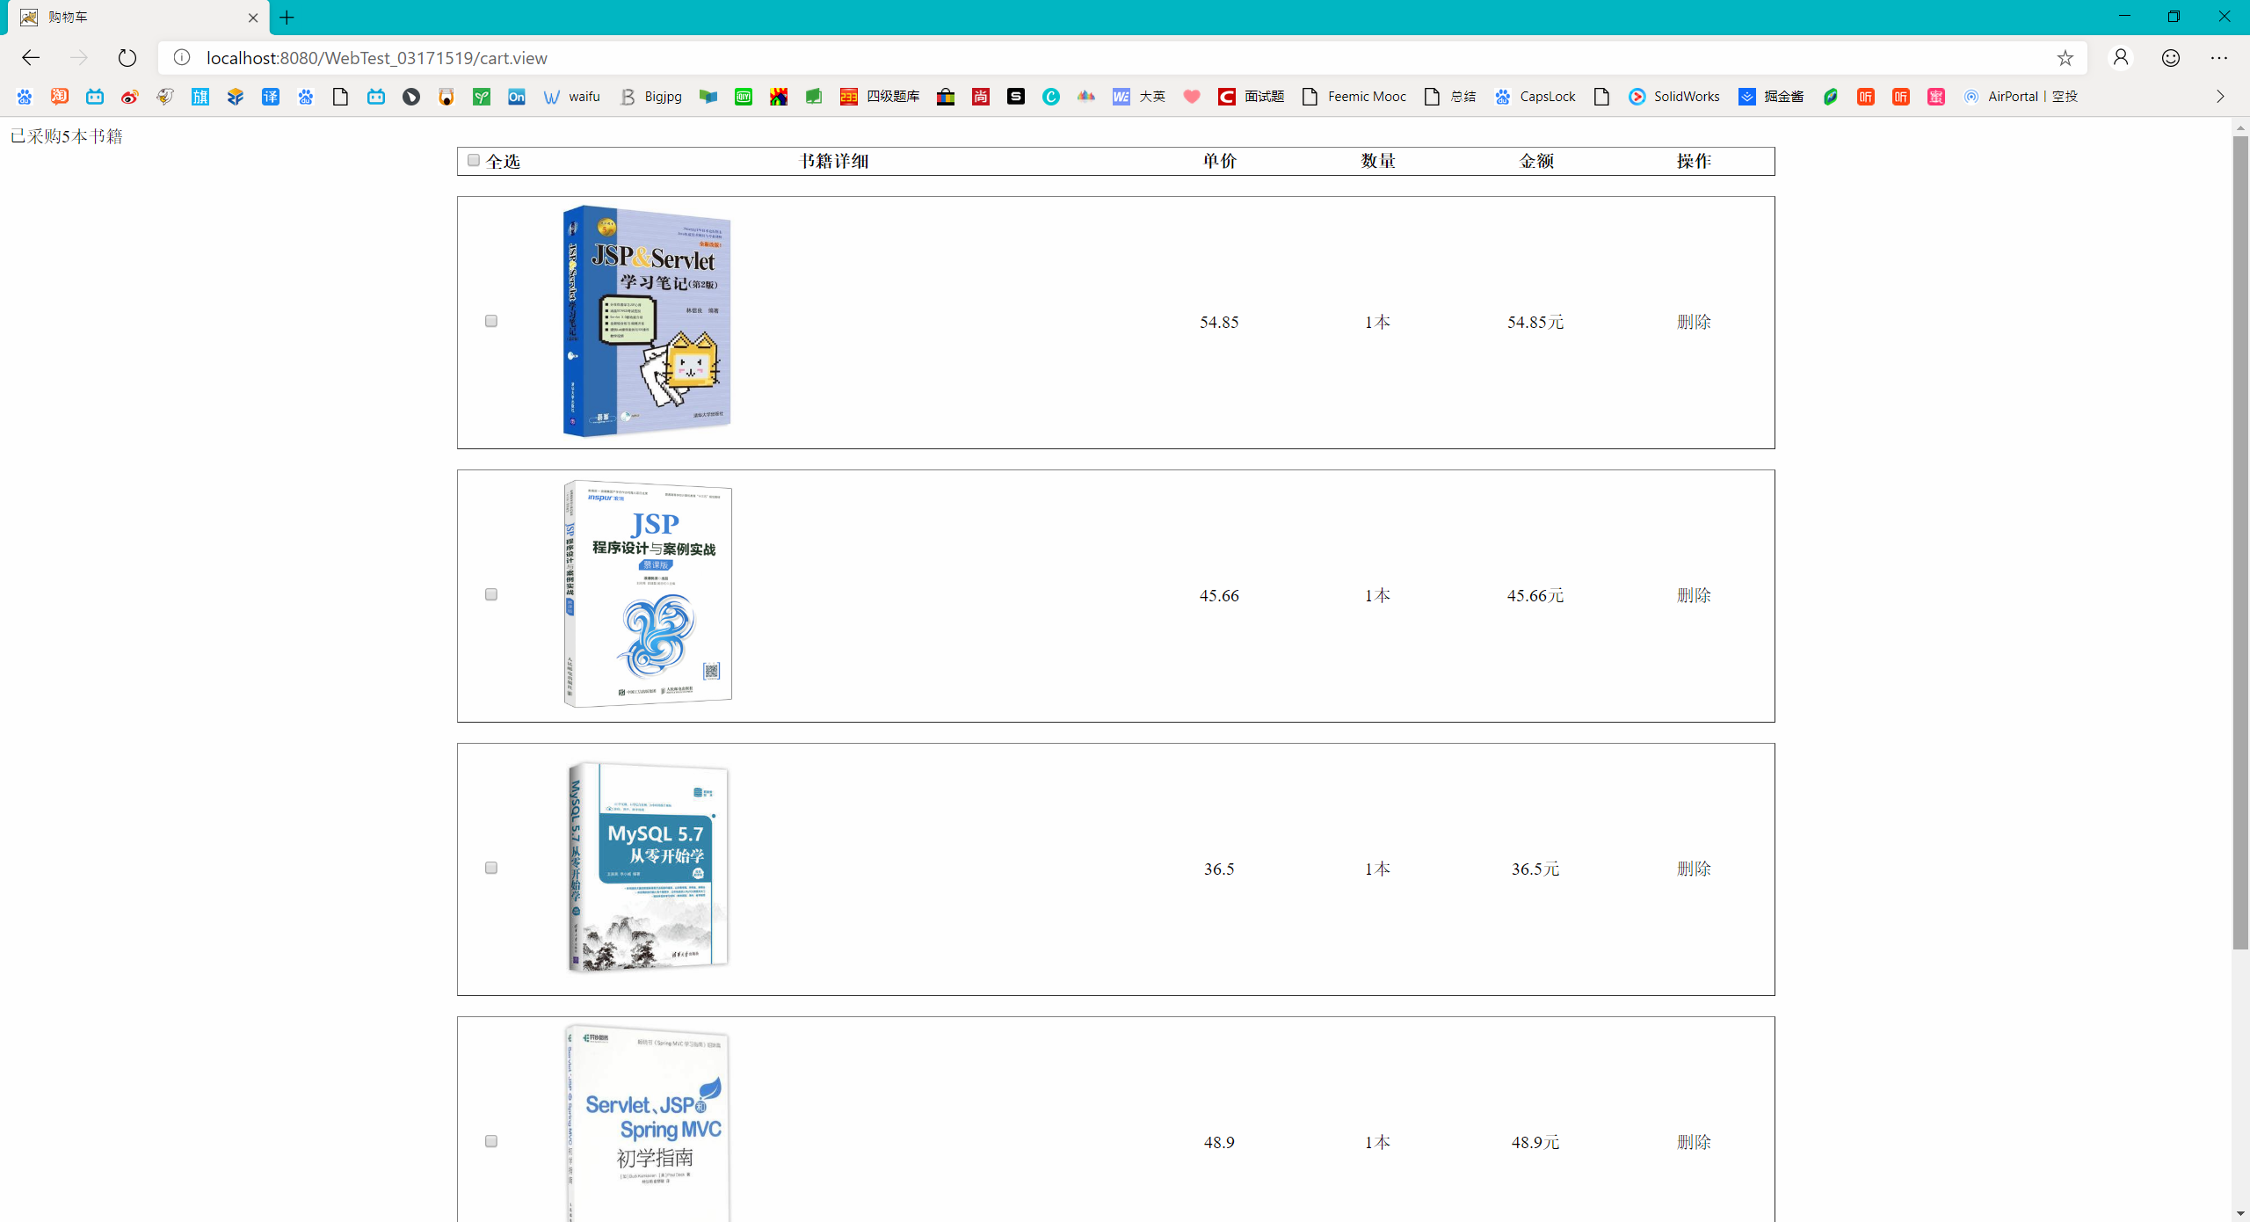

# 收获与问题

谈一谈你在本实验中所收获的内容及问题。