**Java Web开发**

**实验五**

**作业报告**

|  |  |
| --- | --- |
| 学 院 | 计算机 |
| 所在系 班 级 | 2017软件工程系10班 |
| 学 号 姓 名 | 04171723曾雪娟 |
| 指 导 教 师 | 郭晓燕 |
| 完 成 时 间 | 2018年5月- |

# 实验题目

1. 练习老师在理论课上演示的购物车实例，理解购物功能如何实现，理解如何利用session对象保存购物信息，如何设计封装数据类。（请参考“第四章会话管理课上的购物车实例代码.docx”文档）；
2. 第四章课后练习3购物车，实现一个购物车应用程序，可以购物，显示购物数量并查看购物车内容。（此题模版test4E，提供给大家参考。）提示：采购此书做成超链接，并用URL重写带关键信息
   1. Shopping.view?bookID=‘0001’，其中0001是你选中图书对应的ID号，每点击一次就在相应的购书数量上加一，并返回当前的选购页面。

除了要保存图书的ID号、书名，还要保存购书数量，所以session对象保存的信息需要考虑清楚，最好是一个对象数组或列表。

# 分析与设计

第二题：设计一个java类：Book；两个Servlet： CarServlet,ShoppingServlet;一个jsp：Shopping.jsp.

在Book类里定义bookID; bookName; bookPrice; bookImg; shopNum; ,在Shopping.jsp里输出购物车的图片及

# 关键源码（部分）

第一题：

<%@ page contentType=*"text/html;charset=UTF-8"* language=*"java"* %>

<%@ page import=*"javax.servlet.http.HttpSession"*%>

<html>

<head>

<title>Title</title>

</head>

<body>

<p>请输入用户名进行登录

<form action=*"04171723/ShopLogin"* method=*post* name=*form*>

<input type=*"text"* name =*name*>

<input type=*"submit"* value=*"提交"* name =*submit*>

</form>

<%

String ID=(String ) session .getId() ;

String name=(String ) session .getAttribute("customerName") ;

**if**((name!=**null**)&&(name.length() >0))

{

%> <p>登录成功的ID号<%=ID%>

<p>session

<a href=*"/04171723/Food.jsp"*>欢迎选购商品</a>

<%

}

%>

</body>

package shopping;

import java.io.IOException;

import java.io.PrintWriter;

import javax.servlet.ServletException;

import javax.servlet.annotation.WebServlet;

import javax.servlet.http.HttpServlet;

import javax.servlet.http.HttpServletRequest;

import javax.servlet.http.HttpServletResponse;

import javax.servlet.http.HttpSession;

public class ShopLogin extends HttpServlet {

public ShopLogin() {

super();

}

public void destroy() {

super.destroy(); // Just puts "destroy" string in log

// Put your code here

}

public void doGet(HttpServletRequest request, HttpServletResponse response)

throws ServletException, IOException {

doPost(request,response);

}

public void doPost(HttpServletRequest request, HttpServletResponse response)

throws ServletException, IOException {

request.setCharacterEncoding("UTF-8");

HttpSession session=request.getSession();

String name=request.getParameter("name");

if(name==null){

name="";

response.sendRedirect("/04171723/main.jsp");

}

else{

session.setAttribute("customerName", name);

Chart[] chart=initChart();

session.setAttribute("chart", chart);

response.sendRedirect("/04171723/Food.jsp");

}

}

public Chart[] initChart(){

Chart[] charts=new Chart[6];

charts[0]=new Chart("0001","雀巢咖啡",88.18);

charts[1]=new Chart("0002","维维豆奶",12);

charts[2]=new Chart("0003","红茶",5.2);

charts[3]=new Chart("0004","美味源橙汁",20.5);

charts[4]=new Chart("0005","可口可乐",6.6);

charts[5]=new Chart("0006","露露杏仁露",22.60);

return charts;

}

public void init() throws ServletException {

// Put your code here

}

}

<%@page import=*"shopping.Chart"*%>

<%@ page language=*"java"* import=*"java.util.*"* pageEncoding=*"UTF-8"*%>

<%

String path = request.getContextPath();

String basePath = request.getScheme()+"://"+request.getServerName()+":"+request.getServerPort()+path+"/";

%>

<!DOCTYPE HTML PUBLIC "-//W3C//DTD HTML 4.01 Transitional//EN">

<html>

<body bgcolor=*cyan*><FONT Size=*5*>

</FONT>

ID号<%= (String)session.getId() %><br>

<%

String name=(String)session.getAttribute("customerName");

Chart[] charts=((Chart[])session.getAttribute("chart"));

%>

欢迎你，<%=name %>

<p>这里是食品柜台，请选择您要购买的食品：

<form action=*"FoodCount"* method=*post* name=*form*>

<%

**if**(charts!=**null**){

**for**(Chart chart:charts){

%><br>

<input type=*"checkbox"* name=*"choice"* value=<%=chart.getProductID() %>>

<%=chart.getProductName() %>

<%=chart.getProductPrice() %>

<% }

}

%>

<input type=*"submit"* value=*"提交"* name=*"submit"*>

</form>

</body>

</html>

package shopping;

import javax.servlet.ServletException;

import javax.servlet.annotation.WebServlet;

import javax.servlet.http.HttpServlet;

import javax.servlet.http.HttpServletRequest;

import javax.servlet.http.HttpServletResponse;

import javax.servlet.http.HttpSession;

import java.io.IOException;

import java.io.PrintWriter;

public class FoodCountServlet extends HttpServlet {

protected void doPost(HttpServletRequest request, HttpServletResponse response) throws ServletException, IOException {

response .setContentType("text/html;charset=utf-8");

HttpSession session =request .getSession() ;

request .setCharacterEncoding("utf-8") ;

String id="";

/* String id,name="";

float price=0,totalPtice=0,num=0;*/

Chart [] chartS =( Chart[])session.getAttribute("chart");

String prodS[]=request .getParameterValues("choice");

if(prodS!=null)

{

for(int k=0;k<prodS.length ;k++)

{

id=prodS[k];

for(int i=0;i<chartS .length ;i++)

{

if(id.equals(chartS [i].getProductID() ) )

{

chartS [i].setShopNum(chartS [i].getShopNum() +1);

break;

}

}

}

}

printChar(request ,response );

}

protected void doGet(HttpServletRequest request, HttpServletResponse response) throws ServletException, IOException {

doPost(request, response );

}

public void printChar(HttpServletRequest request, HttpServletResponse response)throws IOException {

HttpSession session =request .getSession() ;

PrintWriter out=response .getWriter() ;

int num=0;

float totalPrice=0;

out.println("<html><body><font stze=8>");

out.println("<p>这里是结账处，您的姓名以及选择的商品：");

out.println("<br>您的姓名："+(String) session.getAttribute("customerName"));

Chart [] chartS =( Chart[])session.getAttribute("chart");

for(int i=0;i<chartS.length ;i++) {

if(chartS [i].getShopNum()>0 ){

out.println("<br>商品："+chartS [i].getProductName() +"价格："

+chartS [i].getProductPrice() +"件数"+chartS [i].getShopNum());

num=num+chartS[i].getShopNum() ;

totalPrice =totalPrice +(chartS [i].getProductPrice() *chartS [i].getShopNum() );

}

}

out.println("<P>商品总件数价"+num+"商品总价格"+totalPrice );

out.println("<P>点击超链接，继续选购商品。");

out.println("<a href=./Food.jsp>欢迎选购商品</a>");

out.println("<P>点击超链接，连接到主页面，去修改姓名。");

out.println("<a href=./main.jsp>欢迎到主页面</a>");

out.println("</font></body></html>");

}

}

**package** shopping;

**public** **class** Chart {

/**

* **@param** args

*/

String productID;

String productName;

**float** productPrice;

**int** shopNum;

**public** Chart(String id,String name,**double** price ){

**this**.productID=id;

**this**.productName=name;

**this**.productPrice=(**float**)price;

**this**.shopNum=0;

}

**public** String getProductID(){

**return** productID;

}

**public** **void** setProductID(String productID){

**this**.productID=productID;

}

**public** String getProductName(){

**return** productName;

}

**public** **void** setProductName(String productName) {

**this**.productName = productName;

}

**public** **float** getProductPrice() {

**return** productPrice;

}

**public** **void** setProductPrice(**float** productPrice) {

**this**.productPrice = productPrice;

}

**public** **int** getShopNum() {

**return** shopNum;

}

**public** **void** setShopNum(**int** shopNum) {

**this**.shopNum = shopNum;

}

**public** **static** **void** main(String[] args) {

// **TODO** Auto-generated method stub

}

}

## 第二题：

**package** test5_book;

**public** **class** Book {

String bookID;

String bookName;

**float** bookPrice;

String bookImg;

**int** shopNum;

**public** String getBookImg() {

**return** bookImg;

}

**public** **void** setBookImg(String bookImg) {

**this**.bookImg=bookImg;

}

**public** String getBookID() {

**return** bookID;

}

**public** **void** setBookID(String bookID) {

**this**.bookID=bookID;

}

**public** String getBookName() {

**return** bookName;

}

**public** **void** setBookName(String booktName) {

**this**.bookName=booktName;

}

**public** **float** getBookPrice() {

**return** bookPrice;

}

**public** **void** setBookPrice(**float** bookPrice) {

**this**.bookPrice=bookPrice;

}

**public** **int** getShopNum() {

**return** shopNum;

}

**public** **void** setShopNum(**int** shopNum) {

**this**.shopNum=shopNum;

}

**public** Book(){}

**public** Book(String bookID,String bookName,String bookImg,**int** shopNum){

**this**.bookID=bookID ;

**this**.bookName=bookName ;

**this**.bookImg=bookImg ;

**this**.shopNum=shopNum ;

}

}

<%@ page contentType=*"text/html;charset=UTF-8"* language=*"java"* %>

<%@ page import=*"test5_book.Book"*%>

<%@ page import=*"java.io.PrintWriter"* %>

<html>

<head>

<title>购书界面</title>

</head>

<% **if**(session.getAttribute("booklist")==**null** ){

Book[] Booklist=**new** Book[4];

Booklist[0]=**new** Book ("0001","JQuery","image/JQuery.jpg",0);

Booklist[1]=**new** Book ("0002","java2","image/java2.jpg",0);

Booklist[2]=**new** Book ("0003","JS","image/JS.jpg",0);

Booklist[3]=**new** Book ("0004","JS2","image/JS2.jpg",0);

session.setAttribute("booklist",Booklist);

session.setAttribute("sum",0);

}

%>

<body>

<a href=*" CarServlet"*>已采购<%=session.getAttribute("sum")%>本书籍</a><br>

<br>

<table border=*'1'*>

<%

Book[] booklist=(Book[])session.getAttribute("booklist");

**for**(Book book: booklist){

out.println("<tr>");

out.println("<td><img src='"+book.getBookImg()+"'width=\"228\"height=\"228\"></td>");

out.println("<td><a href='ShoppingServlet?id="+book.getBookID()+"'>采购此书</a></td>");

out.println("</tr>");

}

%>

</table>

</body>

</html>

package test5_book;

import java.io.IOException;

import java.io.PrintWriter;

import javax.servlet.ServletException;

import javax.servlet.http.HttpServlet;

import javax.servlet.http.HttpServletRequest;

import javax.servlet.http.HttpServletResponse;

import javax.servlet.http.HttpSession;

public class ShoppingServlet extends HttpServlet {

public ShoppingServlet() {

super();

}

public void destroy() {

super.destroy(); // Just puts "destroy" string in log

// Put your code here

}

public void doGet(HttpServletRequest request, HttpServletResponse response)

throws ServletException, IOException {

doPost(request,response);

}

public void doPost(HttpServletRequest request, HttpServletResponse response)

throws ServletException, IOException {

HttpSession session =request.getSession();

request.setCharacterEncoding("utf-8");

int Sum=(Integer)session.getAttribute("sum");

Book[] BookList=(Book[])session.getAttribute("booklist");

String ID=(String)request.getParameter("id");

for(Book book:BookList){

if(book.getBookID().equals(ID))

{

book.setShopNum(book.getShopNum()+1);

Sum++;

}

}

session.setAttribute("booklist",BookList);

session.setAttribute("sum",Sum);

response.sendRedirect("Shopping.jsp");

}

public void init() throws ServletException {

// Put your code here

}

}

package test5_book;

import java.io.IOException;

import java.io.PrintWriter;

import javax.servlet.ServletException;

import javax.servlet.http.HttpServlet;

import javax.servlet.http.HttpServletRequest;

import javax.servlet.http.HttpServletResponse;

import javax.servlet.http.HttpSession;

public class CarServlet extends HttpServlet {

public CarServlet() {

super();

}

public void destroy() {

super.destroy(); // Just puts "destroy" string in log

// Put your code here

}

public void doGet(HttpServletRequest request, HttpServletResponse response)

throws ServletException, IOException {

doPost(request,response);

}

public void doPost(HttpServletRequest request, HttpServletResponse response)

throws ServletException, IOException {

HttpSession session=request.getSession();

request.setCharacterEncoding("utf-8");

response.setContentType("text/html;charset=utf-8");

Book[] BookList=(Book[])session.getAttribute("booklist");

PrintWriter out=response.getWriter();

out.println("<html><body>");

out.println("<table border='1'>");

out.println("<p>已采购"+session.getAttribute("sum")+"本书");

for(Book book:BookList){

if(book.getShopNum()>0)

{

out.println("<tr>");

/* out.println("<td><img src='"+book.getBookImg()+"'width=\"228\"height=\"228\"></td>");*/

out.println("<td>共"+book.getShopNum()+"本</td>");

out.println("</tr>");

}

}

out.println("</body></html>");

}

public void init() throws ServletException {

// Put your code here

}

}

<servlet>

<description>This is the description of my J2EE component</description>

<display-name>This is the display name of my J2EE component</display-name>

<servlet-name>ShoppingServlet</servlet-name>

<servlet-class>test5_book.ShoppingServlet</servlet-class>

</servlet>

<servlet>

<description>This is the description of my J2EE component</description>

<display-name>This is the display name of my J2EE component</display-name>

<servlet-name>CarServlet</servlet-name>

<servlet-class>test5_book.CarServlet</servlet-class>

</servlet>

<servlet-mapping>

<servlet-name>ShoppingServlet</servlet-name>

<url-pattern>/ShoppingServlet</url-pattern>

</servlet-mapping>

<servlet-mapping>

<servlet-name>CarServlet</servlet-name>

<url-pattern> /CarServlet</url-pattern>

</servlet-mapping>

# </html>运行效果图

第一题图：

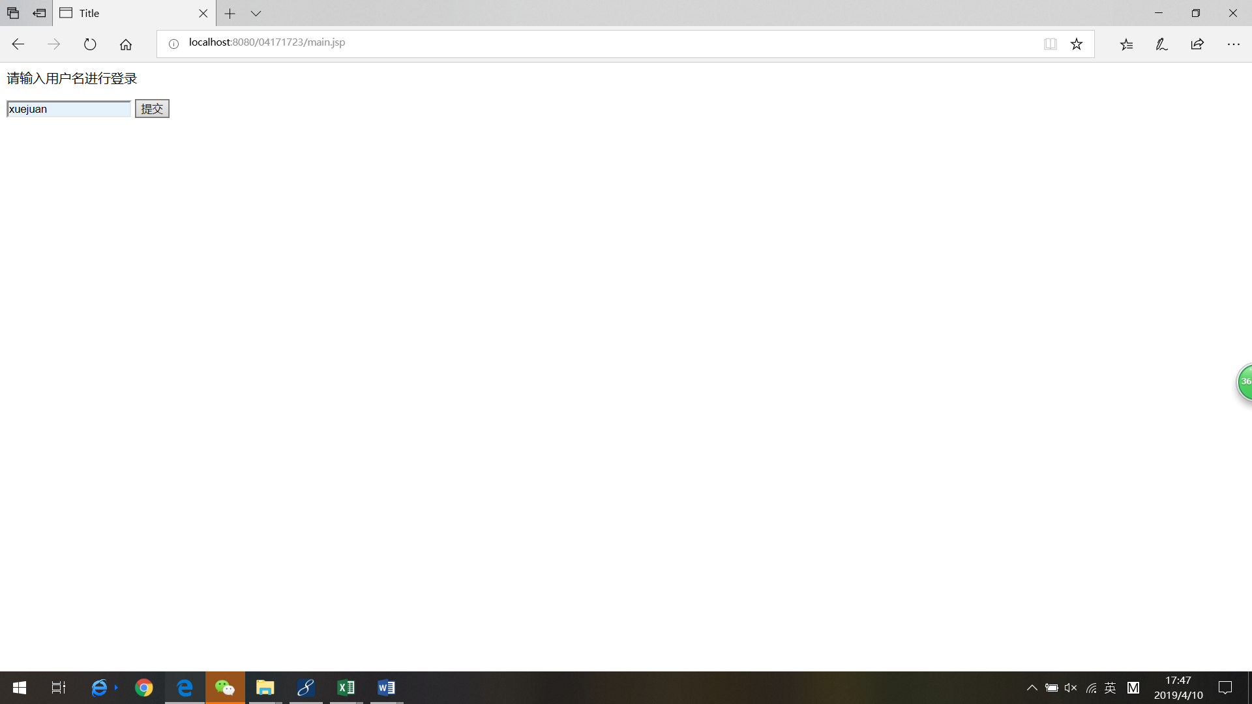

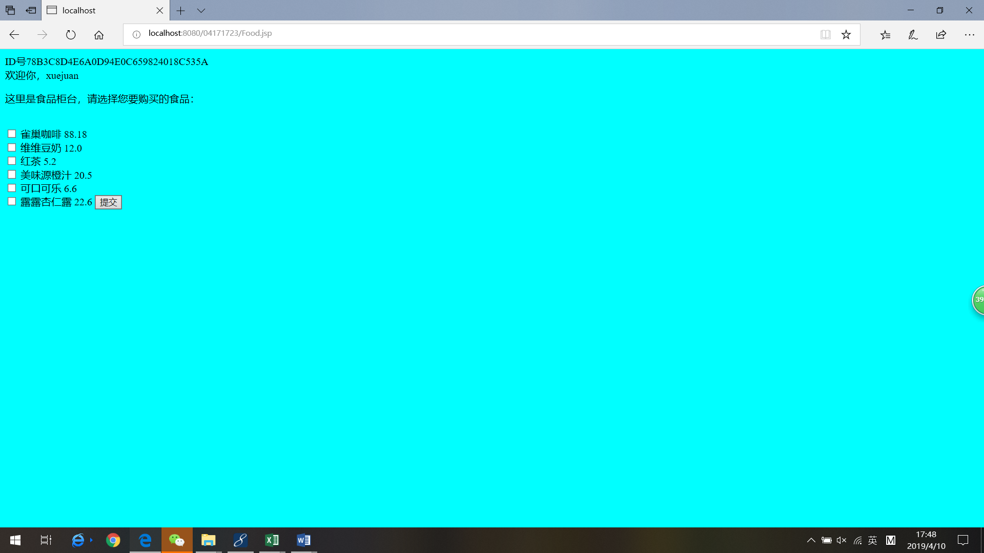

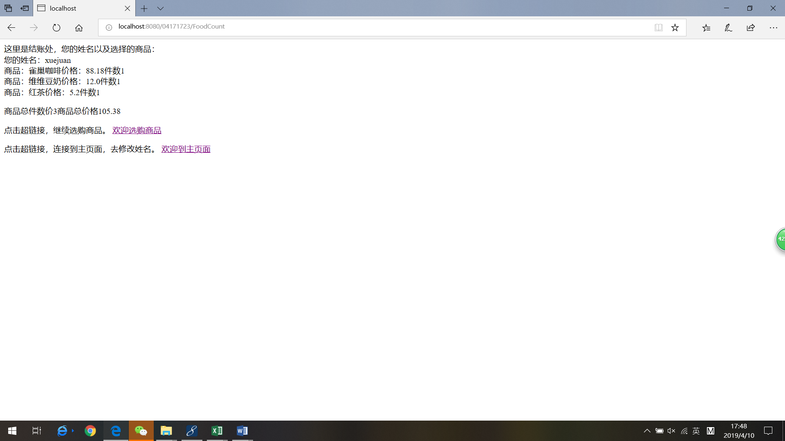

第二题图;

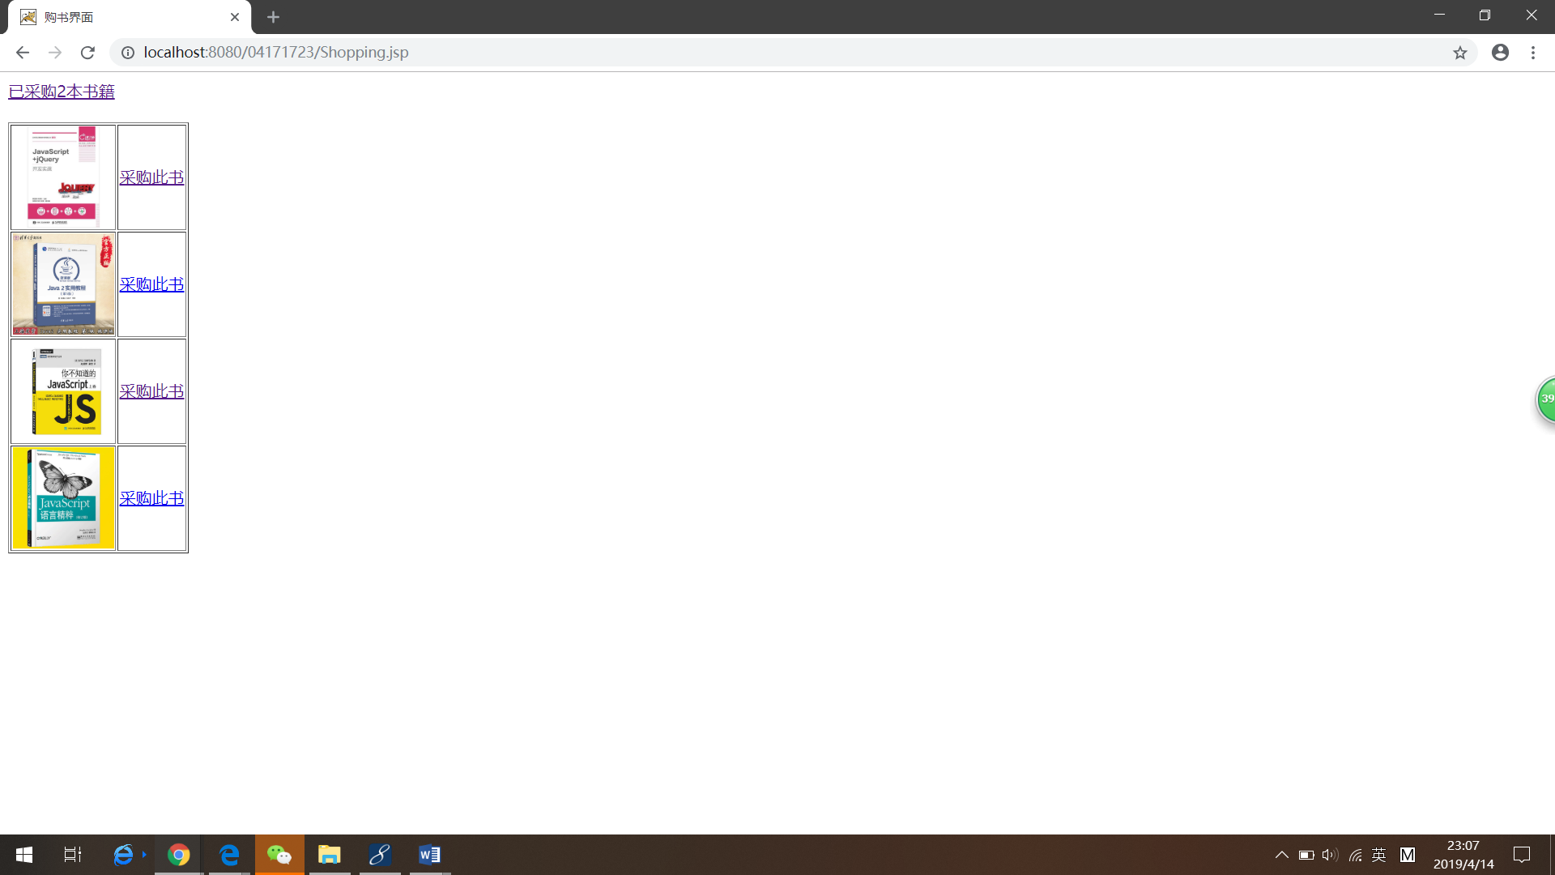

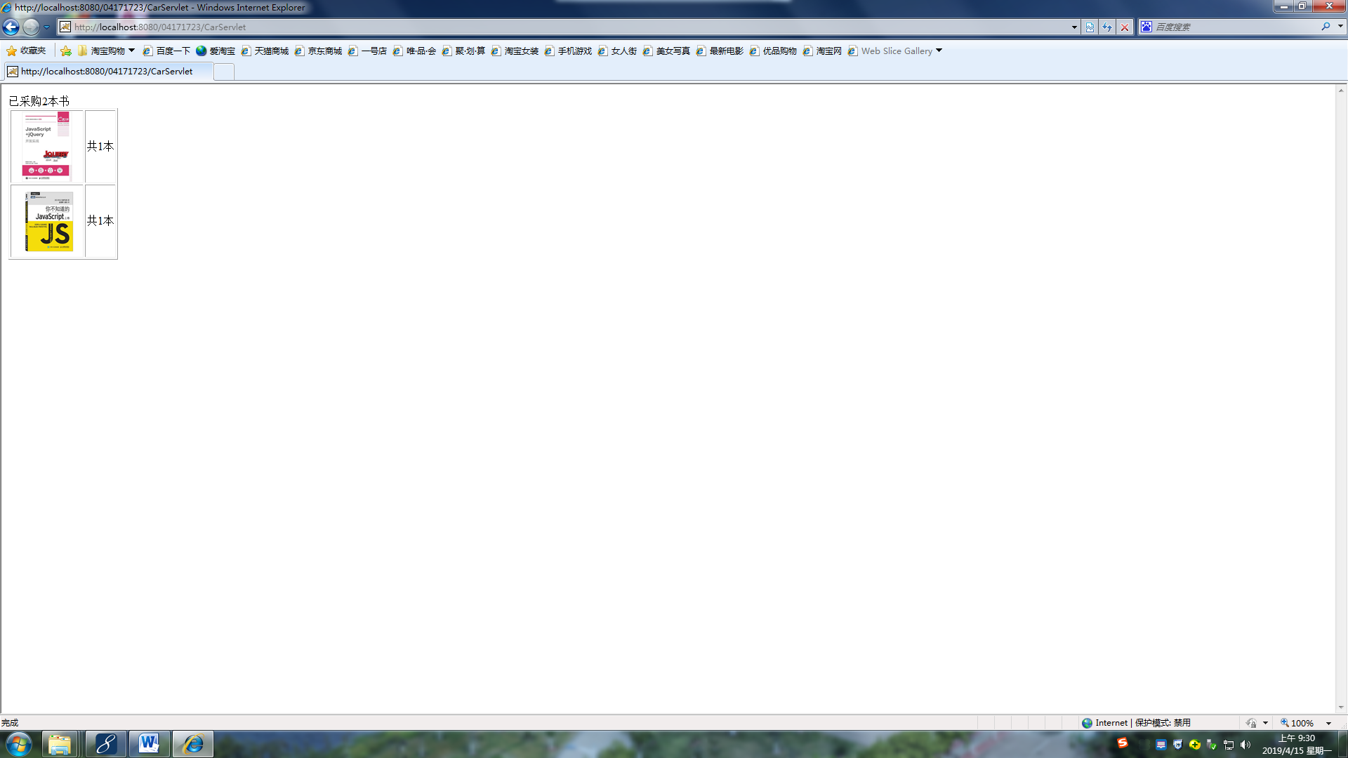

# 收获与问题

谈一谈你在本实验中所收获的内容及问题。