**Java Web开发**

**实验五**

**作业报告**

|  |  |
| --- | --- |
| 学 院 | 计算机 |
| 所在系 班 级 | 2017软件工程系10班 |
| 学 号 姓 名 | 04172112 宋振文 |
| 指 导 教 师 | 郭晓燕 |
| 完 成 时 间 | 2018年4月3号 |

# 实验题目

实验内容：

1、 练习老师在理论课上演示的购物车实例，理解购物功能如何实现，理解如何利用session对象保存购物信息，如何设计封装数据类。（请参考“第四章会话管理课上的购物车实例代码.docx”文档）；

如果上课听懂了购物车的原理或者部分理解，可以参考我的实例完成第2题，此题可忽略不写。

2、 第四章课后练习3购物车，实现一个购物车应用程序，可以购物，显示购物数量并查看购物车内容。（此题模版test4E，提供给大家参考。）

提示：采购此书做成超链接，并用URL重写带关键信息

a) Shopping.view?bookID=‘0001’，其中0001是你选中图书对应的ID号，每点击一次就在相应的购书数量上加一，并返回当前的选购页面。

b) 除了要保存图书的ID号、书名，还要保存购书数量，所以session对象保存的信息需要考虑清楚，最好是一个对象

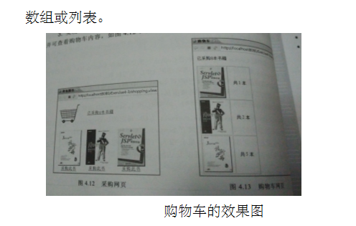

3、 对第三章动态验证码程序实现动态验证。（选做）

提示：在生成动态验证码的同时将其放入HttpSession对象中，在网页上提取出来进行比对。

# 分析与设计

Shopping.jsp、Book.java、 Shoppingservlet、CarServlet.java

# 关键源码（部分）

Shopping.jsp

<%@ page language=*"java"* import=*"java.util.*"* pageEncoding=*"UTF-8"*%>

<%@ page import=*"test.Book"* %>

<!DOCTYPE HTML PUBLIC "-//W3C//DTD HTML 4.01 Transitional//EN">

<html>

<%

**if**(session.getAttribute("bookList")==**null**){

Book[] BookList =**new** Book[4];

BookList[0]=**new** Book("10101","java核心技术","img\\10101.jpg",0);

BookList[1]=**new** Book("10102","java经典实例","img\\10102.jpg",0);

BookList[2]=**new** Book("10103","java7","img\\10103.jpg",0);

BookList[3]=**new** Book("10104","JSP&Servlet","img\\10104.jpg",0);

session.setAttribute("bookList", BookList);

session.setAttribute("sum", 0);

}

%>

<body>

<img src=*"img/cart.jpg"* height=*"60px"* width=*"60px"*>

<% out.print("<td> <a href='cart.view'>"+"已采购"+session.getAttribute("sum")+"本书籍</a></td>"); %>

<br>

<tale border =*1*>

<%

Book[] bookList=(Book[])session.getAttribute("bookList");

**for**(Book book:bookList){

out.print("<tr>");

out.print("<td> <img src ='"+book.getBookImg()+"'height='200px'"+"width='200px'"+"></td>");

out.print("<td> <a href='shopping.view?id="+book.getBookId()+"'>采购此书</a></td>");

out.print("</tr>");

} %>

</body>

</html>

Book.java

**package** test;

**public** **class** Book {

String bookID;

String bookName;

String bookImg;

**int** bookNum;

**public** Book(String id,String name,String img ,**int** num) {

**this**.bookID=id;

**this**.bookName=name;

**this**.bookImg=img;

**this**.bookNum=num;

}

**public** String getBookId(){

**return** bookID;

}

**public** **void** setBookId(String bookID){

**this**.bookID=bookID;

}

**public** String getBookName(){

**return** bookName;

}

**public** **void** setBookName(String bookName){

**this**.bookName=bookName;

}

**public** String getBookImg(){

**return** bookImg;

}

**public** **void** setBookImg(String bookImg){

**this**.bookImg=bookImg;

}

**public** **int** getBookNum()

{

**return** bookNum;

}

**public** **void** setBookNum(**int** bookNum)

{

**this**.bookNum=bookNum;

}

}

ShoppingServlet.java

package test;

import java.io.IOException;

import java.io.PrintWriter;

import javax.servlet.ServletException;

import javax.servlet.annotation.WebServlet;

import javax.servlet.http.HttpServlet;

import javax.servlet.http.HttpServletRequest;

import javax.servlet.http.HttpServletResponse;

import javax.servlet.http.HttpSession;

@WebServlet("/shopping.view")

public class ShoppingServlet extends HttpServlet {

public void doGet(HttpServletRequest request, HttpServletResponse response) throws ServletException, IOException {

doPost(request, response);

}

public void doPost(HttpServletRequest request, HttpServletResponse response) throws ServletException, IOException {

response.setContentType("text/html;charset=utf-8");

response.setCharacterEncoding("UTF-8");

HttpSession session = request.getSession();

PrintWriter out = response.getWriter();

String id = request.getParameter("id");

Book[] bookList = (Book[]) session.getAttribute("bookList");

int[] num = new int[4];

for (int i = 0; i < bookList.length; i++) {

num[i] = bookList[i].getBookNum();

if (id.equals(bookList[i].getBookId())) {

// int num=bookList[i].getBookNum();

num[i]++;

}

bookList[i].setBookNum(num[i]);

}

int sum = 0;

for (int i = 0; i < bookList.length; i++) {

num[i] = bookList[i].getBookNum();

sum = num[i] + sum;

session.setAttribute("sum", sum);

}

response.sendRedirect("Shopping.jsp");

}

}

Carservlet.java

package test;

import java.io.IOException;

import java.io.PrintWriter;

import javax.servlet.ServletException;

import javax.servlet.annotation.WebServlet;

import javax.servlet.http.HttpServlet;

import javax.servlet.http.HttpServletRequest;

import javax.servlet.http.HttpServletResponse;

import javax.servlet.http.HttpSession;

@WebServlet("/cart.view")

public class CarServlet extends HttpServlet {

public void doGet(HttpServletRequest request, HttpServletResponse response) throws ServletException, IOException {

doPost(request, response);

}

public void doPost(HttpServletRequest request, HttpServletResponse response) throws ServletException, IOException {

response.setContentType("text/html;charset=utf-8");

response.setCharacterEncoding("UTF-8");

HttpSession session = request.getSession();

Book[] bookList = (Book[]) session.getAttribute("bookList");

PrintWriter out = response.getWriter();

for (Book book : bookList) {

out.print("<tr>");

out.print("<td> <img src ='" + book.getBookImg() + "'height='200px'" + "width='200px'" + "></td>");

out.print("<td> 共" + book.getBookNum() + "本</td>");

out.print("</tr>");

}

}

}

# 运行效果图

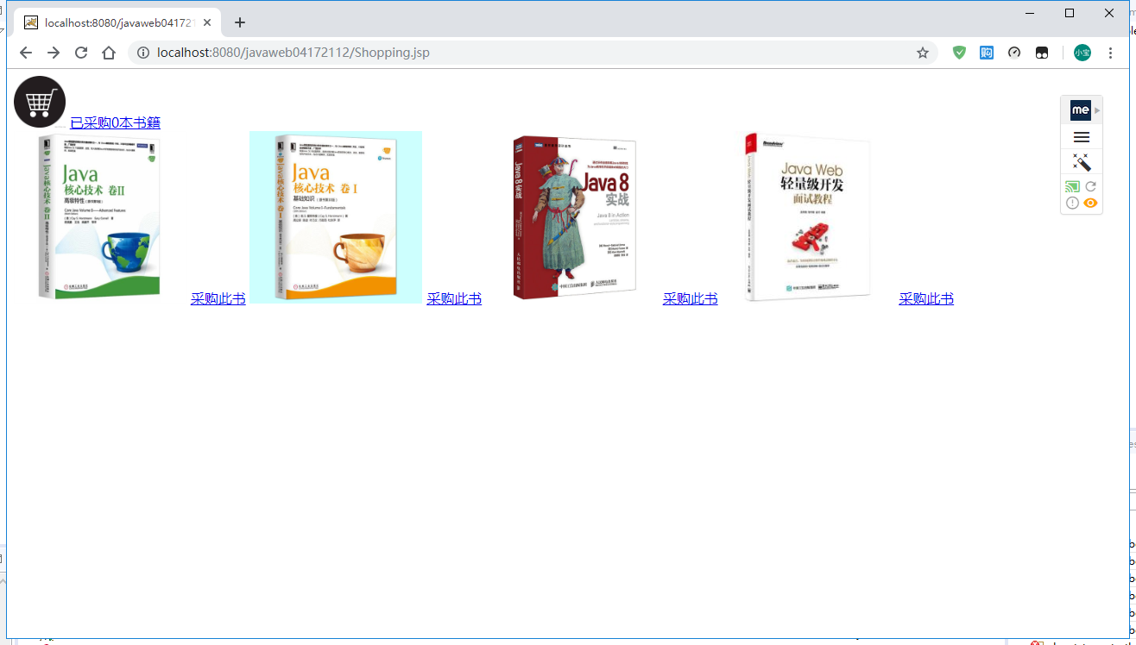

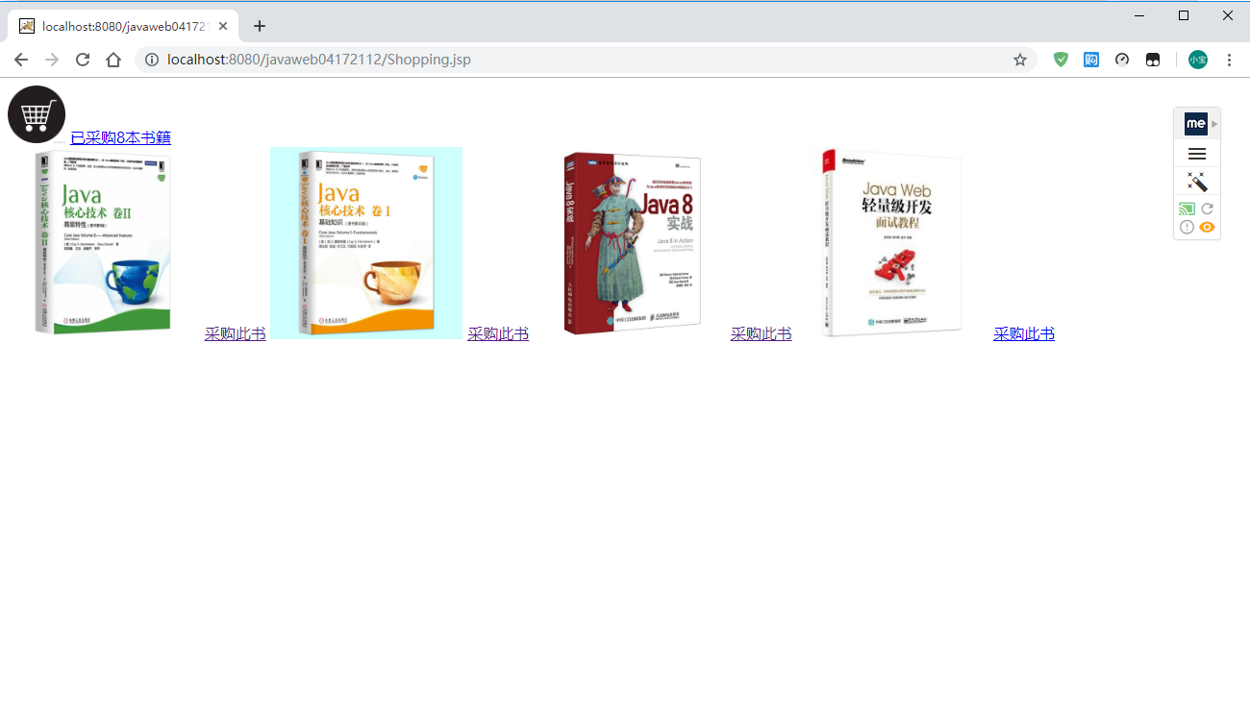

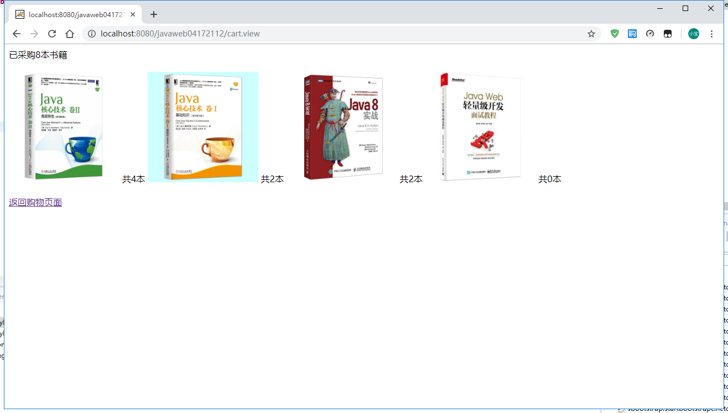

# 收获与问题

1. 1、理解会话的原理和HttpSession会话期；
2. 2、掌握如何使用URL重写；
3. 3、掌握如何使用HttpSession会话管理