**Java Web开发**

**实验五**

**作业报告**

|  |  |
| --- | --- |
| 学 院 | 计算机 |
| 所在系 班 级 | 2017软件工程系09班 |
| 学 号 姓 名 | 莫君炜 |
| 指 导 教 师 | 郭晓燕 |
| 完 成 时 间 | 2018年4月- |

# 实验题目

第四章课后练习3购物车，实现一个购物车应用程序，可以购物，显示购物数量并查看购物车内容。（此题模版test4E，提供给大家参考。）

提示：采购此书做成超链接，并用URL重写带关键信息

* 1. Shopping.view?bookID=‘0001’，其中0001是你选中图书对应的ID号，每点击一次就在相应的购书数量上加一，并返回当前的选购页面。
  2. 除了要保存图书的ID号、书名，还要保存购书数量，所以session对象保存的信息需要考虑清楚，最好是一个对象数组或列表。

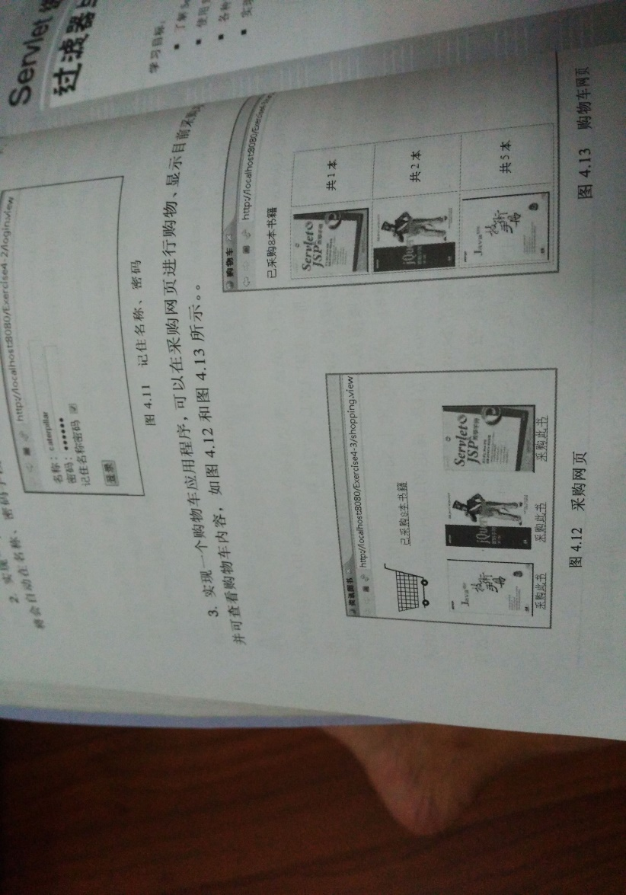

购物车的效果图

# 分析与设计

创建：

一个login.jsp-----用于用户登录

一个Book.java-----用于保存商品的基本信息和购买商品的基本信息！

一个ShopLogin.java---用于确认登录信息和创建对象初始化。

一个BuyBook.jsp---用于显示书籍在浏览器中供用户选择。

一个BookCount.java---用于找到与用户点击ID号相同的那本图书，将其购买数量＋1，同时将总本数＋1，最后将更新好的图书数组和总本数放回session对象。

一个printBook.java---用于在显示购买商品信息。

# 关键源码（部分）

Web.Xml:

<?xml version=*"1.0"* encoding=*"UTF-8"*?>

<web-app xmlns:xsi=*"http://www.w3.org/2001/XMLSchema-instance"* xmlns=*"http://xmlns.jcp.org/xml/ns/javaee"* xsi:schemaLocation=*"http://xmlns.jcp.org/xml/ns/javaee http://xmlns.jcp.org/xml/ns/javaee/web-app_3_1.xsd"* version=*"3.1"*>

<display-name>04172125MOKex4</display-name>

<servlet>

<servlet-name>ShopLogin</servlet-name>

<servlet-class>ex4.ShopLogin</servlet-class>

</servlet>

<servlet-mapping>

<servlet-name>ShopLogin</servlet-name>

<url-pattern>/shopLogin1</url-pattern>

</servlet-mapping>

<servlet>

<servlet-name>BookCount</servlet-name>

<servlet-class>ex4.BookCount</servlet-class>

</servlet>

<servlet-mapping>

<servlet-name>BookCount</servlet-name>

<url-pattern>/BookCount.view</url-pattern>

</servlet-mapping>

<servlet>

<servlet-name>shopInformation</servlet-name>

<servlet-class>ex4.printBook</servlet-class>

</servlet>

<servlet-mapping>

<servlet-name>shopInformation</servlet-name>

<url-pattern>/shopInformation</url-pattern>

</servlet-mapping>

</web-app>

Login.jsp:

<%@ page language=*"java"* import=*"java.util.*"* pageEncoding=*"UTF-8"*%>

<!DOCTYPE HTML PUBLIC "-//W3C//DTD HTML 4.01 Transitional//EN">

<html>

<head>

<title>login.jsp</title>

<meta http-equiv=*"pragma"* content=*"no-cache"*>

<meta http-equiv=*"cache-control"* content=*"no-cache"*>

<meta http-equiv=*"expires"* content=*"0"*>

<meta http-equiv=*"keywords"* content=*"keyword1,keyword2,keyword3"*>

<meta http-equiv=*"description"* content=*"This is my page"*>

<!--

<link rel="stylesheet" type="text/css" href="styles.css">

-->

</head>

<body>

<p>请输入用户名进行登录

<form action=*"*${pageContext.request.contextPath }*/shopLogin1"* method=*"post"* name=*"form"*>

<input type=*"text"* name=*"name"*>

<input type=*"submit"* value=*"提交"* name=*"submit"*>

</form>

</body>

</html>

Book.java:

**package** ex4;

**public** **class** Book {

String BookID;

String BookName;

**float** BookPrice;

**int** BookshopNum=0;

String BookURL;

**public** Book(String id,String name,**double** price,String bookurl){

**this**.BookID=id;

**this**.BookName=name;

**this**.BookPrice=(**float**)price;

**this**.BookURL=bookurl;

}

**public** String getBookID(){

**return** BookID;

}

**public** String getBookName()

{

**return** BookName;

}

**public** String getBookURL()

{

**return** BookURL;

}

**public** **float** getBookPrice()

{

**return** BookPrice;

}

**public** **void** setBookShopNum(**int** num)

{

**this**.BookshopNum=num;

}

**public** **int** getBookShopNum()

{

**return** BookshopNum;

}

}

ShopLogin.java:

package ex4;

import java.io.IOException;

import javax.servlet.ServletException;

import javax.servlet.annotation.WebServlet;

import javax.servlet.http.HttpServlet;

import javax.servlet.http.HttpServletRequest;

import javax.servlet.http.HttpServletResponse;

import javax.servlet.http.HttpSession;

public class ShopLogin extends HttpServlet {

protected void doGet(HttpServletRequest request, HttpServletResponse response) throws ServletException, IOException {

this.doPost(request, response);

}

protected void doPost(HttpServletRequest request, HttpServletResponse response) throws ServletException, IOException {

request.setCharacterEncoding("utf-8");

HttpSession session=request.getSession();

String name=request.getParameter("name");

if(name==null)

{

response.sendRedirect("login.jsp");

}

else{

session.setAttribute("customerName", name);

Book[] Book=initBook();

session.setAttribute("Book", Book);

session.setAttribute("sum", 0);

response.sendRedirect("BuyBook.jsp");

}

}

public Book[] initBook(){

Book[] Books=new Book[6];

Books[0]=new Book("0001","book1",12.33,"/image/book1.jpg");

Books[1]=new Book("0002","book2",13.44,"/image/book2.jpg");

Books[2]=new Book("0003","book3",14.55,"/image/book3.jpg");

Books[3]=new Book("0004","book4",15.66,"/image/book4.jpg");

Books[4]=new Book("0004","book4",16.77,"/image/book5.jpg");

Books[5]=new Book("0005","book5",17.88,"/image/book6.jpg");

return Books;

}

}

BuyBook.jsp:

<%@ page language=*"java"* import=*"java.util.*,ex4.Book"* pageEncoding=*"UTF-8"*%>

<!DOCTYPE HTML PUBLIC "-//W3C//DTD HTML 4.01 Transitional//EN">

<html>

<head>

<title>BuyBook.jsp</title>

<meta http-equiv=*"pragma"* content=*"no-cache"*>

<meta http-equiv=*"cache-control"* content=*"no-cache"*>

<meta http-equiv=*"expires"* content=*"0"*>

<meta http-equiv=*"keywords"* content=*"keyword1,keyword2,keyword3"*>

<meta http-equiv=*"description"* content=*"This is my page"*>

</head>

<body>

<%

String name=(String)session.getAttribute("customerName");

%>

欢迎你，<%=name%>

<p>这是书籍柜台，请选择您要购买的书籍：

<table border=*"1"*>

<%

Book[] Books=(Book[])session.getAttribute("Book");

**for**(Book book:Books)

{

%>

<tr>

<td><img src=*"*${pageContext.request.contextPath }*/*<%=book.getBookURL()%>*"* alt=*"bookurleorr"* width=*"304"* height=*"228"* ></td>

<td><a href=*'*${pageContext.request.contextPath }*/BookCount.view?id=*<%=book.getBookID()%>*'*>采购此书</a></td>

</tr>

<%

}

%>

</table><br>

<img src=*"*${pageContext.request.contextPath }*/image/shoppingcar.jpg"* alt=*"shoppingcar"* width=*"304"* height=*"228"* >

<a href=*'*${pageContext.request.contextPath }*/shopInformation'*>已经采购${sum }本书籍</a>

</body>

</html>

BookCount.java:

package ex4;

import java.io.IOException;

import javax.servlet.ServletException;

import javax.servlet.annotation.WebServlet;

import javax.servlet.http.HttpServlet;

import javax.servlet.http.HttpServletRequest;

import javax.servlet.http.HttpServletResponse;

import javax.servlet.http.HttpSession;

@WebServlet("/BookCount")

public class BookCount extends HttpServlet {

protected void doGet(HttpServletRequest request, HttpServletResponse response) throws ServletException, IOException {

doPost(request, response);

}

protected void doPost(HttpServletRequest request, HttpServletResponse response) throws ServletException, IOException {

request.setCharacterEncoding("UTF-8");

response.setContentType("text/html;charset=UTF-8");

HttpSession session=request.getSession();

Book[] BookS=(Book[])session.getAttribute("Book");

//获取选购的商品ID号

String prod=request.getParameter("id");

if(prod!=null)

{

for(int i=0;i<BookS.length;i++)

{

if(prod.equals(BookS[i].getBookID()))

{

BookS[i].setBookShopNum(BookS[i].getBookShopNum()+1);

break;

}

}

}

session.setAttribute("Book", BookS);

request.getRequestDispatcher("/shopInformation").forward(request,response);

}

}

printBook.java:

package ex4;

import java.io.IOException;

import java.io.PrintWriter;

import javax.servlet.ServletException;

import javax.servlet.annotation.WebServlet;

import javax.servlet.http.HttpServlet;

import javax.servlet.http.HttpServletRequest;

import javax.servlet.http.HttpServletResponse;

import javax.servlet.http.HttpSession;

public class printBook extends HttpServlet {

protected void doGet(HttpServletRequest request, HttpServletResponse response) throws ServletException, IOException {

doPost(request, response);

}

protected void doPost(HttpServletRequest request, HttpServletResponse response) throws ServletException, IOException {

HttpSession session=request.getSession();

PrintWriter out=response.getWriter();

int num=0;

float totalPrice=0;

out.println("<html><body>");

out.println("<p>这里是结账处，您的姓名以及选择的商品为：");

out.println("<br>你的名字："+(String)session.getAttribute("customerName"));

Book[] BookS=(Book[])session.getAttribute("Book");

for(int i=0;i<BookS.length;i++)

{

if(BookS[i].getBookShopNum()>0)

{

out.println("<br>商品："+BookS[i].getBookName()+"价格："

+BookS[i].getBookPrice()+"件数："+ BookS[i].getBookShopNum());

num=num+BookS[i].getBookShopNum();

totalPrice=totalPrice+(BookS[i].getBookPrice()*BookS[i].getBookShopNum());

}

}

response.setContentType("UTF-8");

session.setAttribute("sum", num);

out.println("<p>商品总件数价"+num+"商品总价格"+totalPrice);

out.println("<p>点击超链接，继续选购商品。");

out.println("<a href='BuyBook.jsp'> 欢迎去BOOK.JSP!</a>");

out.println("<p>点击超链接，链接到login.jsp的页面，去修改姓名。");

out.println("<a href='login.jsp'> 欢迎去LOGIN.jsp!</a>");

out.println("</font></body></html>");

}

}

# 运行效果图

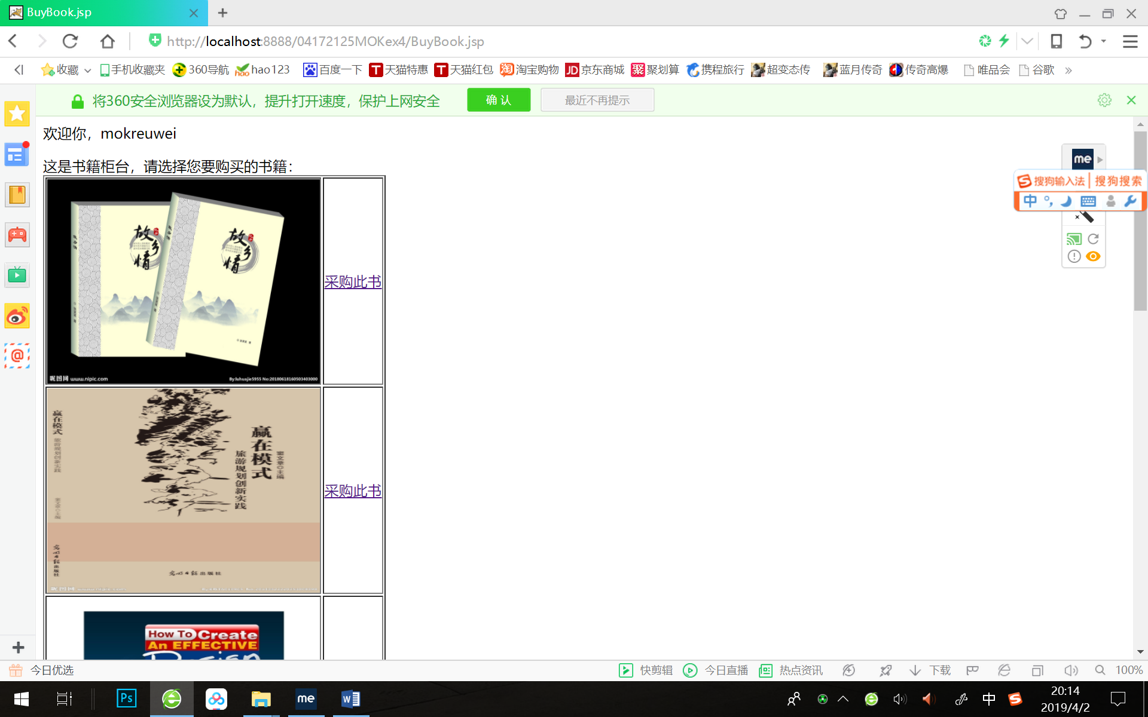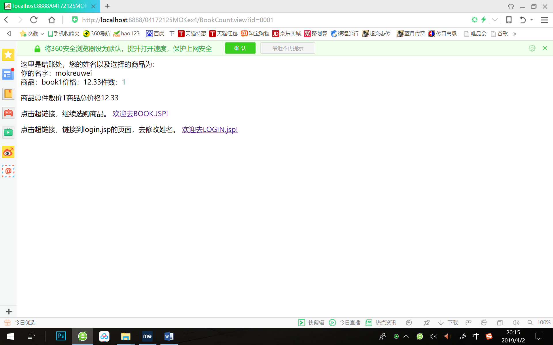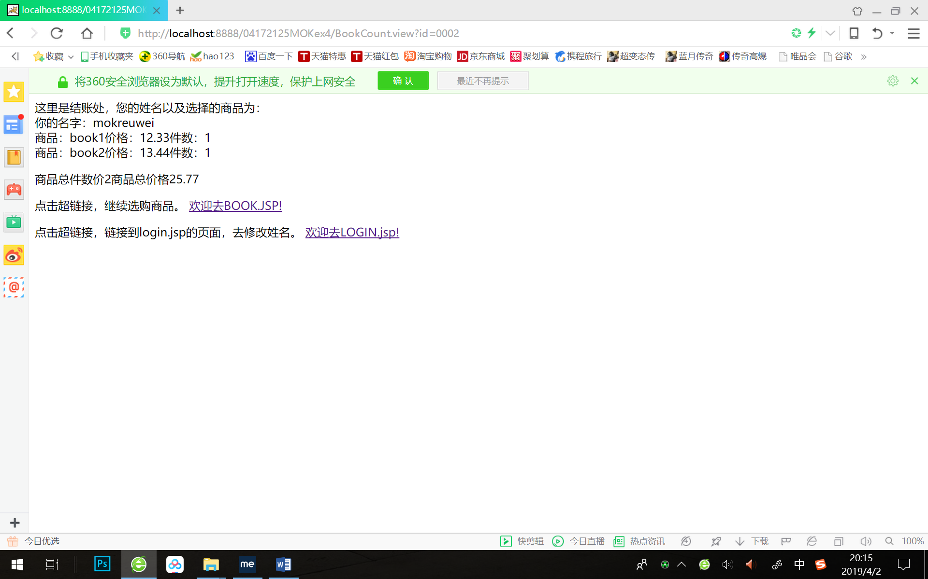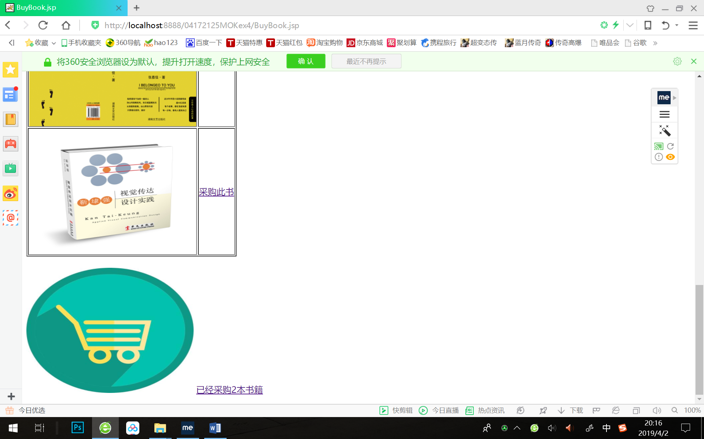

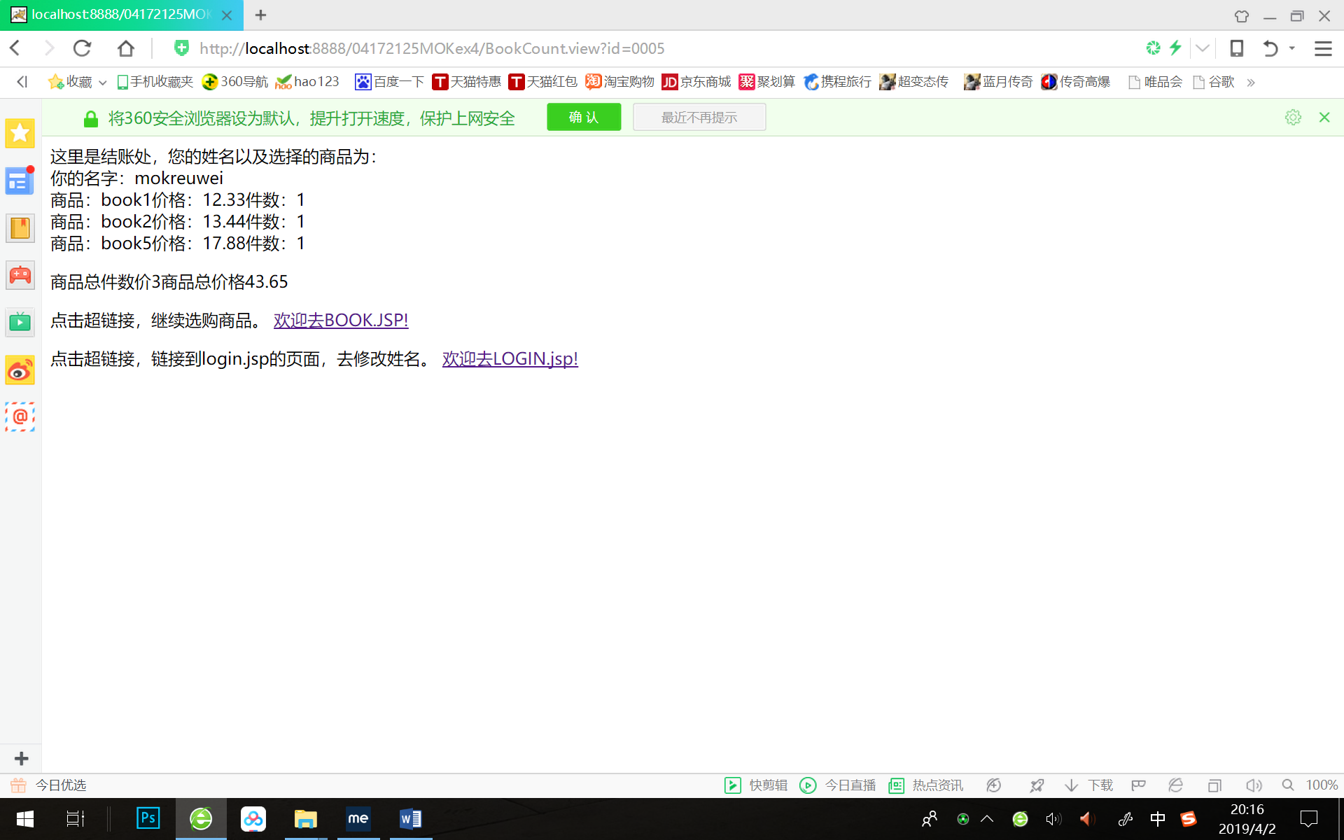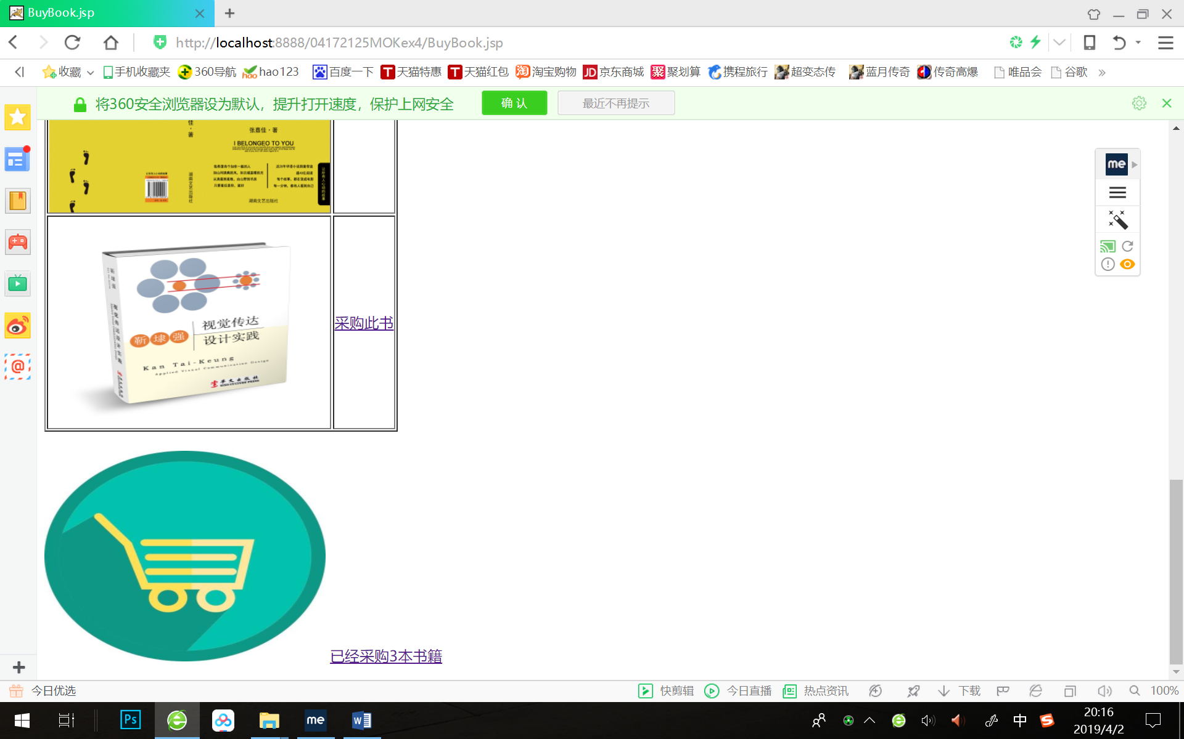

# 收获与问题

* + 1. 在jsp文件的Java语句块中要获取到一个类的对象，要使用page指令中的import属性导入那个类包才可以。
    2. 需要将更新好的图书数组和总本数重新放回session对象中，其对应的key不变即可。
    3. 在jsp中常用的有九大内置对象，其中Httpsession的对象包括在其中。其内置对象名就是session。因为jsp中的java代码块被tomcat的翻译引擎翻译为Servlet后，会放在一个_JSPService()方法中，而九大内置对象就是这个方法的一个局部变量。因此可以直接使用。