**Java Web开发**

**实验五**

**作业报告**

|  |  |
| --- | --- |
| 学院 | 计算机 |
| 所在系班级 | 2017软件工程系11班 |
| 学号姓名 | 04172208姚华仕 |
| 指导教师 | 郭晓燕 |
| 完成时间 | 2019年4月- |

# 实验题目

2、 第四章课后练习3购物车，实现一个购物车应用程序，可以购物，显示购物数量并查看购物车内容。（此题模版test4E，提供给大家参考。）

提示：采购此书做成超链接，并用URL重写带关键信息

a) Shopping.view?bookID=‘0001’，其中0001是你选中图书对应的ID号，每点击一次就在相应的购书数量上加一，并返回当前的选购页面。

b) 除了要保存图书的ID号、书名，还要保存购书数量，所以session对象保存的信息需要考虑清楚，最好是一个对象

数组或列表。

# 分析与设计

Shopping.jsp:展示购物首页面；car.jsp：展示所购买的东西的页面；

Buy_Book.java:用来定义一些属性；ShoppingServlet.java:业务处理，用来对所买的书籍进行统计；img文件夹：用来放一些图片

# 核心代码

第2题：

<%@ page language=*"java"* import=*"java.util.*"* contentType=*"text/html; charset=utf-8"*%>

<%@ page import=*"com.demo4.javaBean.*"*%>

<!DOCTYPE HTML PUBLIC "-//W3C//DTD HTML 4.01 Transitional//EN">

<html>

<head>

<title>购物车</title>

</head>

<%

**if**(session.getAttribute("books") == **null**){

//在session中存储采购信息

Buy_Book[] BookList = **new** Buy_Book[4];

BookList[0] = **new** Buy_Book("10101", "Java核心技术", "img\\10101.jpg");

BookList[1] = **new** Buy_Book("10102", "Java经典实例", "img\\10102.jpg");

BookList[2] = **new** Buy_Book("10103", "Java7", "img\\10103.jpg");

BookList[3] = **new** Buy_Book("10104", "JSP&Servlet", "img\\10104.jpg");

//存入session对象

session.setAttribute("books",BookList );

session.setAttribute("sum", 0);

}

%>

<body>

<%

Buy_Book[] books = (Buy_Book[])session.getAttribute("books");

**int** sum =(Integer)session.getAttribute("sum");

%>

<p><img src=*"img/cart.jpg"* height=*"60px"* width=*"60px"*>请选择你要采购的书籍：</p >

<a href=*"car.jsp "*>当前已采购<%=sum%>本书籍</ a>

<form action=*"/test4/shopping.view"* method=*"post"*>

<%

**if**(books != **null**){

**for**(Buy_Book book : books){

%>

<div style="float: *left*">

<img style="width:*150px* ;height:*200*" src=*"*<%=book.getImg()%>*"*><br>

<a href=*"/test4/shopping.view?id=*<%=book.getId()%>*"*>采购此书</ a>

</div>

<%}%>

<%}%>

</form>

</body>

</html>

<!DOCTYPE HTML PUBLIC "-//W3C//DTD HTML 4.01 Transitional//EN">

<html>

<head>

<%@ page language=*"java"* import=*"java.util.*"* pageEncoding=*"UTF-8"*%>

<%@page import=*"com.demo4.javaBean.*"* %>

<meta http-equiv=*"Content-Type"* content=*"text/html; charset=UTF-8"*>

<title>购物车</title>

</head>

<body>

<%

Buy_Book[] books=(Buy_Book[])session.getAttribute("books");

**int** sum=(Integer)session.getAttribute("sum");

%>

<p>以采购<%=sum%>本书籍</p>

<a href=*"Shopping.jsp"*>返回继续采购</a>

<%

**if**(books!=**null**){%>

<table>

<%**for**(Buy_Book book:books){ %>

<tr>

<td> <img height=*"60px"* width=*"60px"* src=*"*<%=book.getImg()%>*"*></td>

<td>共<%=book.getNumber()%>本</td>

</tr>

<%} %>

</table>

<%}%>

</body>

</html>

**package** com.demo4.javaBean;

**public** **class** Buy_Book {

String id,name,img;

**int** number;

**public** Buy_Book(String id,String name,String img) {

**this**.id=id;

**this**.name=name;

**this**.img=img;

**this**.number=0;

}

**public** String getId() {

**return** id;

}

**public** **void** setId(String id) {

**this**.id = id;

}

**public** String getName() {

**return** name;

}

**public** **void** setName(String name) {

**this**.name = name;

}

**public** String getImg() {

**return** img;

}

**public** **void** setImg(String img) {

**this**.img = img;

}

**public** **int** getNumber() {

**return** number;

}

**public** **void** setNumber(**int** number) {

**this**.number = number;

}

}

package com.demo4.javaBean;

import java.io.IOException;

import javax.servlet.ServletException;

import javax.servlet.annotation.WebServlet;

import javax.servlet.http.HttpServlet;

import javax.servlet.http.HttpServletRequest;

import javax.servlet.http.HttpServletResponse;

import javax.servlet.http.HttpSession;

@SuppressWarnings("serial")

@WebServlet("/shopping.view")

public class ShoppingServlet extends HttpServlet {

protected void doGet(HttpServletRequest request, HttpServletResponse response) throws ServletException, IOException {

doPost(request, response);

}

/**

* @see HttpServlet#doPost(HttpServletRequest request, HttpServletResponse response)

*/

protected void doPost(HttpServletRequest request, HttpServletResponse response) throws ServletException, IOException {

// TODO Auto-generated method stub

request.setCharacterEncoding("utf-8");

HttpSession session=request.getSession();

Buy_Book[] books=(Buy_Book[])session.getAttribute("books");

int sum=(Integer)session.getAttribute("sum");

for(Buy_Book bk:books) {

if(request.getParameter("id").equals(bk.getId())) {

bk.setNumber(bk.getNumber()+1);

}

session.setAttribute("sum", sum+1);

}

response.sendRedirect("Shopping.jsp");

}}

# 运行效果图

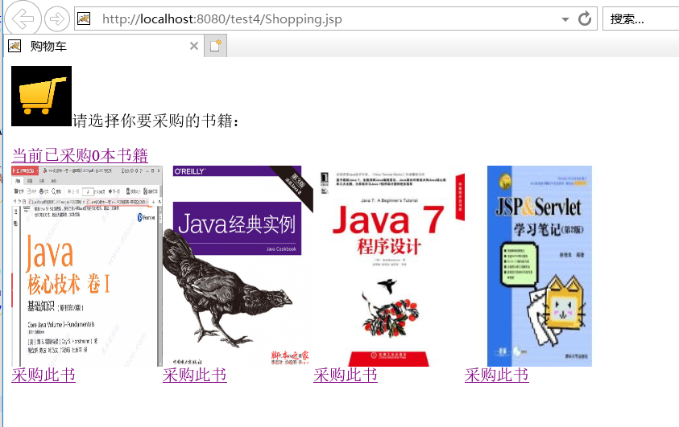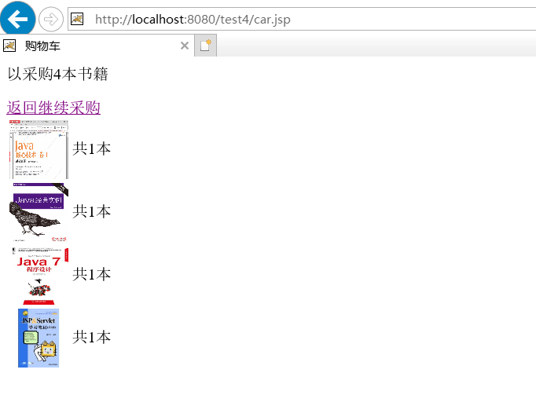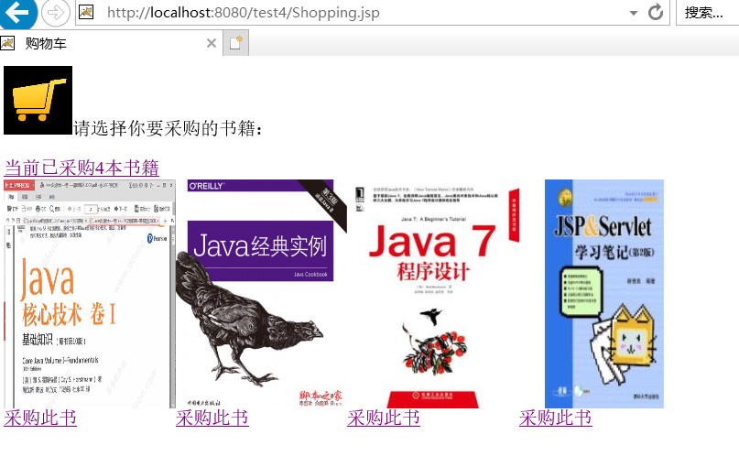

# 收获与问题

谈一谈你在本实验中所收获的内容及问题。