**Java Web开发**

**实验五**

**作业报告**

|  |  |
| --- | --- |
| 学 院 | 计算机 |
| 所在系 班 级 | 2017软件工程系11班 |
| 学 号 姓 名 | 04172505李鸿智 |
| 指 导 教 师 | 罗永升 |
| 完 成 时 间 | 2019年4月- |

# 实验题目

第四章课后练习3购物车，实现一个购物车应用程序，可以购物，显示购物数量并查看购物车内容。（此题模版test4E，提供给大家参考。）

# 分析与设计

建立三个java类。Book.java ShoppingServlet.java CardServlet.java

两个jsp页面：Shopping.jsp(购物车界面) card.jsp(统计书籍数量页面)

# 关键源码（部分）

**Book.java**

**import** java.io.Serializable;

**public** **class** Book **implements** Serializable {

**private** **static** **final** **long** *serialVersionUID* = 1L;

**private** String b_id;

**private** String b_name;

**private** String b_img;

**private** Integer b_count;

**public** Book(String b_id, String b_name, String b_img, Integer b_count) {

**super**();

**this**.b_id = b_id;

**this**.b_name = b_name;

**this**.b_img = b_img;

**this**.b_count = b_count;

}

**public** String getB_id() {

**return** b_id;

}

**public** **void** setB_id(String b_id) {

**this**.b_id = b_id;

}

**public** String getB_name() {

**return** b_name;

}

**public** **void** setB_name(String b_name) {

**this**.b_name = b_name;

}

**public** String getB_img() {

**return** b_img;

}

**public** **void** setB_img(String b_img) {

**this**.b_img = b_img;

}

**public** Integer getB_count() {

**return** b_count;

}

**public** **void** setB_count(Integer b_count) {

**this**.b_count = b_count;

}

}

**ShoppingServlet.java:**

**import** java.io.IOException;

**import** javax.servlet.ServletException;

**import** javax.servlet.http.HttpServlet;

**import** javax.servlet.http.HttpServletRequest;

**import** javax.servlet.http.HttpServletResponse;

**import** javax.servlet.http.HttpSession;

**import** com.id0304.pojo.Book;

**public** **class** ShoppingServlet **extends** HttpServlet {

**private** **static** **final** **long** *serialVersionUID* = 1L;

@Override

**protected** **void** doGet(HttpServletRequest request,

HttpServletResponse response) **throws** ServletException, IOException {

String b_id = (String) request.getParameter("b_id");

Integer allCount = 0;

Book[] books;

**if** (**null** == request.getSession().getAttribute("books")) {

books = **new** Book[3];

books[0] = **new** Book("1", "读者", "img/book1.png", 0);

books[1] = **new** Book("2", "如果一切重来", "img/book2.png", 0);

books[2] = **new** Book("3", "悲惨世界", "img/book3.png", 0);

request.getSession().setAttribute("allCount", allCount);

}**else**{

books = (Book[]) request.getSession().getAttribute(

"books");

}

allCount = (Integer) request.getSession().getAttribute("allCount");

**for** (Book book : books) {

**if** (book.getB_id().equals(b_id)) {

book.setB_count(book.getB_count() + 1);

++allCount;

}

}

request.getSession().setAttribute("books", books);

request.getSession().setAttribute("allCount", allCount);

request.getRequestDispatcher("/Shopping.jsp").forward(

request, response);

}

**public** **void** doGet(HttpServletRequest request, HttpServletResponse response,

HttpSession session) **throws** ServletException, IOException {

}

}

**CardServlet.java:**

import java.io.IOException;

import javax.servlet.ServletException;

import javax.servlet.http.HttpServlet;

import javax.servlet.http.HttpServletRequest;

import javax.servlet.http.HttpServletResponse;

public class CardServlet extends HttpServlet {

private static final long serialVersionUID = 1L;

@Override

protected void doGet(HttpServletRequest request, HttpServletResponse response)

throws ServletException, IOException {

request.getRequestDispatcher("/card.jsp").forward(request, response);

}

}

**Shopping.jsp:**

<%@ page language=*"java"* import=*"java.util.*"* pageEncoding=*"UTF-8"*%>

<%@ taglib uri=*"http://java.sun.com/jsp/jstl/core"* prefix=*"c"*%>

<%

String path = request.getContextPath();

String basePath = request.getScheme()+"://"+request.getServerName()+":"+request.getServerPort()+path+"/";

%>

<!DOCTYPE HTML PUBLIC "-//W3C//DTD HTML 4.01 Transitional//EN">

<html>

<head>

<base href=*"*<%=basePath%>*"*>

<title>My JSP 'Shopping.jsp' starting page</title>

<meta http-equiv=*"pragma"* content=*"no-cache"*>

<meta http-equiv=*"cache-control"* content=*"no-cache"*>

<meta http-equiv=*"expires"* content=*"0"*>

<meta http-equiv=*"keywords"* content=*"keyword1,keyword2,keyword3"*>

<meta http-equiv=*"description"* content=*"This is my page"*>

<!--

<link rel="stylesheet" type="text/css" href="styles.css">

-->

</head>

<body>

<div style="height:*130px*;width:*100px*;">

<table style="height:*100px*;width:*800px*;">

<tr >

<td>

<img style="height:*100px*;width:*100px*;" src=*"*${pageContext.request.contextPath}*/img/payCar.png"*>

</td>

<td >

<a href=*"*${pageContext.request.contextPath}*/card.view"*>已购买${sessionScope.allCount}本书</a>

</td>

</tr>

</table>

</div>

<div style="height:*450px*;width:*400px*;">

<table>

<tr height=*"280px"*>

<c:forEach items="${books }" var=*"book"*>

<td><img style="height:*280px*;" src=*"*${pageContext.request.contextPath}*/*${book.b_img}*"*></td>

</c:forEach>

</tr>

<tr height=*"20px"* align=*"center"*>

<c:forEach items="${books }" var=*"book"*>

<td><a href=*"*${pageContext.request.contextPath}*/shopping.view?b_id=*${book.b_id }*"*>购买</a></td>

</c:forEach>

</tr>

</table>

</div>

</body>

</html>

**card.jsp:**

<%@ page language=*"java"* import=*"java.util.*"* pageEncoding=*"UTF-8"*%>

<%@ taglib uri=*"http://java.sun.com/jsp/jstl/core"* prefix=*"c"*%>

<%

String path = request.getContextPath();

String basePath = request.getScheme()+"://"+request.getServerName()+":"+request.getServerPort()+path+"/";

%>

<!DOCTYPE HTML PUBLIC "-//W3C//DTD HTML 4.01 Transitional//EN">

<html>

<head>

<base href=*"*<%=basePath%>*"*>

<title>My JSP 'Shopping.jsp' starting page</title>

<meta http-equiv=*"pragma"* content=*"no-cache"*>

<meta http-equiv=*"cache-control"* content=*"no-cache"*>

<meta http-equiv=*"expires"* content=*"0"*>

<meta http-equiv=*"keywords"* content=*"keyword1,keyword2,keyword3"*>

<meta http-equiv=*"description"* content=*"This is my page"*>

<!--

<link rel="stylesheet" type="text/css" href="styles.css">

-->

</head>

<body>

<div style="height:*60px*;width:*150px*;">

已购买${sessionScope.allCount }本书籍<br>

<a href=*"*${pageContext.request.contextPath}*/shopping.view"*>返回</a>

</div>

<div style="height:*450px*;width:*400px*;">

<table style="height:*450px*;width:*400px*;" border=*"1px"*>

<c:forEach items="${books }" var=*"book"*>

<tr>

<td><img style="height:*150px*;" src=*"*${pageContext.request.contextPath}*/*${book.b_img}*"*></td>

<td>共${book.b_count }本</td>

</tr>

</c:forEach>

</table>

</div>

</body>

</html>

# 运行效果图

购买页面：

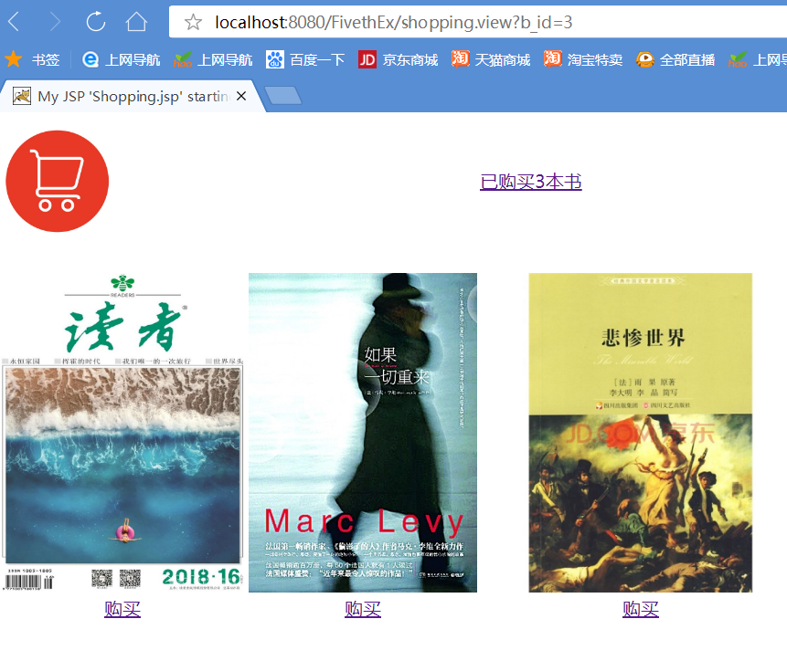

点击上方超链接可以显示购买的各本书籍的数量及总数：

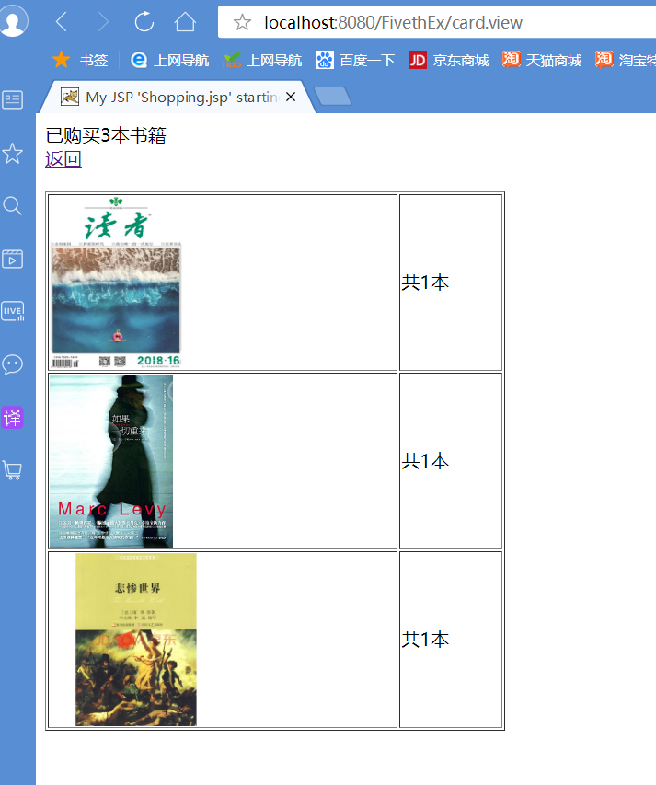

# 收获与问题