**Java Web开发**

**实验五**

**作业报告**

|  |  |
| --- | --- |
| 学 院 | 计算机 |
| 所在系 班 级 | 2017软件工程系10班 |
| 学 号 姓 名 | 06171532郭智峰 |
| 指 导 教 师 | 郭晓燕 |
| 完 成 时 间 | 2018年4月-25 |

# 实验题目

实现一个购物车应用程序，可以购物，显示购物数量并查看购物车内容。（此题模版test4E，提供给大家参考。）

提示：采购此书做成超链接，并用URL重写带关键信息

a) Shopping.view?bookID=‘0001’，其中0001是你选中图书对应的ID号，每点击一次就在相应的购书数量上加一，并返回当前的选购页面。

b) 除了要保存图书的ID号、书名，还要保存购书数量，所以session对象保存的信息需要考虑清楚，最好是一个对象

# 分析与设计

利用javabean和sessions来存放数组对象放置书本数据，实现购买图书

# 关键源码（部分）

<%@ page language="java" contentType="text/html; charset=UTF-8"

pageEncoding="UTF-8" import="com.juice.Book"%>

<!DOCTYPE html>

<html>

<%

if(session.getAttribute("bookList")==null){

Book[] BookList = new Book[4];

BookList[0] = new Book("10101","java核心技术","img/10101.jpg",50);

BookList[1] = new Book("10102","java经典实例","img/10102.jpg",40);

BookList[2] = new Book("10103","java7","img/10103.jpg",30);

BookList[3] = new Book("10104","java&servlet","img/10104.jpg",60);

session.setAttribute("bookList", BookList);

session.setAttribute("sum", 0);

}

%>

<head>

<meta charset="UTF-8">

<title>书城</title>

</head>

<body>

<img src="img/cart.jpg" height="60px" width="60px">

<a href="cart.view">已采购<%=session.getAttribute("sum") %>本书</a><br>

<br>

<table border="1">

<%

Book[] BookList = (Book[])session.getAttribute("bookList");

for(Book book:BookList){

out.println("<tr>");

out.println("<td> <img src="+book.getImg()+"> </td>");

out.println("<td>"+book.getName()+"</td>");

out.println("<td><a href='http://localhost:8080"+request.getContextPath()+"/shopping.view?id="+book.getID()+"''>购买</td>");

out.println("</tr>");

}

%>

</body>

</html>

@WebServlet("/shopping.view")

public class ShoppingServlet extends HttpServlet {

protected void doGet(HttpServletRequest request, HttpServletResponse response)

throws ServletException, IOException {

response.setHeader("content-type", "text/html;charset=utf-8");

HttpSession session = request.getSession();

String id = request.getParameter("id");

PrintWriter writer = response.getWriter();

Book[] BookList = (Book[])session.getAttribute("bookList");

int sum = (int) session.getAttribute("sum");

sum++;

session.setAttribute("sum", sum);

for(int i=0;i<BookList.length;i++) {

if(BookList[i].getID().equals(id)) {

BookList[i].setNum(BookList[i].getNum()+1);

writer.println("价格："+BookList[i].getPrize());

}

}

session.setAttribute("bookList", BookList);

writer.println("<br><a href='http://localhost:8080/ShopCar/Shoping.jsp'>加入购物车");

}

@WebServlet("/cart.view")

public class CarServlet extends HttpServlet {

protected void doGet(HttpServletRequest request, HttpServletResponse response)

throws ServletException, IOException {

response.setHeader("content-type", "text/html;charset=utf-8");

HttpSession session = request.getSession();

PrintWriter writer = response.getWriter();

String id = request.getParameter("id");

Book[] BookList = (Book[])session.getAttribute("bookList");

float totalPrice = 0;

writer.println("<table border=1>");

for(int i=0;i<BookList.length;i++) {

if(BookList[i].getNum()>0) {

writer.println("<html>");

writer.println("<body>");

writer.println("<tr>");

writer.println("<td> <img src="+BookList[i].getImg()+"> </td>");

writer.println("<td>商品："+BookList[i].getName()+"</td>");

writer.println("<td>价格："+BookList[i].getPrize()+"</td>");

writer.println("<td>本数："+BookList[i].getNum()+"</td>");

totalPrice = totalPrice + BookList[i].getPrize()*BookList[i].getNum();

writer.println("</tr>");

writer.println("</body>");

writer.println("</html>");

}

}

writer.println("<br>总价："+totalPrice);

writer.println("<br><a href='http://localhost:8080/ShopCar/Shoping.jsp'>返回商城");

}

# 运行效果图

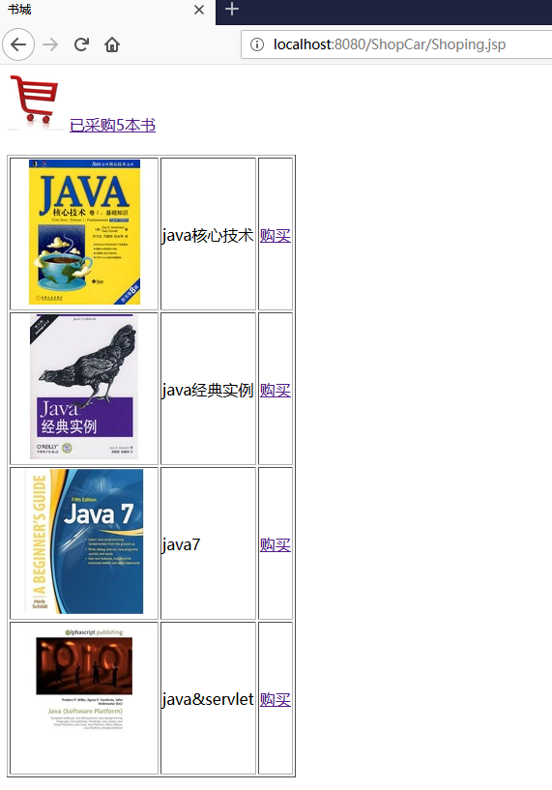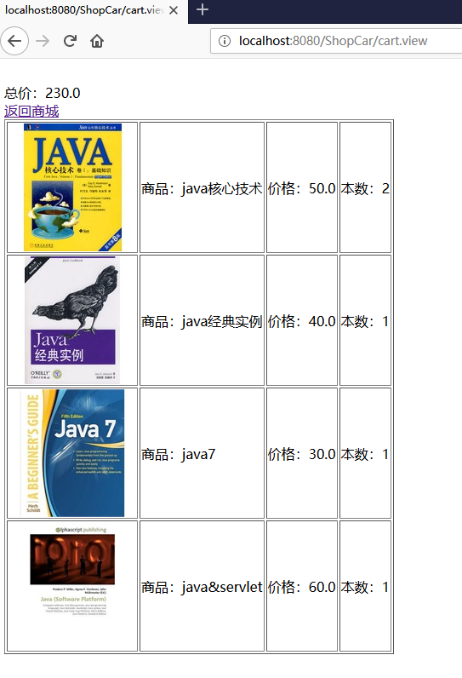

# 收获与问题

学会了使用session来存放数组对象，使用javabean来定义规范数据，方便调用各种所需属性。