**Java Web开发**

**实验五**

**作业报告**

|  |  |
| --- | --- |
| 学 院 | 计算机 |
| 所在系 班 级 | 2017软件工程系11班 |
| 学 号 姓 名 | 13170829 秦浩瀚 |
| 指 导 教 师 | 郭晓燕 |
| 完 成 时 间 | 2018年4月13号 |

# 实验题目

实验内容：

1、 练习老师在理论课上演示的购物车实例，理解购物功能如何实现，理解如何利用session对象保存购物信息，如何设计封装数据类。（请参考“第四章会话管理课上的购物车实例代码.docx”文档）；

如果上课听懂了购物车的原理或者部分理解，可以参考我的实例完成第2题，此题可忽略不写。

2、 第四章课后练习3购物车，实现一个购物车应用程序，可以购物，显示购物数量并查看购物车内容。（此题模版test4E，提供给大家参考。）

提示：采购此书做成超链接，并用URL重写带关键信息

a) Shopping.view?bookID=‘0001’，其中0001是你选中图书对应的ID号，每点击一次就在相应的购书数量上加一，并返回当前的选购页面。

b) 除了要保存图书的ID号、书名，还要保存购书数量，所以session对象保存的信息需要考虑清楚，最好是一个对象

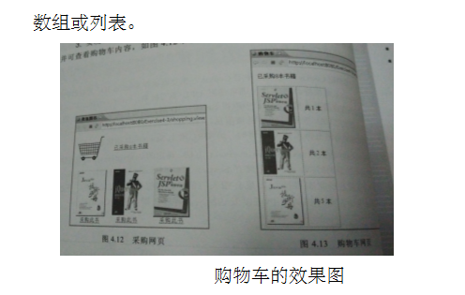

3、 对第三章动态验证码程序实现动态验证。（选做）

提示：在生成动态验证码的同时将其放入HttpSession对象中，在网页上提取出来进行比对。

# 分析与设计

Shopping.jsp、Book.java、 Shoppingservlet、CarServlet.java

# 关键源码（部分）

Shopping.jsp

<%@ page language=*"java"* import=*"ex1.Book,javax.servlet.http.HttpSession"* pageEncoding=*"UTF-8"*%>

<!DOCTYPE HTML PUBLIC "-//W3C//DTD HTML 4.01 Transitional//EN">

<head>

<title>我的购物车</title>

</head>

<html>

<%

**if**(session.getAttribute("bookList")==**null**)

{

Book[] bookList = **new** Book[4];

bookList[0]=**new** Book("10101","Java程序设计基础"," 10101.jpg",0);

bookList[1]=**new** Book("10102","Java面向对象编程"," 10102.jpg",0);

bookList[2]=**new** Book("10103","Java特种兵"," 10103.jpg",0);

bookList[3]=**new** Book("10104","Javaweb入门到精通"," 10104.jpg",0);

session.setAttribute("bookList",bookList);

session.setAttribute("sum",0);

}

%>

<body>

=<img src=*"img/cart.jpg"* height=*"60px"* width=*"60px"*>

<a href=*"cart.view"*>已采购<%=session.getAttribute("sum") %>本书籍</a></br>

<br>

<table border=*"1"*></table>

<%

Book[] bookList=(Book[])session.getAttribute("bookList");

**for** (Book book:bookList){

out.println("<tr>");

out.println("<td> <img src='"+book.getBookImg()+"'height='200px'" + "width='200px'" + "></td>");

out.println("<td> <a href='shopping.view?id="+book.getBookId()+"'>采购此书</a></td>");

out.println("</tr>");

}

%>

</body>

</html>

Book.java

**package** ex1;

**public** **class** Book {

String ID;

String Name;

String imageUrl;

**double** price;

**int** Num;

**public** Book(String iD, String name, String imageUrl, **int** num) {

ID = iD;

Name = name;

**this**.imageUrl = imageUrl;

Num = num;

}

**public** String getBookId() {

**return** ID;

}

**public** **void** setID(String iD) {

ID = iD;

}

**public** String getName() {

**return** Name;

}

**public** **void** setName(String name) {

Name = name;

}

**public** String getBookImg() {

**return** imageUrl;

}

**public** **void** setImageUrl(String imageUrl) {

**this**.imageUrl = imageUrl;

}

**public** **int** getNum() {

**return** Num;

}

**public** **void** setNum(**int** num) {

Num = num;

}

**public** **double** getPrice() {

**return** price;

}

**public** **void** setPrice(**double** price) {

**this**.price = price;

}

}

ShoppingServlet.java

package ex1;

import java.io.IOException;

import java.io.PrintWriter;

import javax.servlet.ServletException;

import javax.servlet.http.HttpServlet;

import javax.servlet.http.HttpSession;

import javax.servlet.http.HttpServletRequest;

import javax.servlet.http.HttpServletResponse;

public class shoppingservlet extends HttpServlet {

public void doGet(HttpServletRequest request, HttpServletResponse response)

throws ServletException, IOException {

doPost(request,response);

}

public void doPost(HttpServletRequest request, HttpServletResponse response)

throws ServletException, IOException {

response.setContentType("text/html;charset=utf-8");

HttpSession session=request.getSession();

request.setCharacterEncoding("utf-8");

double price=0,totalPrice=0,num=0;

String id = request.getParameter("id");

Book[] bookList=(Book[])session.getAttribute("bookList");

int[] nums = new int[4];

for (int i = 0; i < bookList.length; i++) {

nums[i] = bookList[i].getNum();

if (id.equals(bookList[i].getBookId())) {

nums[i]++;

}

bookList[i].setNum(nums[i]);

}

int sum = 0;

for (int i = 0; i < bookList.length; i++) {

nums[i] = bookList[i].getNum();

sum = nums[i] + sum;

session.setAttribute("sum", sum);

}

response.sendRedirect("shopping.jsp");

}

/* private void printBook(HttpServletRequest request,HttpServletResponse response)throws IOException{

// TODO Auto-generated method stub

HttpSession session=request.getSession();

PrintWriter out=response.getWriter();

int num=0;

double totalPrice=0;

out.println("<html><body><font Size=8>");

out.println("<p>这里是结账处，您的姓名以及选择的商品：</p>");

out.println("<br>您的姓名："+(String)session.getAttribute("customerName"));

Book[] bookList=(Book[])session.getAttribute("bookList");

for(int i=0;i<bookList.length;i++){

if(bookList[i].getNum()>0){

out.println("<br>商品: "+bookList[i].getName()+"价格： "+bookList[i].getPrice()+"件数"+bookList[i].getNum());

num=num+bookList[i].getNum();

totalPrice=totalPrice+(bookList[i].getPrice()*bookList[i].getNum());

}

}

out.println("<p>商品总件数价"+num+"商品总价格"+totalPrice);

out.println("<p>点击链接,继续选购商品: ");

out.println("<a href=shopping.jsp>欢迎去选购页面</a>");

out.println("<p>点击链接,去登陆页面修改姓名: ");

out.println("<a href=main.jsp>欢迎去登陆页面</a>");

out.println("</front></body></html>");

}

*/

}

Carservlet.java

package ex1;

import java.io.IOException;

import java.io.PrintWriter;

import javax.servlet.ServletException;

import javax.servlet.annotation.WebServlet;

import javax.servlet.http.HttpServlet;

import javax.servlet.http.HttpServletRequest;

import javax.servlet.http.HttpServletResponse;

import javax.servlet.http.HttpSession;

public class Cartservlet extends HttpServlet {

public void doGet(HttpServletRequest request, HttpServletResponse response) throws ServletException, IOException {

doPost(request, response);

}

public void doPost(HttpServletRequest request, HttpServletResponse response) throws ServletException, IOException {

response.setContentType("text/html;charset=utf-8");

response.setCharacterEncoding("UTF-8");

HttpSession session = request.getSession();

Book[] bookList = (Book[]) session.getAttribute("bookList");

PrintWriter out = response.getWriter();

for (Book book : bookList) {

out.print("<tr>");

out.print("<td> <img src ='" + book.getBookImg() + "'height='200px'" + "width='200px'" + "></td>");

out.print("<td> 共" + book.getNum() + "本</td>");

out.print("</tr>");

}

}

}

}

# 运行效果图

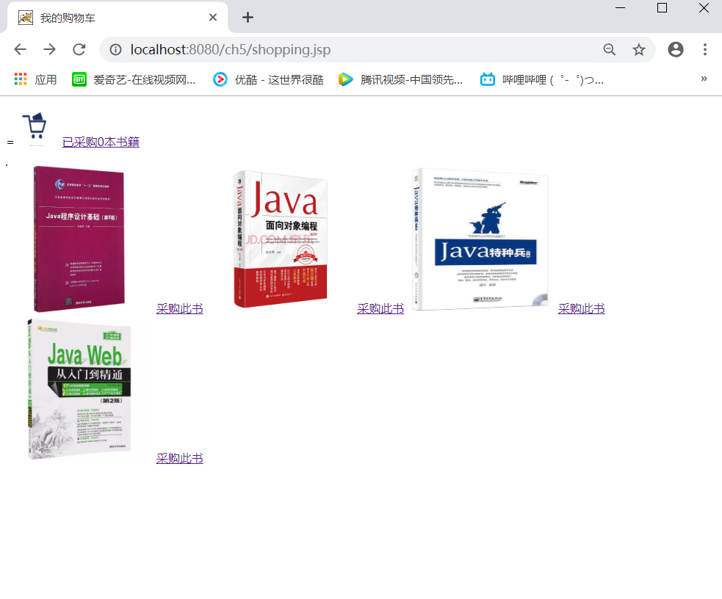

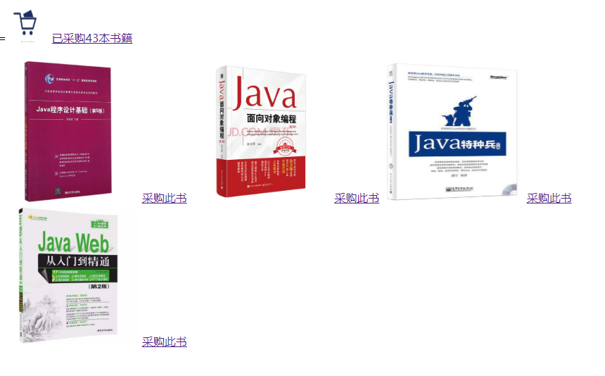

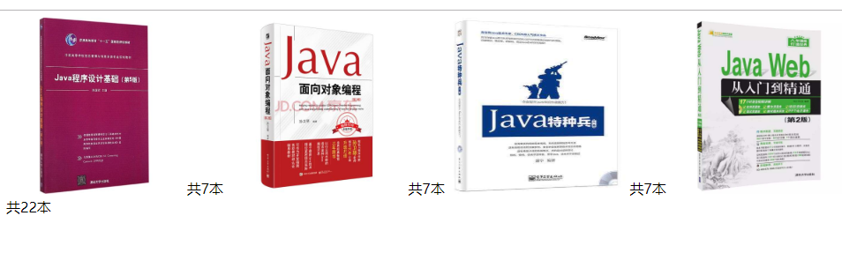

# 收获与问题

1. 1、理解会话的原理和HttpSession会话期；
2. 2、掌握如何使用URL重写；
3. 3、掌握如何使用HttpSession会话管理