**Java Web开发**

**实验六**

**作业报告**

|  |  |
| --- | --- |
| 学 院 | 计算机 |
| 所在系 班 级 | 2017软件工程系09班 |
| 学 号 姓 名 | 03171314庄烈辉 |
| 指 导 教 师 | 郭晓燕 |
| 完 成 时 间 | 2019年 |

# 实验题目

将题目贴上去

# 分析与设计

Book类存储图书信息

Shopping.jsp购物页面

shoppingServelt处理添加购物车

deleteServlet处理删除已加入购物车的商品

shoppingCar.jsp购物车页面

# 关键源码（部分）

**Book类**

**public** **class** Book {

**private** String name ; //书名

**private** **int** number; //数量

**private** String id; //id

**private** **int** price; //价格

**private** String imgPath;//图片路径

**private** String bookPath;//详细页面路径

**public** Book(String id,String name,**int** price,**int** number,String imgPath,String bookPath){

**this**.id = id;

**this**.name = name;

**this**.price = price;

**this**.number = number;

**this**.imgPath = imgPath;

**this**.bookPath = bookPath;

Shopping.jsp 购物页面：

<body>

<%

**if**(session.getAttribute("bookList")==**null**){

Book[] BookList = **new** Book[4];

BookList[0] = **new** Book("1","中国近代史纲要",20,0,"img/005.jpg","book1.jsp");

BookList[1] = **new** Book("2","大英2",30,0,"img/002.jpg","book2.jsp");

BookList[2] = **new** Book("3","jsp&servlet",50,0,"img/003.jpg","book3.jsp");

BookList[3] = **new** Book("4","java从入门到精通",30,0,"img/004.jpg","book4.jsp");

session.setAttribute("bookList", BookList);

session.setAttribute("sum", 0);

}

%>

<table>

<tr>

<td colspan=*"2"*>购物页面</td>

<td colspan=*"2"* align=*"right"*><a href=*"shoppingCar.jsp"*>查看购物车</a></td>

</tr>

<%

Book[] bookList = (Book[])session.getAttribute("bookList");

out.println("<tr>");

**for**(Book book:bookList)

{

out.println("<td>");

out.println("<a href=\""+book.getBookPath()+"\">");

out.println("<img src=\""+book.getImgPath()+"\" height=\"350\" width=\"350\"/>");

out.println("</a>");

out.println("</td>");

}

out.println("</tr>");

out.println("<tr>");

**for**(Book book:bookList)

{

out.println("<td align=\"center\">");

out.println("<a href=\"http://localhost:8080/test5/servlet/ShoppingServlet?id="+book.getId()+"\">加入购物车</a>");

out.println("</td>");

}

out.println("</tr>");

%>

</table>

shoppingServlet.java 处理添加购物车

**public** **void** doGet(HttpServletRequest request, HttpServletResponse response) **throws** ServletException, IOException {

response.setContentType("text/html;charset=utf-8");

PrintWriter out = response.getWriter();

String id = request.getParameter("id");

Book[] bookList = (Book[])request.getSession().getAttribute("bookList");

**int** sum = (**int**)request.getSession().getAttribute("sum");

**for**(Book book:bookList)

{

**if**(book.getId().equals(id))

{

book.setNumber(book.getNumber()+1);

sum += book.getPrice();

}

}

request.getSession().setAttribute("bookList", bookList);

request.getSession().setAttribute("sum", sum);

//request.getRequestDispatcher("/Shopping.jsp").forward(request, response);

out.println("<html>");

out.println("<body>");

out.println("<h1>加入购物车成功</h1>");

out.println("<a href=\"http://localhost:8080/test5/Shopping.jsp\">回到首页</a><br>");

out.println("<a href=\"http://localhost:8080/test5/shoppingCar.jsp\">查看购物车</a><br>");

out.println("<html>");

out.println("</body>");

out.println("</html>");

shoppingCar.jsp 购物车页面

<table>

<tr>

<td align=*"center"*>图片</td>

<td width=*"250"*>书籍名称</td>

<td width=*"250"*>单价</td>

<td width=*"250"*>数量</td>

</tr>

<%

Book[] bookList = (Book[])session.getAttribute("bookList");

**int** sum = (**int**)session.getAttribute("sum");

**if**(sum!=0)

{

**for**(Book book:bookList)

{

**if**(book.getNumber()!=0)

{

out.println("<tr>");

out.print("<td>");

out.println("<img src=\""+book.getImgPath()+"\" height=\"200\" width=\"200\"/>");

out.println("</td>");

out.print("<td>");

out.print(book.getName());

out.println("</td>");

out.print("<td>");

out.print(book.getPrice());

out.println("</td>");

out.print("<td>");

out.print(book.getNumber());

out.println("</td>");

out.print("<td>");

out.print("<a href=\"http://localhost:8080/test5/servlet/deleteServlet?id="+book.getId()+"\">删除</a>");

out.println("</td>");

out.println("</tr>");

}

}

out.println("<tr>");

out.println("<td align=\"right\" colspan=\"4\">");

out.println("合计:"+sum);

out.println("</td>");

out.println("</tr>");

}

**else**

{

out.println("<tr>");

out.println("<th align=\"center\" colspan=\"4\">");

out.println("购物车为空");

out.println("</th>");

out.println("</tr>");

out.println("<tr>");

out.println("<th align=\"center\" colspan=\"4\">");

out.println("<a href=\"http://localhost:8080/test5/Shopping.jsp\">回到首页</a><br>");

out.println("</th>");

out.println("</tr>");

}

out.println("</table>");

%>

deleteServlet.java 删除已加入购物车的商品

response.setContentType("text/html;charset=utf-8");

PrintWriter out = response.getWriter();

String id = request.getParameter("id");

Book[] bookList = (Book[])request.getSession().getAttribute("bookList");

**int** sum = (**int**)request.getSession().getAttribute("sum");

**for**(Book book:bookList)

{

**if**(book.getId().equals(id))

{

sum-=(book.getPrice()*book.getNumber());

book.setNumber(0);

}

}

request.getSession().setAttribute("bookList", bookList);

request.getSession().setAttribute("sum", sum);

request.getRequestDispatcher("/shoppingCar.jsp").forward(request, response);

# }运行效果图

实验在浏览器下运行的结果截图，并进行解释。.

进入到购物车页面：

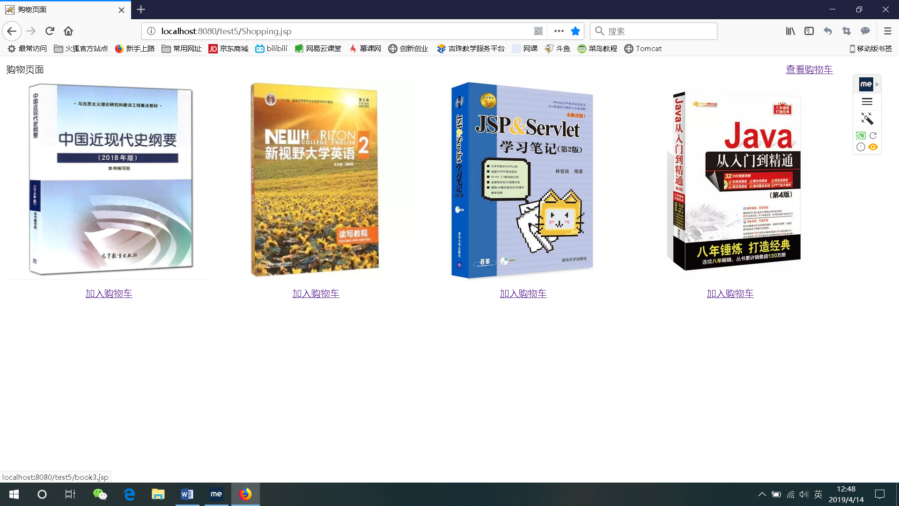

点击第一个图片进入详细页面：

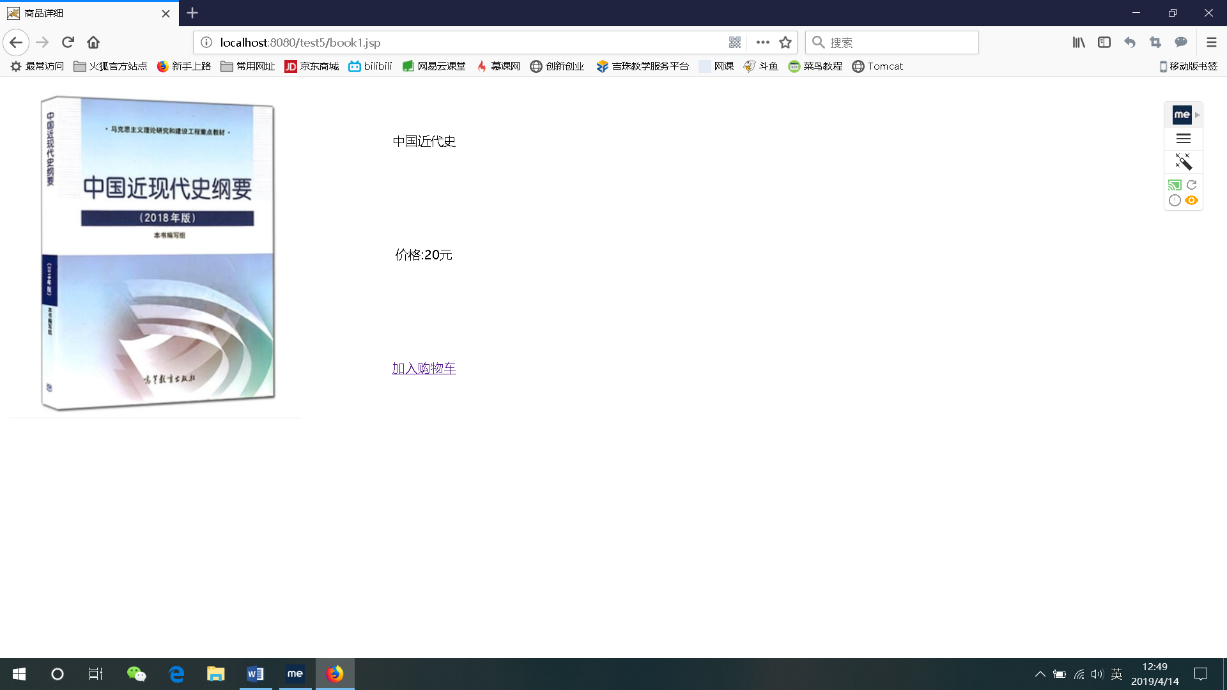

点击加入购物车：

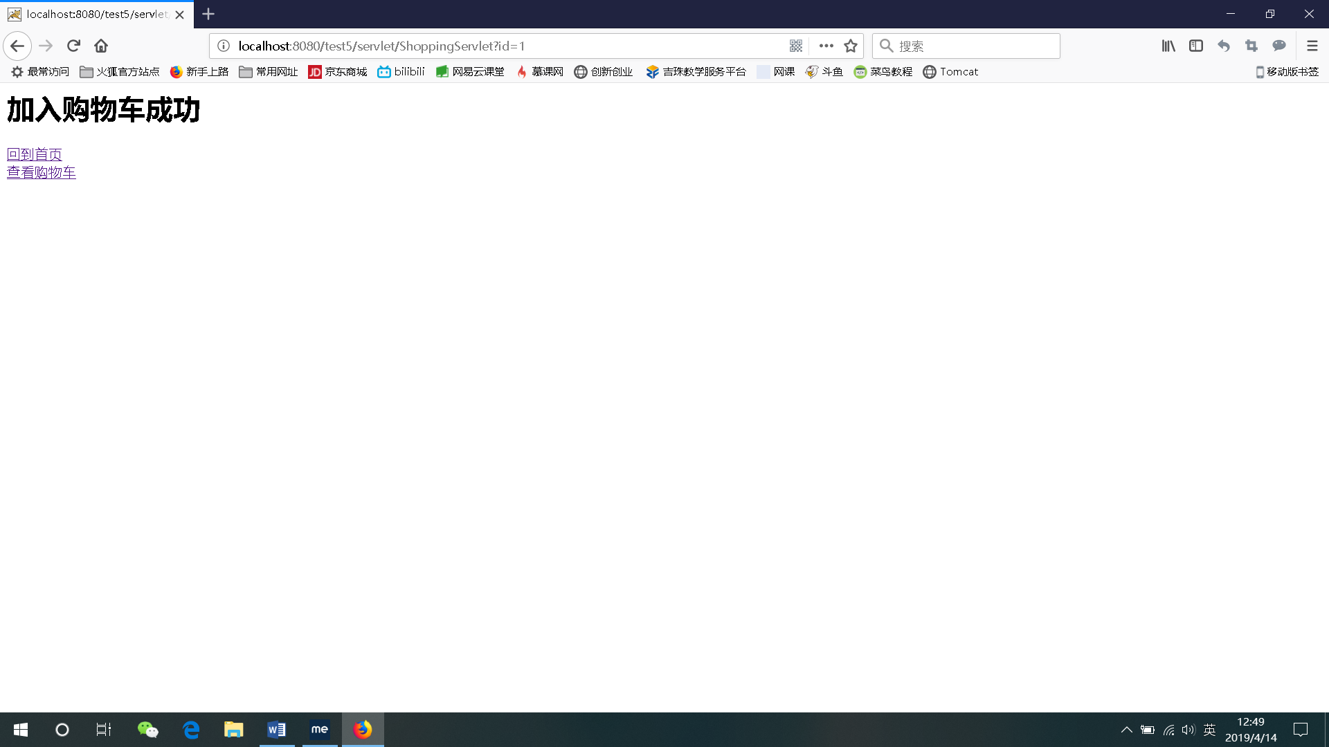

查看购物车：

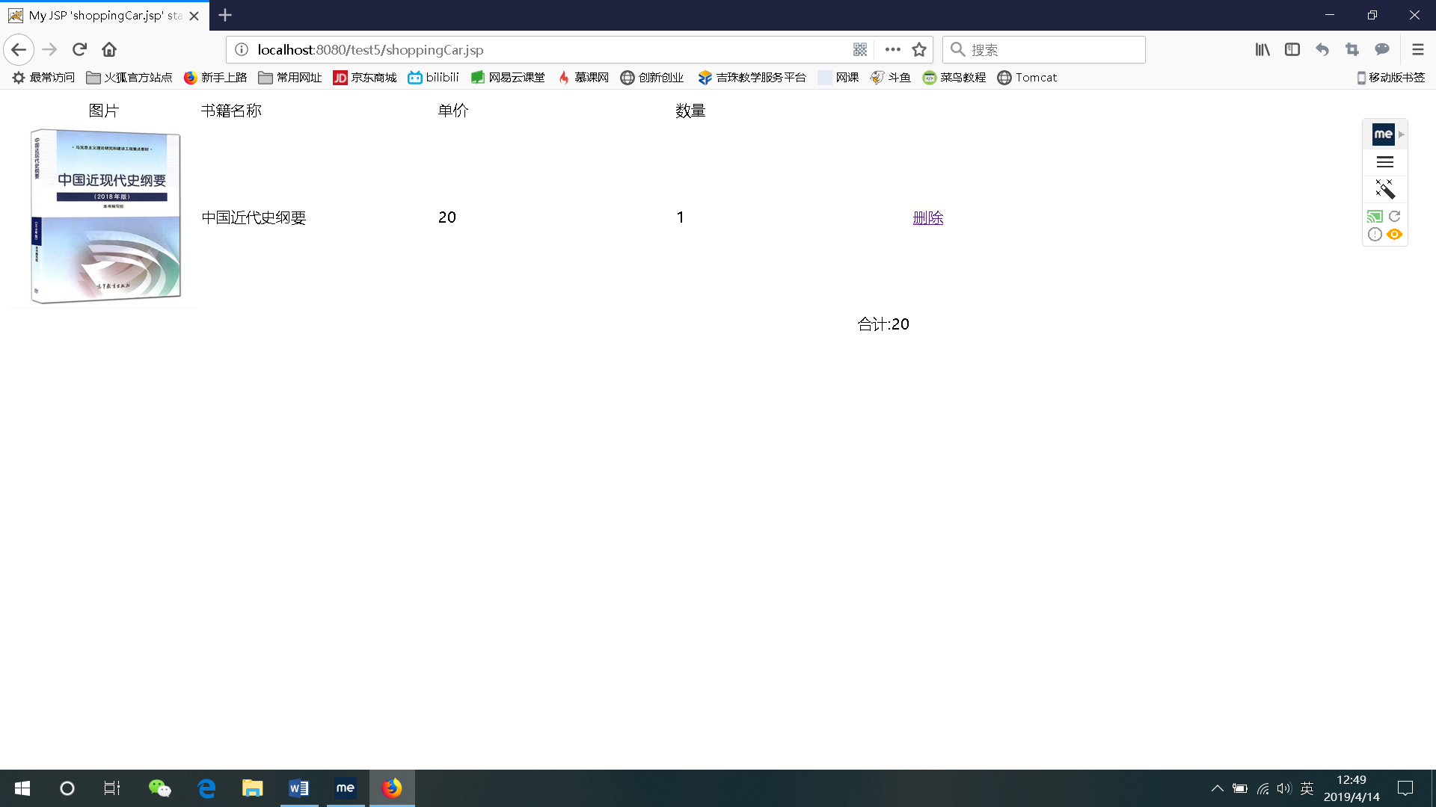

点击删除按钮：

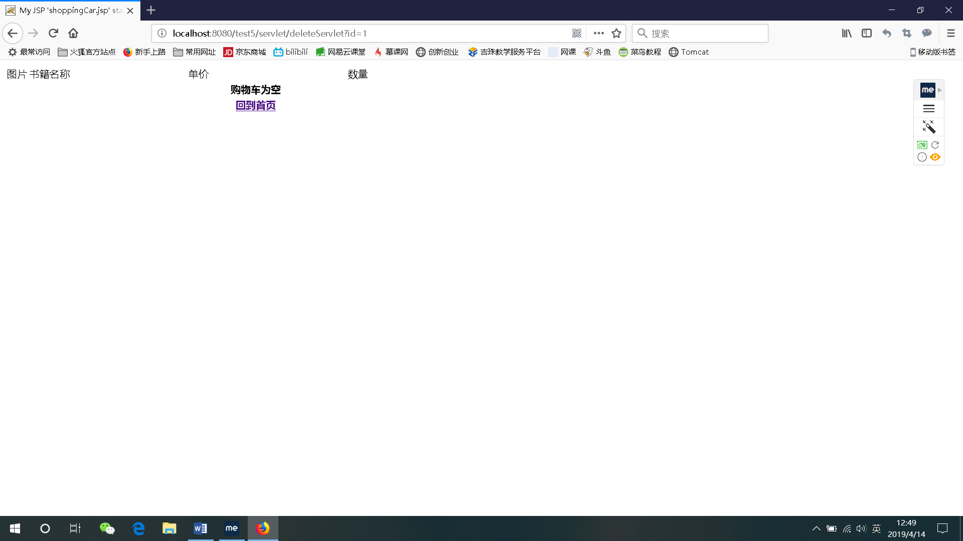

# 收获与问题

谈一谈你在本实验中所收获的内容及问题。