**Java Web开发**

**实验六**

**作业报告**

|  |  |
| --- | --- |
| 学 院 | 计算机 |
| 所在系 班 级 | 2017软件工程系10班 |
| 学 号 姓 名 | 04172112 宋振文 |
| 指 导 教 师 | 郭晓燕 |
| 完 成 时 间 | 2018年4月11号 |

# 实验题目

1、上周没有完成作业的同学请继续完成，完成了作业的同学请为购物车增加功能：

2、参考成熟的购物系统，为购物车增加功能，完善购物车：删除商品，查看商品具体信息，计算商品总价，修改商品购买件数等等。界面尽量美观。

提示：Java文件即Book.java的设计需要重构，需要分离商品基本信息和购买信息，需要有类分别来保存单件商品的购买信息和所有商品的购买信息。所以至少要三个Java类才能完成购物的基本功能。

Servlet也需要响应更多的操作，可以在一个Servlet中也可以分多个文件响应。并在适当的地方调用Java方法。

# 分析与设计

五个文件：：删除商品，查看商品具体信息，计算商品总价，修改商品购买件数等等。界面尽量美观。

# 关键源码（部分）

Shopping.jsp

<%@ page language=*"java"* import=*"java.util.*"* pageEncoding=*"UTF-8"*%>

<%@ page import=*"Car.Book"* %>

<!DOCTYPE HTML PUBLIC "-//W3C//DTD HTML 4.01 Transitional//EN">

<html>

<%

**if**(session.getAttribute("bookList")==**null**){

Book[] BookList =**new** Book[4];

BookList[0]=**new** Book("10101","java核心技术","img\\10101.jpg",0);

BookList[1]=**new** Book("10102","java经典实例","img\\10102.jpg",0);

BookList[2]=**new** Book("10103","java7","img\\10103.jpg",0);

BookList[3]=**new** Book("10104","JSP&Servlet","img\\10104.jpg",0);

session.setAttribute("bookList", BookList);

session.setAttribute("sum", 0);

}

%>

<head>

<meta charset=*"utf-8"*>

<title>Bootstrap 实例 - 按钮选项</title>

<link rel=*"stylesheet"* href=*"https://cdn.staticfile.org/twitter-bootstrap/3.3.7/css/bootstrap.min.css"*>

<script src=*"https://cdn.staticfile.org/jquery/2.1.1/jquery.min.js"*></script>

<script src=*"https://cdn.staticfile.org/twitter-bootstrap/3.3.7/js/bootstrap.min.js"*></script>

</head>

<body>

<img src=*"img/cart.jpg"* height=*"60px"* width=*"60px"*>

<% out.print("<td> <a href='Car.jsp'>"+"<button type='button' class='btn btn-primary'>已采购"+session.getAttribute("sum")+"本书籍</button></a></td>"); %>

<a href=*"goods.view"*><button type=*"button"* class=*"btn btn-primary"*>商品设置</button></a>

<br>

<tale border =*1*>

<%

Book[] bookList=(Book[])session.getAttribute("bookList");

**for**(Book book:bookList){

out.print("<tr>");

out.print("<td> <img src ='"+book.getBookImg()+"'height='200px'"+"width='200px'"+"></td>");

out.print("<td> <a href='shopping.view?id="+book.getBookId()+"'><button type='button' class='btn btn-primary'>采购此书</button></a></td><br>");

out.print("</tr>");

} %>

</tale>

</body>

</html>

Car.jsp

<%@ page language=*"java"* import=*"java.util.*"* pageEncoding=*"UTF-8"*%>

<%@ page import=*"Car.Book"* %>

<!DOCTYPE HTML PUBLIC "-//W3C//DTD HTML 4.01 Transitional//EN">

<html>

<head>

<meta charset=*"utf-8"*>

<title>Bootstrap 实例 - 按钮选项</title>

<link rel=*"stylesheet"* href=*"https://cdn.staticfile.org/twitter-bootstrap/3.3.7/css/bootstrap.min.css"*>

<script src=*"https://cdn.staticfile.org/jquery/2.1.1/jquery.min.js"*></script>

<script src=*"https://cdn.staticfile.org/twitter-bootstrap/3.3.7/js/bootstrap.min.js"*></script>

</head>

<body>

<tale border =*1*>

<%

Book[] bookList=(Book[])session.getAttribute("bookList");

out.print("<td> <button type='button' class='btn btn-primary'>已采购"+session.getAttribute("sum")+"本书籍</button></td><br><br>");

**for** (Book book : bookList) {

out.print("<tr>");

out.print("<td> <img src ='" + book.getBookImg() + "'height='200px'" + "width='200px'" + "></td>");

out.print("<td> <a href='car2.view?id="+book.getBookId()+"'><button type='button' class='btn btn-primary'>+</button></a></td>");

out.print("<td> 共" + book.getBookNum() + "本</td>");

out.print("<td> <a href='car.view?id="+book.getBookId()+"'><button type='button' class='btn btn-primary'>-</button></a></a></td>");

out.print("</tr><br>");

}

out.print(" <br><br><td> <a href='Shopping.jsp'><button type='button' class='btn btn-primary'>返回购物页面</button></a></td>");

out.print(" </body></html>"); %>

</tale>

</body>

</html>

Book.java

**package** Car;

**public** **class** Book {

String bookID;

String bookName;

String bookImg;

**int** bookNum;

**public** Book(String id,String name,String img ,**int** num) {

**this**.bookID=id;

**this**.bookName=name;

**this**.bookImg=img;

**this**.bookNum=num;

}

**public** String getBookId(){

**return** bookID;

}

**public** **void** setBookId(String bookID){

**this**.bookID=bookID;

}

**public** String getBookName(){

**return** bookName;

}

**public** **void** setBookName(String bookName){

**this**.bookName=bookName;

}

**public** String getBookImg(){

**return** bookImg;

}

**public** **void** setBookImg(String bookImg){

**this**.bookImg=bookImg;

}

**public** **int** getBookNum()

{

**return** bookNum;

}

**public** **void** setBookNum(**int** bookNum)

{

**this**.bookNum=bookNum;

}

}

Carservlet.java

package Car;

import java.io.IOException;

import java.io.PrintWriter;

import javax.servlet.ServletException;

import javax.servlet.annotation.WebServlet;

import javax.servlet.http.HttpServlet;

import javax.servlet.http.HttpServletRequest;

import javax.servlet.http.HttpServletResponse;

import javax.servlet.http.HttpSession;

@WebServlet("/car.view")

public class CarServlet extends HttpServlet {

public void doGet(HttpServletRequest request, HttpServletResponse response) throws ServletException, IOException {

doPost(request, response);

}

public void doPost(HttpServletRequest request, HttpServletResponse response) throws ServletException, IOException {

response.setContentType("text/html;charset=utf-8");

response.setCharacterEncoding("UTF-8");

HttpSession session = request.getSession();

PrintWriter out = response.getWriter();

String id = request.getParameter("id");

Book[] bookList = (Book[]) session.getAttribute("bookList");

int[] num = new int[100];

for (int i = 0; i < bookList.length; i++) {

num[i] = bookList[i].getBookNum();

if (id.equals(bookList[i].getBookId())) {

// int num=bookList[i].getBookNum();

if(num[i]>0)

num[i]--;

}

bookList[i].setBookNum(num[i]);

}

int sum = 0;

for (int i = 0; i < bookList.length; i++) {

num[i] = bookList[i].getBookNum();

sum = num[i] + sum;

session.setAttribute("sum", sum);

}

response.sendRedirect("Car.jsp");}

}

Carservlet2.java

package Car;

import java.io.IOException;

import java.io.PrintWriter;

import javax.servlet.ServletException;

import javax.servlet.annotation.WebServlet;

import javax.servlet.http.HttpServlet;

import javax.servlet.http.HttpServletRequest;

import javax.servlet.http.HttpServletResponse;

import javax.servlet.http.HttpSession;

@WebServlet("/car2.view")

public class CarServlet2 extends HttpServlet {

public void doGet(HttpServletRequest request, HttpServletResponse response) throws ServletException, IOException {

doPost(request, response);

}

public void doPost(HttpServletRequest request, HttpServletResponse response) throws ServletException, IOException {

response.setContentType("text/html;charset=utf-8");

response.setCharacterEncoding("UTF-8");

HttpSession session = request.getSession();

PrintWriter out = response.getWriter();

String id = request.getParameter("id");

Book[] bookList = (Book[]) session.getAttribute("bookList");

int[] num = new int[100];

for (int i = 0; i < bookList.length; i++) {

num[i] = bookList[i].getBookNum();

if (id.equals(bookList[i].getBookId())) {

// int num=bookList[i].getBookNum();

num[i]++;

}

bookList[i].setBookNum(num[i]);

}

int sum = 0;

for (int i = 0; i < bookList.length; i++) {

num[i] = bookList[i].getBookNum();

sum = num[i] + sum;

session.setAttribute("sum", sum);

}

response.sendRedirect("Car.jsp");}

}

goods.java

package Car;

import java.io.IOException;

import java.io.PrintWriter;

import javax.servlet.ServletException;

import javax.servlet.annotation.WebServlet;

import javax.servlet.http.HttpServlet;

import javax.servlet.http.HttpServletRequest;

import javax.servlet.http.HttpServletResponse;

import javax.servlet.http.HttpSession;

@WebServlet("/goods.view")

public class goods extends HttpServlet {

public void doGet(HttpServletRequest request, HttpServletResponse response) throws ServletException, IOException {

doPost(request, response);

}

public void doPost(HttpServletRequest request, HttpServletResponse response) throws ServletException, IOException {

response.setContentType("text/html;charset=utf-8");

response.setCharacterEncoding("UTF-8");

HttpSession session = request.getSession();

Book[] bookList = (Book[]) session.getAttribute("bookList");

PrintWriter out = response.getWriter();

out.println("<!DOCTYPE HTML PUBLIC \"-//W3C//DTD HTML 4.01 Transitional//EN\">");

out.println("<HTML>");

out.println(" <Head><meta charset='utf-8'><title>Bootstrap 实例 - 按钮选项</title>"+

"<link rel='stylesheet' href='https://cdn.staticfile.org/twitter-bootstrap/3.3.7/css/bootstrap.min.css'> " +

"<script src='https://cdn.staticfile.org/jquery/2.1.1/jquery.min.js'></script>"+

"<script src='https://cdn.staticfile.org/twitter-bootstrap/3.3.7/js/bootstrap.min.js'></script></head>");

out.println(" <BODY>");

out.print("<div class='container'><h2>商品表格目录</h2><table class='table'><thead><tr><th>ID</th><th>Name</th></tr></thead><tbody>");

for (Book book : bookList) {

out.print("<tr>");

out.print("<td> " + book.getBookId() + "</td>");

out.print("<td> " + book.getBookName() + "</td>");

out.print("</tr>");

}

out.println(" </tbody> </table> </div>");

out.print(" <br><br><a href='Shopping.jsp'><button type='button' class='btn btn-primary'>返回购物页面</button></a>");

out.println("</BODY></HTML>");

out.flush();

out.close();

}

}

ShoppingServlet.java

package Car;

import java.io.IOException;

import java.io.PrintWriter;

import javax.servlet.ServletException;

import javax.servlet.annotation.WebServlet;

import javax.servlet.http.HttpServlet;

import javax.servlet.http.HttpServletRequest;

import javax.servlet.http.HttpServletResponse;

import javax.servlet.http.HttpSession;

@WebServlet("/shopping.view")

public class ShoppingServlet extends HttpServlet {

public void doGet(HttpServletRequest request, HttpServletResponse response) throws ServletException, IOException {

doPost(request, response);

}

public void doPost(HttpServletRequest request, HttpServletResponse response) throws ServletException, IOException {

response.setContentType("text/html;charset=utf-8");

response.setCharacterEncoding("UTF-8");

HttpSession session = request.getSession();

PrintWriter out = response.getWriter();

String id = request.getParameter("id");

Book[] bookList = (Book[]) session.getAttribute("bookList");

int[] num = new int[100];

for (int i = 0; i < bookList.length; i++) {

num[i] = bookList[i].getBookNum();

if (id.equals(bookList[i].getBookId())) {

// int num=bookList[i].getBookNum();

num[i]++;

}

bookList[i].setBookNum(num[i]);

}

int sum = 0;

for (int i = 0; i < bookList.length; i++) {

num[i] = bookList[i].getBookNum();

sum = num[i] + sum;

session.setAttribute("sum", sum);

}

response.sendRedirect("Shopping.jsp");

}

}

# 运行效果图

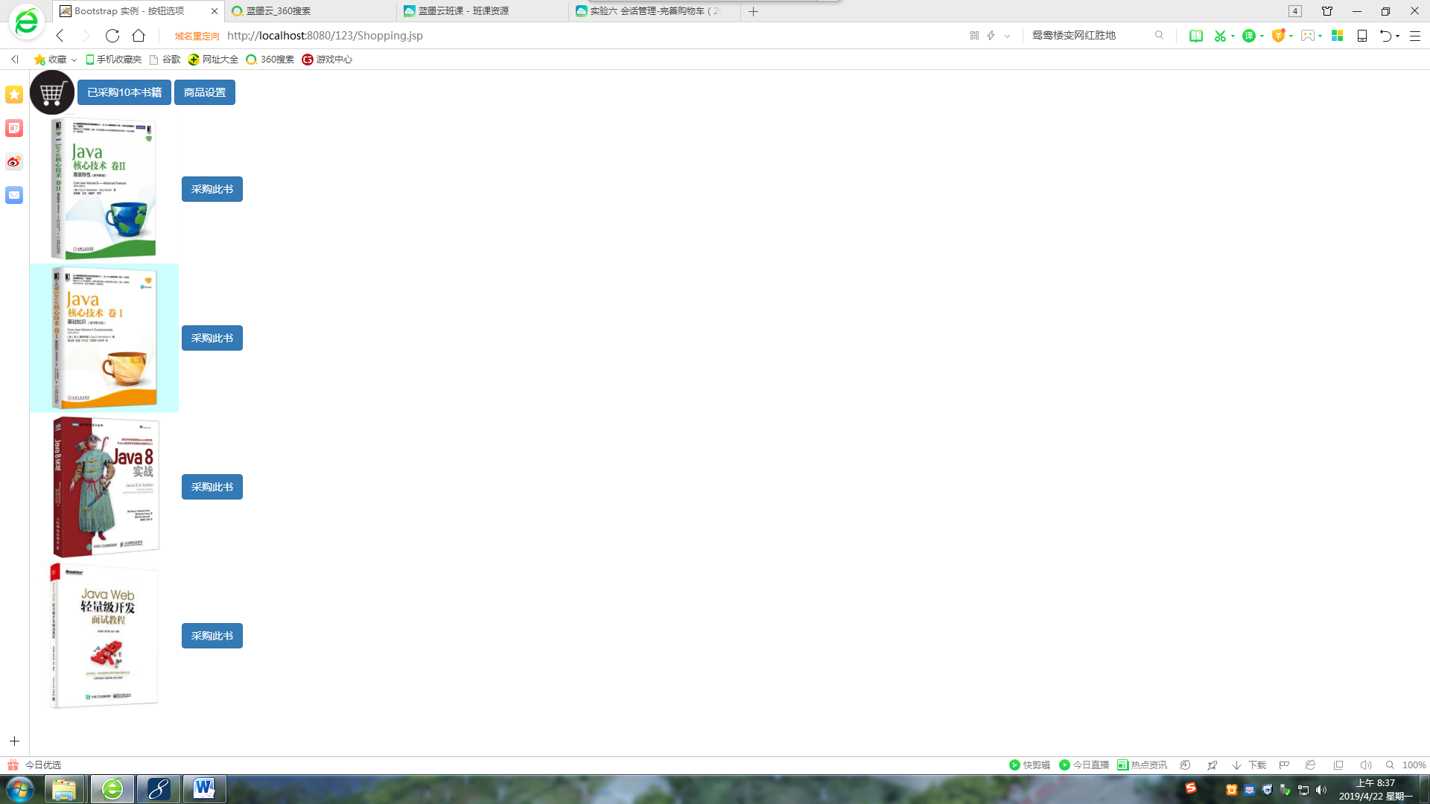

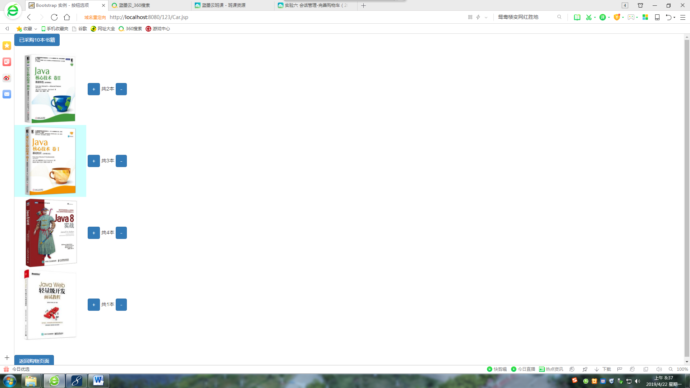

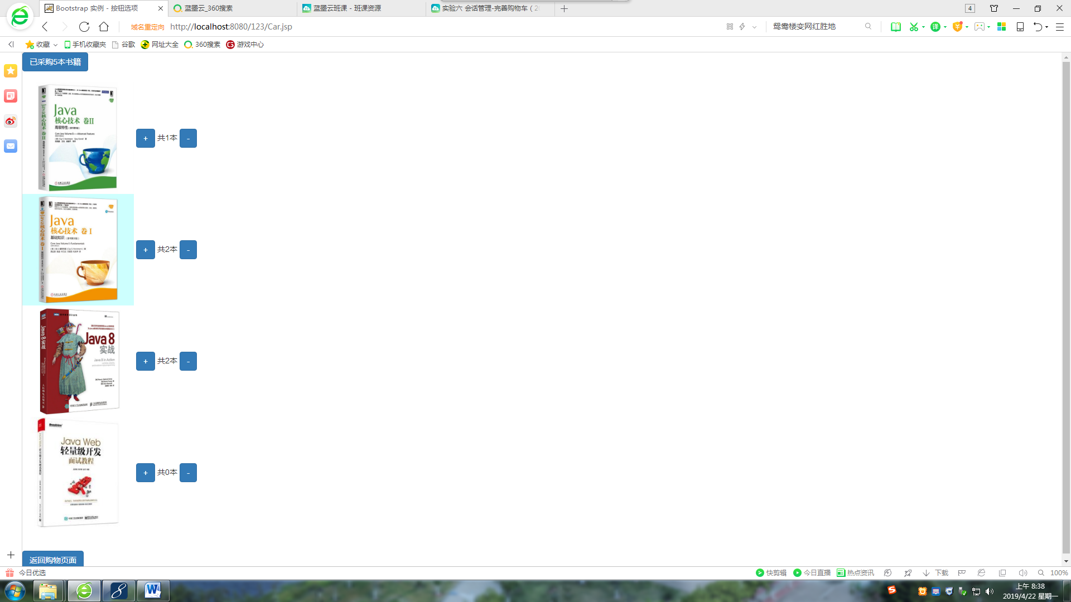

# 收获与问题

1、 学习更好的设计Java类。从而灵活使用session对象；

2、 完善购物车的功能；

3、 优化购物车的结构。