**Java Web开发**

**实验六**

**作业报告**

|  |  |
| --- | --- |
| 学 院 | 计算机 |
| 所在系 班 级 | 2017软件工程系09班 |
| 学 号 姓 名 | 莫君炜 |
| 指 导 教 师 | 郭晓燕 |
| 完 成 时 间 | 2018年4月- |

# 实验题目

1、参考成熟的购物系统，为购物车增加功能，完善购物车：删除商品，查看商品具体信息，计算商品总价，修改商品购买件数等等。界面尽量美观。

# 分析与设计

1. 创建一系列java类：

Book.java：用于设置或获取商品信息；

deleteBook.java:用于删除指定的商品书籍；

reduceBook.java:用于减少指定的商品书籍；

addBook.java:用于增加指定的商品书籍；

1. 创建Login.jsp---用于提交用户信息登录；
2. 创建ShoppingLogin.java：用于初始化book数组并将book数组放入session域中；同时用于创建删除，增加，减少类对应的对象从而来调用对应的方法来达到删除，减少，增加书籍的目的。
3. 创建BuyingBook.jsp---用于显示商品给用户选择；
4. 创建BuyBookCount.java---用于统计书籍数量并把更新的book数组存入session域。
5. 创建ShopCartBook.jsp---用于显示用户的购物车信息，即其选择的商品。和一些删除，减少，增加商品书籍的功能。

# 关键代码（部分）

Web.Xml:

<?xml version="1.0" encoding="UTF-8"?>

<web-app xmlns:xsi="http://www.w3.org/2001/XMLSchema-instance" xmlns="http://xmlns.jcp.org/xml/ns/javaee" xsi:schemaLocation="http://xmlns.jcp.org/xml/ns/javaee http://xmlns.jcp.org/xml/ns/javaee/web-app_3_1.xsd" version="3.1">

<display-name>04172125MOKex4</display-name>

<servlet>

<servlet-name>ShopLogin</servlet-name>

<servlet-class>ex6.ShoppingLogin</servlet-class>

</servlet>

<servlet-mapping>

<servlet-name>ShopLogin</servlet-name>

<url-pattern>/shoppingLogin.view</url-pattern>

</servlet-mapping>

<servlet>

<servlet-name>BookCount</servlet-name>

<servlet-class>ex6.BuyBookCount</servlet-class>

</servlet>

<servlet-mapping>

<servlet-name>BookCount</servlet-name>

<url-pattern>/BuyBookCount.view</url-pattern>

</servlet-mapping>

</web-app>

Book.java:

**package** ex4;

**public** **class** Book {

String BookID;

String BookName;

**float** BookPrice;

**int** BookshopNum=0;

String BookURL;

**public** Book(String id,String name,**double** price,String bookurl){

**this**.BookID=id;

**this**.BookName=name;

**this**.BookPrice=(**float**)price;

**this**.BookURL=bookurl;

}

**public** String getBookID(){

**return** BookID;

}

**public** String getBookName()

{

**return** BookName;

}

**public** String getBookURL()

{

**return** BookURL;

}

**public** **float** getBookPrice()

{

**return** BookPrice;

}

**public** **void** setBookShopNum(**int** num)

{

**this**.BookshopNum=num;

}

**public** **int** getBookShopNum()

{

**return** BookshopNum;

}

}

deleteBook.java:

**package** ex6;

**public** **class** deleteBook1 {

**private** String bookid;

**private** Book[] bookS;

**public** deleteBook1(){ }

**public** **void** setBookS(Book[] bookS)

{

**this**.bookS=bookS;

}

**public** **void** delete(String id)

{

**for**(**int** i=0;i<bookS.length;i++)

{

**if**(id.equals(bookS[i].getBookID()))

{

**if**(bookS[i].getBookNum()>0)

{

bookS[i].setBookNum(bookS[i].getBookNum()-bookS[i].getBookNum());

**break**;

}

}

}

}

}

reduceBook.java:

**package** ex6;

**public** **class** reduceBook {

**private** String bookid;

**private** Book[] bookS;

**public** reduceBook(){ }

**public** **void** setBookS(Book[] bookS)

{

**this**.bookS=bookS;

}

**public** **void** reduce(String id)

{

**for**(**int** i=0;i<bookS.length;i++)

{

**if**(id.equals(bookS[i].getBookID()))

{

bookS[i].setBookNum(bookS[i].getBookNum()-1);

**break**;

}

}

}

}

addBook.java:

**package** ex6;

**public** **class** addBook {

**private** String bookid;

**private** Book[] bookS;

**public** addBook(){ }

**public** **void** setBookS(Book[] bookS)

{

**this**.bookS=bookS;

}

**public** **void** add(String id)

{

**for**(**int** i=0;i<bookS.length;i++)

{

**if**(id.equals(bookS[i].getBookID()))

{

bookS[i].setBookNum(bookS[i].getBookNum()+1);

**break**;

}

}

}

}

Login.jsp：

<%@ page language=*"java"* import=*"java.util.*"* pageEncoding=*"UTF-8"*%>

<%

String path = request.getContextPath();

String basePath = request.getScheme()+"://"+request.getServerName()+":"+request.getServerPort()+path+"/";

%>

<!DOCTYPE HTML PUBLIC "-//W3C//DTD HTML 4.01 Transitional//EN">

<html>

<head>

<base href=*"*<%=basePath%>*"*>

<title>Login.jsp</title>

<meta http-equiv=*"pragma"* content=*"no-cache"*>

<meta http-equiv=*"cache-control"* content=*"no-cache"*>

<meta http-equiv=*"expires"* content=*"0"*>

<meta http-equiv=*"keywords"* content=*"keyword1,keyword2,keyword3"*>

<meta http-equiv=*"description"* content=*"This is my page"*>

<!--

<link rel="stylesheet" type="text/css" href="styles.css">

-->

</head>

<body>

<p>请输入用户名进行登录：

<form action=*"*${pageContext.request.contextPath }*/shoppingLogin.view"* method=*"post"* >

<input type=*"text"* name=*"name"* >

<input type=*"submit"* value=*"提交"* name=*"submit"*>

</form>

</body>

</html>

ShoppingLogin.java：

package ex6;

import java.io.IOException;

import java.util.ArrayList;

import java.util.List;

import javax.servlet.ServletException;

import javax.servlet.annotation.WebServlet;

import javax.servlet.http.HttpServlet;

import javax.servlet.http.HttpServletRequest;

import javax.servlet.http.HttpServletResponse;

import javax.servlet.http.HttpSession;

import ex6.Book;

public class ShoppingLogin extends HttpServlet {

protected void doGet(HttpServletRequest request, HttpServletResponse response) throws ServletException, IOException {

this.doPost(request, response);

}

protected void doPost(HttpServletRequest request, HttpServletResponse response) throws ServletException, IOException {

request.setCharacterEncoding("utf-8");

HttpSession session=request.getSession();

String name=request.getParameter("name");

String param=request.getParameter("param");

if("delete".equals(param))

{

String id=request.getParameter("id");

Book[] bookS=(Book[]) session.getAttribute("Book");

deleteBook1 dB=new deleteBook1();

dB.setBookS(bookS);

dB.delete(id);

response.sendRedirect("ShopCartBook.jsp");

}

else if("reduce".equals(param))

{

String id=request.getParameter("id");

Book[] bookS=(Book[]) session.getAttribute("Book");

reduceBook rB=new reduceBook();

rB.setBookS(bookS);

rB.reduce(id);

response.sendRedirect("ShopCartBook.jsp");

}

else if("add".equals(param))

{

String id=request.getParameter("id");

Book[] bookS=(Book[]) session.getAttribute("Book");

addBook aB=new addBook();

aB.setBookS(bookS);

aB.add(id);

response.sendRedirect("ShopCartBook.jsp");

}

else if(name==null)

response.sendRedirect("Login.jsp");

else{

session.setAttribute("customerName", name);

Book[] Book=initBook();

session.setAttribute("Book", Book);

session.setAttribute("sum", 0);

response.sendRedirect("BuyingBook.jsp");

}

}

public Book[] initBook(){

Book[] Books=new Book[6];

Books[0]=new Book("0001","book1",12.33,"/image/book1.jpg");

Books[1]=new Book("0002","book2",13.44,"/image/book2.jpg");

Books[2]=new Book("0003","book3",14.55,"/image/book3.jpg");

Books[3]=new Book("0004","book4",15.66,"/image/book4.jpg");

Books[4]=new Book("0004","book4",16.77,"/image/book5.jpg");

Books[5]=new Book("0005","book5",17.88,"/image/book6.jpg");

return Books;

}

}

BuyingBook.jsp：

<%@ page language=*"java"* import=*"java.util.*,ex6.Book"* pageEncoding=*"UTF-8"*%>

<%

String path = request.getContextPath();

String basePath = request.getScheme()+"://"+request.getServerName()+":"+request.getServerPort()+path+"/";

%>

<!DOCTYPE HTML PUBLIC "-//W3C//DTD HTML 4.01 Transitional//EN">

<html>

<head>

<base href=*"*<%=basePath%>*"*>

<title>My JSP 'BuyingBook.jsp' starting page</title>

<meta http-equiv=*"pragma"* content=*"no-cache"*>

<meta http-equiv=*"cache-control"* content=*"no-cache"*>

<meta http-equiv=*"expires"* content=*"0"*>

<meta http-equiv=*"keywords"* content=*"keyword1,keyword2,keyword3"*>

<meta http-equiv=*"description"* content=*"This is my page"*>

<!--

<link rel="stylesheet" type="text/css" href="styles.css">

-->

</head>

<body>

<%

String name=(String)session.getAttribute("customerName");

%>

欢迎你，<%=name%>

<p>这是书籍柜台，请选择您要购买的书籍：

<table border=*"1"*>

<%

Book[] Books=(Book[])session.getAttribute("Book");

**for**(Book book:Books)

{

%>

<tr>

<td><img src=*"*${pageContext.request.contextPath }*/*<%=book.getBookURL()%>*"* alt=*"bookurleorr"* width=*"304"* height=*"228"* ></td>

<td><a href=*'*${pageContext.request.contextPath }*/BuyBookCount.view?id=*<%=book.getBookID()%>*'*>采购此书</a></td>

</tr>

<%

}

%>

</table><br>

<img src=*"*${pageContext.request.contextPath }*/image/shoppingcar.jpg"* alt=*"shoppingcar"* width=*"304"* height=*"228"* >

<a href=*'*${pageContext.request.contextPath }*/ShopCartBook.jsp'*>已经采购${sum }本书籍</a>

</body>

</html>

BuyBookCount.java：

package ex6;

import java.io.IOException;

import javax.servlet.ServletException;

import javax.servlet.annotation.WebServlet;

import javax.servlet.http.HttpServlet;

import javax.servlet.http.HttpServletRequest;

import javax.servlet.http.HttpServletResponse;

import javax.servlet.http.HttpSession;

import ex6.Book;

public class BuyBookCount extends HttpServlet {

protected void doGet(HttpServletRequest request, HttpServletResponse response) throws ServletException, IOException {

doPost(request, response);

}

protected void doPost(HttpServletRequest request, HttpServletResponse response) throws ServletException, IOException {

request.setCharacterEncoding("UTF-8");

response.setContentType("text/html;charset=UTF-8");

HttpSession session=request.getSession();

Book[] BookS=(Book[])session.getAttribute("Book");

String prod=request.getParameter("id");

if(prod!=null)

{

for(int i=0;i<BookS.length;i++)

{

if(prod.equals(BookS[i].getBookID()))

{

BookS[i].setBookNum(BookS[i].getBookNum()+1);

break;

}

}

}

session.setAttribute("Book", BookS);

request.getRequestDispatcher("/ShopCartBook.jsp").forward(request,response);

}

}

ShopCartBook.jsp：

<%@ page language=*"java"* import=*"java.util.*,ex6.Book"* pageEncoding=*"UTF-8"*%>

<%

String path = request.getContextPath();

String basePath = request.getScheme()+"://"+request.getServerName()+":"+request.getServerPort()+path+"/";

%>

<!DOCTYPE HTML PUBLIC "-//W3C//DTD HTML 4.01 Transitional//EN">

<html>

<head>

<base href=*"*<%=basePath%>*"*>

<title>ShopCartBook.jsp</title>

<meta http-equiv=*"pragma"* content=*"no-cache"*>

<meta http-equiv=*"cache-control"* content=*"no-cache"*>

<meta http-equiv=*"expires"* content=*"0"*>

<meta http-equiv=*"keywords"* content=*"keyword1,keyword2,keyword3"*>

<meta http-equiv=*"description"* content=*"This is my page"*>

<!--

<link rel="stylesheet" type="text/css" href="styles.css">

-->

</head>

<body>

<p>这里是结账处，您的姓名以及选择的商品为：<br>

你的名字：<%=(String)session.getAttribute("customerName") %>

<%

**int** num=0;

**float** totalPrice=0;

Book[] BookS=(Book[])session.getAttribute("Book");

**for**(**int** i=0;i<BookS.length;i++)

{

**if**(BookS[i].getBookNum()>0)

{

%>

<table border=*"1"*>

<tr>

<th>商品名称</th>

<th>商品价格</th>

<th>商品数量</th>

<th>商品总价</th>

<th>商品操作</th>

</tr>

<tr>

<td><%=BookS[i].getBookName() %></td>

<td><%=BookS[i].getBookPrice() %></td>

<td><a href=*'*${pageContext.request.contextPath }*/shoppingLogin.view?param=reduce&id=*<%=BookS[i].getBookID() %>*'*>减少商品</a>

<%=BookS[i].getBookNum() %>

<a href=*'*${pageContext.request.contextPath }*/shoppingLogin.view?param=add&id=*<%=BookS[i].getBookID()%>*'*>增加商品</a>

</td>

<td><%=(**float**) ((BookS[i].getBookPrice()*BookS[i].getBookNum())) %></td>

<td><a href=*'*${pageContext.request.contextPath }*/shoppingLogin.view?param=delete&id=*<%=BookS[i].getBookID() %>*'*>删除商品</a></td>

</tr>

</table>

<%

num=num+BookS[i].getBookNum();

totalPrice=(**float**) (totalPrice+(BookS[i].getBookPrice()*BookS[i].getBookNum()));

}

}

%>

<p><strong>商品总件数价:</strong><%=num %><br>

<strong>商品总价格:</strong><%=totalPrice %><br></p>

<p><strong>点击超链接，继续选购商品。</strong>

<a href=*'BuyingBook.jsp'*> 欢迎去BOOK.JSP!</a><br>

<p><strong>点击超链接，链接到login.jsp的页面，去修改姓名。</strong>

<a href=*'Login.jsp'*> 欢迎去LOGIN.jsp!</a>

</body>

</html>

</body>

</html>

# 运行效果图

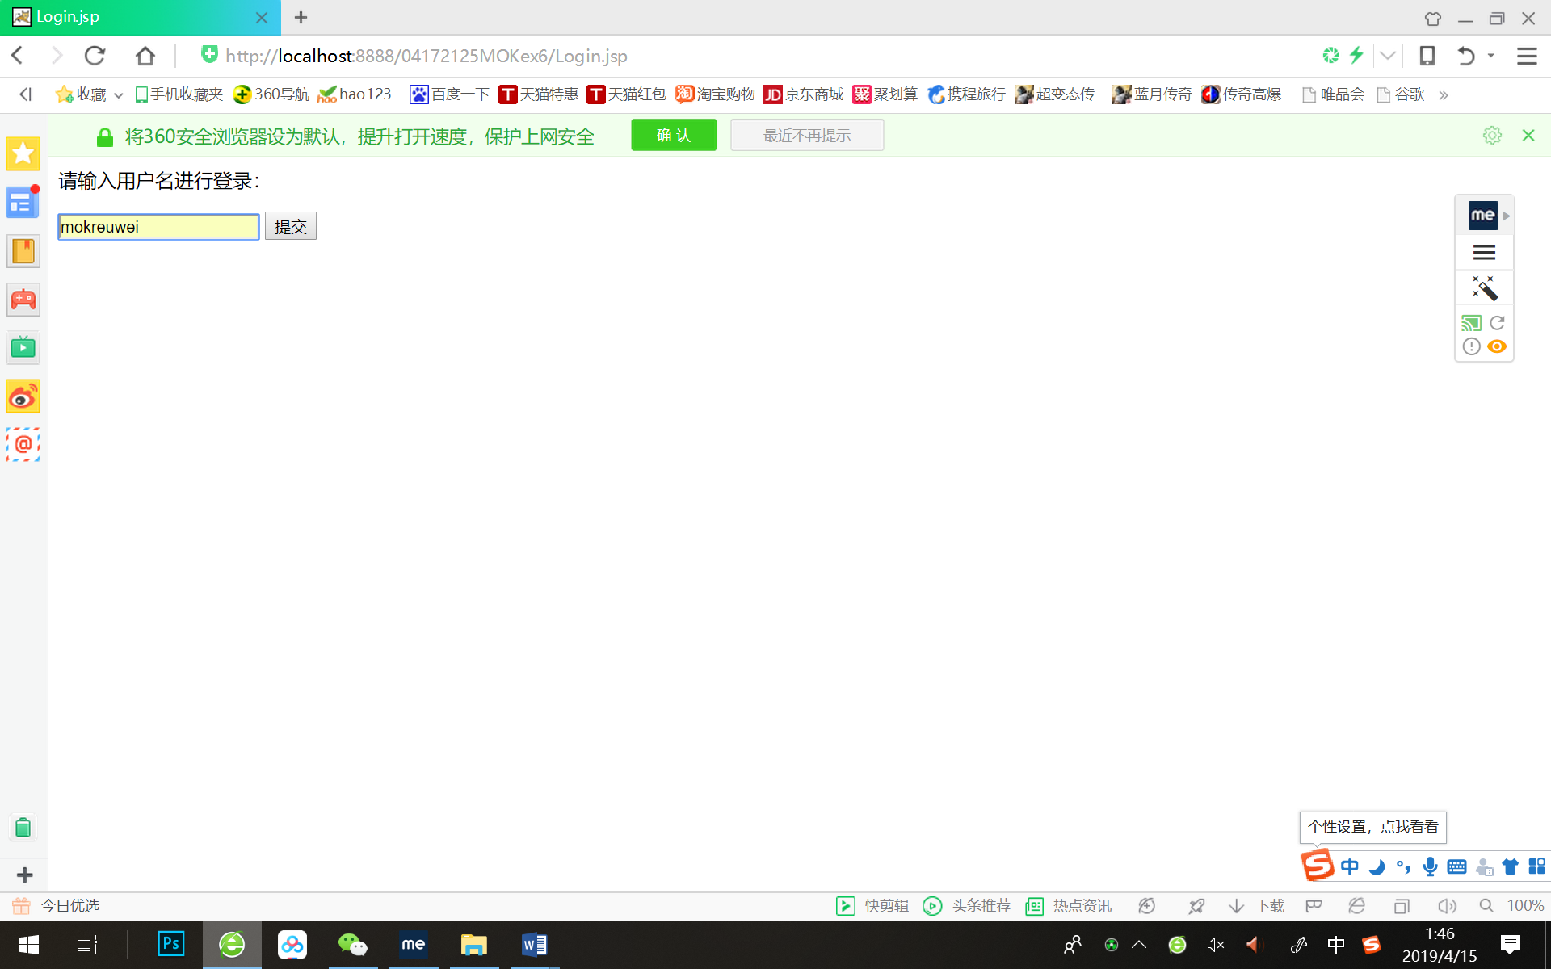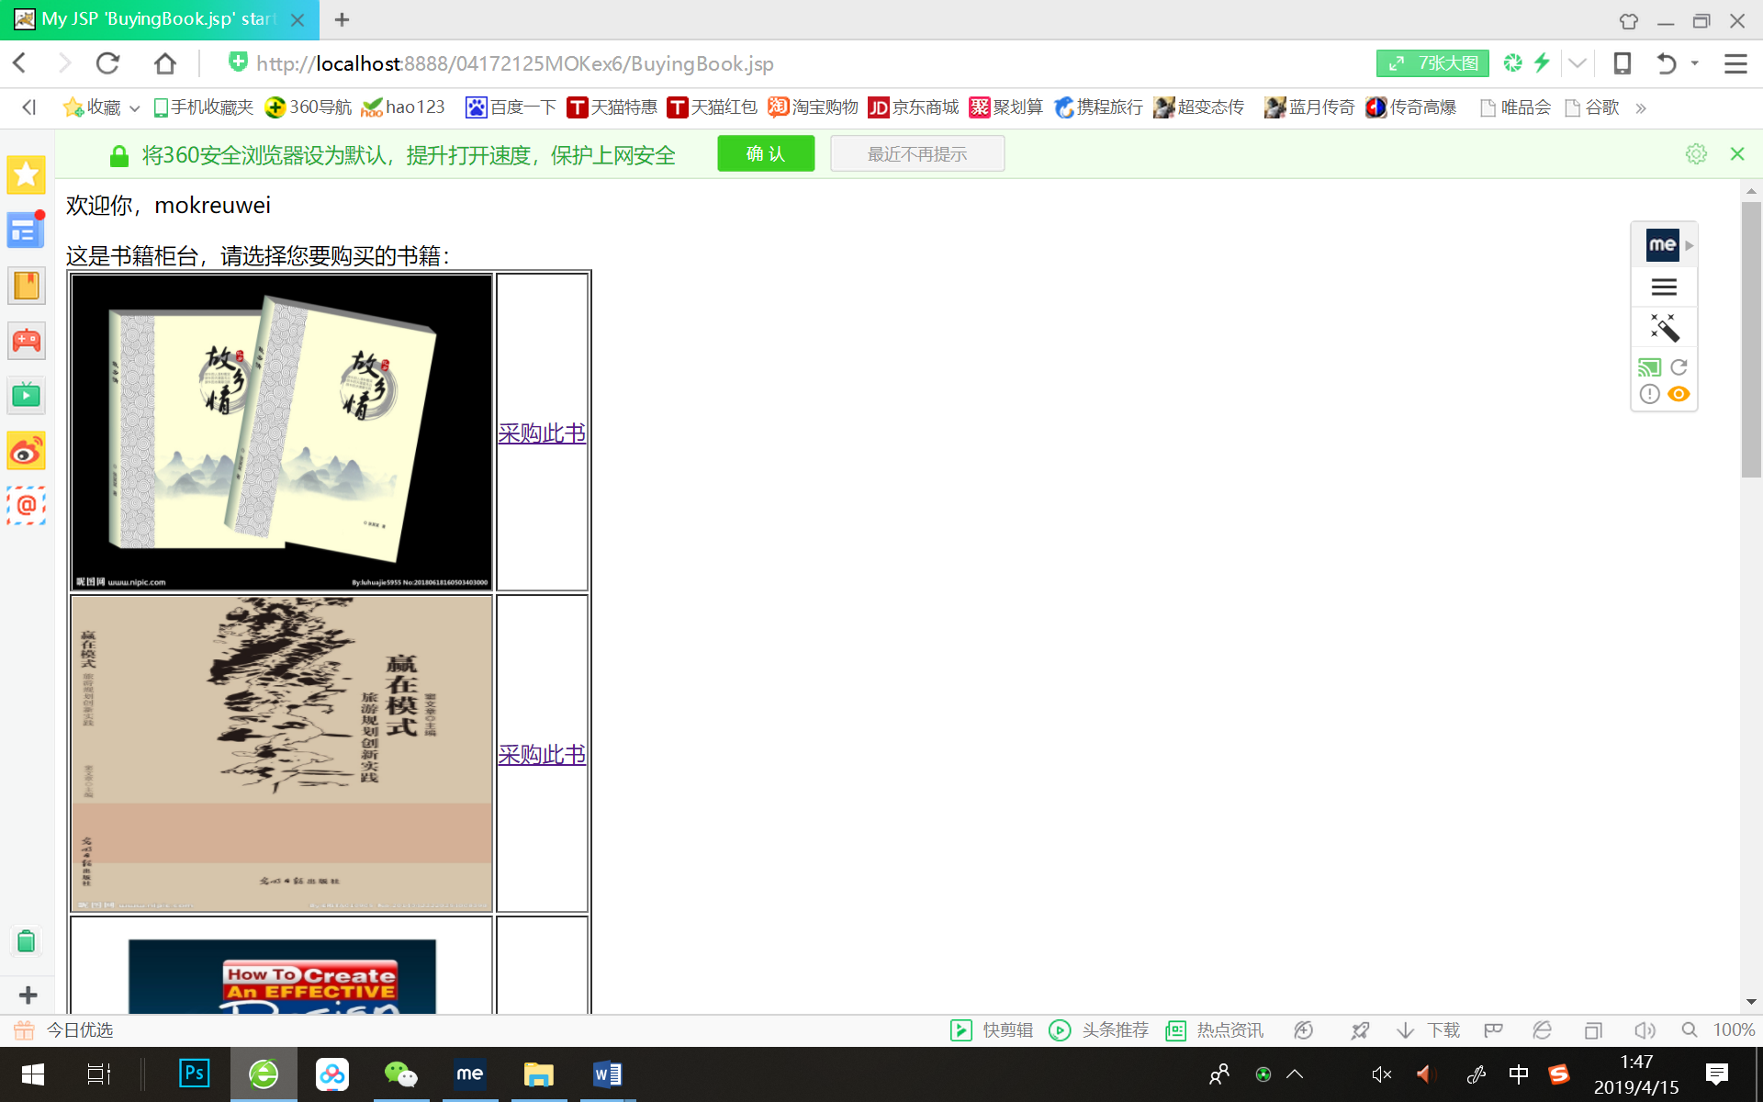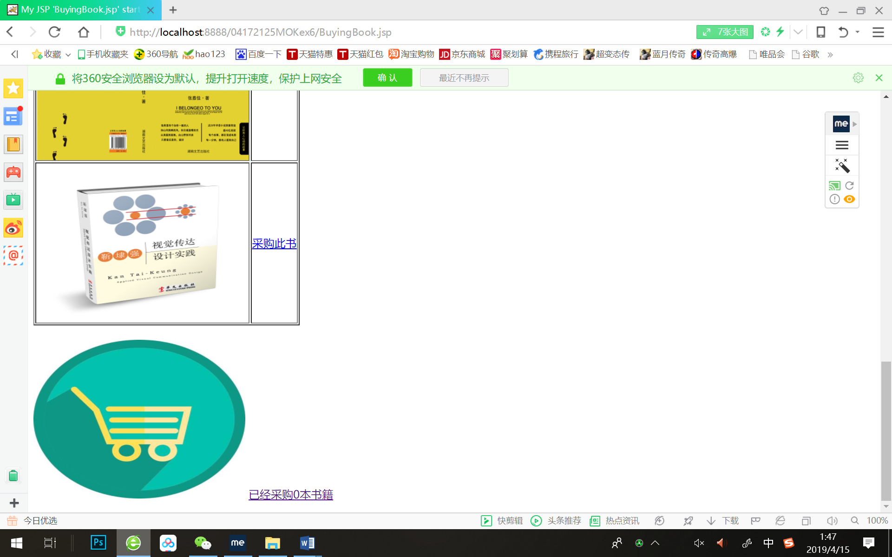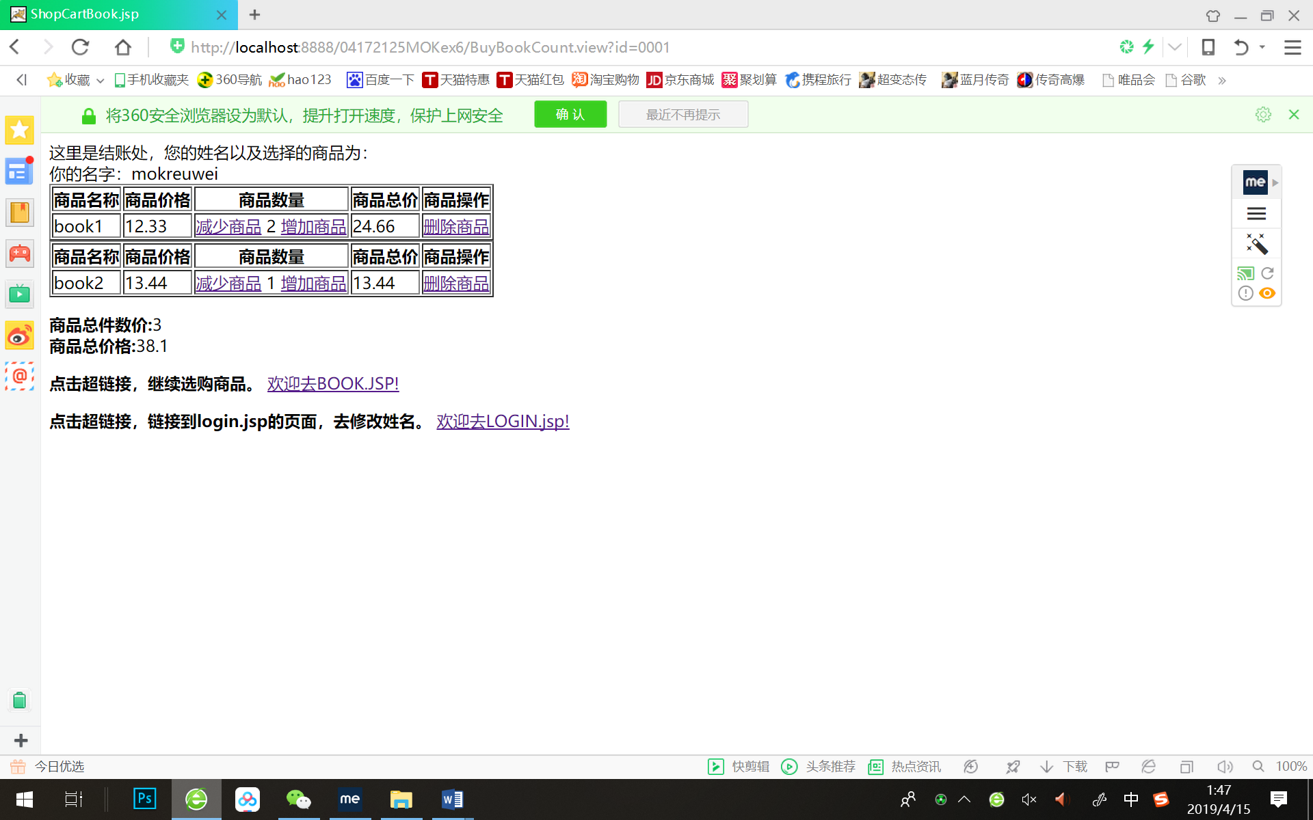

我直接按book2的增加商品：

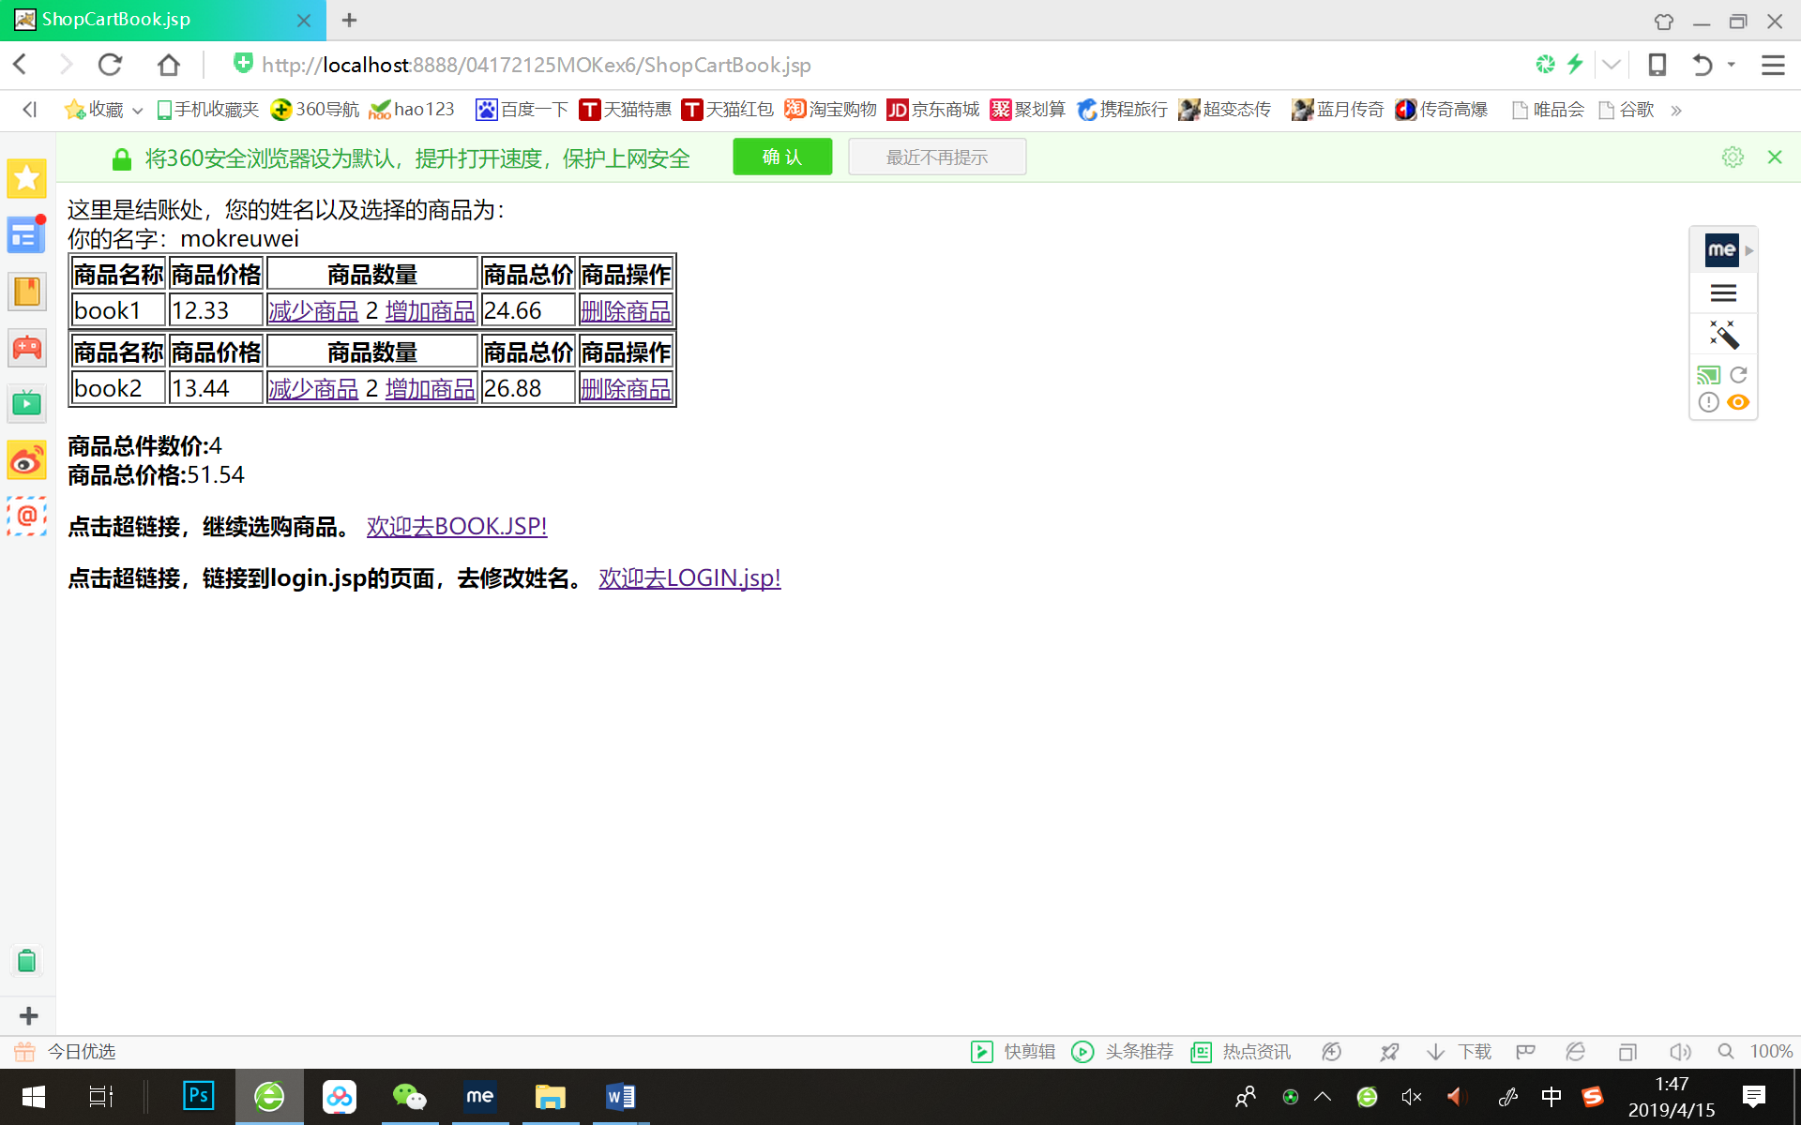

直接按book1的减少商品：

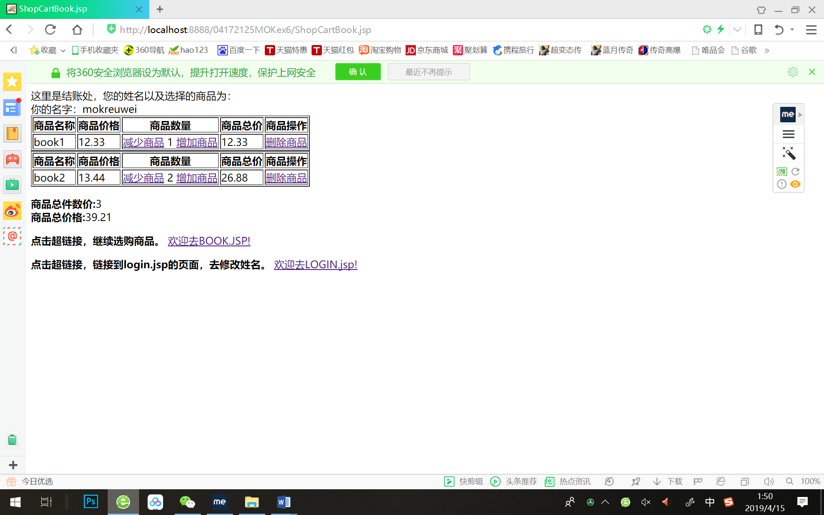

按book1的删除商品操作：

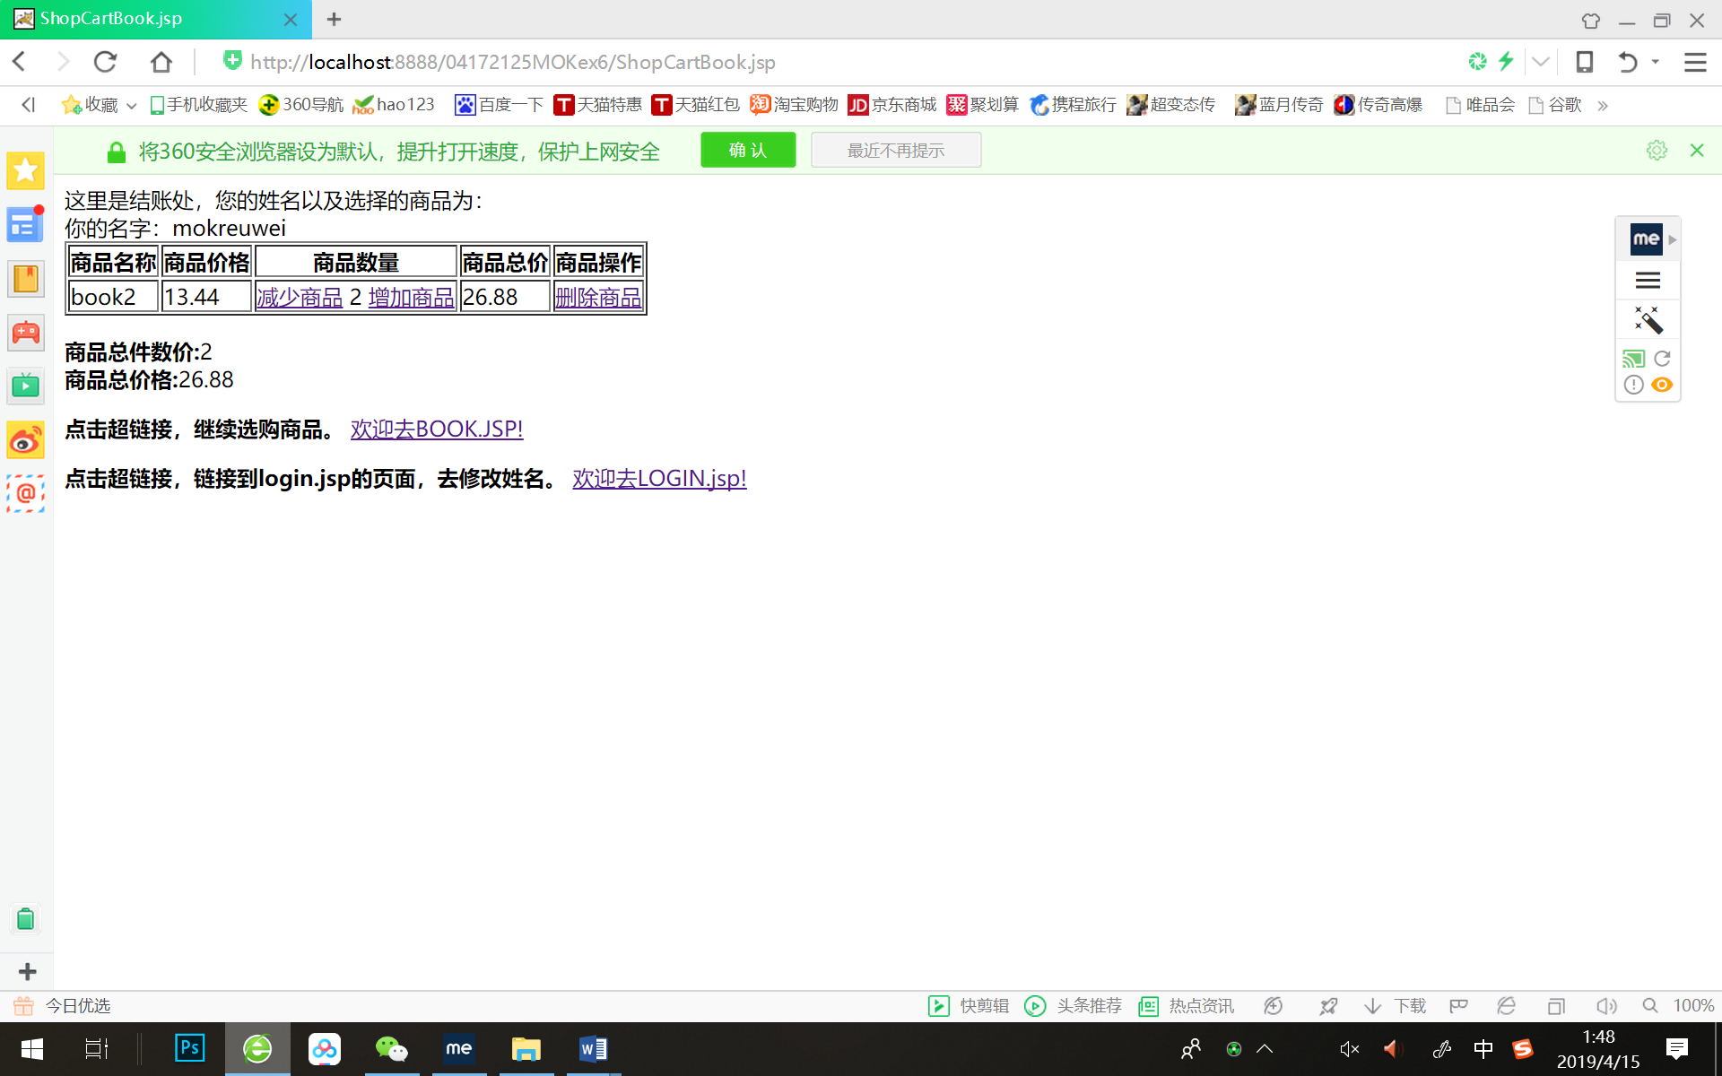

# 收获与问题

1. 熟练掌握了session域的用法，越来越熟悉做购物车的操作。但是觉得在写代码过程中有些许繁琐，想要今后在学习了更多后改进代码从而变得更加简洁美观。