**Java Web开发**

**实验六**

**作业报告**

|  |  |
| --- | --- |
| 学 院 | 计算机 |
| 所在系 班 级 | 2017软件工程系11班 |
| 学 号 姓 名 | 04172505李鸿智 |
| 指 导 教 师 | 郭晓燕 |
| 完 成 时 间 | 2019年4月 |

# 实验题目

1、上周没有完成作业的同学请继续完成，完成了作业的同学请为购物车增加功能：

2、参考成熟的购物系统，为购物车增加功能，完善购物车：删除商品，查看商品具体信息，计算商品总价，修改商品购买件数等等。界面尽量美观。

提示：Java文件即Book.java的设计需要重构，需要分离商品基本信息和购买信息，需要有类分别来保存单件商品的购买信息和所有商品的购买信息。所以至少要三个Java类才能完成购物的基本功能。

Servlet也需要响应更多的操作，可以在一个Servlet中也可以分多个文件响应。并在适当的地方调用Java方法

# 分析与设计

计划设计一个book类，用于获取商品属性，一个ShoppingServlet类一个CardServlet类，设计两个jsp文件，Shopping.jsp和card.jsp用于展示购物车

# 关键源码（部分）

Shopping.jsp

<body>

<div style="height:*130px*;width:*100px*;">

<table style="height:*100px*;width:*800px*;">

<tr >

<td>

<img style="height:*100px*;width:*100px*;" src=*"*${pageContext.request.contextPath}*/img/payCar.png"*>

</td>

<td >

<a href=*"*${pageContext.request.contextPath}*/card.view"*>已购买${sessionScope.allCount}本书</a>

</td>

</tr>

</table>

</div>

<div style="height:*450px*;width:*400px*;">

<table>

<tr height=*"280px"*>

<c:forEach items="${books }" var=*"book"*>

<td><img style="height:*280px*;" src=*"*${pageContext.request.contextPath}*/*${book.b_img}*"*></td>

</c:forEach>

</tr>

<tr height=*"20px"* align=*"center"*>

<c:forEach items="${books }" var=*"book"*>

<td><a href=*"*${pageContext.request.contextPath}*/shopping.view?b_id=*${book.b_id }*"*>购买</a>

价格：${book.b_cost1 }

</td>

</c:forEach>

</tr>

</table>

</div>

</body>

card.jsp

<body>

<div style="height:*60px*;width:*150px*;">

已购买${sessionScope.allCount }本书籍<br>

<a href=*"*${pageContext.request.contextPath}*/shopping.view"*>返回</a>

</div>

<div style="height:*450px*;width:*400px*;">

<table style="height:*450px*;width:*400px*;" border=*"1px"*>

<c:forEach items="${books }" var=*"book"*>

<tr>

<td><img style="height:*150px*;" src=*"*${pageContext.request.contextPath}*/*${book.b_img}*"*></td>

<td>价格：${book.b_cost*book.b_count}</td>

<td>共${book.b_count }本</td>

<td><a href=*"*${pageContext.request.contextPath}*/shopping.view?b_delete=*${book.b_delete }*"* >删除</a></td>

</tr>

</c:forEach>

</table>

</div>

</body>

book.java

**public** **class** Book **implements** Serializable {

**private** **static** **final** **long** *serialVersionUID* = 1L;

**private** String b_id;

**private** String b_name;

**private** String b_img;

**private** Integer b_count;

**private** Integer b_cost;

**private** Integer b_cost1;

**private** String b_delete;

**public** Book(String b_id, String b_name, String b_img, Integer b_count,Integer b_cost,Integer b_cost1,String b_delete) {

**super**();

**this**.b_id = b_id;

**this**.b_name = b_name;

**this**.b_img = b_img;

**this**.b_count = b_count;

**this**.b_cost = b_cost;

**this**.b_cost1=b_cost1;

**this**.b_delete=b_delete;

}

**public** String getB_id() {

**return** b_id;

}

**public** **void** setB_id(String b_id) {

**this**.b_id = b_id;

}

**public** String getB_name() {

**return** b_name;

}

**public** **void** setB_name(String b_name) {

**this**.b_name = b_name;

}

**public** String getB_img() {

**return** b_img;

}

**public** **void** setB_img(String b_img) {

**this**.b_img = b_img;

}

**public** Integer getB_count() {

**return** b_count;

}

**public** **void** setB_count(Integer b_count) {

**this**.b_count = b_count;

}

**public** Integer getB_cost() {

**return** b_cost;

}

**public** **void** setB_cost(Integer b_cost) {

**this**.b_cost = b_cost;

}

**public** Integer getB_cost1() {

**return** b_cost1;

}

**public** **void** setB_cost1(Integer b_cost1) {

**this**.b_cost1 = b_cost1;

}

**public** String getB_delete() {

**return** b_delete;

}

**public** **void** setB_delete(String b_delete) {

**this**.b_delete = b_delete;

}

}

ShoppingServlet.java

**protected** **void** doGet(HttpServletRequest request,

HttpServletResponse response) **throws** ServletException, IOException {

String b_id = (String) request.getParameter("b_id");

String b_delete = (String) request.getParameter("b_delete");

Integer allCount = 0;

Book[] books;

**if** (**null** == request.getSession().getAttribute("books")) {

books = **new** Book[3];

books[0] = **new** Book("1", "读 者", "img/book1.png", 0,25,25,"1");

books[1] = **new** Book("2", "如果一切重来", "img/book2.png", 0,30,30,"2");

books[2] = **new** Book("3", "悲惨世界", "img/book3.png", 0,35,35,"3");

request.getSession().setAttribute("allCount", allCount);

}**else**{

books = (Book[]) request.getSession().getAttribute(

"books");

}

allCount = (Integer) request.getSession().getAttribute("allCount");

**for** (Book book : books) {

book.setB_cost1(book.getB_cost1());

**if** (book.getB_id().equals(b_id)) {

book.setB_count(book.getB_count() + 1);

++allCount;

}

**if** (book.getB_delete().equals(b_delete)&&allCount!=0&&book.getB_count()!=0)

{

book.setB_count(book.getB_count() - 1);

--allCount;

}

}

request.getSession().setAttribute("books", books);

request.getSession().setAttribute("allCount", allCount);

request.getRequestDispatcher("/Shopping.jsp").forward(

request, response);

}

CardServlet.java

**public** **class** CardServlet **extends** HttpServlet {

/**

*

*/

**private** **static** **final** **long** *serialVersionUID* = 1L;

@Override

**protected** **void** doGet(HttpServletRequest request, HttpServletResponse response)

**throws** ServletException, IOException {

request.getRequestDispatcher("/card.jsp").forward(request, response);

}

}

# 运行效果图



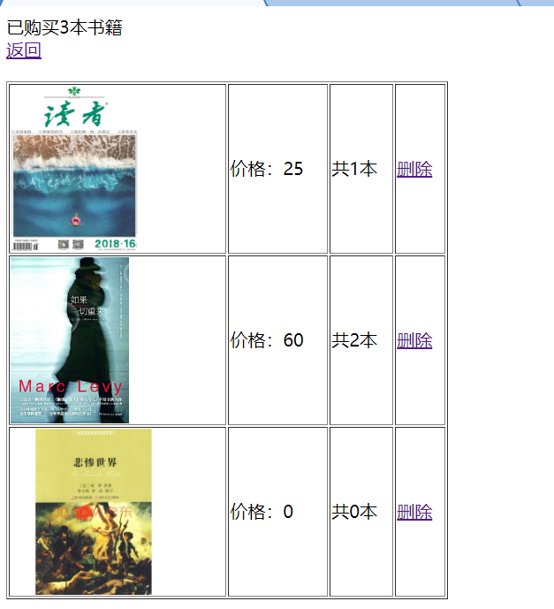

# 收获与问题