**Java Web开发**

**实验六**

**作业报告**

|  |  |
| --- | --- |
| 学 院 | 计算机 |
| 所在系 班 级 | 2017软件工程系11班 |
| 学 号 姓 名 | 04172603李国鹏 |
| 指 导 教 师 | 郭晓燕 |
| 完 成 时 间 | 2019年4月10日 |

# 实验题目

参考成熟的购物系统，为购物车增加功能，完善购物车：删除商品，查看商品具体信息，计算商品总价，修改商品购买件数等等。界面尽量美观。

# 分析与设计

**Shopping.jsp 购买书籍的页面**

**Session.java 创建session和修改数据的页面**

**shopcar.jsp 显示购买的书籍数量页面**

**sum.jsp 统计书籍总价的页面**

**Book.java 关键传参的页面**

# 关键源码（部分）

Shopping.jsp

<%@ page language=*"java"* import=*"GPshopping.Book,javax.servlet.http.HttpSession"* pageEncoding=*"UTF-8"*%>

<html>

<body bgcolor=*cyan*><font size=*6*>

<%

**if**(session.getAttribute("bookList")==**null**)

{

Book[] bookList = **new** Book[4];

bookList[0]=**new** Book("1","Java&Servlet","img/1.png",0);

bookList[1]=**new** Book("2","Java经典实例","img/2.png",0);

bookList[2]=**new** Book("3","Java核心技术","img/3.png",0);

bookList[3]=**new** Book("4","Java7","img/4.png",0);

session.setAttribute("bookList",bookList);

session.setAttribute("num",0);

}

%>

<%

Book[] books = (Book[])session.getAttribute("bookList"); //定义books数组

**int** num = (Integer)session.getAttribute("num"); //定义书数量

%>

<p>请选择采购的书籍</p>

<%

**if**(books != **null**){

**int** []sale={56,66,77,88}; //定义每本书的价钱

session.setAttribute("sale",sale);

**for**(**int** i=0;i<books.length;i++){

%>

<div style="float: *left*">

<img style="width:*150px* ;height:*200*" src=*"*<%=books[i].getBookImg() %>*"*><br>

<a href=*"shopping.view?id=*<%=books[i].getBookId()%>*"*><img src=*"img/6.jpg"* width=*"30"* height=*"30"* alt=*"加一本"*></a>

<a href=*"shopping.view?id=*<%=(books[i].getBookId()+10)%>*"*><img src=*"img/7.jpg"* width=*"25"* height=*"25"* alt=*"减一本"*></a><br>

价格:<%=sale[i]+"/本"%> <br>

</div>

<%

}

%>

<br><br><br><br><br><br><br><br>

<a href=*"shopcar.jsp"*><font size=*6* >当前已采购<%=num%>本书籍</a>

<br><br>

<details>

<summary>Java&Servlet详情</summary>

<p>出版社：清华大学出版社</p>

<p>著作人:林信良</p>

</details>

<details>

<summary>Java经典实例详情</summary>

<p>出版社：清华大学出版社</p>

<p>著作人:林信良</p>

</details>

<details>

<summary>Java核心技术详情</summary>

<p>出版社：清华大学出版社</p>

<p>著作人:林信良</p>

</details>

<details>

<summary>Java7详情</summary>

<p>出版社：清华大学出版社</p>

<p>著作人:林信良</p>

</details>

Session.java

@WebServlet("/shopping.view")

public void doPost(HttpServletRequest request, HttpServletResponse response) throws ServletException, IOException {

response.setContentType("text/html;charset=utf-8");

request.setCharacterEncoding("UTF-8");

HttpSession session = request.getSession();

Book[] bookList = (Book[]) session.getAttribute("bookList");

PrintWriter out = response.getWriter();

for (Book book : bookList) {

if(request.getParameter("id").equals(book.getBookId()))

{

book.setNum(book.getNum()+1);

session.setAttribute("num", (Integer)session.getAttribute("num")+1);

}

else if(request.getParameter("id").equals((book.getBookId()+10))&& book.getNum()!=0)//为什么加10？

{

book.setNum(book.getNum()-1);

session.setAttribute("num", (Integer)session.getAttribute("num")-1);

}

}

response.sendRedirect("Shopping.jsp");

}

}

Shopcar.jsp

<%@ page language=*"java"* import=*"java.util.*"* contentType=*"text/html; charset=utf-8"*%>

<%@ page import=*"GPshopping.Book"* %>

<%

<body>

<%

Book[] books = (Book[])session.getAttribute("bookList");

**int** num= (Integer)session.getAttribute("num");

%>

<form action=*"sum.jsp"* method=*post*>

<%

**if**(books != **null**){

**for**(**int** i=0;i<books.length;i++){

out.println("<br>");

out.println("<tr>");

out.println("<td><img src='"+books[i].getBookImg()+"' height='auto' width='100px'></td>");

out.println("<td>已选"+books[i].getName()+"</a></td>");

out.println("<td>"+books[i].getNum()+"本</td>");

out.println("</tr>");

out.println("<br>");

}

}%>

<a href=*"Shopping.jsp"*>返回选购</a>

<hr>

<input type=*"submit"* value=*"提交结算购买"* name=*"money"* >

</form>

</body>

</html>

Sum.jsp

<%@page import=*"javax.servlet.http.HttpSession"*%>

<%@ page contentType=*"text/html;charset=utf-8"*%>

<%@ page import=*"GPshopping.Book"* %>

<html>

<body bgcolor=*cyan*><font size=*6*>

<body>

<font size=*"7"* face=*"宋体"* color=*black*>

<%

Book[] books = (Book[])session.getAttribute("bookList");

**int** num= (Integer)session.getAttribute("num");

**int** []sale=(**int** [])session.getAttribute("sale");

**int** all=0;

**for**(**int** i=0;i<books.length;i++)

{

all+=(sale[i]*books[i].getNum());

%>

<img style="width:*150px* ;height:*200*" src=*"*<%=books[i].getBookImg() %>*"*>

<%

out.println("<td>"+books[i].getName()+" "+"合算为:"+sale[i]*books[i].getNum()+"元</td>");

out.println("<br>");

}

out.println("<br>");

out.println("总价为："+all+"元");

%>

</font>

</body>

</html>

Book.jsp

public class Book {

String ID;

String Name;

String imageUrl;

double price;

int Num;

public Book(String iD, String name, String imageUrl, int num) {

ID = iD;

Name = name;

this.imageUrl = imageUrl;

Num = num;

}

public String getBookId() {

return ID;

}

public void setID(String iD) {

ID = iD;

}

public String getName() {

return Name;

}

public void setName(String name) {

Name = name;

}

public String getBookImg() {

return imageUrl;

}

public void setImageUrl(String imageUrl) {

this.imageUrl = imageUrl;

}

public int getNum() {

return Num;

}

public void setNum(int num) {

Num = num;

}

public double getPrice() {

return price;

}

public void setPrice(double price) {

this.price = price;

}

}

# 运行效果图

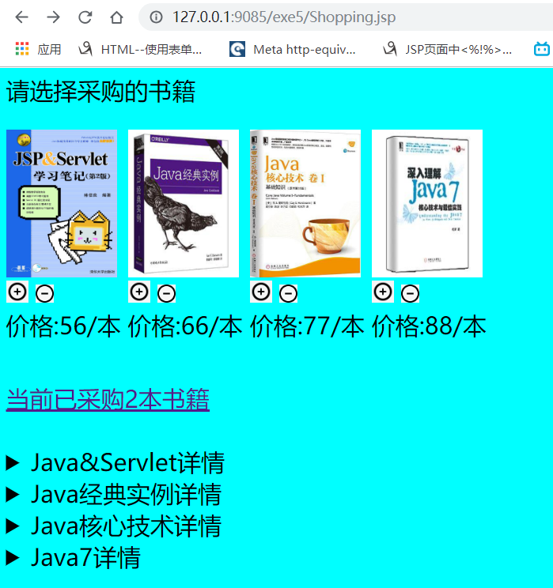

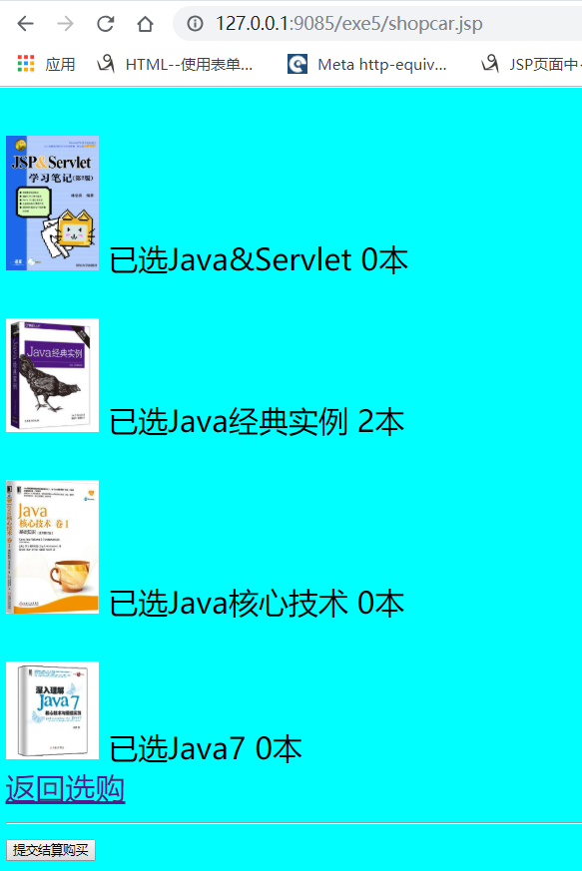

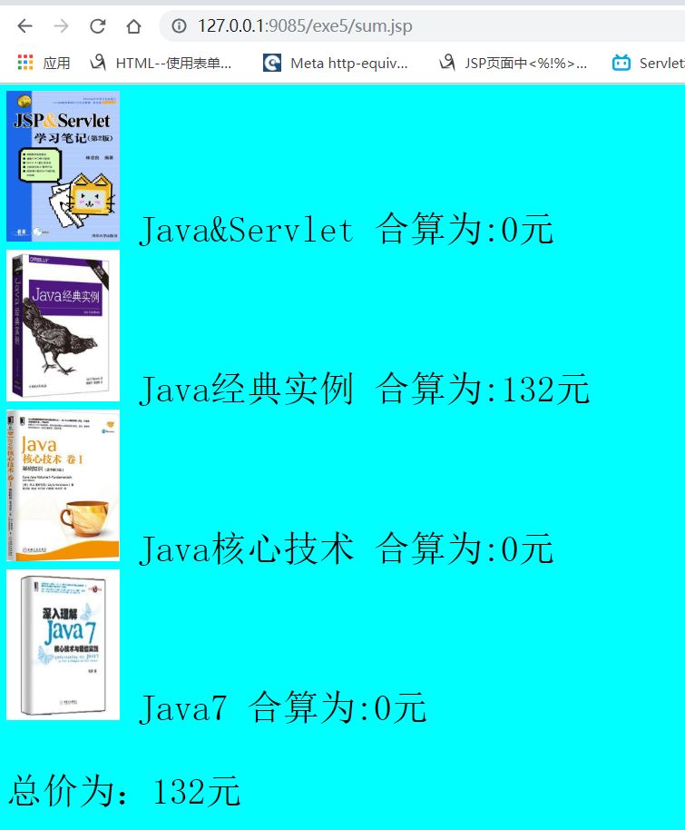

# 收获与问题

理解了会话的原理和HttpSession会话期，掌握如何使用URL重写传递参数和修改数据。