**Java Web开发**

**实验六**

**作业报告**

|  |  |
| --- | --- |
| 学 院 | 计算机 |
| 所在系 班 级 | 2017软件工程系10班 |
| 学 号 姓 名 | 06170915梁一惠 |
| 指 导 教 师 | 罗永升 |
| 完 成 时 间 | 2019年4月13日 |

# **实验题目**

实验内容：

1、上周没有完成作业的同学请继续完成，完成了作业的同学请为购物车增加功能：

2、参考成熟的购物系统，为购物车增加功能，完善购物车：删除商品，查看商品具体信息，计算商品总价，修改商品购买件数等等。界面尽量美观。

二、 分析与设计

有一个register3.jsp登录界面的jsp文件，三个servlet文件，一个registerdoservlet文件，识别用户名和密码长度及是否为空，成功登录转至successservlet文件，失败则重定向至error4servlet文件（成功和失败可用jsp文件写）。

三、关键源码（部分）

**package** com.itcast.controller;  
  
**import** com.itcast.domain.Book;  
**import** org.springframework.stereotype.Controller;  
**import** org.springframework.web.bind.annotation.RequestMapping;  
  
**import** javax.servlet.http.HttpServletRequest;  
**import** javax.servlet.http.HttpServletResponse;  
**import** javax.servlet.http.HttpSession;  
  
*/**  
 \** ***@author:*** *xiaohei  
 \** ***@Description:*** *\** ***@Date:*** *下午11:00 19-4-10  
 */*@Controller  
@RequestMapping(**"/book"**)  
**public class** BookController {  
  
 @RequestMapping(value = **"/shopping"**)  
 **public** String bookShopping(String bookId, HttpServletRequest request, HttpServletResponse response) {  
  
 HttpSession session = request.getSession();  
 Book book = (Book) session.getAttribute(bookId);  
  
 Integer count = book.getCount();  
 count = count + 1;  
 book.setCount(count);  
  
 session.setAttribute(bookId, book);  
 **return "show"**;  
 }  
  
 @RequestMapping(value = **"/updateCount"**)  
 **public** String addCout(Integer updateCount, String bookId, HttpServletRequest request, HttpServletResponse response) {  
 HttpSession session = request.getSession();  
 Book book = (Book) session.getAttribute(bookId);  
  
 Integer count = book.getCount();  
 count = count + updateCount;  
 **if** (count < 0 || updateCount == 0 || **""**.equals(updateCount)) {  
 String error = **"输入的数量有问题,无法修改"**;  
 request.setAttribute(**"error"**, error);  
 session.setAttribute(bookId, book);  
 **return "show"**;  
 }  
 book.setCount(count);  
 session.setAttribute(bookId, book);  
 **return "show"**;  
 }  
}

**package** com.itcast.interceptor;  
  
**import** com.itcast.domain.Book;  
**import** org.springframework.web.servlet.HandlerInterceptor;  
**import** org.springframework.web.servlet.ModelAndView;  
  
**import** javax.servlet.http.HttpServletRequest;  
**import** javax.servlet.http.HttpServletResponse;  
**import** javax.servlet.http.HttpSession;  
  
**public class** BookInterceptor **implements** HandlerInterceptor {  
  
 @Override  
 **public boolean** preHandle(HttpServletRequest request, HttpServletResponse response, Object handler) **throws** Exception {  
  
  
 HttpSession session = request.getSession();  
 Book book = (Book) session.getAttribute(**"book1"**);  
 **if** (book == **null**) {  
*// Integer id, String bookName, String picture, Integer price, Integer count)* Book book1 = **new** Book(1, **"Java EE互联网轻量级框架整合开发SSM框架"**, **"images/book1.jpg"**, 50, 0);  
 Book book2 = **new** Book(2, **"JavaEE开发的颠覆者 Spring Boot实战"**, **"images/book2.jpg"**, 60, 0);  
 Book book3 = **new** Book(3, **"Spring Boot实战 spring开发攻略教程"**, **"images/book3.jpg"**, 70, 0);  
 Book book4 = **new** Book(4, **"轻量级Java EE企业应用实战"**, **"images/book4.jpg"**, 80, 0);  
  
 session.setAttribute(**"book1"**, book1);  
 session.setAttribute(**"book2"**, book2);  
 session.setAttribute(**"book3"**, book3);  
 session.setAttribute(**"book4"**, book4);  
 }  
  
 **return true**;  
 }  
  
 @Override  
 **public void** postHandle(HttpServletRequest request, HttpServletResponse response, Object handler, ModelAndView modelAndView) **throws** Exception {  
  
 }  
  
 @Override  
 **public void** afterCompletion(HttpServletRequest request, HttpServletResponse response, Object handler, Exception ex) **throws** Exception {  
  
 }  
}

# 

# **运行效果图**

# **1555262782(1)1555262718(1)**

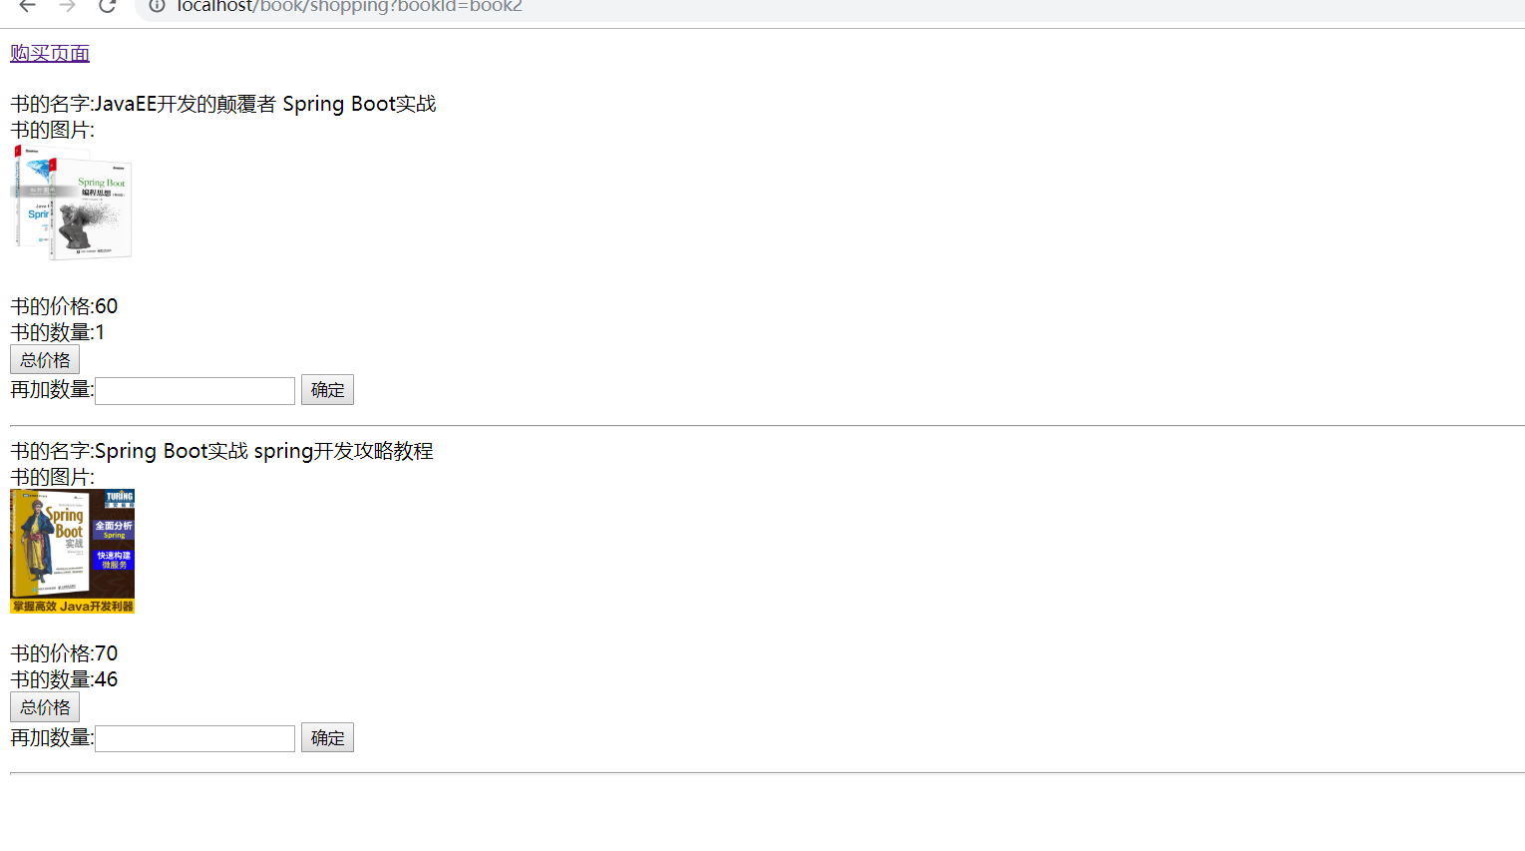

# **五、收获与问题**