**Java Web开发**

**实验七**

**作业报告**

|  |  |
| --- | --- |
| 学 院 | 计算机 |
| 所在系 班 级 | 2017软件工程系九班 |
| 学 号 姓 名 | 03170509 卢增伟 |
| 指 导 教 师 | 郭晓燕 |
| 完 成 时 间 | 2019年4月-21 |

# 实验题目

编写一个JavaBean计算税收，并在JSP页面输出结果

# 分析与设计

**设计3个文件来实现购物车的应用程序，**SsBean.java:数据类，用来保存g个人收入信息和个人所得税起征额度信息、并按级数计算全月应纳税所得额计算方法：全月应纳税所得额＝月收入－1600元。Ssinput.jsp:输入页面，通过此页面输入个人收入信息和最低个人所得税起征额度。**result.jsp:**利用上面的计算方法计算，并将结果显示在此页面上。

# 关键源码（部分）

1.( SsBean.java)

**package** test7;

**import** java.io.*;

**public** **class** SsBean4{

**public** SsBean4(){

}

**private** String incom;

**private** String taxstart;

**private** **double** taxes;

**public** **void** setIncom(String incom) {

**this**.incom = incom;

}

**public** String getIncom(){

**return** incom;

}

**public** **void** setTaxstart(String taxstart) {

**this**.taxstart = taxstart;

}

**public** String getTaxstart(){

**return** taxstart;

}

**public** **void** setTaxes(**double** taxes) {

**this**.taxes = taxes;

}

**public** **double** getTaxes(){

**return** taxes;

}

**public** **void** calculate(){

**double** totalmoney = Double.*parseDouble*(incom);

**double** basemoney = Double.*parseDouble*(taxstart);

**double** balance = totalmoney - basemoney;

**try**

{

**if**(balance<0) taxes=0;

**if**(balance>0&&balance<=500) taxes=balance*0.05;

**if**(balance>500&&balance<=2000) taxes=balance*0.1-25;

**if**(balance>2000&&balance<=5000) taxes=balance*0.15-125;

**if**(balance>5000&&balance<=20000) taxes=balance*0.2-375;

**if**(balance>20000&&balance<=40000) taxes=balance*0.25-1375;

**if**(balance>40000&&balance<=60000) taxes=balance*0.3-3375;

**if**(balance>60000&&balance<=80000) taxes=balance*0.35-6375;

**if**(balance>80000&&balance<=100000) taxes=balance*0.4-10375;

**if**(balance>100000) taxes=balance*0.45-15375;

}

**catch**(Exception e) {

System.***out***.println(e.toString());

}

}

}

2.( Ssinput.jsp)

<%@ page language="java" import="java.util.*" pageEncoding="UTF-8"%>

<%

String path = request.getContextPath();

String basePath = request.getScheme()+"://"+request.getServerName()+":"+request.getServerPort()+path+"/";

%>

<!DOCTYPE HTML PUBLIC "-//W3C//DTD HTML 4.01 Transitional//EN">

<html>

<head>

<base href="<%=basePath%>">

<title>个人所得税计算器</title>

<meta http-equiv="pragma" content="no-cache">

<meta http-equiv="cache-control" content="no-cache">

<meta http-equiv="expires" content="0">

<meta http-equiv="keywords" content="keyword1,keyword2,keyword3">

<meta http-equiv="description" content="This is my page">

<!--

<link rel="stylesheet" type="text/css" href="styles.css">

-->

</head>

<body>

<center>

<form name="form1" method="post" action="result.jsp">

<table width="358" height="140" border="0" cellpadding="0" cellspacing="0" bgcolor="#E6E6E6">

<tr align="center">

<td colspan="3"><strong>个人所得税计算器</strong></td>

</tr>

<tr>

<td colspan="2">当月个人总收入：</td>

<td width="177"><input name="incom" type="text" id="incom"></td>

</tr>

<tr>

<td colspan="2">当地个人所得税起征额：</td>

<td><input name="taxstart" type="text" id="taxstart"></td>

</tr>

<tr align="center">

<td width="161" align="right"> <input type="submit" name="Submit" value="确定">

</td>

<td width="20"></td>

<td align="left"> <input type="reset" name="Submit2" value="重置"></td>

</tr>

</table>

</form>

</center>

</body>

</html> </body>

</html>

3.(result.jsp)

<%@ page contentType=*"text/html;charset=UTF-8"* language=*"java"* %>

<jsp:useBean id=*"splBean"* class=*"test7.SsBean4"*/>

<html>

<head>

<title>个人所得税计算器</title>

</head>

<body>

<%

String incom = request.getParameter("incom");

String taxstart = request.getParameter("taxstart");

splBean.setIncom(incom);

splBean.setTaxstart(taxstart);

splBean.calculate();

%>

<center>

<p> 当月应缴个人所得税额为： <strong>

<%

out.println(splBean.getTaxes());

%>

元</strong> </p>

人人都需依法纳税！

</center>

</body>

</html>

# 运行效果图

1. 输入界面

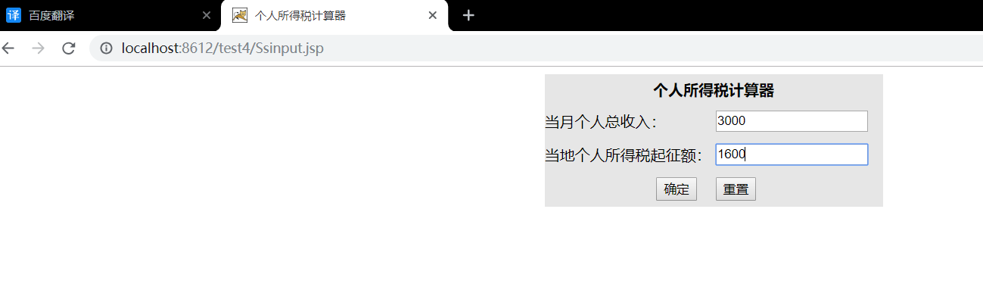

2.结果显示界面

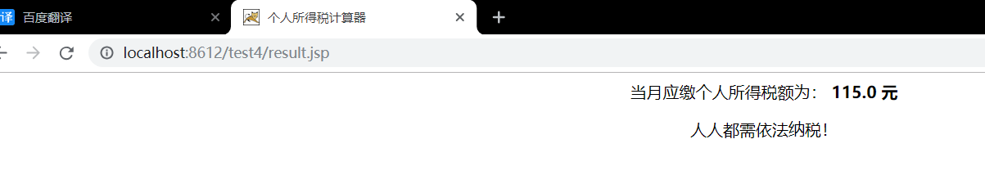

# 收获与问题

# 学习了在JSP中如何使用JavaBean。希望以后的学习能更加专注细心，学好专业基础知识。