**Java Web开发**

**实验八**

**作业报告**

|  |  |
| --- | --- |
| 学 院 | 计算机 |
| 所在系 班 级 | 2017软件工程系九班 |
| 学 号 姓 名 | 03170509 卢增伟 |
| 指 导 教 师 | 郭晓燕 |
| 完 成 时 间 | 2019年5月-10 |

# 实验题目

请用MVC模式完成一个功能：查询

# 分析与设计

**设计6个文件来实现mvc模式的查询程序**Model层Controller层( queryServlet.java)**，**Dao层( studentDao.java)：调用数据库内的信息，View层( Student.java):数据类，用来保存学生个人信息。**Form.jsp**:输入页面，通过此页面进行模糊查询。**result.jsp:**利用并将结果显示在此页面上。还需**数据库Sql**文件。

# 关键源码（部分）

1.controller层( queryServlet.java)

**package** ktest.Controller;

**import** java.io.IOException;

**import** java.util.ArrayList;

**import** javax.servlet.RequestDispatcher;

**import** javax.servlet.ServletContext;

**import** javax.servlet.ServletException;

**import** javax.servlet.annotation.WebServlet;

**import** javax.servlet.http.HttpServlet;

**import** javax.servlet.http.HttpServletRequest;

**import** javax.servlet.http.HttpServletResponse;

**import** ktest.dao.studentDao;

/**

* Servlet implementation class queryServlet

*/

@WebServlet("/queryServlet")

**public** **class** queryServlet **extends** HttpServlet {

**private** **static** **final** **long** ***serialVersionUID*** = 1L;

/**

* **@see** HttpServlet#HttpServlet()

*/

**public** queryServlet() {

**super**();

// **TODO** Auto-generated constructor stub

}

/**

* **@see** HttpServlet#doGet(HttpServletRequest request, HttpServletResponse response)

*/

**protected** **void** doGet(HttpServletRequest request, HttpServletResponse response) **throws** ServletException, IOException {

// **TODO** Auto-generated method stub

response.getWriter().append("Served at: ").append(request.getContextPath());

}

/**

* **@see** HttpServlet#doPost(HttpServletRequest request, HttpServletResponse response)

*/

**protected** **void** doPost(HttpServletRequest request, HttpServletResponse response) **throws** ServletException, IOException {

// **TODO** Auto-generated method stub

String sname = request.getParameter("sname");

**try** {

sname = **new** String(sname.getBytes("UTF-8"));

}**catch**(Exception ex) {ex.printStackTrace();}

studentDao studentDao = **new** studentDao();

ArrayList stus = studentDao.queryStuByName(sname);

request.setAttribute("stus", stus);

ServletContext application = **this**.getServletContext();

RequestDispatcher rd = application.getRequestDispatcher("/Result.jsp");

rd.forward(request,response);

}

}

2.Dao层( studentDao.java)

**package** ktest.dao;

**import** java.sql.*;

**import** java.util.ArrayList;

**import** ktest.vo.Student;

**public** **class** studentDao {

**private** Connection connect = **null** ;

**public** **void** initConnection(){

**try** {

Class.*forName*("com.mysql.jdbc.Driver");

System.***out***.println("Success loading Mysql Driver!");

}

**catch** (Exception e) {

System.***out***.print("Error loading Mysql Driver!");

e.printStackTrace();

}

**try** {

connect = DriverManager.*getConnection*( "jdbc:mysql://localhost:3306/class","root","123456");

System.***out***.println("Success connect Mysql server!");

}

**catch** (Exception e) {

System.***out***.print("get data error!");

e.printStackTrace();

}

}

**public** ArrayList queryStuByName(String sname) {

ArrayList stus = **new** ArrayList();

String sql = "Select Name, City, Age, Sex From city where Name LIKE '%" + sname + "%' ";

**try** {

**this**.initConnection();

ResultSet rs = connect.createStatement().executeQuery(sql);

**while**(rs.next()) {

Student stu = **new** Student();

stu.setStuname(rs.getString("Name"));

stu.setStucity(rs.getString("City"));

stu.setStuage(rs.getString("Age"));

stu.setStusex(rs.getString("Sex"));

stus.add(stu);

}

}**catch**(Exception ex) {ex.printStackTrace();}

**finally** {

**this**.closeConnection();

}

**return** stus;

}

**public** **void** closeConnection() {

**try** {

**if**(connect!=**null**) {

connect.close();

connect = **null**;

}

}

**catch**(Exception e) {e.printStackTrace();}

}

}

3.View层( Student.java)

**package** ktest.vo;

**public** **class** Student {

**private** String stuname;

**private** String stucity;

**private** String stuage;

**private** String stusex;

**public** String getStuname() {

**return** stuname;

}

**public** **void** setStuname(String stuname) {

**this**.stuname = stuname;

}

**public** String getStucity() {

**return** stucity;

}

**public** **void** setStucity(String stucity) {

**this**.stucity = stucity;

}

**public** String getStuage() {

**return** stuage;

}

**public** **void** setStuage(String stuage) {

**this**.stuage = stuage;

}

**public** String getStusex() {

**return** stusex;

}

**public** **void** setStusex(String stusex) {

**this**.stusex = stusex;

}

}

（4）（Form.jsp）

<%@ page language=*"java"* import=*"java.util.*"* pageEncoding=*"UTF-8"*%>

<%

String path = request.getContextPath();

String basePath = request.getScheme()+"://"+request.getServerName()+":"+request.getServerPort()+path+"/";

%>

<!DOCTYPE HTML PUBLIC "-//W3C//DTD HTML 4.01 Transitional//EN">

<html>

<head>

<base href=*"*<%=basePath%>*"*>

<title>My JSP 'Form.jsp' starting page</title>

<meta http-equiv=*"pragma"* content=*"no-cache"*>

<meta http-equiv=*"cache-control"* content=*"no-cache"*>

<meta http-equiv=*"expires"* content=*"0"*>

<meta http-equiv=*"keywords"* content=*"keyword1,keyword2,keyword3"*>

<meta http-equiv=*"description"* content=*"This is my page"*>

<!--

<link rel="stylesheet" type="text/css" href="styles.css">

-->

</head>

<body>

查询：<br>

<form action = *"queryServlet"* method = *"post"*>

请您输入学生姓名：<input name=*"sname"*>

<input type=*"submit"* value=*"查询"*>

</body>

</html>

（5）（Result.jsp）

%@ page language=*"java"* import=*"java.util.*"* pageEncoding=*"UTF-8"* import=*"ktest.vo.Student"* %>

<%

String path = request.getContextPath();

String basePath = request.getScheme()+"://"+request.getServerName()+":"+request.getServerPort()+path+"/";

%>

<!DOCTYPE HTML PUBLIC "-//W3C//DTD HTML 4.01 Transitional//EN">

<html>

<head>

<base href=*"*<%=basePath%>*"*>

<title>My JSP 'queryResult.jsp' starting page</title>

<meta http-equiv=*"pragma"* content=*"no-cache"*>

<meta http-equiv=*"cache-control"* content=*"no-cache"*>

<meta http-equiv=*"expires"* content=*"0"*>

<meta http-equiv=*"keywords"* content=*"keyword1,keyword2,keyword3"*>

<meta http-equiv=*"description"* content=*"This is my page"*>

<!--

<link rel="stylesheet" type="text/css" href="styles.css">

-->

</head>

<body>

显示结果：<br>

<%

//表示服务端代码

ArrayList stus =(ArrayList)request.getAttribute("stus");

%>

<table bgcolor=*"#C0C0C0"*>

<tr>

<td>name</td>

<td>City</td>

<td>Age</td>

<td>Sex</td>

</tr>

<%

**for**(**int** i=0;i<stus.size();i++){

Student stu = (Student)stus.get(i);

%>

<tr>

<td><%=stu.getStuname() %></td>

<td><%=stu.getStucity() %></td>

<td><%=stu.getStuage() %></td>

<td><%=stu.getStusex() %></td>

</tr>

<%

}

%>

</table>

</body>

</html>

（6）数据库文件

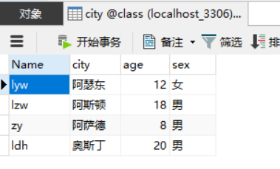

# 运行效果图

1. 输入界面

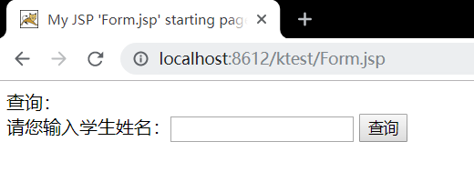

2.结果显示界面

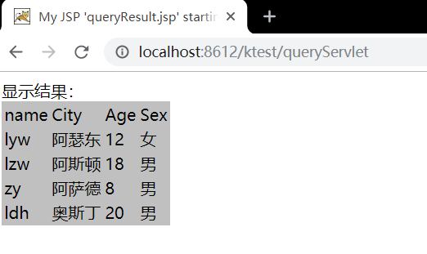

# 收获与问题

尝试编写MVC模式的查询功能程序