**Java Web开发**

**实验八**

**作业报告**

|  |  |
| --- | --- |
| 学 院 | 计算机 |
| 所在系 班 级 | 2017软件工程系10班 |
| 学 号 姓 名 | 04171723曾雪娟 |
| 指 导 教 师 | 郭晓燕 |
| 完 成 时 间 | 2018年5月- |

# 实验题目

请用模型2MVC模式完成1个功能，功能自选，例如：登录、注册、发帖、计算税收等；

# 分析与设计

设计一个servlet：salary_servlet用来做控制层，进行数据的判断；一个javabean：test8_count：对数据进行存储和计算；两个jsp：test8_salary.jsp，test8_input.jsp，对收入进行输入和输出。

# 关键源码（部分）

package test8;

import java.io.IOException;

import java.io.PrintWriter;

import javax.servlet.ServletException;

import javax.servlet.http.HttpServlet;

import javax.servlet.http.HttpServletRequest;

import javax.servlet.http.HttpServletResponse;

import javax.servlet.http.HttpSession;

import shopping.Chart;

import test7.test7_count;

public class salary_servlet extends HttpServlet {

public salary_servlet() {

super();

}

public void destroy() {

super.destroy(); // Just puts "destroy" string in log

// Put your code here

}

public void doGet(HttpServletRequest request, HttpServletResponse response)

throws ServletException, IOException {

response.setContentType("text/html");

doPost(request, response);

}

public void doPost(HttpServletRequest request, HttpServletResponse response)

throws ServletException, IOException {

response .setContentType("text/html;charset=utf-8");

HttpSession session =request .getSession() ;

request.setCharacterEncoding("utf-8") ;

double Salary=Double.valueOf(request.getParameter("salar_y"));

PrintWriter out=response.getWriter();

test8_count counts=new test8_count();

if(Salary>0){

request.setAttribute("Salary",Salary);

double count=counts.count(Salary);

session.setAttribute("count",count);

request.getRequestDispatcher("test8_input.jsp").forward(request, response);

}

else{

request.getRequestDispatcher("test8_salary.jsp").forward(request, response);

out.println("输入的值为空");

}

}

public void init() throws ServletException {

// Put your code here

}

}

package test8;

public class test8_count {

public double Salary;

public double getSalary() {

return Salary;

}

public void setSalary(double salary) {

Salary = salary;

}

public test8_count(){

}

public double count(double salary){

double dr;

double sui=0.0;

dr=salary-1600;

if(0<dr&&dr<=500){

sui=dr*0.05;

}

if(500<dr&&dr<=3000){

sui=dr*0.1-25;

}

if(3000<dr&&dr<=5000){

sui=dr*0.15-125;

}

if(5000<dr&&dr<=20000){

sui=dr*0.2-375;

}

if(20000<dr&&dr<=40000){

sui=dr*0.25-1375;

}

if(40000<dr&&dr<=60000){

sui=dr*0.3-3375;

}

if(60000<dr&&dr<=80000){

sui=dr*0.35-6375;

}

if(80000<dr&&dr<=100000){

sui=dr*0.4-10375;

}

if(dr>100000)

{

sui=dr*0.45-15375;

}

return sui;

}

}

<%@ page contentType=*"text/html;charset=UTF-8"* language=*"java"* %>

<jsp:useBean id=*"person"* class=*"test8.test8_count"* scope=*"session"*/>

<jsp:setProperty name=*"person"* property=*"salary"* param=*"salar_y"*/>

<%--<%int salary=(int)person.getSalary();--%>

<html>

<head>

<title>缴税金额</title>

</head>

<body>

<h1>您的收入是:

${Salary}

</h1>

<h1>您需要交的税是:

${count}

</h1>

<h1>实际收入:

${person.salary-count}

</h1>

</body>

</html>

<%@ page contentType=*"text/html;charset=UTF-8"* language=*"java"* %>

<html>

<head>

<title>收入</title>

</head>

<body>

<form action=*"salary_servlet"* method=*"post"*>

您的收入:<input type=*"text"* name=*"salar_y"*>

<input type=*"submit"* value=*"提交"*>

</form>

</body>

</html>

# 运行效果图

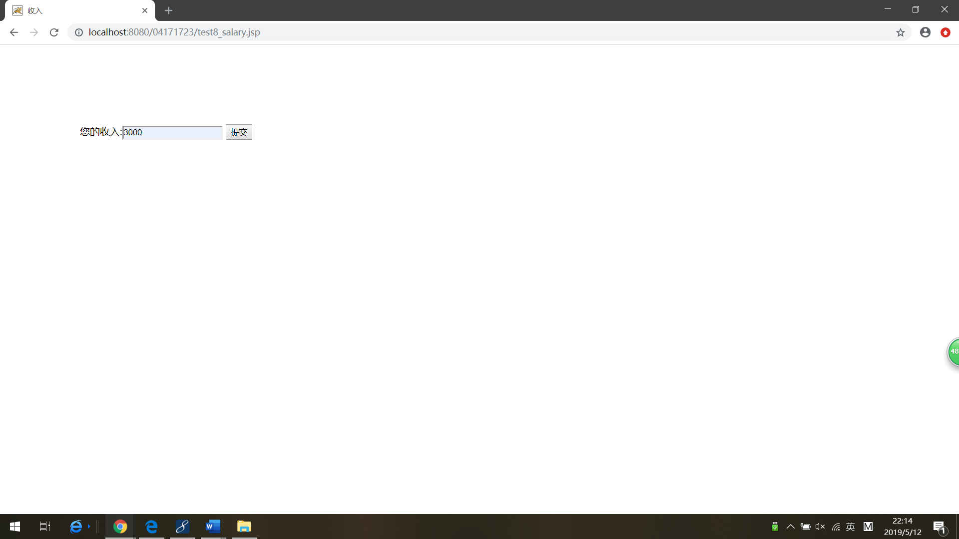

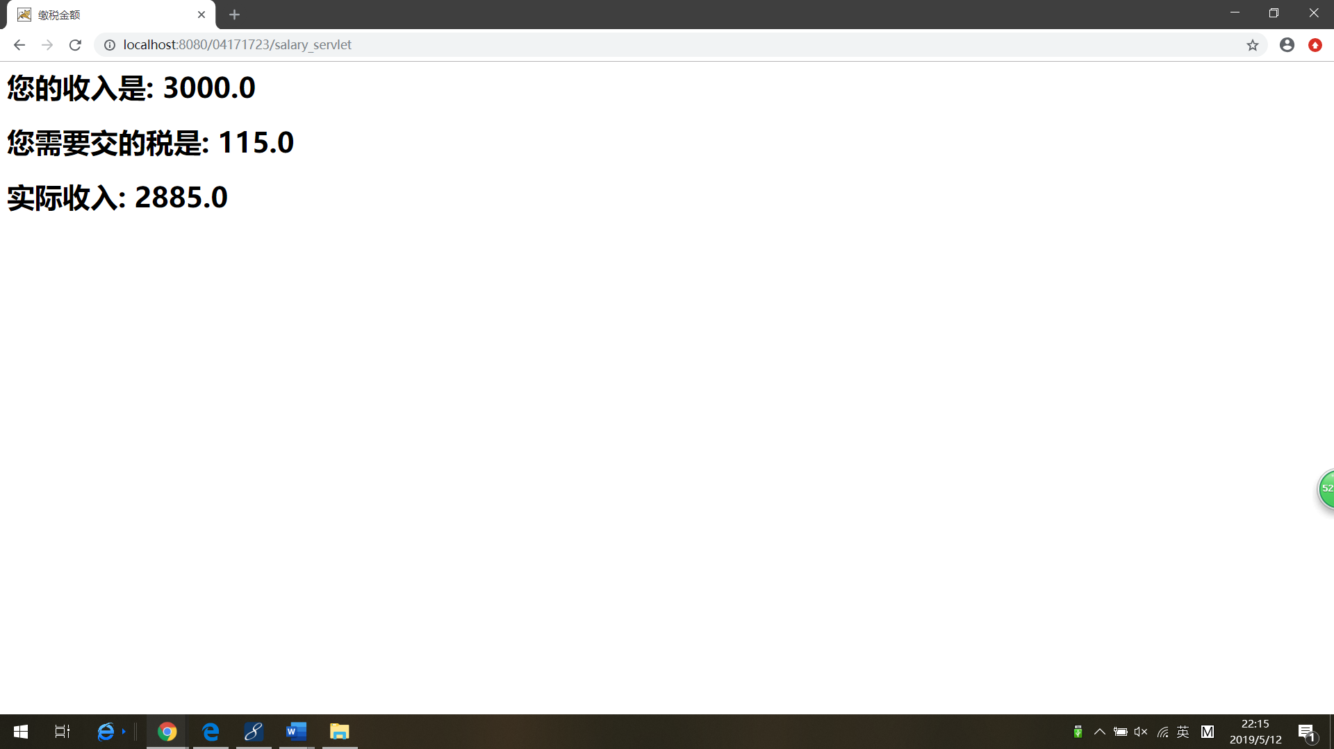

# 收获与问题

理解了MVC模式的基本思想；能掌握MVC模式的编程。