**Java Web开发**

**实验八**

**作业报告**

|  |  |
| --- | --- |
| 学 院 | 计算机 |
| 所在系 班 级 | 2017软件工程系9班 |
| 学 号 姓 名 | 04172125莫君炜 |
| 指 导 教 师 | 郭晓燕，罗永生 |
| 完 成 时 间 | 2018年4月- |

# 实验题目

1、（必做）请用模型2MVC模式完成1个功能，功能自选，例如：登录、注册、发帖、计算税收等；

# 分析与设计

使用MVC模式：设计一个功能为查询某公司各部门的员工信息：

* + 1. 创建（jsp）Select.jsp：----用于提交表单；
    2. 创建（JavaBean）PepoleInformation.java------用于设置，获取员工信息；
    3. 创建（JavaBean）AddInformation.java------用于作业务处理层；
    4. 创建（Servlet）Addpepole.java------用于接受表单信息，调用方法获得结果，并将结果保存在session域；
    5. 创建（jsp）ShowInformation.jsp------用于获取想要查询的部门信息，输出显示结果在页面中。

# 关键源码（部分）

Web.xml:

<?xml version=*"1.0"* encoding=*"UTF-8"*?>

<web-app xmlns:xsi=*"http://www.w3.org/2001/XMLSchema-instance"*

xmlns=*"http://xmlns.jcp.org/xml/ns/javaee"*

xsi:schemaLocation=*"http://xmlns.jcp.org/xml/ns/javaee*

*http://xmlns.jcp.org/xml/ns/javaee/web-app_3_1.xsd"*

version=*"3.1"*>

<servlet>

<servlet-name>Addpepole</servlet-name>

<servlet-class>ex8.Addpepole</servlet-class>

</servlet>

<servlet-mapping>

<servlet-name>Addpepole</servlet-name>

<url-pattern>/Addpepole.view</url-pattern>

</servlet-mapping>

</web-app>

Select.jsp:

<body>

<form action=*"*${pageContext.request.contextPath }*/Addpepole.view"* method=*"post"*>

<strong>请选择你想查找的部门信息：</strong><br>

<select name=*"DeptName"* >

<option value=*"financialDept"*>财务部</option>

<option value=*"HRDept"*>人事部</option>

<option value=*"InformationDept"*>信息部</option>

<option value=*"SaleDept"*>营销部</option>

</select>

<input type=*"submit"* value=*"查询"* name=*"submit"* >

</form>

</body>

PepoleInformation.java:

**package** ex8;

**public** **class** P**epoleInformation** {

**private** String name;

**private** String age;

**private** String gender;

**private** String position;

**private** String workingYears;

**private** String salary;

**public** PepoleInformation(){ }

**public** PepoleInformation(String name,String age,String gender,String position,

String workingYears,String salary)

{

**this**.name=name;

**this**.age=age;

**this**.gender=gender;

**this**.position=position;

**this**.workingYears=workingYears;

**this**.salary=salary;

}

**public** String getName() {

**return** name;

}

**public** String getAge() {

**return** age;

}

**public** String getGender() {

**return** gender;

}

**public** String getPosition() {

**return** position;

}

**public** String getWorkingYears() {

**return** workingYears;

}

**public** String getSalary() {

**return** salary;

}

}

AddInformation.java:

**package** ex8;

**import** java.util.ArrayList;

**import** java.util.List;

**public** **class** AddInformation {

**private** PepoleInformation pi;

public AddInformation(){ }

**public** List<PepoleInformation> financialDept_pepole()

{

List<PepoleInformation> list=**new** ArrayList<PepoleInformation>();

PepoleInformation pi1=**new** PepoleInformation("Mirah","30","female","职员","3","8000");

list.add(pi1);

PepoleInformation pi2=**new** PepoleInformation("Wingwing","28","female","职员","3","8800");

list.add(pi2);

PepoleInformation pi3=**new** PepoleInformation("Mary","27","male","职员","2","7800");

list.add(pi3);

PepoleInformation pi4=**new** PepoleInformation("ZhangXiFan","32","male","经理","5","18000");

list.add(pi4);

PepoleInformation pi5=**new** PepoleInformation("Lucas","30","male","经理","4","20000");

list.add(pi5);

**return** list;

}

**public** List<PepoleInformation> HRDept_pepole()

{

List<PepoleInformation> list=**new** ArrayList<PepoleInformation>();

PepoleInformation pi1=**new** PepoleInformation("ZhouZiHao","31","male","职员","3","8000");

list.add(pi1);

PepoleInformation pi2=**new** PepoleInformation("XianYu","32","female","职员","3","8800");

list.add(pi2);

PepoleInformation pi3=**new** PepoleInformation("CaiHan","29","female","职员","2","7800");

list.add(pi3);

PepoleInformation pi4=**new** PepoleInformation("LuoJiaXin","30","female","经理","5","18000");

list.add(pi4);

PepoleInformation pi5=**new** PepoleInformation("XueYueMing","33","male","经理","5","20000");

list.add(pi5);

**return** list;

}

**public** List<PepoleInformation> InformationDept_pepole()

{

List<PepoleInformation> list=**new** ArrayList<PepoleInformation>();

PepoleInformation pi1=**new** PepoleInformation("YangDi","31","male","职员","3","8000");

list.add(pi1);

PepoleInformation pi2=**new** PepoleInformation("WuGui","32","female","职员","3","8800");

list.add(pi2);

PepoleInformation pi3=**new** PepoleInformation("OuZhanHong","29","female","职员","2","7800");

list.add(pi3);

PepoleInformation pi4=**new** PepoleInformation("OuJianJie","30","female","经理","5","18000");

list.add(pi4);

PepoleInformation pi5=**new** PepoleInformation("LinHanghui","33","male","经理","5","20000");

list.add(pi5);

**return** list;

}

**public** List<PepoleInformation> SaleDept_pepole()

{

List<PepoleInformation> list=**new** ArrayList<PepoleInformation>();

PepoleInformation pi1=**new** PepoleInformation("Tom","31","male","职员","3","8000");

list.add(pi1);

PepoleInformation pi2=**new** PepoleInformation("Kary","32","female","职员","3","8800");

list.add(pi2);

PepoleInformation pi3=**new** PepoleInformation("Mary","29","female","职员","2","7800");

list.add(pi3);

PepoleInformation pi4=**new** PepoleInformation("Mirah","30","female","经理","5","18000");

list.add(pi4);

PepoleInformation pi5=**new** PepoleInformation("Jack","33","male","经理","5","20000");

list.add(pi5);

**return** list;

}

}

Addpepole.java:

**package** ex8;

**import** java.io.IOException;

**import** java.util.List;

**import** javax.servlet.ServletException;

**import** javax.servlet.annotation.WebServlet;

**import** javax.servlet.http.HttpServlet;

**import** javax.servlet.http.HttpServletRequest;

**import** javax.servlet.http.HttpServletResponse;

**import** javax.servlet.http.HttpSession;

**public** **class** Addpepole **extends** HttpServlet {

**protected** **void** doGet(HttpServletRequest request, HttpServletResponse response) **throws** ServletException, IOException {

doPost(request, response);

}

**protected** **void** doPost(HttpServletRequest request, HttpServletResponse response) **throws** ServletException, IOException {

String DeptName=request.getParameter("DeptName");

HttpSession session=request.getSession();

AddInformation ai=**null**;

List<PepoleInformation> list=**null**;

session.setAttribute("DeptName", DeptName);

**if**("financialDept".equals(DeptName))

{

ai=**new** AddInformation();

list = ai.financialDept_pepole();

}

**else** **if**("HRDept".equals(DeptName))

{

ai=**new** AddInformation();

list = ai.HRDept_pepole();

}

**else** **if**("InformationDept".equals(DeptName))

{

ai=**new** AddInformation();

list = ai.InformationDept_pepole();

}

**else** **if**("SaleDept".equals(DeptName))

{

ai=**new** AddInformation();

list = ai.SaleDept_pepole();

}

session.setAttribute("list", list);

response.sendRedirect("ShowInformation.jsp");

}

}

ShowInformation.jsp:

<%@ page language=*"java"* import=*"java.util.*"* pageEncoding=*"UTF-8"*%>

<%@ taglib prefix=*"c"* uri=*"http://java.sun.com/jsp/jstl/core"* %>

<!DOCTYPE HTML PUBLIC "-//W3C//DTD HTML 4.01 Transitional//EN">

<html>

<head>

<title>ShowInformation.jsp</title>

<meta http-equiv=*"pragma"* content=*"no-cache"*>

<meta http-equiv=*"cache-control"* content=*"no-cache"*>

<meta http-equiv=*"expires"* content=*"0"*>

<meta http-equiv=*"keywords"* content=*"keyword1,keyword2,keyword3"*>

<meta http-equiv=*"description"* content=*"This is my page"*>

</head>

<body>

<strong>您所要查找的${DeptName }的所有员工信息为：</strong>

<table border=*"1"*>

<tr>

<th>姓名</th>

<th>年龄</th>

<th>性别</th>

<th>职位</th>

<th>工龄</th>

<th>薪水</th>

</tr>

<c:forEach var=*"pepole"* items=*"*${sessionScope.list }*"*>

<tr>

<td><c:out value=*"*${pepole.name }*"* default=*"name"*/></td>

<td><c:out value=*"*${pepole.age }*"* default=*"age"*/></td>

<td><c:out value=*"*${pepole.gender }*"* default=*"gender"*/></td>

<td><c:out value=*"*${pepole.position }*"* default=*"position"*/></td>

<td><c:out value=*"*${pepole.workingYears }*"* default=*"workingYears"*/></td>

<td><c:out value=*"*${pepole.salary }*"* default=*"salary"*/></td>

</tr>

</c:forEach>

</table>

</body>

</html>

# 运行效果图

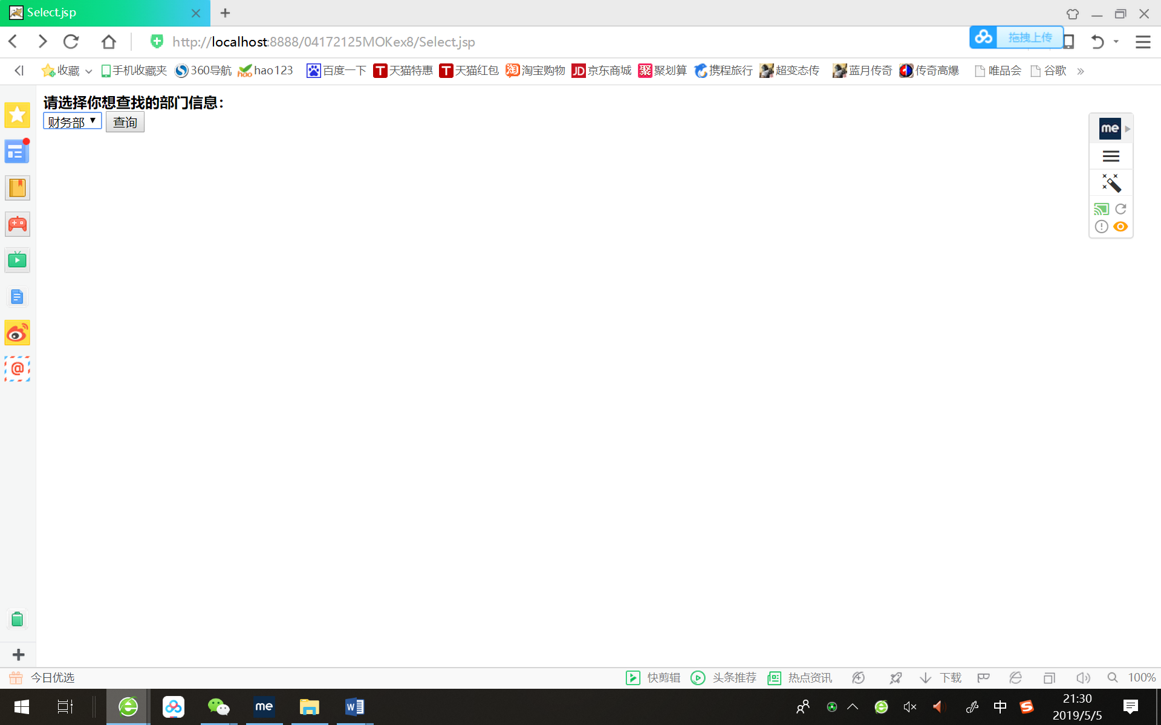

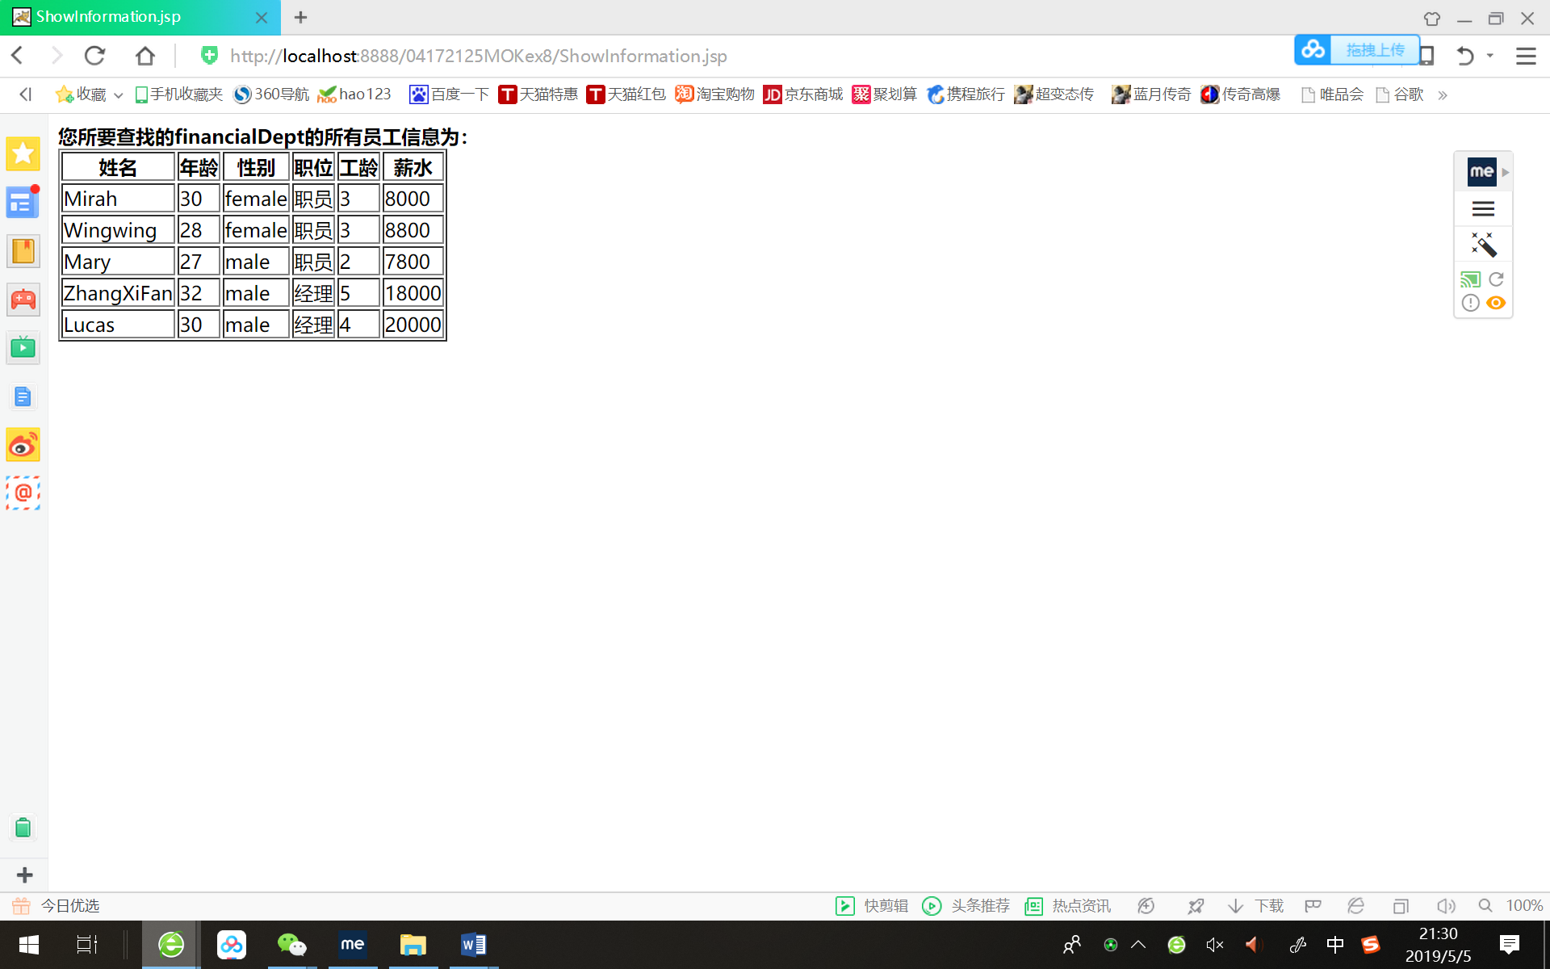

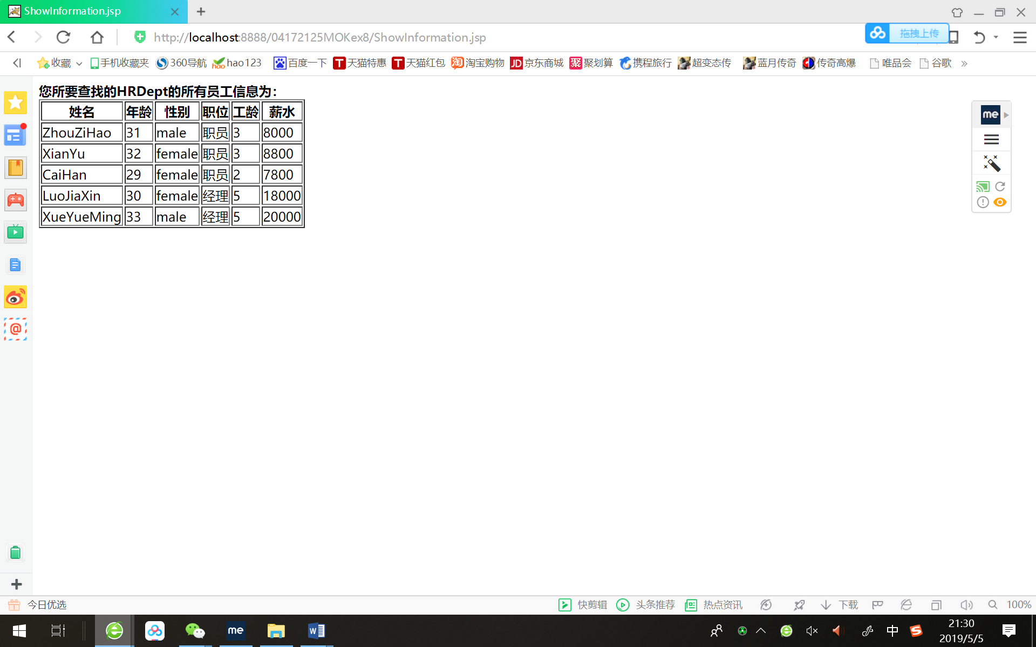

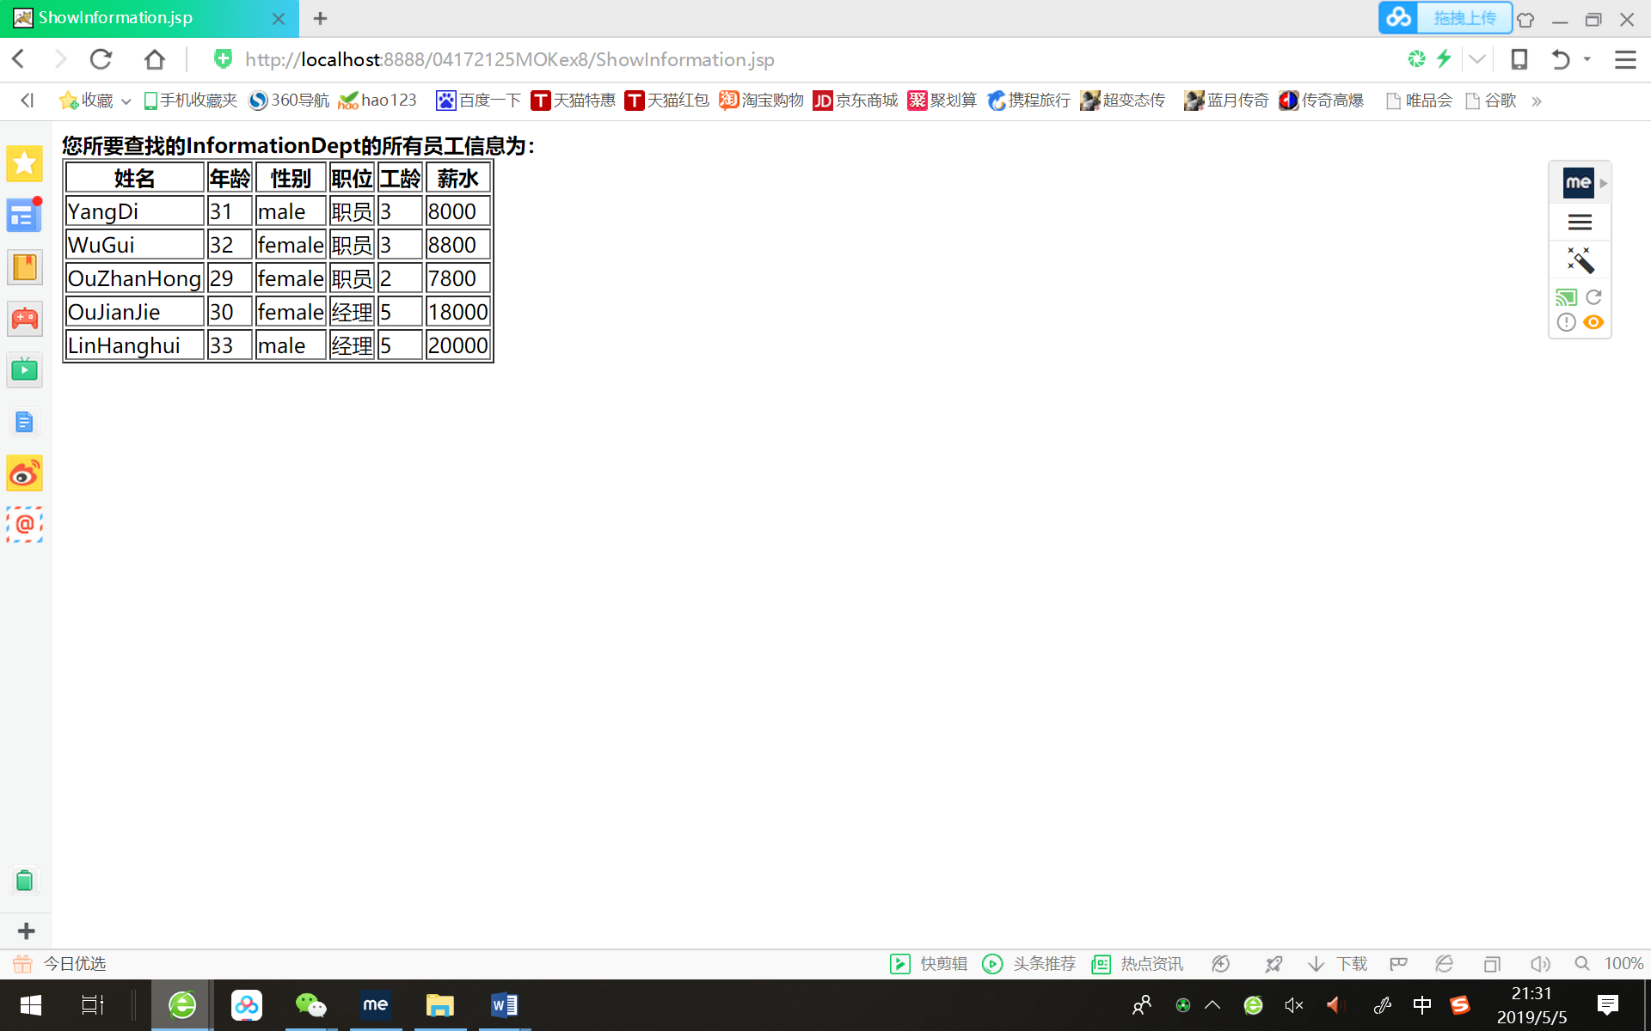 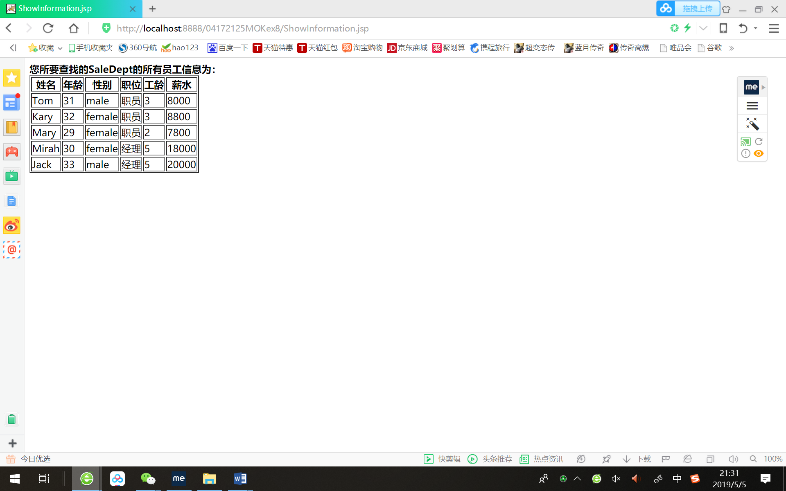

# 收获与问题

已经熟悉掌握用MVC模式编写代码！！！！