**Java Web开发**

**实验八**

**作业报告**

|  |  |
| --- | --- |
| 学 院 | 计算机 |
| 所在系 班 级 | 2017软件工程系10班 |
| 学 号 姓 名 | 06170308 陈科泽 |
| 指 导 教 师 | 罗永升 |
| 完 成 时 间 | 2018年5月-4号 |

# 实验题目

1、理解会话的原理和HttpSession会话期；

1. 掌握如何使用URL重写；

3、掌握如何使用HttpSession会话管理

1. 第四章课后练习3购物车，实现一个购物车应用程序，可以购物，显示购物数量并查看购物车内容。（此题模版test4E，提供给大家参考。）

# 分析与设计

模型2MVC完成税收功能，Index.jsp商品显示首页，details.jsp商品详细信息，购买等，items.java是javabean存放书本的各种信息，DBHelper.java连接数据库，failure.jsp显示失败页面，success.jsp显示成功页面,cart.jsp显示购物车页面。用EL表达式来代替之前的数据对象调用。

# 关键源码（部分）

必做

Cal.jsp

<%@ page language=*"java"* import=*"java.util.*"* contentType=*"text/html; charset=utf-8"*%>

<%

String path = request.getContextPath();

String basePath = request.getScheme()+"://"+request.getServerName()+":"+request.getServerPort()+path+"/";

%>

<!DOCTYPE HTML PUBLIC "-//W3C//DTD HTML 4.01 Transitional//EN">

<html>

<head>

<base href=*"*<%=basePath%>*"*>

<title>My JSP 'cal.jsp' starting page</title>

<meta http-equiv=*"pragma"* content=*"no-cache"*>

<meta http-equiv=*"cache-control"* content=*"no-cache"*>

<meta http-equiv=*"expires"* content=*"0"*>

<meta http-equiv=*"keywords"* content=*"keyword1,keyword2,keyword3"*>

<meta http-equiv=*"description"* content=*"This is my page"*>

<!--

<link rel="stylesheet" type="text/css" href="styles.css">

-->

</head>

<body>

<form action=*"calculate.view"* method=*"post"* name=*"form"*>

输入您的工资：<input type=*"text"* id=*"cash"* name=*"cash"*>

<input type=*"submit"* value=*"提交"*>

</form>

</body>

</html>

Calculate.java

package sevlet_cal;

import java.io.IOException;

import java.io.PrintWriter;

import javax.servlet.ServletException;

import javax.servlet.annotation.WebServlet;

import javax.servlet.http.HttpServlet;

import javax.servlet.http.HttpServletRequest;

import javax.servlet.http.HttpServletResponse;

@WebServlet("/calculate.view")

public class calculate extends HttpServlet {

public void doGet(HttpServletRequest request, HttpServletResponse response)

throws ServletException, IOException {

this.doPost(request, response);

}

public void doPost(HttpServletRequest request, HttpServletResponse response)

throws ServletException, IOException {

response.setCharacterEncoding("utf-8");

request.setCharacterEncoding("utf-8");

calbean mul = new calbean();

double a = Double.parseDouble(request.getParameter("cash"));

double tax = mul.cal(a);

System.out.println(tax);

PrintWriter out = response.getWriter();

out.print("<script type='text/javascript'> alert('您需要交税"+tax+"元');document.location.href='cal.jsp';</script>");

}

}

Calbean.java

**package** sevlet_cal;

**public** **class** calbean {

**private** **double** money;

**private** **double** tax;

**public** **void** calbean(){

}

**public** **double** getMoney() {

**return** money;

}

**public** **void** setMoney(**double** money) {

**this**.money = money;

}

**public** **double** getTax() {

**return** tax;

}

**public** **void** setTax(**double** tax) {

**this**.tax = tax;

}

**public** **double** cal(**double** m){

**if**(m<1600){

**return** 0;

}

**else** **if**(m<=2100){

**return** (m-1600)*0.05;

}**else** **if**(m<=4600){

**return** (m-1600)*0.1;

}**else** **if**(m<=6600){

**return** (m-1600)*0.15;

}**else** **if**(m<=21600){

**return** (m-1600)*0.2;

}**else** **if**(m<=41600){

**return** (m-1600)*0.25;

}**else** **if**(m<=61600){

**return** (m-1600)*0.3;

}**else** **if**(m<=81600){

**return** (m-1600)*0.35;

}**else** **if**(m<=101600){

**return** (m-1600)*0.4;

}**else**{

**return** (m-1600)*0.45;

}

}

}

选做

Index.jsp商品总页面

<%@ page language=*"java"* import=*"java.util.*"* contentType=*"text/html; charset=utf-8"*%>

<%@ page import=*"entity.Items"*%>

<%@ page import=*"dao.ItemsDAO"*%>

<%

String path = request.getContextPath();

String basePath = request.getScheme()+"://"+request.getServerName()+":"+request.getServerPort()+path+"/";

%>

<!DOCTYPE HTML PUBLIC "-//W3C//DTD HTML 4.01 Transitional//EN">

<html>

<head>

<base href=*"*<%=basePath%>*"*>

<title>My JSP 'index.jsp' starting page</title>

<meta http-equiv=*"pragma"* content=*"no-cache"*>

<meta http-equiv=*"cache-control"* content=*"no-cache"*>

<meta http-equiv=*"expires"* content=*"0"*>

<meta http-equiv=*"keywords"* content=*"keyword1,keyword2,keyword3"*>

<meta http-equiv=*"description"* content=*"This is my page"*>

<!--

<link rel="stylesheet" type="text/css" href="styles.css">

-->

<style type=*"text/css"*>

**hr**{

border-color:*FF7F00*;

}

**div**{

float:*left*;

margin: *10px*;

}

**div** **dd**{

margin:*0px*;

font-size:*10pt*;

}

**div** **dd***.dd_name*

{

color:*blue*;

}

**div** **dd***.dd_city*

{

color:*#000*;

}

</style>

</head>

<body>

<h1>商品展示</h1>

<hr>

<center>

<table width=*"750"* height=*"60"* cellpadding=*"0"* cellspacing=*"0"* border=*"0"*>

<tr>

<td>

<!-- 商品循环开始 -->

<%

ItemsDAO itemsDao = **new** ItemsDAO();

ArrayList<Items> list = itemsDao.getAllItems();

**if**(list!=**null**&&list.size()>0)

{

**for**(**int** i=0;i<list.size();i++)

{

request.setAttribute("names", list.get(i));

%>

<div>

<dl>

<dt>

<a href=*"details.jsp?id=*${names.getId() }*"*><img src=*"images/*${names.getPicture() }*"* width=*"120"* height=*"90"* border=*"1"*/></a>

</dt>

<dd class=*"dd_name"*>${names.getName() }</dd>

<dd class=*"dd_city"*>产地:${names.getCity() }&nbsp;&nbsp;价格:￥ ${names.getPrice() }</dd>

</dl>

</div>

<!-- 商品循环结束 -->

<%

}

}

%>

</td>

</tr>

</table>

</center>

</body>

</html>

Success.jsp加入购物车成功页面

<%@ page language=*"java"* import=*"java.util.*"* contentType=*"text/html; charset=utf-8"*%>

<%

String path = request.getContextPath();

String basePath = request.getScheme()+"://"+request.getServerName()+":"+request.getServerPort()+path+"/";

%>

<!DOCTYPE HTML PUBLIC "-//W3C//DTD HTML 4.01 Transitional//EN">

<html>

<head>

<base href=*"*<%=basePath%>*"*>

<title>My JSP 'success.jsp' starting page</title>

<meta http-equiv=*"pragma"* content=*"no-cache"*>

<meta http-equiv=*"cache-control"* content=*"no-cache"*>

<meta http-equiv=*"expires"* content=*"0"*>

<meta http-equiv=*"keywords"* content=*"keyword1,keyword2,keyword3"*>

<meta http-equiv=*"description"* content=*"This is my page"*>

<!--

<link rel="stylesheet" type="text/css" href="styles.css">

-->

</head>

<body>

<center>

<img src=*"images/add_cart_success.jpg"*/>

<hr>

<%

String id = request.getParameter("id");

String num = request.getParameter("num");

%>

您成功购买了<%=num%>件商品编号为<%=id%>的商品&nbsp;&nbsp;&nbsp;&nbsp;

<br>

<br>

<br>

</center>

</body>

</html>

Failure.jsp加入购物车失败页面

<%@ page language=*"java"* import=*"java.util.*"* contentType=*"text/html; charset=utf-8"*%>

<%

String path = request.getContextPath();

String basePath = request.getScheme()+"://"+request.getServerName()+":"+request.getServerPort()+path+"/";

%>

<!DOCTYPE HTML PUBLIC "-//W3C//DTD HTML 4.01 Transitional//EN">

<html>

<head>

<base href=*"*<%=basePath%>*"*>

<title>My JSP 'success.jsp' starting page</title>

<meta http-equiv=*"pragma"* content=*"no-cache"*>

<meta http-equiv=*"cache-control"* content=*"no-cache"*>

<meta http-equiv=*"expires"* content=*"0"*>

<meta http-equiv=*"keywords"* content=*"keyword1,keyword2,keyword3"*>

<meta http-equiv=*"description"* content=*"This is my page"*>

<!--

<link rel="stylesheet" type="text/css" href="styles.css">

-->

</head>

<body>

<center>

<img src=*"images/add_cart_failure.jpg"*/>

<hr>

<br>

<br>

<br>

</center>

</body>

</html>

Details.jsp商品详细信息显示

<%@ page language=*"java"* import=*"java.util.*"* contentType=*"text/html; charset=utf-8"* %>

<%@ page import=*"entity.Items"*%>

<%@ page import=*"dao.ItemsDAO"*%>

<%

String path = request.getContextPath();

String basePath = request.getScheme()+"://"+request.getServerName()+":"+request.getServerPort()+path+"/";

%>

<!DOCTYPE HTML PUBLIC "-//W3C//DTD HTML 4.01 Transitional//EN">

<html>

<head>

<base href=*"*<%=basePath%>*"*>

<title>My JSP 'details.jsp' starting page</title>

<meta http-equiv=*"pragma"* content=*"no-cache"*>

<meta http-equiv=*"cache-control"* content=*"no-cache"*>

<meta http-equiv=*"expires"* content=*"0"*>

<meta http-equiv=*"keywords"* content=*"keyword1,keyword2,keyword3"*>

<meta http-equiv=*"description"* content=*"This is my page"*>

<!--

<link rel="stylesheet" type="text/css" href="styles.css">

-->

<script type=*"text/javascript"* src=*"js/lhgcore.js"*></script>

<script type=*"text/javascript"* src=*"js/lhgdialog.js"*></script>

<script type=*"text/javascript"*>

**function** selflog_show(id)

{

**var** num = document.getElementById("number").value;

J.dialog.get({id: 'haoyue_creat',title: '购物成功',width: 1000,height:800, link: '<%=path%>/servlet/CartServlet?id='+id+'&num='+num+'&action=add', cover:true});

}

**function** add()

{

**var** num = parseInt(document.getElementById("number").value);

**if**(num<100)

{

document.getElementById("number").value = ++num;

}

}

**function** sub()

{

**var** num = parseInt(document.getElementById("number").value);

**if**(num>1)

{

document.getElementById("number").value = --num;

}

}

</script>

<style type=*"text/css"*>

**hr**{

border-color:*FF7F00*;

}

**div**{

float:*left*;

margin-left: *30px*;

margin-right:*30px*;

margin-top: *5px*;

margin-bottom: *5px*;

}

**div** **dd**{

margin:*0px*;

font-size:*10pt*;

}

**div** **dd***.dd_name*

{

color:*blue*;

}

**div** **dd***.dd_city*

{

color:*#000*;

}

**div** *#cart*

{

margin:*0px auto*;

text-align:*right*;

}

**span**{

padding:*0 2px*;border:*1px #c0c0c0 solid*;cursor:*pointer*;

}

**a**{

text-decoration: *none*;

}

</style>

</head>

<body>

<h1>商品详情</h1>

<a href=*"index.jsp"*>首页</a> >> <a href=*"index.jsp"*>商品列表</a>

<hr>

<center>

<table width=*"750"* height=*"60"* cellpadding=*"0"* cellspacing=*"0"* border=*"0"*>

<tr>

<!-- 商品详情 -->

<%

ItemsDAO itemDao = **new** ItemsDAO();

Items item = itemDao.getItemsById(Integer.parseInt(request.getParameter("id")));

**if**(item!=**null**)

{

request.setAttribute("item", item);

%>

<td width=*"70%"* valign=*"top"*>

<table>

<tr>

<td rowspan=*"5"*><img src=*"images/*${item.getPicture() }*"* width=*"200"* height=*"160"*/></td>

</tr>

<tr>

<td><B>${item.getName() }</B></td>

</tr>

<tr>

<td>产地：${item.getCity() }</td>

</tr>

<tr>

<td>价格：${item.getPrice() }￥</td>

</tr>

<tr>

<td>购买数量：<span id=*"sub"* onclick="sub();">-</span><input type=*"text"* id=*"number"* name=*"number"* value=*"1"* size=*"2"*/><span id=*"add"* onclick="add();">+</span></td>

</tr>

</table>

<div id=*"cart"*>

<img src=*"images/buy_now.png"*><a href=*"javascript:selflog_show(*${item.getId() }*)"*><img src=*"images/in_cart.png"*></a><a href=*"servlet/CartServlet?action=show"*><img src=*"images/view_cart.jpg"*/></a>

</div>

</td>

<%

}

%>

<%

String list ="";

//从客户端获得Cookies集合

Cookie[] cookies = request.getCookies();

//遍历这个Cookies集合

**if**(cookies!=**null**&&cookies.length>0)

{

**for**(Cookie c:cookies)

{

**if**(c.getName().equals("ListViewCookie"))

{

list = c.getValue();

}

}

}

list+=request.getParameter("id")+",";

//如果浏览记录超过1000条，清零.

String[] arr = list.split(",");

**if**(arr!=**null**&&arr.length>0)

{

**if**(arr.length>=1000)

{

list="";

}

}

Cookie cookie = **new** Cookie("ListViewCookie",list);

response.addCookie(cookie);

%>

<!-- 浏览过的商品 -->

<td width=*"30%"* bgcolor=*"#EEE"* align=*"center"*>

<br>

<b><font color=*"#FF7F00"*>您浏览过的商品</font></b><br>

<!-- 循环开始 -->

<%

ArrayList<Items> itemlist = itemDao.getViewList(list);

**if**(itemlist!=**null**&&itemlist.size()>0 )

{

System.out.println("itemlist.size="+itemlist.size());

**for**(Items i:itemlist)

{

request.setAttribute("i", i);

%>

<div>

<dl>

<dt>

<a href=*"details.jsp?id=*${i.getId() }*"*><img src=*"images/*${i.getPicture() }*"* width=*"120"* height=*"90"* border=*"1"*/></a>

</dt>

<dd class=*"dd_name"*>${i.getName() }</dd>

<dd class=*"dd_city"*>产地:${i.getCity() }&nbsp;&nbsp;价格:${i.getPrice() } ￥ </dd>

</dl>

</div>

<%

}

}

%>

<!-- 循环结束 -->

</td>

</tr>

</table>

</center>

</body>

</html>

Cart.jsp购物添加功能

<%@ page language=*"java"* import=*"java.util.*"* contentType=*"text/html; charset=utf-8"*%>

<%@ page import=*"entity.Cart"* %>

<%@ page import=*"entity.Items"* %>

<%

String path = request.getContextPath();

String basePath = request.getScheme()+"://"+request.getServerName()+":"+request.getServerPort()+path+"/";

%>

<!DOCTYPE HTML PUBLIC "-//W3C//DTD HTML 4.01 Transitional//EN">

<html>

<head>

<base href=*"*<%=basePath%>*"*>

<title>My JSP 'cart.jsp' starting page</title>

<meta http-equiv=*"pragma"* content=*"no-cache"*>

<meta http-equiv=*"cache-control"* content=*"no-cache"*>

<meta http-equiv=*"expires"* content=*"0"*>

<meta http-equiv=*"keywords"* content=*"keyword1,keyword2,keyword3"*>

<meta http-equiv=*"description"* content=*"This is my page"*>

<!--

<link rel="stylesheet" type="text/css" href="styles.css">

-->

<link type=*"text/css"* rel=*"stylesheet"* href=*"css/style1.css"* />

<script language=*"javascript"*>

**function** delcfm() {

**if** (!confirm("确认要删除？")) {

window.event.returnValue = **false**;

}

}

</script>

</head>

<body>

<h1>我的购物车</h1>

<a href=*"index.jsp"*>首页</a> >> <a href=*"index.jsp"*>商品列表</a>

<hr>

<div id=*"shopping"*>

<form action=*""* method=*""*>

<table>

<tr>

<th>商品名称</th>

<th>商品单价</th>

<th>商品价格</th>

<th>购买数量</th>

<th>操作</th>

</tr>

<%

//首先判断session中是否有购物车对象

**if**(request.getSession().getAttribute("cart")!=**null**)

{

%>

<!-- 循环的开始 -->

<%

Cart cart = (Cart)request.getSession().getAttribute("cart");

HashMap<Items,Integer> goods = cart.getGoods();

request.setAttribute("goods", goods);

Set<Items> items = goods.keySet();

Iterator<Items> it = items.iterator();

**while**(it.hasNext())

{

Items i = it.next();

request.setAttribute("i", i);

%>

<tr name=*"products"* id=*"product_id_1"*>

<td class=*"thumb"*><img src=*"images/*${i.getPicture()}*"* /><a href=*""*>${i.getName() }</a></td>

<td class=*"number"*>${i.getPrice() }</td>

<td class=*"price"* id=*"price_id_1"*>

<span>${i.getPrice()*goods.get(i) }</span>

<input type=*"hidden"* value=*""* />

</td>

<td class=*"number"*>

${goods.get(i) }

</td>

<td class=*"delete"*>

<a href=*"servlet/CartServlet?action=delete&id=*${i.getId() }*"* onclick="delcfm();">删除</a>

</td>

</tr>

<%

}

%>

<!--循环的结束-->

</table>

<div class=*"total"*><span id=*"total"*>总计：${cart.getTotalPrice() }￥</span></div>

<%

}

%>

<div class=*"button"*><input type=*"submit"* value=*""* /></div>

</form>

</div>

</body>

</html>

Cart.java 存放商品数量对象等信息

package entity;

import java.util.HashMap;

import java.util.Iterator;

import java.util.Map;

import java.util.Set;

//购物车类

public class Cart {

//购买商品的集合

private HashMap<Items,Integer> goods;

//购物车的总金额

private double totalPrice;

//构造方法

public Cart()

{

goods = new HashMap<Items,Integer>();

totalPrice = 0.0;

}

public HashMap<Items, Integer> getGoods() {

return goods;

}

public void setGoods(HashMap<Items, Integer> goods) {

this.goods = goods;

}

public double getTotalPrice() {

return totalPrice;

}

public void setTotalPrice(double totalPrice) {

this.totalPrice = totalPrice;

}

//添加商品进购物车的方法

public boolean addGoodsInCart(Items item ,int number)

{

if(goods.containsKey(item))//equal重写

{

goods.put(item, goods.get(item)+number);

}

else

{

goods.put(item, number);

}

calTotalPrice(); //重新计算购物车的总金额

return true;

}

//删除商品的方法

public boolean removeGoodsFromCart(Items item)

{

goods.remove(item);

calTotalPrice(); //重新计算购物车的总金额

return true;

}

//统计购物车的总金额

public double calTotalPrice()

{

double sum = 0.0;

Set<Items> keys = goods.keySet(); //获得键的集合

Iterator<Items> it = keys.iterator(); //获得迭代器对象

while(it.hasNext())

{

Items i = it.next();

sum += i.getPrice()* goods.get(i);

}

this.setTotalPrice(sum); //设置购物车的总金额

return this.getTotalPrice();

}

public static void main(String[] args) {

//先创建两个商品对象

Items i1 = new Items(1,"沃特篮球鞋","温州",200,500,"001.jpg");

Items i2 = new Items(2,"李宁运动鞋","广州",300,500,"002.jpg");

Items i3 = new Items(1,"沃特篮球鞋","温州",200,500,"001.jpg");

Cart c = new Cart();

c.addGoodsInCart(i1, 1);

c.addGoodsInCart(i2, 2);

//再次购买沃特篮球鞋，购买3双

c.addGoodsInCart(i3, 3);

//变量购物商品的集合

Set<Map.Entry<Items, Integer>> items= c.getGoods().entrySet();

for(Map.Entry<Items, Integer> obj:items)

{

System.out.println(obj);

}

System.out.println("购物车的总金额："+c.getTotalPrice());

}

}

# 运行效果图

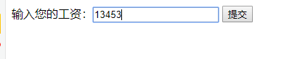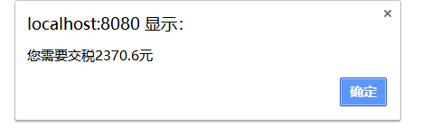

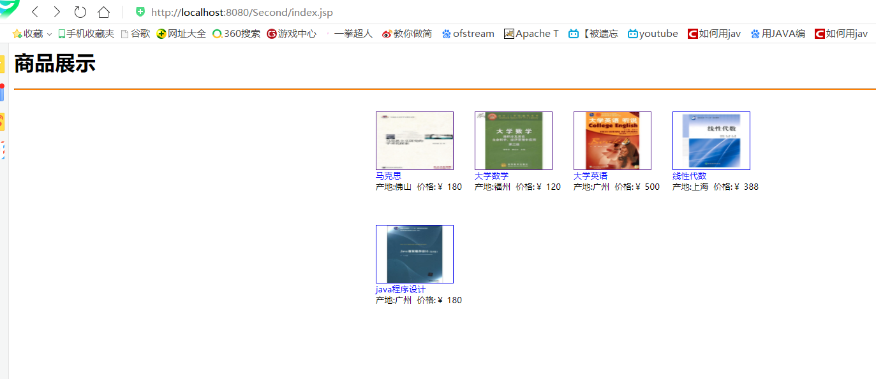

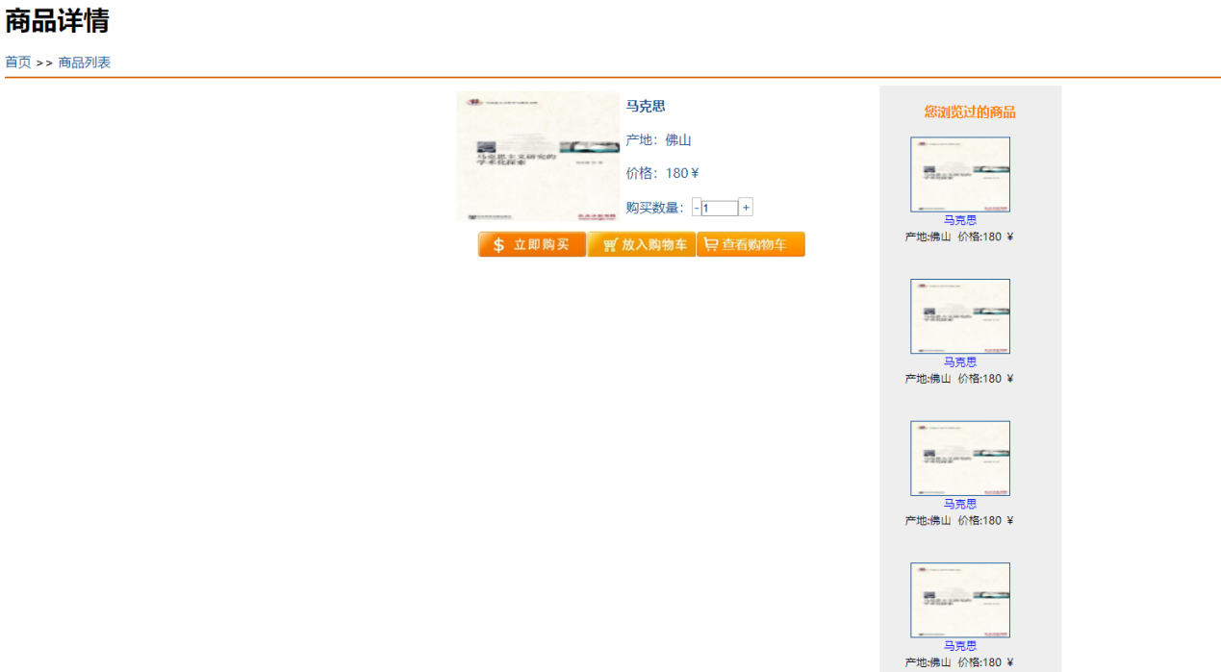

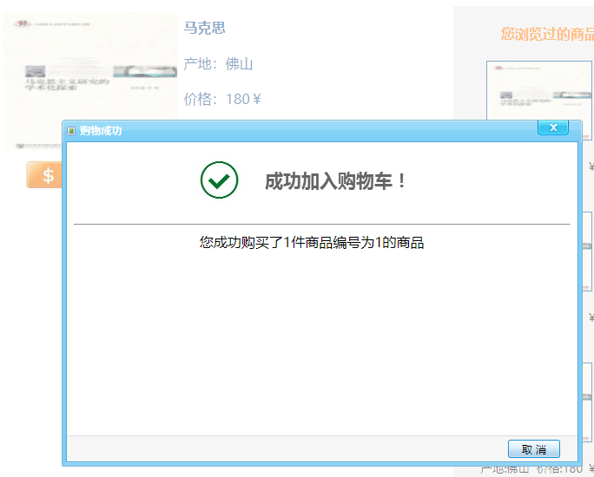

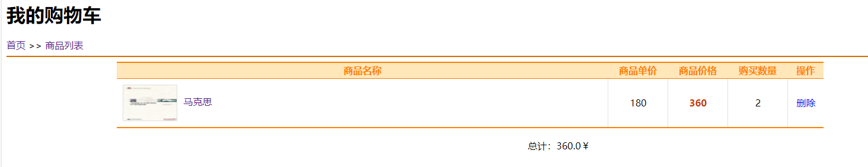

# 收获与问题

用EL表达式能更加简单地编写代码。