**Java Web开发**

**实验八**

**作业报告**

|  |  |
| --- | --- |
| 学 院 | 计算机 |
| 所在系 班 级 | 2017软件工程系9班 |
| 学 号 姓 名 | 10171421钟质昌 |
| 指 导 教 师 | 罗永升 |
| 完 成 时 间 | 2019年5月- |

**实验八 使用JSP及JavaBean（二）**

实验目标：

理解MVC模式的基本思想；理解两种模型：模型1及模型

熟练掌握MVC模式的编程。

实验内容：

1、继续完成上周未完成的作业；

2、请用模型2完成1个功能，功能自选，例如：登录、注册、计算税收或购物车等；

3、继续完善网上购图书程序，采用MVC模式，完成增加计算商品总价及添加商品数量等功能，用JavaBean改写，其中购物车和商品价格等内容都用JavaBean实现，JSP页面实现增加、删除所选图书，显示所选图书及其价格的功能。尽量用EL表达式或JSTL标签库，少用程序片及表达式。

购物车提示：javaBean：

Book.java：存储一本图书的信息

BookList.java：一条记录，用于记录订单的一条信息(可省略)

CartBook.java：购物车，用于存储用户所有购物信息

JSP：

index.jsp：购图书首页

addbook.jsp:添加一条图书信息至购物车。

delbook.jsp:删除一条图书信息至购物车

showCart.jsp:显示购物车的信息

实验报告：

提交相关程序文件即可（非工程包）。

# 关键源码（部分）

JavaBean部分

**package** com;

**public** **class** Book {

**private** String id;

**private** String bookname;

**private** String img;

**private** **double** price;

**private** **int** count;

**public** String getId() {

**return** id;

}

**public** **void** setId(String id) {

**this**.id = id;

}

**public** String getBookname() {

**return** bookname;

}

**public** **void** setBookname(String bookname) {

**this**.bookname = bookname;

}

**public** String getImg() {

**return** img;

}

**public** **void** setImg(String img) {

**this**.img = img;

}

**public** **double** getPrice() {

**return** price;

}

**public** **void** setPrice(**double** price) {

**this**.price = price;

}

**public** **int** getCount() {

**return** count;

}

**public** **void** setCount(**int** count) {

**this**.count = count;

}

**public** Book(String id, String bookname, String img, **double** price,**int** count) {

**super**();

**this**.id = id;

**this**.bookname = bookname;

**this**.img = img;

**this**.price = price;

**this**.count = count;

}

}

**public** **class** CartBook {

**private** **double** zongjia;

**private** **int** count;

**public** **double** getZongjia() {

**return** zongjia;

}

**public** **void** setZongjia(**double** zongjia) {

**this**.zongjia = zongjia;

}

**public** **int** getCount() {

**return** count;

}

**public** **void** setCount(**int** count) {

**this**.count = count;

}

}

Servlet部分

import java.io.IOException;

import javax.servlet.ServletException;

import javax.servlet.annotation.WebServlet;

import javax.servlet.http.HttpServlet;

import javax.servlet.http.HttpServletRequest;

import javax.servlet.http.HttpServletResponse;

import com.Book;

@WebServlet("/shopping.view")

public class ShoppingServlet extends HttpServlet {

private static final long serialVersionUID = 1L;

public void doGet(HttpServletRequest request, HttpServletResponse response)

throws ServletException, IOException {

CartBook c =new CartBook();

CartBook cb = (CartBook) request.getSession().getAttribute("c");

if(cb!=null){

c=cb;

}

String id =request.getParameter("id");

double price = Double.parseDouble(request.getParameter("price"));

Book[] BookList = (Book[])request.getSession().getAttribute("BookList");

for(Book book:BookList){

if(id.equals(book.getId())){

c.setZongjia(c.getZongjia()+price);

c.setCount(c.getCount()+1);

book.setCount(book.getCount()+1);

}

}

request.getSession().setAttribute("c",c);

request.getSession().setAttribute("BookList", BookList);

response.sendRedirect("ShoppingCart/Shopping.jsp");

}

**public** **class** AddorRemoveServlet **extends** HttpServlet {

**private** **static** **final** **long** *serialVersionUID* = 1L;

**public** **void** doGet(HttpServletRequest request, HttpServletResponse response)

**throws** ServletException, IOException {

CartBook c =**new** CartBook();

CartBook cb = (CartBook) request.getSession().getAttribute("c");

**if**(cb!=**null**){

c=cb;

}

String id = request.getParameter("id");

**double** price = Double.*parseDouble*(request.getParameter("price"));

String count = request.getParameter("count");

System.*out*.println(count);

**if**(count.equals("1")){

System.*out*.println("----------");

}

Book[] BookList = (Book[])request.getSession().getAttribute("BookList");

**for**(Book book:BookList){

**if**(id.equals(book.getId())&&count.equals("1")){

c.setZongjia(c.getZongjia()+price);

c.setCount(c.getCount()+1);

book.setCount(book.getCount()+1);

}**else**{

**if**(id.equals(book.getId())&&book.getCount()>0){

c.setZongjia(c.getZongjia()-price);

c.setCount(c.getCount()-1);

book.setCount(book.getCount()-1);

}

}

}

request.getSession().setAttribute("c", c);

request.getSession().setAttribute("BookList",BookList );

response.sendRedirect("ShoppingCart/cart.jsp");

}

**public** **void** doGet(HttpServletRequest request, HttpServletResponse response)

**throws** ServletException, IOException {

Book[] BookList = (Book[])request.getSession().getAttribute("BookList");

CartBook c = **new** CartBook();

c = (CartBook)request.getSession().getAttribute("c");

**if**(c!=**null**&&BookList!=**null**){

c.setCount(0);

c.setZongjia(0);

**for**(Book book:BookList){

book.setCount(0);

}

request.getSession().setAttribute("c",c);

request.getSession().setAttribute("BookList", BookList);

}

request.getRequestDispatcher("ShoppingCart/cart.jsp").forward(request, response);

}

jsp部分

<%@ page import= *"com.Book"* import= *"com.CartBook"* import=*'java.io.PrintWriter'* %>

<%@ page language=*"java"* contentType=*"text/html; charset=UTF-8"*

pageEncoding=*"UTF-8"*%>

<%@ taglib uri=*"http://java.sun.com/jsp/jstl/core"* prefix=*"c"*%>

<!DOCTYPE html PUBLIC "-//W3C//DTD HTML 4.01 Transitional//EN" "http://www.w3.org/TR/html4/loose.dtd">

<html>

<%

**if**(session.getAttribute("BookList")==**null**){

Book[] BookList = **new** Book[3];

BookList[0] = **new** Book("01","思修","//img//sixiu.jpg",17.5,0);

BookList[1] = **new** Book("02","毛概","//img//maogai.jpg",16.0,0);

BookList[2] = **new** Book("03","高数","//img//gaoshu.jpg",15.0,0);

session.setAttribute("BookList",BookList);

session.setAttribute("sum",0);

}

%>

<body >

<img src=*"*${pageContext.request.contextPath}*/img/cart.jpg"*>

<a href=*'*${pageContext.request.contextPath}*/ShoppingCart/cart.jsp'*>已采购${c.getCount()}本</a>

<br>

<table border=*'1'*>

<c:forEach var=*"book"* items=*"*${BookList}*"*>

<tr>

<td>

<a href=*"*${pageContext.request.contextPath}*/ShoppingCart/information.jsp"*>

<img src =*"*${pageContext.request.contextPath}*/*${book.getImg()}*"*>

</a>

</td>

<td style="width: *100px*"><a href=*'*${pageContext.request.contextPath}*/shopping.view?id=*${book.getId()}*&&price=*${book.getPrice()}*'*>采购此书</a></td>

</tr>

</c:forEach>

</table>

</body>

</html>

<%@ page import= *"com.Book"* import=*'java.io.PrintWriter'* %>

<%@ page language=*"java"* contentType=*"text/html; charset=UTF-8"*

pageEncoding=*"UTF-8"*%>

<%@ taglib uri=*"http://java.sun.com/jsp/jstl/core"* prefix=*"c"*%>

<!DOCTYPE html PUBLIC "-//W3C//DTD HTML 4.01 Transitional//EN" "http://www.w3.org/TR/html4/loose.dtd">

<html>

<head>

<link rel=*"stylesheet"*

href=*"*${pageContext.request.contextPath}*/bootstrap-3.3.7-dist/css/bootstrap.min.css"*>

<script src=*"*${pageContext.request.contextPath}*/js/jquery-1.11.0.js"*></script>

<script src=*"*${pageContext.request.contextPath}*/bootstrap-3.3.7-dist/js/bootstrap.min.js"*></script>

<script src=*"*${pageContext.request.contextPath}*/shopjs/count.js"*></script>

</head>

<body>

<img src=*"*${pageContext.request.contextPath}*/img/cart.jpg"*>

<br>

<a href=*'*${pageContext.request.contextPath}*/ShoppingCart/Shopping.jsp'*>已采购${c.getCount()}本</a><br>

<a href=*'*${pageContext.request.contextPath}*/empty'*>清空购物车</a>

<br>

<table border=*'2'*>

<tr>

<td>商品</td>

<td>数量</td>

</tr>

<c:forEach var=*"book"* items=*"*${BookList}*"*>

<tr>

<td><img src =*"*${pageContext.request.contextPath}*/*${book.getImg()}*"*></td>

<td style="width: *110px*">

<a href=*'*${pageContext.request.contextPath}*/AddorRemoveServlet?id=*${book.getId()}*&&price=*${book.getPrice()}*&&count=-1'*>

<button>-</button>

</a>

${book.getCount()}

<a href=*'*${pageContext.request.contextPath}*/AddorRemoveServlet?id=*${book.getId()}*&&price=*${book.getPrice()}*&&count=1'*>

<button>+</button>

</a>

</td>

</tr>

</c:forEach>

</table>

<br>

<font>总价:${c.getZongjia()}</font>

</body>

</html>

# 运行效果图

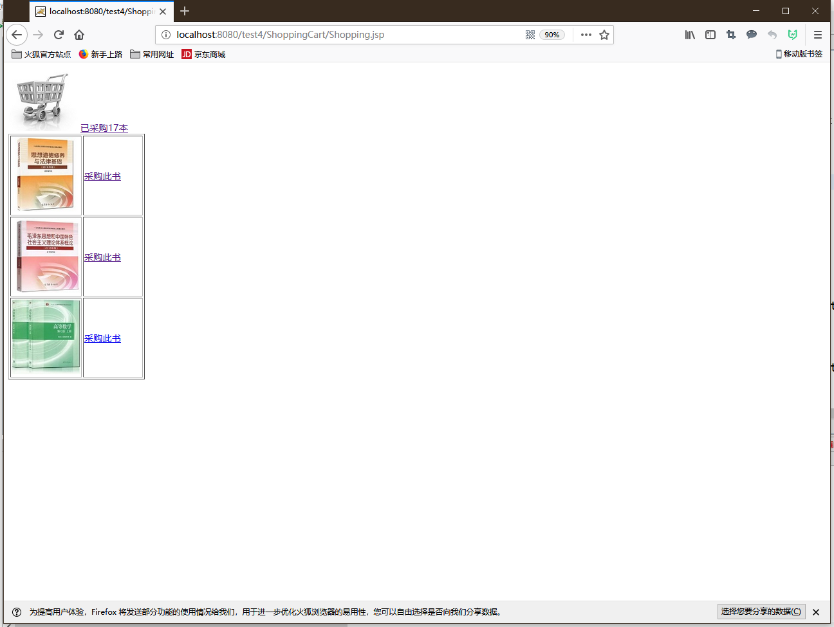 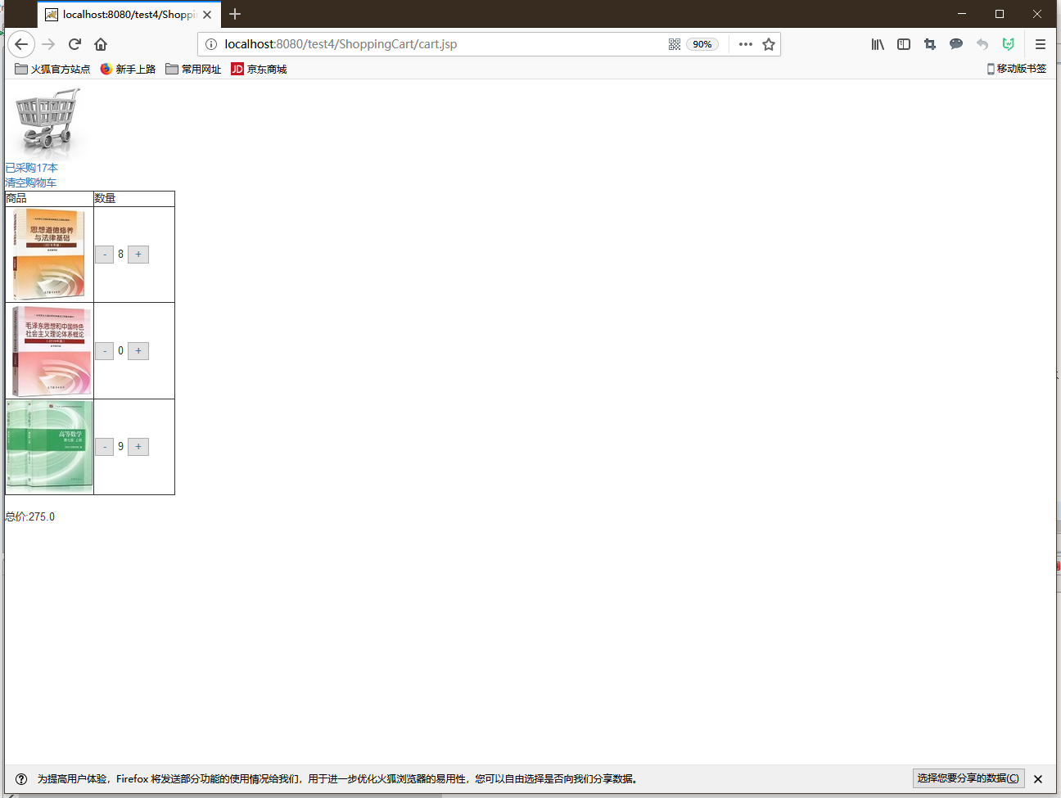

下图为清空回收站

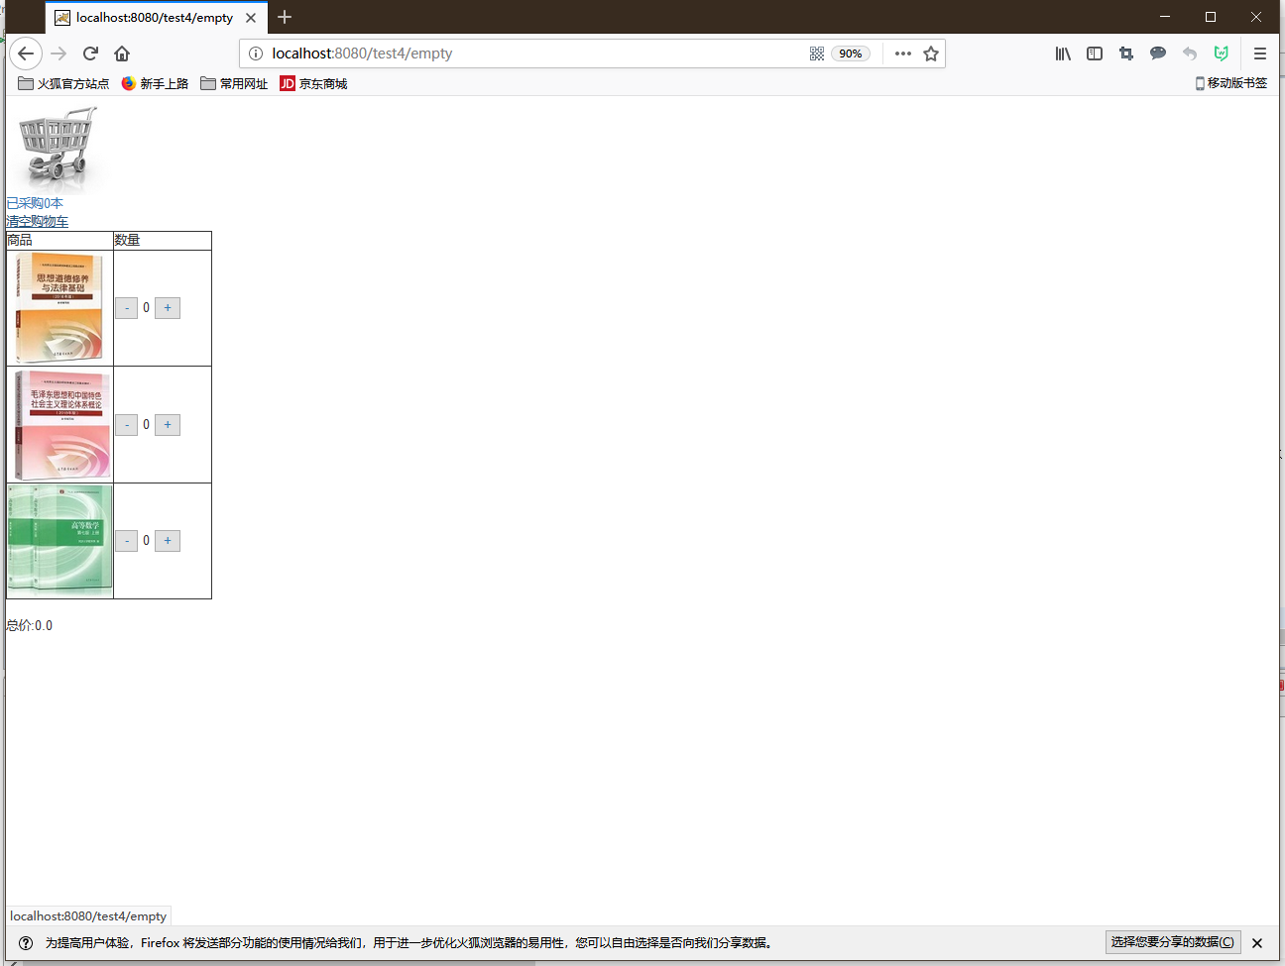

# 收获与问题

收获很多，学会了javaBean的基本使用方法