1.<%@ page contentType="text/html;charset=utf-8" %>
<HTML><BODY bgcolor=cyan><Font size=5>
<FORM action="receive.jsp" method=post name=form>
<P>请输入下列信息：
<BR>输入您的姓名:<INPUT type="text" name="name" value="张三"></BR>
<BR>选择性别:<INPUT type="radio" name="R" value="男" checked="default">男
<INPUT type="radio" name="R" value="女">女
</BR>
<BR>选择您喜欢的歌手:
<input type="checkbox" name="superstar" value="张歌手" >张歌手
<input type="checkbox" name="superstar" value="李歌手" >李歌手
<input type="checkbox" name="superstar" value="刘歌手" >刘歌手
<input type="checkbox" name="superstar" value="王歌手" >王歌手
</BR>
<INPUT TYPE="hidden" value="这是隐藏信息" name="secret">
<INPUT TYPE="submit" value="提交" name="submit">
</FORM>
</FONT></BODY></HTML>
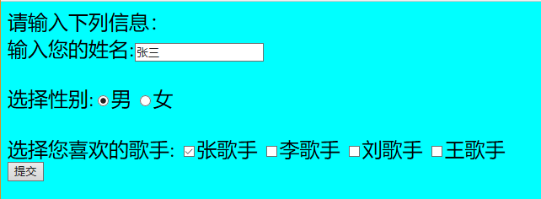

2.<%@ page contentType="text/html;charset=utf-8"%>
<%@ page import="java.net.*"%>
<HTML>
<BODY bgcolor=cyan>
<Font size=5> <a href="index.jsp">回到首页</a> <% request.setCharacterEncoding("utf-8") ;
// String yourName=new String((request.getParameter("name")).getBytes("iso-8859-1"),"utf-8"); // 获取text提交的值

String yourName=request.getParameter("name");
//String tt=URLEncoder.encode("林","utf-8");
//out.println("中文编码:"+tt);

//String yourName=URLDecoder.decode(request.getParameter("name"),"utf-8");

String yourSex=request.getParameter("R"); //获取radio提交的值
String secretMess=request.getParameter("secret"); //获取hidden提交的值
String personName[]=request.getParameterValues("superstar"); //获取checkbox提交的值
out.println("<P> 您的姓名:"+yourName+"</P>");
out.println("<P> 您的性别:"+yourSex+"</P>");
out.println("<P> 您喜欢的歌手:");
if(personName==null)
{ out.print("一个都不喜欢");
}
else
{ for(int k=0;k<personName.length;k++)
{ out.println(" "+personName[k]);
}
}
out.println("<P> hidden提交的值:"+secretMess);
%>
<p>姓名：${param.name}
<p>ttt${paramValues.superstar}
</FONT>

</BODY>
</HTML>
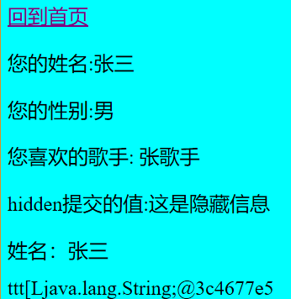
- input：
<%@ page contentType="text/html;charset=utf-8" %>
<!DOCTYPE HTML PUBLIC "-//W3C//DTD HTML 4.01 Transitional//EN">
<HTML>
<BODY bgcolor=yellow><Font size=5>
<FORM action="receive1.jsp" method=post name=form>
<P>请输入您的个人信息：
<BR>输入您的学号:<INPUT type="text" name="number" value="04171507"></BR>
<BR>输入您的姓名:<INPUT type="text" name="name" value="邓家荣"> </BR>
<BR>您的性别:<INPUT type="radio" name="R" value="男" checked="default">男
<INPUT type="radio" name="R" value="女">女
</BR>
<INPUT TYPE="hidden" value="这是隐藏信息" name="secret">
<INPUT TYPE="submit" value="提交" name="submit">
</FORM>
</FONT></BODY>
</HTML>
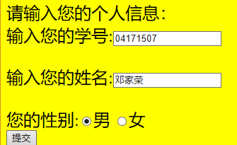
receive：
<%@ page contentType="text/html;charset=utf-8"%>
<%@ page import="java.net.*"%>
<HTML>
<BODY bgcolor=yellow>
<Font size=5> <a href="input1.jsp">回到上一页</a> <% request.setCharacterEncoding("utf-8") ;
String yourName=request.getParameter("name");
String yourSex=request.getParameter("R");
String yourNumber=request.getParameter("number");
String secretMess=request.getParameter("secret");
String personName[]=request.getParameterValues("superstar");
out.println("<P> 您的学号:"+yourNumber+"</P>");
out.println("<P> 您的姓名:"+yourName+"</P>");
out.println("<P> 您的性别:"+yourSex+"</P>");
if(personName==null)
{ out.print(" ");
}
else
{ for(int k=0;k<personName.length;k++)
{ out.println(" "+personName[k]);
}
}
out.println("<P> hidden提交的值:"+secretMess);
%>
</FONT>
</BODY>
</HTML>
