实验一：Java Web 入门
实验目标：
1、了解并学会配置MyEclipse集成开发环境，学会在其环境下创建工程并发布运行一个JSP程序；
2、熟悉Tomcat服务器的目录，学习如何设置Web服务目录。并在其目录下运行一个简单的JSP页面；
3、熟悉和掌握HTML中表单的设计和提交。

实验内容：
（一）必做。
- 熟悉MyEclipse环境，在软件下绑定JDK和Tomcat，新建项目并运行；（必做）
- 在MyEclipse环境下新建一个项目取名为Webtest+学号（必做）
  - 并在其下创建一个JSP程序，并在IE下运行；
  - 将课件第一章的例题input.jsp、receive.jsp内容拷入项目中。并运行访问该JSP页面；
- 预习第二章，编写并运行第P29页例题HelloServelt.java文件。
（二）选做
- 仿照test1文件夹下的input.jsp/receive.jsp，自己设计新建一个表单（登录网页，input文件中显示学号、姓名，表单设计还可参考第三章P57页 form-get.html文件），尝试用receive.jsp接收表单传回的信息。（选做）
- 设置Web虚拟服务目录，请在自己的D盘下新建目录test1，并将jsp文件拷贝至该目录下，修改Tomcat安装目录下conf子文件夹下的Server.xml，使其可以用http://127.0.0.1:8080/hello/**.jsp的形式访问该文件。记录下修改过程并适当截图。（选做）
实验报告：
请将各题实验运行成功的界面截图放至于实验报告中。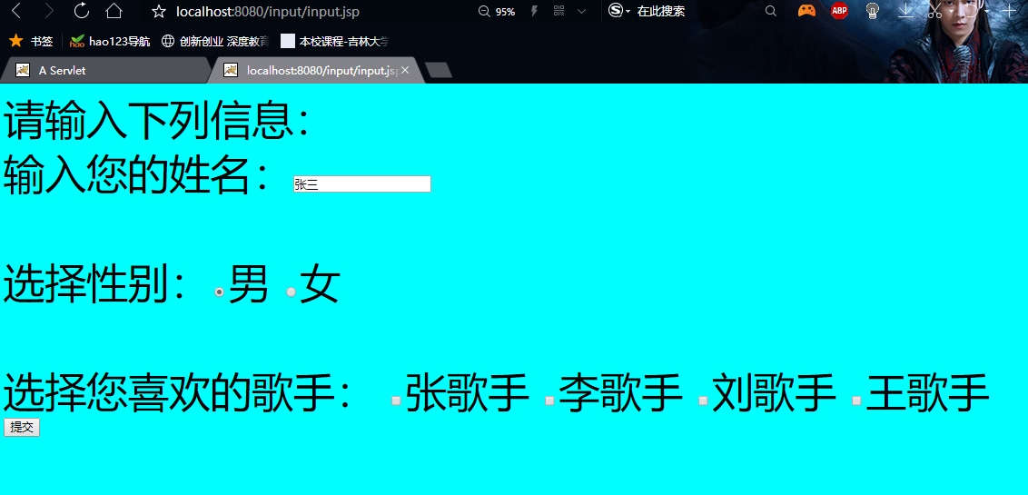

<%@ page contentType="text/html;charset=utf-8"%>

<HTML><BODY bgcolor=cyan><Font size=8>
<FORM action="receive.jsp" method=post name=form>
<P>请输入下列信息：
<BR>输入您的姓名：<INPUT type="text" name="name" value="张三"></BR>
<BR>选择性别：<INPUT type="radio" name="R" value="男" checked="do">男
<INPUT type="radio" name="R" value="女">女
</BR>
<BR>选择您喜欢的歌手：
<input type="checkbox" name="superstar" value="张歌手">张歌手
<input type="checkbox" name="superstar" value="李歌手">李歌手
<input type="checkbox" name="superstar" value="刘歌手">刘歌手
<input type="checkbox" name="superstar" value="王歌手">王歌手
</BR>
<INPUT TYPE="hidden" value="这是隐藏信息" name="secret">
<INPUT TYPE="submit" value="提交" name="submit">
</FORM>
</Font></BODY></HTML>

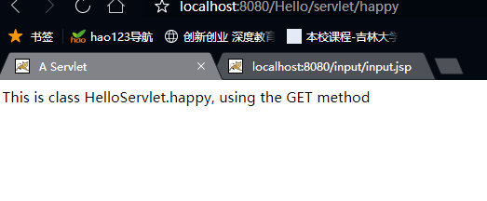

package HelloServlet;

import java.io.IOException;
import java.io.PrintWriter;

import javax.servlet.ServletException;
import javax.servlet.http.HttpServlet;
import javax.servlet.http.HttpServletRequest;
import javax.servlet.http.HttpServletResponse;

public class happy extends HttpServlet {

/**
* Constructor of the object.
*/
public happy() {
super();
}

/**
* Destruction of the servlet. <br>
*/
public void destroy() {
super.destroy(); // Just puts "destroy" string in log
// Put your code here
}

/**
* The doGet method of the servlet. <br>
*
* This method is called when a form has its tag value method equals to get.
*
* @param request the request send by the client to the server
* @param response the response send by the server to the client
* @throws ServletException if an error occurred
* @throws IOException if an error occurred
*/
public void doGet(HttpServletRequest request, HttpServletResponse response)
throws ServletException, IOException {

response.setContentType("text/html");
PrintWriter out = response.getWriter();
out.println("<!DOCTYPE HTML PUBLIC \"-//W3C//DTD HTML 4.01 Transitional//EN\">");
out.println("<HTML>");
out.println(" <HEAD><TITLE>Simple Servlet</TITLE></HEAD>");
out.println(" <BODY>");
out.print(" This is ");
out.print(this.getClass());
out.println(", using the GET method");
out.println(" </BODY>");
out.println("</HTML>");
out.flush();
out.close();
}

/**
* The doPost method of the servlet. <br>
*
* This method is called when a form has its tag value method equals to post.
*
* @param request the request send by the client to the server
* @param response the response send by the server to the client
* @throws ServletException if an error occurred
* @throws IOException if an error occurred
*/
public void doPost(HttpServletRequest request, HttpServletResponse response)
throws ServletException, IOException {

response.setContentType("text/html");
PrintWriter out = response.getWriter();
out.println("<!DOCTYPE HTML PUBLIC \"-//W3C//DTD HTML 4.01 Transitional//EN\">");
out.println("<HTML>");
out.println(" <HEAD><TITLE>Simple Servlet</TITLE></HEAD>");
out.println(" <BODY>");
out.print(" This is ");
out.print(this.getClass());
out.println(", using the POST method");
out.println(" </BODY>");
out.println("</HTML>");
out.flush();
out.close();
}

/**
* Initialization of the servlet. <br>
*
* @throws ServletException if an error occurs
*/
public void init() throws ServletException {
// Put your code here
}

}

