Java Web开发

实验二

作业报告

学 院 | 计算机
所在系 班 级 | 2017软件工程系8班
学 号 姓 名 | 04171619谭明亮
指 导 教 师 | 郭晓燕
完 成 时 间 | 2018年3月15日

实验题目
1. 新建项目，练习教材上相关例子HelloServlet.java文件，P29。并练习如何在Tomcat服务器上发布该文件
1） HelloServlet文件内容
2） 请分别用注释法和文件配置法（web.xml）来完成对HelloServlet文件的发布。 注释法访问的地址是 http://127.0.0.1:8080/项目工程名/test2/hello.view（请注意要根据题目要求修改代码中的注释内容）
文件配置法的地址是http://127.0.0.1:8080/项目工程名/test2/hello.do
2. 请编写WelcomeYou.java文件，代码内容如下图，
1） 图中第25行是何意思？
2） 编写好之后请用如下两个地址来分别访问该文件：
http://127.0.0.1:8080/项目工程名/test2/welcome?user=‘李华’
http://127.0.0.1:8080/项目工程名/test2/welcome?user=‘Lihua’
记录下浏览器的显示内容，并分析其原因。
3. 请编写程序，完成以下功能：
1) 一个邮箱注册表单register.html文件，具体见图。
2) 自行编写两个html文件，一个success.jsp成功页面，一个fail.jsp失败页面。
3) 点击注册按钮后，跳转到成功页面success.jsp。
4) 尝试：能否在成功页面显示该用户的昵称，邮箱名称？比如“开心，恭喜你！你的happyToday@163.com”
5) 注意注册页面的表单应当提交什么请求方式
6) 如果下一步，我还希望能把失败页面加上去，怎么办？

分析与设计
根据题目要求，计划设计几个文件来完成实验，每个文件的名字、作用。如果是类，要求写出类的变量和方法

关键源码（部分）
1.
import java.io.IOException;
import java.io.PrintWriter;

import javax.servlet.ServletException;
import javax.servlet.annotation.WebServlet;
import javax.servlet.http.HttpServlet;
import javax.servlet.http.HttpServletRequest;
import javax.servlet.http.HttpServletResponse;

@WebServlet(name="HelloServlet",urlPatterns={"/test2/hello.view"})

public class HelloServlet extends HttpServlet {

/**
* Constructor of the object.
*/
public HelloServlet() {
super();
}

/**
* Destruction of the servlet. <br>
*/
public void destroy() {
super.destroy(); // Just puts "destroy" string in log
// Put your code here
}

/**
* The doGet method of the servlet. <br>
*
* This method is called when a form has its tag value method equals to get.
*
* @param request the request send by the client to the server
* @param response the response send by the server to the client
* @throws ServletException if an error occurred
* @throws IOException if an error occurred
*/
public void doGet(HttpServletRequest request, HttpServletResponse response)
throws ServletException, IOException {

response.setContentType("text/html; charset=GB2312");
PrintWriter out=response.getWriter();
out.println("<html><head>");
out.println("<h2>你好，欢迎各位软件工程专业的同学。<br><br>Hello,you are welcome</h2>");
out.println("</html></head>");
}

}
2.
package ccc;

import java.io.IOException;
import java.io.PrintWriter;

import javax.servlet.ServletException;
import javax.servlet.http.HttpServlet;
import javax.servlet.http.HttpServletRequest;
import javax.servlet.http.HttpServletResponse;

public class WelcomeYou extends HttpServlet {

public void doGet(HttpServletRequest request, HttpServletResponse response) throws ServletException, IOException {
String user=request.getParameter("user");
String welcomeInfo="Welcome You "+user+"同学！";

response.setContentType("text/html;charset=UTF-8");
PrintWriter out = response.getWriter();
out.println("<html>");
out.println("<head><title>欢迎页面</title></head>");
out.println("<body>");
out.println(welcomeInfo);
out.println("</body>");
out.println("</html>");

out.close();
}
}
3.
register.jsp
<%@ page language="java" import="java.util.*" pageEncoding="utf-8"%>
<%
String path = request.getContextPath();
String basePath = request.getScheme()+"://"+request.getServerName()+":"+request.getServerPort()+path+"/";
%>

<!DOCTYPE HTML PUBLIC "-//W3C//DTD HTML 4.01 Transitional//EN">
<html>
<head>
<base href="<%=basePath%>">

<title>My JSP 'register.jsp' starting page</title>

<meta http-equiv="pragma" content="no-cache">
<meta http-equiv="cache-control" content="no-cache">
<meta http-equiv="expires" content="0">
<meta http-equiv="keywords" content="keyword1,keyword2,keyword3">
<meta http-equiv="description" content="This is my page">
<!--
<link rel="stylesheet" type="text/css" href="styles.css">
-->

</head>

<body bgcolor="yellow">
<form action="success.jsp" method="post">
<p><label>邮箱账号</label><input name="account" type="text" /></p>
<p><label >&nbsp;&nbsp;&nbsp;&nbsp;&nbsp;&nbsp;&nbsp;&nbsp;昵称</label><input name="name" type="text" /></p>
<p><label>&nbsp;&nbsp;&nbsp;&nbsp;&nbsp;&nbsp;&nbsp;&nbsp;密码</label><input name="password" type="text" /></p>
<p><label>确认密码</label><input name="passwords" type="text" /></p>
<p><label>&nbsp;&nbsp;&nbsp;&nbsp;&nbsp;&nbsp;&nbsp;&nbsp;性别</label>
<label>
<input type="radio" name="sex" value="man" id="sex_0" />
男</label>

<label>
<input type="radio" name="sex" value="woman" id="sex_1" />
女</label>
<br />
</p>
<p><label>&nbsp;&nbsp;&nbsp;&nbsp;&nbsp;&nbsp;&nbsp;&nbsp;生日<select name="birth">
<option value="lunar">农历</option>
<option value="new">新历</option>
</select><select name="date"><option value="one">2018</option>
<option value="two">2019</option></select><select name="month">
<option value="oneo">一月</option>
<option value="twoo">二月</option>
</select><select name="day"><option value="oneone">一日</option>
<option value="twotwo">二日</option></select></label></p>
<p><label>&nbsp;&nbsp;&nbsp;&nbsp;&nbsp;所在地</label></p>
<p><label>&nbsp;&nbsp;&nbsp;&nbsp;&nbsp;验证码</label><input name="ensure" type="text" /></p>
<p>&nbsp;&nbsp;&nbsp;&nbsp;&nbsp; &nbsp;&nbsp;&nbsp;&nbsp;&nbsp;&nbsp;&nbsp;&nbsp;&nbsp;&nbsp;&nbsp;&nbsp;&nbsp; &nbsp;&nbsp;<input name="register" type="submit" value="立即注册" /></p>
<p></p>
<p></p>
<p></p>
<p></p>
</form>

</body>
</html>

Success.jsp

<%@ page contentType="text/html;charset=utf-8" %>
<%response.setCharacterEncoding("utf-8");
response.setHeader("iso-8859-1","utf-8");
request.setCharacterEncoding("utf-8");
String name = request.getParameter("name");
String psd = request.getParameter("password");
if(name.equals("")||psd.equals("")){
response.setHeader("Refresh","1;url=fail.jsp");
return;
}
else{
String acc=request.getParameter("account");
String yourName=request.getParameter("name");
out.println("<HTML><BODY><Font size=8><P>注册成功！你的邮箱账号为");
out.println(acc);
out.println("</P><BR>SUCCESS</BR></FONT></BODY></HTML>");
//response.setHeader("Refresh","1;url=success.jsp");
}
%>
Fail.jsp
<%@ page language="java" import="java.util.*" pageEncoding="utf-8"%>
<%
String path = request.getContextPath();
String basePath = request.getScheme()+"://"+request.getServerName()+":"+request.getServerPort()+path+"/";
%>

<!DOCTYPE HTML PUBLIC "-//W3C//DTD HTML 4.01 Transitional//EN">
<html>
<head>
<base href="<%=basePath%>">

<title>My JSP 'fail.jsp' starting page</title>

<meta http-equiv="pragma" content="no-cache">
<meta http-equiv="cache-control" content="no-cache">
<meta http-equiv="expires" content="0">
<meta http-equiv="keywords" content="keyword1,keyword2,keyword3">
<meta http-equiv="description" content="This is my page">
<!--
<link rel="stylesheet" type="text/css" href="styles.css">
-->

</head>

<body>
<Font size=8><P>注册失败，昵称或密码不能为空！</P>
<BR>FAIL</BR></FONT></BODY></HTML><br>
</body>
</html>

运行效果图
1.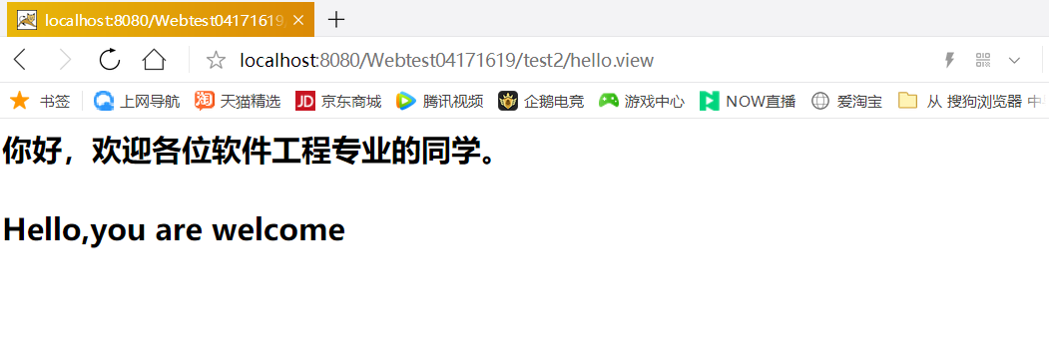
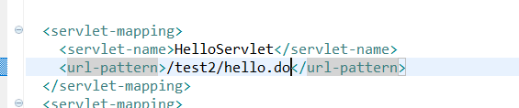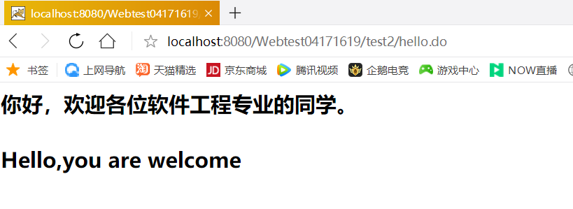
2.
25行：通过HttpServletRequest的getparameter()指定请求参数名称为“user”来取得用户发送的请求参数值。

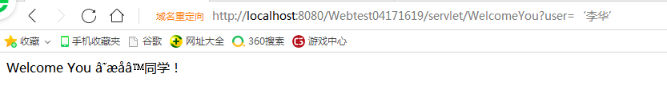
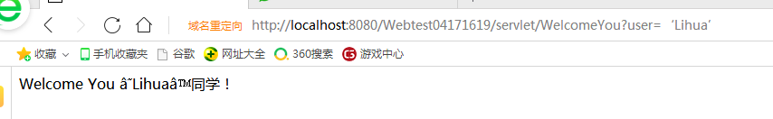

3.
