Java Web开发

实验三
作业报告

学 院 | 计算机
所在系 班 级 | 2017软件工程系8班
学 号 姓 名 | 04171624 程朗
指 导 教 师 | 罗永升
完 成 时 间 | 2019年3月24日

实验题目

将第二章实训题的第二题，登录页面，提交用户名、密码，若用户名不为空字符串且长度在6-8位间，密码不为，空长度为6位，则登录成功，显示“***（用户名）登录成功！”，否则显示“***登录失败”。分析与设计
根据题目要求，计划设计几个文件来完成实验，每个文件的名字、作用。如果是类，要求写出类的变量和方法

关键源码（部分）
Register.jsp
<%@ page language="java" import="java.util.*" pageEncoding="UTF-8"%>
<%
String path = request.getContextPath();
String basePath = request.getScheme()+"://"+request.getServerName()+":"+request.getServerPort()+path+"/";
%>

<!DOCTYPE HTML PUBLIC "-//W3C//DTD HTML 4.01 Transitional//EN">
<html>
<head>
<base href="<%=basePath%>">

</head>
<title>登录页面</title>
<body bgcolor=cyan >
<table align="center">
<tr>
<td>
<FORM action="/CH32/identify" method=post name=form>
<br> &nbsp; &nbsp;用户名&nbsp;<INPUT type="text" name="name" >
<br> &nbsp; &nbsp; &nbsp; &nbsp; 密码&nbsp;<INPUT type="password" name="password">
<br> &nbsp; &nbsp; &nbsp; &nbsp; &nbsp; &nbsp;&nbsp; &nbsp; &nbsp;&nbsp; &nbsp;<input type="submit" value="立即登录" name="submit">

</FORM></td>></tr></table></body></html>

Identify.java//用于判断密码和用户名是否符合条件，根据情况进行跳转

public class identify extends HttpServlet {

public void doPost(HttpServletRequest request, HttpServletResponse response)
throws ServletException, IOException {

response.setCharacterEncoding("UTF-8");//加了这两句后，目标jsp文件原有的中文可以正常显示了
request.setCharacterEncoding("utf-8");//
Student X=new Student();

//response.setCharacterEncoding("gb2312");
PrintWriter out = response.getWriter();
//response.setContentType("text/html;charset=UTF-8");
String name=request.getParameter("name");
String pwd=request.getParameter("password");
name=new String(name.getBytes("iso-8859-1"),"utf-8");
X.setName(name);
X.setpwd(pwd);

request.setAttribute("user",X);
if((pwd.length()==6)&&(name.length()<=8&&name.length()>=6))
{
RequestDispatcher dis=request.getRequestDispatcher("/success.jsp");
dis.forward(request, response);
}
else {RequestDispatcher dix=request.getRequestDispatcher("/fail.jsp");
dix.forward(request, response);
}
}
}

Success.jsp
<%@ page language="java" import="java.util.*" pageEncoding="UTF-8" contentType="text/html; charset=UTF-8"%>
<%@ page contentType="text/html; charset=UTF-8" %>
<%
String path = request.getContextPath();
String basePath = request.getScheme()+"://"+request.getServerName()+":"+request.getServerPort()+path+"/";
%>

<!DOCTYPE HTML PUBLIC "-//W3C//DTD HTML 4.01 Transitional//EN">
<html>
<head>

</head>
<body>
<% request.setCharacterEncoding("utf-8");
String yourName=request.getParameter("name");
yourName=new String(yourName.getBytes("iso-8859-1"),"utf-8");
out.println(yourName+"<p> 登录成功"+"</p>");

%>
</body></html>

fail.jsp
<%@ page language="java" import="java.util.*" pageEncoding="UTF-8"%>
<%
String path = request.getContextPath();
String basePath = request.getScheme()+"://"+request.getServerName()+":"+request.getServerPort()+path+"/";
%>

<!DOCTYPE HTML PUBLIC "-//W3C//DTD HTML 4.01 Transitional//EN">
<html>
<head>
<base href="<%=basePath%>">

<title>My JSP 'fail.jsp' starting page</title>

</head>
<body>
<% request.setCharacterEncoding("utf-8");
String yourName=request.getParameter("name");
out.println(yourName+"<p>登录失败"+"</p>"); %>
<br> </body></html>

贴上这道题中最关键的部分源码。也是你实验练习的主要知识点相关的源码。并在代码旁附上详细的解释

运行效果图
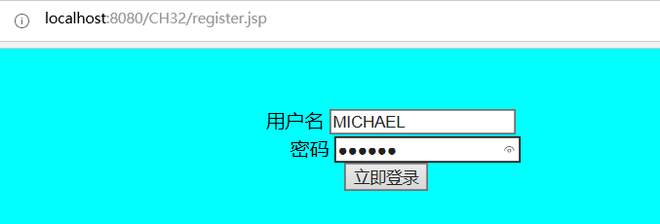
输入正确
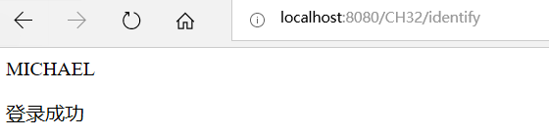
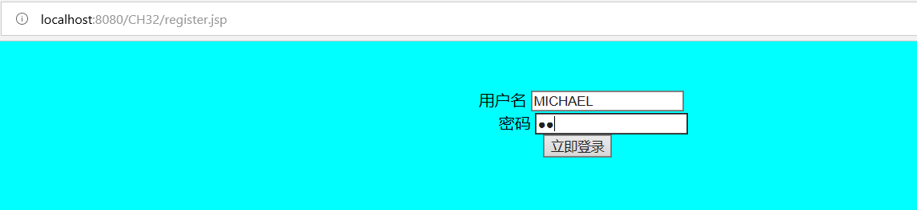
密码格式不对

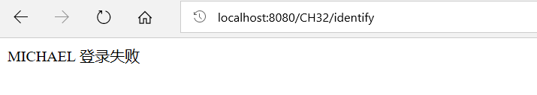

收获与问题
谈一谈你在本实验中所收获的内容及问题。

