Java Web开发

实验四

作业报告

学 院 | 计算机
所在系 班 级 | 2017软件工程系8班
学 号 姓 名 | 04171619谭明亮
指 导 教 师 | 郭晓燕
完 成 时 间 | 2019年3月30日

实验题目
- 将实验三的三题进行改写，在Servlet控制器中获取信息，验证后根据具体情况跳转到对应页面，成功请求转发到成功页面，否则重定向跳转到失败页面（可将动态验证码添加在页面上）
- 登录页面，提交用户名、密码及身份
改写一：支持中文，确保两种表单提交方式（get、post）都支持中文，另外对程序的空对象情况进行处理。
改写二：比如登录页面除了之前的用户名、密码另外再加上所在专业（计算机、软件工程及网络工程，单选框或下拉列表框皆可），登录成功后根据身份进行跳转，进入对应的页面，页面需显示****专业学号姓名。登录失败转向失败页面，并进行报错！

关键源码（部分）
1.register.jsp
<%@ page language="java" import="java.util.*" pageEncoding="utf-8"%>
<%
String path = request.getContextPath();
String basePath = request.getScheme()+"://"+request.getServerName()+":"+request.getServerPort()+path+"/";
%>

<!DOCTYPE HTML PUBLIC "-//W3C//DTD HTML 4.01 Transitional//EN">
<html>
<head>
<base href="<%=basePath%>">

<title>My JSP 'register.jsp' starting page</title>

<meta http-equiv="pragma" content="no-cache">
<meta http-equiv="cache-control" content="no-cache">
<meta http-equiv="expires" content="0">
<meta http-equiv="keywords" content="keyword1,keyword2,keyword3">
<meta http-equiv="description" content="This is my page">
<!--
<link rel="stylesheet" type="text/css" href="styles.css">
-->

</head>

<body bgcolor="#FFFFFF">
<form action="NC" method="post">

<p><label >学号</label><input name="name" type="text" /></p>
<p><label>姓名</label><input name="password" type="text" /></p>
<p><label>密码</label><input name="jk" type="text" /></p>
<p><label>专业</label>
<label>
<input type="radio" name="major" value="计算机科学与技术" id="major_0" />
计算机科学与技术</label>

<label>
<input type="radio" name="major" value="软件工程" id="major_1" />
软件工程</label>
<label>
<input type="radio" name="major" value="网络工程" id="major_2" />
网络工程</label>
<br />
</p>

<p>&nbsp;&nbsp;&nbsp;&nbsp;&nbsp;&nbsp;&nbsp;&nbsp;&nbsp;&nbsp;&nbsp;&nbsp;&nbsp; &nbsp;&nbsp;<input name="register" type="submit" value="登陆" /></p>
<p></p>
<p></p>
<p></p>
<p></p>
</form>

</body>
</html>
2.success.jsp

<%@ page contentType="text/html;charset=utf-8" %>
<%response.setCharacterEncoding("utf-8");
response.setHeader("iso-8859-1","utf-8");
request.setCharacterEncoding("utf-8");

String name=request.getParameter("name");
String yourName=request.getParameter("password");
String major=request.getParameter("major");
out.println("<HTML><BODY><Font size=8><P>你好！");
out.println(major+"专业的");
out.println(name+yourName+"同学");

out.println("<a href='register.jsp'>返回首页</a>");
out.println("</P><BR>SUCCESS</BR></FONT></BODY></HTML>");
//response.setHeader("Refresh","1;url=success.jsp");

%>
3.fail.jsp
<%@ page language="java" import="java.util.*" pageEncoding="utf-8"%>
<%
String path = request.getContextPath();
String basePath = request.getScheme()+"://"+request.getServerName()+":"+request.getServerPort()+path+"/";
%>

<!DOCTYPE HTML PUBLIC "-//W3C//DTD HTML 4.01 Transitional//EN">
<html>
<head>
<base href="<%=basePath%>">

<title>My JSP 'fail.jsp' starting page</title>

<meta http-equiv="pragma" content="no-cache">
<meta http-equiv="cache-control" content="no-cache">
<meta http-equiv="expires" content="0">
<meta http-equiv="keywords" content="keyword1,keyword2,keyword3">
<meta http-equiv="description" content="This is my page">
<!--
<link rel="stylesheet" type="text/css" href="styles.css">
-->

</head>

<body>
<Font size=8><P>注册失败，昵称或密码不能为空！</P>
<BR>FAIL</BR></FONT></BODY></HTML><br>
</body>
</html>

4.NC.java
import java.io.IOException;
import java.io.PrintWriter;

import javax.servlet.ServletException;
import javax.servlet.http.HttpServlet;
import javax.servlet.http.HttpServletRequest;
import javax.servlet.http.HttpServletResponse;

public class NC extends HttpServlet {

/**
* Constructor of the object.
*/
public NC() {
super();
}

/**
* Destruction of the servlet. <br>
*/
public void destroy() {
super.destroy(); // Just puts "destroy" string in log
// Put your code here
}

/**
* The doGet method of the servlet. <br>
*
* This method is called when a form has its tag value method equals to get.
*
* @param request the request send by the client to the server
* @param response the response send by the server to the client
* @throws ServletException if an error occurred
* @throws IOException if an error occurred
*/
public void doGet(HttpServletRequest request, HttpServletResponse response)
throws ServletException, IOException {

response.setContentType("text/html");
PrintWriter out = response.getWriter();
out.println("<!DOCTYPE HTML PUBLIC \"-//W3C//DTD HTML 4.01 Transitional//EN\">");
out.println("<HTML>");
out.println(" <HEAD><TITLE>A Servlet</TITLE></HEAD>");
out.println(" <BODY>");
out.print(" This is ");
out.print(this.getClass());
out.println(", using the GET method");
out.println(" </BODY>");
out.println("</HTML>");
out.flush();
out.close();
}

/**
* The doPost method of the servlet. <br>
*
* This method is called when a form has its tag value method equals to post.
*
* @param request the request send by the client to the server
* @param response the response send by the server to the client
* @throws ServletException if an error occurred
* @throws IOException if an error occurred
*/
public void doPost(HttpServletRequest request, HttpServletResponse response)
throws ServletException, IOException {
request.setCharacterEncoding("utf-8");
String name = request.getParameter("name");
String psd = request.getParameter("password");
if(name.equals("")||psd.equals("")||name.length()>8||name.length()<6){
response.sendRedirect("fail.jsp");}
else
request.getRequestDispatcher("success.jsp").forward(request,response);

response.setContentType("text/html");
PrintWriter out = response.getWriter();
out.println("<!DOCTYPE HTML PUBLIC \"-//W3C//DTD HTML 4.01 Transitional//EN\">");
out.println("<HTML>");
out.println(" <HEAD><TITLE>A Servlet</TITLE></HEAD>");
out.println(" <BODY>");
out.print(" This is ");
out.print(this.getClass());
out.println(", using the POST method");
out.println(" </BODY>");
out.println("</HTML>");
out.flush();
out.close();
}

/**
* Initialization of the servlet. <br>
*
* @throws ServletException if an error occurs
*/
public void init() throws ServletException {
// Put your code here
}

}

运行效果图
1.
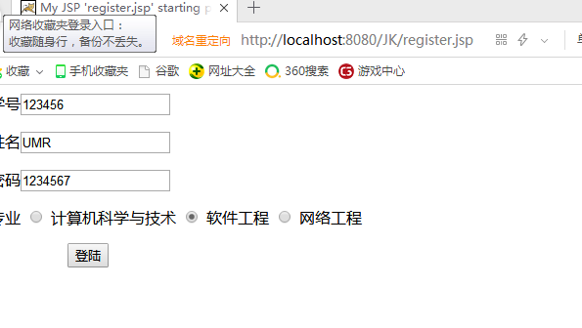
2.
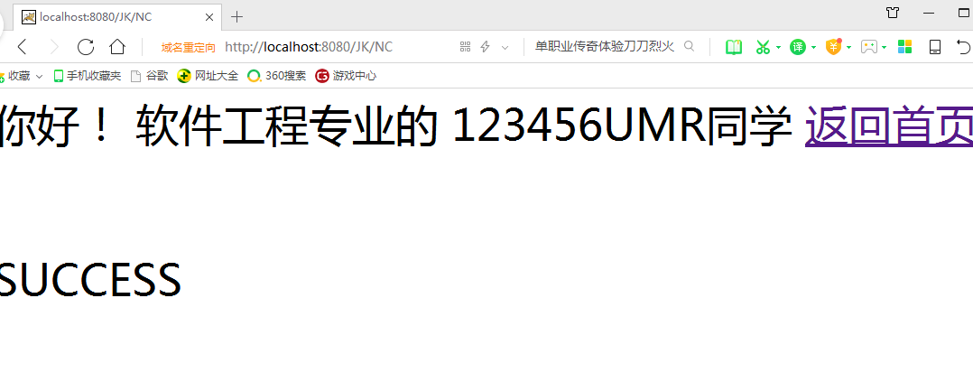
3.
