Java Web开发

实验五
作业报告

学院 | 计算机
所在系班级 | 软件8班
学号姓名 | 04171625孙金德
指导教师 | 郭晓燕
完成时间 | 2019年4月12号
实验目标：

1、理解会话的原理和HttpSession会话期；

2、掌握如何使用URL重写；

3、掌握如何使用HttpSession会话管理
实验内容：
- 练习老师在理论课上演示的购物车实例，理解购物功能如何实现，理解如何利用session对象保存购物信息，如何设计封装数据类。（请参考“第四章会话管理课上的购物车实例代码.docx”文档）；
如果上课听懂了购物车的原理或者部分理解，可以参考我的实例完成第2题，此题可忽略不写。
- 第四章课后练习3购物车，实现一个购物车应用程序，可以购物，显示购物数量并查看购物车内容。（此题模版test4E，提供给大家参考。）
提示：采购此书做成超链接，并用URL重写带关键信息
  - Shopping.view?bookID=‘0001’，其中0001是你选中图书对应的ID号，每点击一次就在相应的购书数量上加一，并返回当前的选购页面。
  - 除了要保存图书的ID号、书名，还要保存购书数量，所以session对象保存的信息需要考虑清楚，最好是一个对象数组或列表。
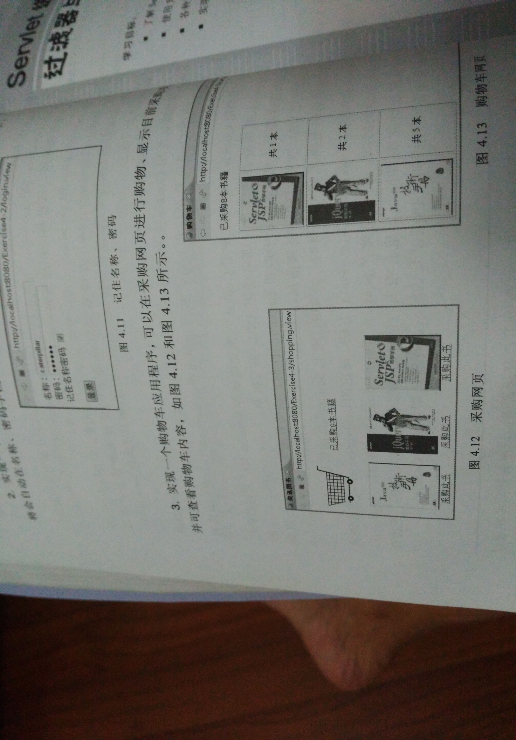
购物车的效果图
- 对第三章动态验证码程序实现动态验证。（选做）
提示：在生成动态验证码的同时将其放入HttpSession对象中，在网页上提取出来进行比对。
- 分析与设计

关键源码（部分）
Shopping.jsp
<%@ page language="java" import="java.util.*" pageEncoding="utf-8"%>
<%@ page import="Shop.Book" %>>
<%
String path = request.getContextPath();
String basePath = request.getScheme()+"://"+request.getServerName()+":"+request.getServerPort()+path+"/";
%>

<!DOCTYPE HTML PUBLIC "-//W3C//DTD HTML 4.01 Transitional//EN">
<html>
<head>
<title>网上书店</title>
</head>
<%
if(session.getAttribute("bookList")==null){
Book[] BookList = new Book[4];
BookList[0] = new Book("10101","Java语言程序设计","img\\10101.jpg",0);
BookList[1] = new Book("10102","Java开发手册","img\\10102.jpg",0);
BookList[2] = new Book("10103","网页设计基础","img\\10103.jpg",0);
BookList[3] = new Book("10104","Java程序设计","img\\10104.jpg",0);

session.setAttribute("bookList",BookList);
session.setAttribute("sum",0);
}
%>

<body>
<img scr="/Ch5/img/cart.jpg"style= "width:60px;height:60px" >
<a href="Show.jsp">已采购<%=session.getAttribute("sum") %>本书籍</a><br>
<br>
<table border="1">
<%
Book[] bookList=(Book[])session.getAttribute("bookList");
for(Book book:bookList){%>

<a href="shopping.view?id=<%=book.getBookId() %>">
<img src="<%=book.getBookImg() %>">加入购物车</a>

<%}
%></table>
</body>
</html>

Chart.java
package Shop;
public class Book{
String bookId;
String bookName;
String bookImg;
double bookPrice;
int num;

public Book(String id,String name,String bookImg,int num)
{
this.bookId = id;
this.bookName = name;
this.bookImg = bookImg;
this.num = num;
}

public String getBookId() {
return bookId;
}

public void setBookId(String bookId) {
this.bookId = bookId;
}

public String getBookName() {
return bookName;
}

public void setBookName(String bookName) {
this.bookName = bookName;
}

public String getBookImg() {
return bookImg;
}

public void setBookImg(String bookImg) {
this.bookImg = bookImg;
}

public double getBookPrice() {
return bookPrice;
}

public void setBookPrice(double bookPrice) {
this.bookPrice = bookPrice;
}

public int getNum() {
return num;
}

public void setNum(int num) {
this.num = num;
}

}

Show.jsp
<%@ page language="java" import="java.util.*" pageEncoding="utf-8"%>
<%@ page import="Shop.Book" %>>
<%
String path = request.getContextPath();
String basePath = request.getScheme()+"://"+request.getServerName()+":"+request.getServerPort()+path+"/";
%>

<!DOCTYPE HTML PUBLIC "-//W3C//DTD HTML 4.01 Transitional//EN">
<html>
<head>

<title>我的购物车</title>

</head>

<body>
<%
Book[] bookList = (Book[])session.getAttribute("bookList");
int sum=(Integer)session.getAttribute("sum");
%>
<p>已采购<%=sum %>本书籍</p>
<a href="Shopping.jsp">返回首页</a>
<%if(bookList!=null) {%>
<table>
<%
for(Book book:bookList){
%>
<tr>
<td><img style="width:150px;height:200px" src="<%=book.getBookImg() %>"></td>
<td>共<%=book.getNum() %>本</td>
<%} %>
</tr>
</table>
<%} %>>
</body>
</html>

ShopServlet.java
package Shop;

import java.io.IOException;
import java.io.PrintWriter;

import javax.servlet.ServletException;

import javax.servlet.http.HttpServlet;
import javax.servlet.http.HttpServletRequest;
import javax.servlet.http.HttpServletResponse;
import javax.servlet.http.HttpSession;

public class ShopServlet extends HttpServlet {

public void doGet(HttpServletRequest request, HttpServletResponse response)
throws ServletException, IOException {
doPost(request,response);
}

public void doPost(HttpServletRequest request, HttpServletResponse response)
throws ServletException, IOException {
response.setContentType("text/html;charset=utf-8");
response.setCharacterEncoding("UTF-8");
HttpSession session = request.getSession();
Book[] bookList = (Book[]) session.getAttribute("bookList");
int sum=(Integer)session.getAttribute("sum");
PrintWriter out = response.getWriter();
if(bookList!=null)
{
for (Book book : bookList) {
if(book.getBookId().equals(request.getParameter("id")))
{
book.setNum(book.getNum()+1);
session.setAttribute("sum", sum+1);
request.getRequestDispatcher("Shopping.jsp").forward(request, response);

}
}

}}

}

- 运行效果图
