Java Web开发

实验六

作业报告

学 院 | 计算机
所在系 班 级 | 2017软件工程系8班
学 号 姓 名 | 04171624 程朗
指 导 教 师 | 罗永升
完 成 时 间 | 2019年4月14日

实验题目
参考成熟的购物系统，为购物车增加功能，完善购物车：删除商品，查看商品具体信息，计算商品总价，修改商品购买件数等等。界面尽量美观。
提示：Java文件即Book.java的设计需要重构，需要分离商品基本信息和购买信息，需要有类分别来保存单件商品的购买信息和所有商品的购买信息。所以至少要三个Java类才能完成购物的基本功能。
Servlet也需要响应更多的操作，可以在一个Servlet中也可以分多个文件响应。并在适当的地方调用Java方法。

分析与设计
采用3个类
Book类储存购买时的信息,
Cart类用于储存购物车信息
Good类用于储存商品信息

关键源码（部分）
Book类 //用于储存选购商品时的临时信息
package cc.test.vo;
public class BOok {
private String bookId; //
private String bookName;//
String bookImg; //??
private int bookNum; //鱾
public static int totalnum=0;

public BOok(String bookId, String bookName, String bookImg, int bookNum) {
this.bookId = bookId;
this.bookName = bookName;
this.bookImg = bookImg;
this.bookNum = 0;
}
public String getBookId() {
return bookId;
}
public String getBookName() {
return bookName;
}
public String getBookImg() {
return bookImg;
}
public int getBookNum() {
return bookNum;
}
public void setBookNum()
{this.bookNum=this.bookNum+1;
}
}
Cart类 //用于储存购物车信息
package cc.test.vo;

public class cart {
private String ID;
private float Price;
private int Num;
private String Name;
private String Img;
public cart(String ID,int Price,int Num,String Img,String Name)
{
this.ID=ID;
this.Price=Price;
this.Img=Img;
this.Name=Name;
this.Num=Num;
}
public void SetImg(String Img)
{
this.Img=Img;
}
public void setNum(int Num)
{
this.Num=Num;
}
public int getNum()
{return this.Num;}
public String getID()
{
return this.ID;
}

public String getImg( )
{
return this.Img;
}
public String getName( )
{
return this.Name;
}
public float getPrice()
{
return this.Price;
}
}

Good类 //用于储存商品的基本信息
package cc.test.vo;

public class Good
{
private String ID;
private float Price;

private String Name;
private String Img;

public Good(String ID,float Price,String Img,String Name)
{
this.ID=ID;
this.Price=Price;
this.Img=Img;
this.Name=Name;
}

public void SetImg(String Img)
{
this.Img=Img;
}
public String getID()
{
return this.ID;
}
public String getImg( )
{
return this.Img;
}
public String getName( )
{
return this.Name;
}
public float getPrice()
{
return this.Price;
}
}

ShoppingServlet.java //用于处理购买页面Shopping,Jsp点击商品时增加对应商品的数量，由Shopping.Jsp跳转过来，处理完后自动跳转回shopping.jsp
@WebServlet("/Shopping.view")
public class ShoppingServlet extends HttpServlet {
public void doGet(HttpServletRequest request, HttpServletResponse response)
throws ServletException, IOException {
String ID=request.getParameter("id");
if(ID!=null)
{
HttpSession session=request.getSession();

BOok[] BOoklistx=(BOok[])session.getAttribute("book");

for(BOok books:BOoklistx)
{
if(ID.equals(books.getBookId()))
{
books.setBookNum();
}
}
session.setAttribute("book",BOoklistx);
int k=(Integer)session.getAttribute("sum")+1;
session.setAttribute("sum", k);

RequestDispatcher dis=request.getRequestDispatcher("/Shopping.jsp");
dis.forward(request, response);
}

}

public void doPost(HttpServletRequest request, HttpServletResponse response)
throws ServletException, IOException {

doGet(request,response);
}

}

CartServlet.java(cart.view) //把Book类的信息付给Cart类，用于显示购物车界面，接受并显示购物车修改商品数量(跳转到cartedit.Java)和结算的操作(跳转到cart.jsp)
@WebServlet("/cart.view")
public class CartServlet extends HttpServlet {
public void doGet(HttpServletRequest request, HttpServletResponse response)
throws ServletException, IOException {
response.setContentType("text/html;charset=UTF-8");
/*response.setCharacterEncoding("UTF-8");
request.setCharacterEncoding("utf-8");
request.setCharacterEncoding("GBK");*/
PrintWriter out = response.getWriter();
HttpSession session=request.getSession();
if(session.getAttribute("cart")==null)
{
cart[] cartlist=new cart[4];
BOok[] BOoklistx=(BOok[])session.getAttribute("book");

cartlist[0] = new cart(BOoklistx[0].getBookId(),10, BOoklistx[0].getBookNum(),BOoklistx[0].getBookImg(),BOoklistx[0].getBookName());
cartlist[1] = new cart(BOoklistx[1].getBookId(),12, BOoklistx[1].getBookNum(),BOoklistx[1].getBookImg(),BOoklistx[1].getBookName());
cartlist[2] = new cart(BOoklistx[2].getBookId(),14, BOoklistx[2].getBookNum(),BOoklistx[2].getBookImg(),BOoklistx[2].getBookName());
cartlist[3] = new cart(BOoklistx[3].getBookId(),16, BOoklistx[3].getBookNum(),BOoklistx[3].getBookImg(),BOoklistx[3].getBookName());

session.setAttribute("cart", cartlist);
}

cart[] cartList=(cart[])session.getAttribute("cart");
BOok[] bookList=(BOok[])session.getAttribute("book");

out.println("<HTML>");
out.println(" <BODY>");
out.println("<br>");
for(cart carts:cartList)
{
if(carts.getNum()>=1)
{
int NUM=carts.getNum();
out.println("<tr>");
out.println("<td><img src="+carts.getImg()+"></td>");
out.println("<td>"+carts.getID()+"买了"+carts.getNum()+"本"+"</td>");
out.println("<a href="+"'/test6e/GoodShow.jsp?ID="+carts.getID()+"'"+">"+"查看商品详情"+"</a>");
String IDD=carts.getID();

out.println("<form action="+"'/test6e/cartEdit'" +"method=Get name=form>"+///////这里撒大苏打撒旦
"<input type='text' name='iD' value="+IDD+">"+
"<input type='text' name='amount' value= "+NUM+">"+

"<input type=button value='+' onClick='javascript:this.form.amount.value++;'>"+

"<input type=button value='-' onClick='javascript:this.form.amount.value--;'>"+
"<input type=submit value="+"确定"+">"+
"</form>");
out.println("<br>");
out.println("</tr>");

//carts.setNum(Integer.parseInt(request.getParameter("amount")));
}
//session.setAttribute("cart", cartlist);

}
out.println("<a href="+"'/test6e/cart.jsp'"+">"+"结算"+"</a>");
out.println(" </BODY>");
out.println("</HTML>");

}

cartEdit.Java //用于处理购物车界面的商品数量修改，由CartServle.java(cart.view)跳转过来，处理完后自动跳转回购物车界面CartServle.java(cart.view)

public class cartEdit extends HttpServlet {

public void doGet(HttpServletRequest request, HttpServletResponse response)
throws ServletException, IOException {

HttpSession session=request.getSession();

cart[] cartlist=(cart[])session.getAttribute("cart");
String ID=request.getParameter("iD");
for(cart carts:cartlist)
{
if(ID.equals(carts.getID()))
{
carts.setNum(Integer.parseInt(request.getParameter("amount")));
}
}
RequestDispatcher dis=request.getRequestDispatcher("/cart.view");
dis.forward(request, response);
}

}

Shopping.jsp//
购买商品初始页面，用作选购商品和初始商品信息，会跳转到购物车CartServle.java(cart.view)

<%@ page language="java" import="java.util.*" pageEncoding="UTF-8"%>
<%@page import="cc.test.vo.*" %>

<!DOCTYPE HTML PUBLIC "-//W3C//DTD HTML 4.01 Transitional//EN">
<html>

<%
//当第一次访问采购网页，session对象中还没有book购物车信息时，进行初始化。
if (session.getAttribute("book")==null){
//在session对象中存储图书采购信息
BOok[] BOokList = new BOok[4];
BOokList[0] = new BOok("10101", "Java核心技术", "./img/10101.jpg", 0);
BOokList[1] = new BOok("10102", "Java经典实例", "./img/10102.jpg", 0);
BOokList[2] = new BOok("10103", "Java7", "img/10103.jpg", 0);
BOokList[3] = new BOok("10104", "JSP&Servlet", "img/10104.jpg",0);
//存入session对象中
int t=0;
session.setAttribute("book", BOokList);
session.setAttribute("sum",t);
}

%>
<body>
<br>
<img src="img/cart.jpg" height="60px" width="60px">
<a href="cart.view">已采购 <%=session.getAttribute("sum") %> 本书籍</a><br>
<br>
<table border="1">
<tr>
<td><img src="img/10101.jpg"></td>
<td><img src="img/10102.jpg"></td>
<td><img src="img/10103.jpg"></td>
<td><img src="img/10104.jpg"></td>
</tr>
<tr>
<td><a href="Shopping.view?id=10101">采购此书</a></td>
<td><a href="Shopping.view?id=10102">采购此书</a></td>
<td><a href="Shopping.view?id=10103">采购此书</a></td>
<td><a href="Shopping.view?id=10104">采购此书</a></td>
</tr>
</body>
</html>

GoodShow.jsp//在购物车里点击查看商品详细信息而跳转到的商品信息页面，从CartServle.java(cart.view)跳转过来

<%@ page language="java" import="java.util.*" pageEncoding="UTF-8"%>
<%@page import="cc.test.vo.*" %>
<%
String path = request.getContextPath();
String basePath = request.getScheme()+"://"+request.getServerName()+":"+request.getServerPort()+path+"/";
%>

<!DOCTYPE HTML PUBLIC "-//W3C//DTD HTML 4.01 Transitional//EN">
<html>
<head>
<base href="<%=basePath%>">
<%
if(session.getAttribute("good")==null)
{
cart[] cartList=(cart[])session.getAttribute("cart");
Good []goodlist=new Good[4];
goodlist[0] = new Good("10101", cartList[0].getPrice(),"./img/10101.jpg","Java核心技术");
goodlist[1] = new Good("10102", cartList[1].getPrice(),"./img/10102.jpg","Java经典实例");
goodlist[2] = new Good("10103", cartList[2].getPrice(),"./img/10103.jpg","Java7");
goodlist[3] = new Good("10104", cartList[3].getPrice(),"./img/10104.jpg","JSP&Servlet");

session.setAttribute("good", goodlist);
}
%>

</head><body>
<%
String ID=request.getParameter("ID");
Good[] goodlist=(Good[])session.getAttribute("good");
for(int i=0;i<=3;i++)
{
if(ID.equals(goodlist[i].getID()))
{
out.println("<td><img src="+goodlist[i].getImg()+"></td>");
out.println("<td>"+"书名 :"+goodlist[i].getName()+"</td>");
out.println("<td>"+"编号 :"+goodlist[i].getID()+"</td>");
out.println("<td>"+"价格 :"+goodlist[i].getPrice()+"</td>");
}

}
out.println("<a href="+"cart.view"+">"+"返回"+"</a>");
%></body></html>

Cart.jsp //显示结算金额的页面，由CartServle.java(cart.view)跳转过来
<%@ page language="java" import="java.util.*" pageEncoding="UTF-8"%>
<%@page import="cc.test.vo.*" %>
<%@page import="java.io.PrintWriter.*"%>
<%
String path = request.getContextPath();
String basePath = request.getScheme()+"://"+request.getServerName()+":"+request.getServerPort()+path+"/";
%>
<!DOCTYPE HTML PUBLIC "-//W3C//DTD HTML 4.01 Transitional//EN">
<html>
<head>
<base href="<%=basePath%>">
</head><body>
<%
cart[] cartList=(cart[])session.getAttribute("cart");
//PrintWriter out = response.getWriter();
float Totalprice=0;

for(cart Cart:cartList)
{
if(Cart.getNum()>=1)
{
Totalprice=Totalprice+(Cart.getNum()*Cart.getPrice());

out.println(Cart.getName()+":"+Cart.getNum()+"(本)"+" X "+Cart.getPrice()+"(元)");
out.println("<br>");
}
}
%>
<h1>总价为：<%=Totalprice %>元</h1>
</body></html>

运行效果图
1.购物界面，分别买一本
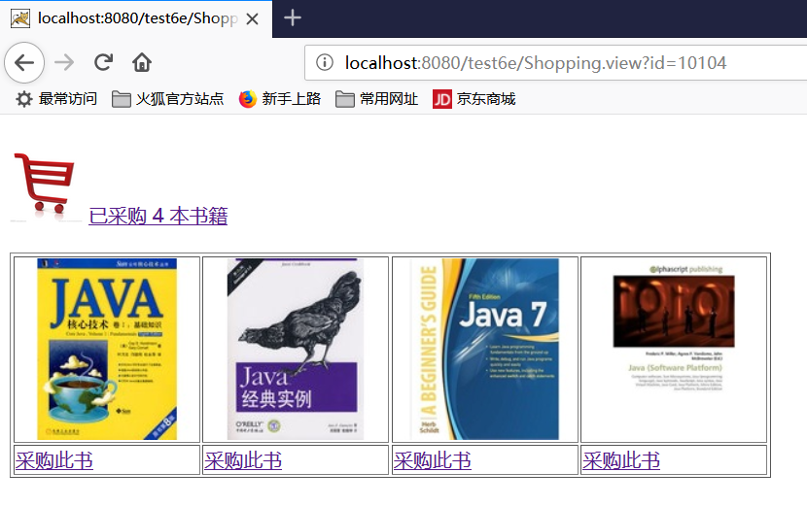
2.显示购物车内容

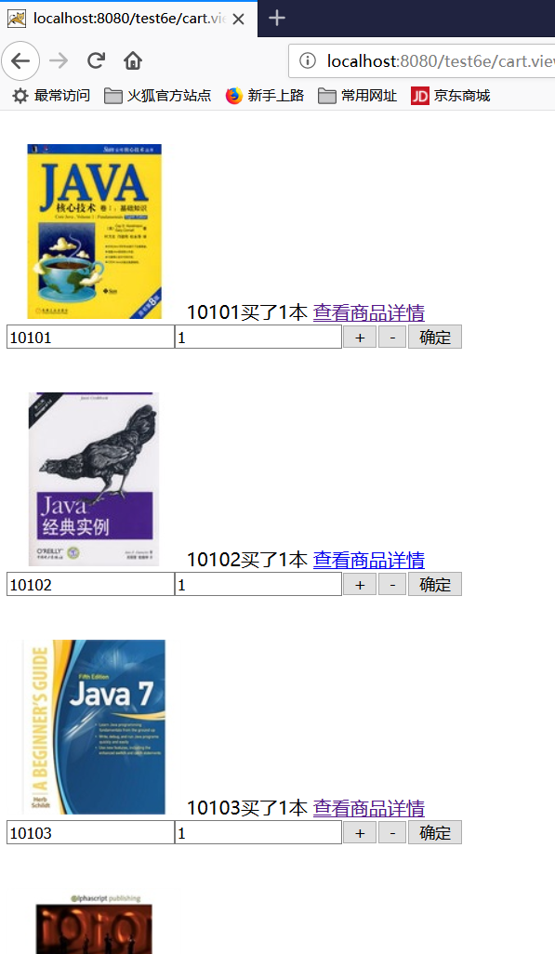

3.修改商品10101商品数量为5，确定
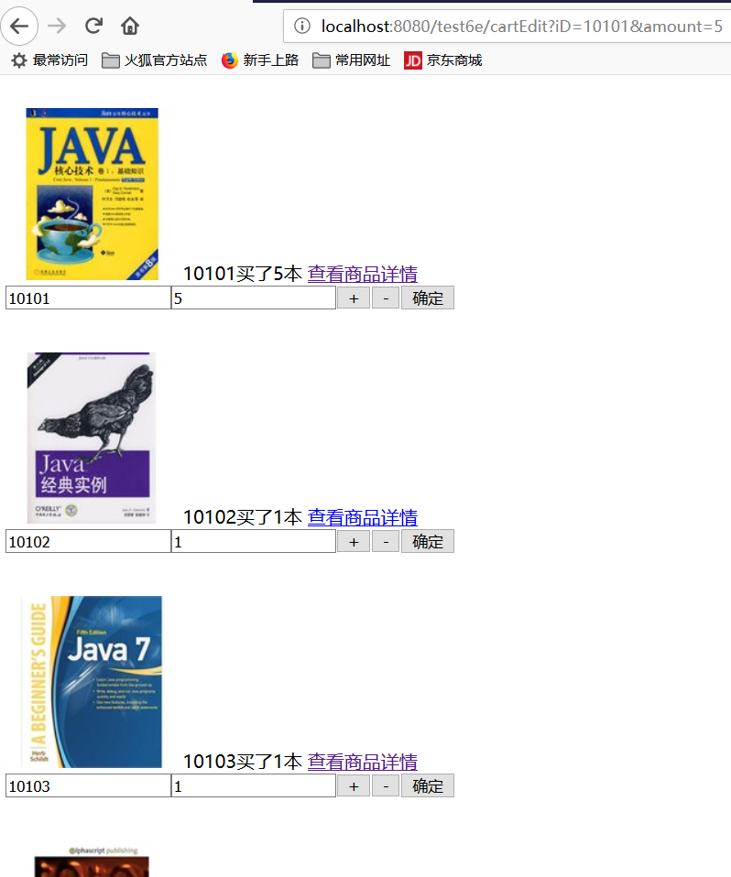

- 按查看商品详情查看10101商品的基本信息
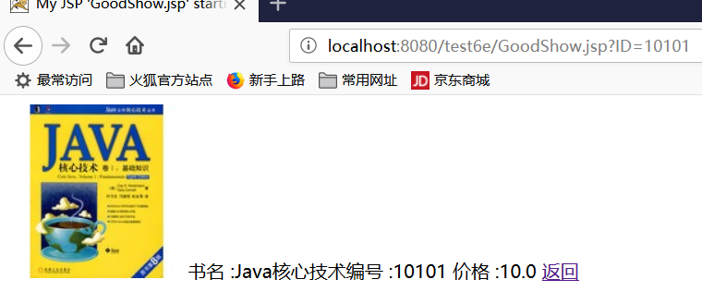
5.返回按结算
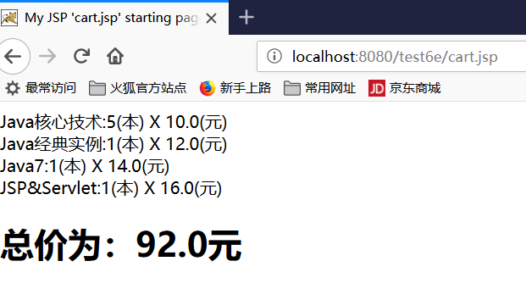

实验在浏览器下运行的结果截图，并进行解释。

收获与问题
谈一谈你在本实验中所收获的内容及问题。

