# 实验报告

1. 熟悉MyEclipse环境，在软件下绑定JDK和Tomcat，新建项目并运行；

代码：<%@ page language=*"java"* import=*"java.util.*"* pageEncoding=*"UTF-8"*%>

<%

String path = request.getContextPath();

String basePath = request.getScheme()+"://"+request.getServerName()+":"+request.getServerPort()+path+"/";

%>

<!DOCTYPE HTML PUBLIC "-//W3C//DTD HTML 4.01 Transitional//EN">

<html>

<head>

<base href=*"*<%=basePath%>*"*>

<title>My JSP 'MyJsp.jsp' starting page</title>

<meta http-equiv=*"pragma"* content=*"no-cache"*>

<meta http-equiv=*"cache-control"* content=*"no-cache"*>

<meta http-equiv=*"expires"* content=*"0"*>

<meta http-equiv=*"keywords"* content=*"keyword1,keyword2,keyword3"*>

<meta http-equiv=*"description"* content=*"This is my page"*>

<!--

<link rel="stylesheet" type="text/css" href="styles.css">

-->

</head>

<body>

This is my JSP page. <br>

</body>

</html>

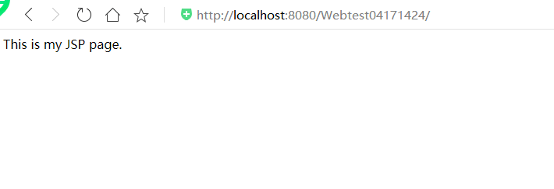

2.

(a)并在其下创建一个JSP程序，并在IE下运行；

<%@ page language=*"java"* contentType=*"text/html; charset=UTF-8"*

pageEncoding=*"UTF-8"*%>

<!DOCTYPE html PUBLIC "-//W3C//DTD HTML 4.01 Transitional//EN" "http://www.w3.org/TR/html4/loose.dtd">

<html>

<head>

<meta http-equiv=*"Content-Type"* content=*"text/html; charset=UTF-8"*>

<title>Insert title here</title>

</head>

<body>

hello!!!!!!

</body>

</html>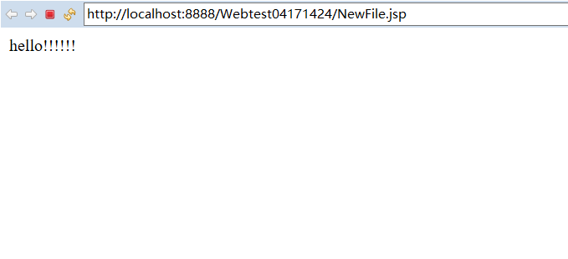

(b)将test1中的例题input.jsp、receive.jsp内容拷入项目中。并运行访问该JSP页面；

代码：

<%@ page contentType=*"text/html;charset=utf-8"* %>

<HTML><BODY bgcolor=*cyan*><Font size=*8*>

<FORM action=*"receive.jsp"* method=*post* name=*form*>

<P>请输入下列信息：

<BR>输入您的姓名:<INPUT type=*"text"* name=*"name"* value=*"张三"*></BR>

<BR>选择性别:<INPUT type=*"radio"* name=*"R"* value=*"男"* checked=*"default"*>男

<INPUT type=*"radio"* name=*"R"* value=*"女"*>女

</BR>

<BR>选择您喜欢的歌手:

<input type=*"checkbox"* name=*"superstar"* value=*"张歌手"* >张歌手

<input type=*"checkbox"* name=*"superstar"* value=*"李歌手"* >李歌手

<input type=*"checkbox"* name=*"superstar"* value=*"刘歌手"* >刘歌手

<input type=*"checkbox"* name=*"superstar"* value=*"王歌手"* >王歌手

</BR>

<INPUT TYPE=*"hidden"* value=*"这是隐藏信息"* name=*"secret"*>

<INPUT TYPE=*"submit"* value=*"提交"* name=*"submit"*>

</FORM>

</FONT></BODY></HTML>

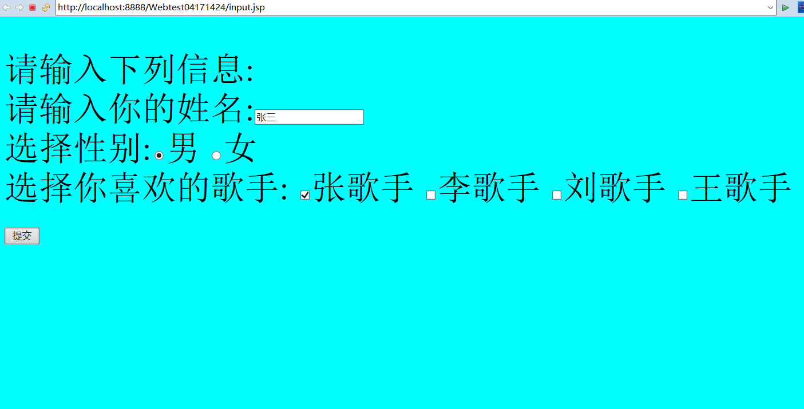

代码：

<%@ page contentType=*"text/html;charset=utf-8"*%>

<%@ page import=*"java.net.*"*%>

<HTML>

<BODY bgcolor=*cyan*>

<Font size=*8*> <a href=*"index.jsp"*>回到首页</a> <% request.setCharacterEncoding("utf-8");

// String yourName=new String((request.getParameter("name")).getBytes("iso-8859-1"),"utf-8"); // 获取text提交的值

String yourName=request.getParameter("name");

//String tt=URLEncoder.encode("林","utf-8");

//out.println("中文编码:"+tt);

//String yourName=URLDecoder.decode(request.getParameter("name"),"utf-8");

String yourSex=request.getParameter("R"); //获取radio提交的值

String secretMess=request.getParameter("secret"); //获取hidden提交的值

String personName[]=request.getParameterValues("superstar"); //获取checkbox提交的值

out.println("<P> 您的姓名:"+yourName+"</P>");

out.println("<P> 您的性别:"+yourSex+"</P>");

out.println("<P> 您喜欢的歌手:");

**if**(personName==**null**)

{ out.print("一个都不喜欢");

}

**else**

{ **for**(**int** k=0;k<personName.length;k++)

{ out.println(" "+personName[k]);

}

}

out.println("<P> hidden提交的值:"+secretMess);

%>

<p>姓名：${param.name}

</FONT>

</BODY>

</HTML>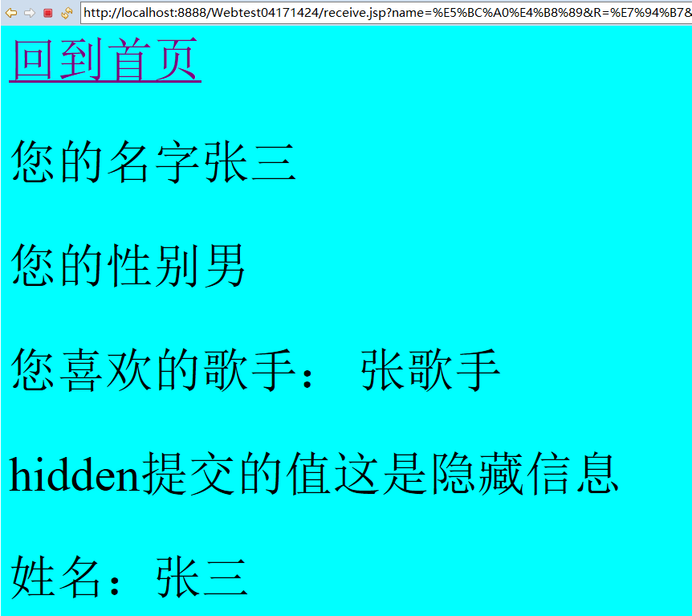

1. 代码：

package cc.openhome;

import java.io.IOException;

import java.io.PrintWriter;

import javax.servlet.ServletException;

import javax.servlet.annotation.WebServlet;

import javax.servlet.http.HttpServlet;

import javax.servlet.http.HttpServletRequest;

import javax.servlet.http.HttpServletResponse;

/**

* Servlet implementation class HelloServlet

*/

@WebServlet("/hello.view")

public class HelloServlet extends HttpServlet {

private static final long serialVersionUID = 1L;

/**

* @see HttpServlet#HttpServlet()

*/

public HelloServlet() {

super();

// TODO Auto-generated constructor stub

}

/**

* @see HttpServlet#doGet(HttpServletRequest request, HttpServletResponse response)

*/

protected void doGet(HttpServletRequest request, HttpServletResponse response) throws ServletException, IOException {

// TODO Auto-generated method stub

response.setContentType("text/html;charset=UTF-8");

PrintWriter out = response.getWriter();

String name =request.getParameter("name");

out.println("<html>");

out.println("<head>");

out.println("<title>Hello Servlet</title>");

out.println("</head>");

out.println("<body>");

out.println("<h1>Hello!"+name +"!</h1>");

out.println("</body>");

out.println("</html>");

out.close();

}

/**

* @see HttpServlet#doPost(HttpServletRequest request, HttpServletResponse response)

*/

protected void doPost(HttpServletRequest request, HttpServletResponse response) throws ServletException, IOException {

// TODO Auto-generated method stub

doGet(request, response);

}

}

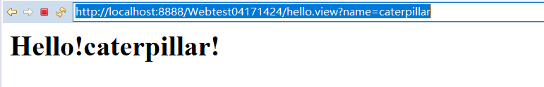

（4）仿照test1文件夹下的input.jsp/receive.jsp，自己设计新建一个表单（登录网页，input文件中显示学号、姓名，表单设计还可参考第三章P57页 form-get.html文件），尝试用receive.jsp接收表单传回的信息。

代码：

<%@ page language=*"java"* contentType=*"text/html; charset=UTF-8"*

pageEncoding=*"UTF-8"*%>

<!DOCTYPE html>

<html>

<head>

<meta charset=*"UTF-8"*>

<title>Insert title here</title>

</head>

<body bgcolor=*cyan*><font size=*8*>

<form action=*"receive1.jsp"* mothod=*post* name=*form*>

<p>请输入下列信息:

<br>请输入你的姓名:<input type=*"text"* name=*"name"* value=*"柯海扬"*>

<br>请输入你的学号:<input type=*"text"* name=*"schoolnumber"* value=*"04171424"*>

</br>

<input type=*"hidden"* value=*"这是隐藏信息"* name=*"secret"*>

<input type=*"submit"* value=*"提交"* name=*"submit"*>

</p >

</form>

</font>

</body>

</html>

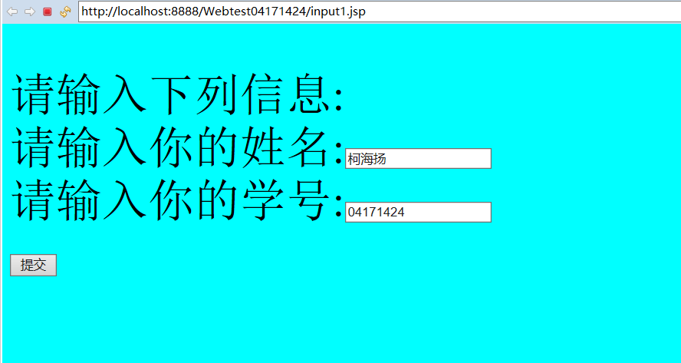

代码：<%@ page language=*"java"* contentType=*"text/html; charset=UTF-8"*

pageEncoding=*"UTF-8"*%>

<!DOCTYPE html PUBLIC "-//W3C//DTD HTML 4.01 Transitional//EN" "http://www.w3.org/TR/html4/loose.dtd">

<html>

<head>

<meta http-equiv=*"Content-Type"* content=*"text/html; charset=UTF-8"*>

<title>Insert title here</title>

</head>

<body bgcolor=*cyan*>

<Font size=*8*><a href=*"index.jsp"*>回到首页</a>

<% request.setCharacterEncoding("utf-8");

String yourName=request.getParameter("name");

String schoolnumber=request.getParameter("schoolnumber");

String secreMess=request.getParameter("secret");

out.println("<p>您的名字"+yourName+"</p>");

out.println("<p>您的学号"+schoolnumber+"</p>");

out.println("<p>hidden提交的值"+secreMess);

%>

<p>姓名：${param.name}

</Font>

</body>

</html>

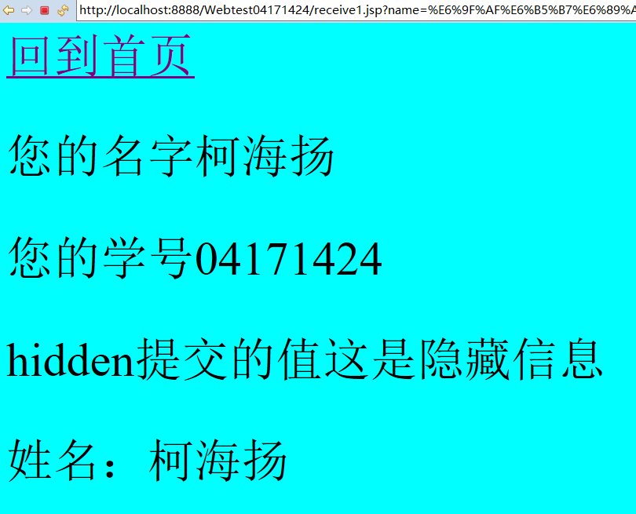

4.设置Web虚拟服务目录，请在自己的D盘下新建目录test1，并将jsp文件拷贝至该目录下，修改Tomcat安装目录下conf子文件夹下的Server.xml，使其可以用[http://127.0.0.1:8080/hello/**.jsp](http://127.0.0.1:8080/hello/**.jsp)的形式访问该文件。记录下修改过程并适当截图。（选做）



