**Java Web开发**

**实验一**

**作业报告**

|  |  |
| --- | --- |
| 学 院 | 计算机 |
| 所在系 班 级 | 2017软件工程系6班 |
| 学 号 姓 名 | 04171427詹明 |
| 指 导 教 师 | 罗永升 |
| 完 成 时 间 | 2019/3/4 |

# 实验题目

1.在MyEclipse环境下新建一个项目取名为Webtest+学号（必做）

并在其下创建一个JSP程序，并在IE下运行；

将课件第一章中的例题input.jsp、receive.jsp内容拷入项目中。并运行访问该JSP页面；

2.预习第二章，编写并运行第P29页例题HelloServelt.java文件；

# 分析与设计

1. 根据题目要求，计划设计2个jsp文件来完成实验;input文件用来选择歌手性别以及名字，receive文件用来获得已选取得歌手信息
2. 编写HelloServelt.java文件
3. 第二章例题servlet建立

# 关键源码（部分）

Input.jsp:

<%@ page language=*"java"* import=*"java.util.*"* pageEncoding=*"utf-8"*%>

<%

String path = request.getContextPath();

String basePath = request.getScheme()+"://"+request.getServerName()+":"+request.getServerPort()+path+"/";

%>

<!DOCTYPE HTML PUBLIC "-//W3C//DTD HTML 4.01 Transitional//EN">

<html>

<head>

<base href=*"*<%=basePath%>*"*>

<title>My JSP 'Myinput.jsp' starting page</title>

<meta http-equiv=*"pragma"* content=*"no-cache"*>

<meta http-equiv=*"cache-control"* content=*"no-cache"*>

<meta http-equiv=*"expires"* content=*"0"*>

<meta http-equiv=*"keywords"* content=*"keyword1,keyword2,keyword3"*>

<meta http-equiv=*"description"* content=*"This is my page"*>

<!--

<link rel="stylesheet" type="text/css" href="styles.css">

-->

</head>

<body bgcolor=*cyan*><font size=*8*>

<form action=*"receive.jsp"* method=*get* name=*form*>

<p>请输入下列信息：

<br>输入您的姓名:<input type=*"text"* name=*"name"* value=*"张三"*></br>

<br>选择性别:<input type=*"radio"* name=*"R"* value=*"男"* checked=*"default"*>男

<input type=*"radio"* name=*"R"* value=*"女"*>女 </br>

<br>选择您喜欢的歌手:

<input type=*"checkbox"* name=*"superstar"* value=*"张歌手"* >张歌手

<input type=*"checkbox"* name=*"superstar"* value=*"李歌手"* >李歌手

<input type=*"checkbox"* name=*"superstar"* value=*"刘歌手"* >刘歌手

<input type=*"checkbox"* name=*"superstar"* value=*"王歌手"* >王歌手

</br>

<input type=*"hidden"* value=*"这是隐藏信息"* name=*"secret"*>

<input type=*"submit"* value=*"提交"* name=*"submit"*>

</form>

</font>

</body>

</html>

Receive.jsp:

<%@ page language=*"java"* import=*"java.util.*"* pageEncoding=*"utf-8"*%>

<%

String path = request.getContextPath();

String basePath = request.getScheme()+"://"+request.getServerName()+":"+request.getServerPort()+path+"/";

%>

<!DOCTYPE HTML PUBLIC "-//W3C//DTD HTML 4.01 Transitional//EN">

<html>

<head>

<base href=*"*<%=basePath%>*"*>

<title>My JSP 'Myreceive.jsp' starting page</title>

<meta http-equiv=*"pragma"* content=*"no-cache"*>

<meta http-equiv=*"cache-control"* content=*"no-cache"*>

<meta http-equiv=*"expires"* content=*"0"*>

<meta http-equiv=*"keywords"* content=*"keyword1,keyword2,keyword3"*>

<meta http-equiv=*"description"* content=*"This is my page"*>

<!--

<link rel="stylesheet" type="text/css" href="styles.css">

-->

</head>

<body bgcolor=*cyan*>

<font size=*8*> <a href=*"index.jsp"*>回到首页</a> <% request.setCharacterEncoding("utf-8");

// String yourName=new String((request.getParameter("name")).getBytes("iso-8859-1"),"utf-8"); // 获取text提交的值

String yourName=request.getParameter("name");

//String tt=URLEncoder.encode("林","utf-8");

//out.println("中文编码:"+tt);

//String yourName=URLDecoder.decode(request.getParameter("name"),"utf-8");

String yourSex=request.getParameter("R"); //获取radio提交的值

String secretMess=request.getParameter("secret"); //获取hidden提交的值

String personName[]=request.getParameterValues("superstar"); //获取checkbox提交的值

out.println("<P> 您的姓名:"+yourName+"</P>");

out.println("<P> 您的性别:"+yourSex+"</P>");

out.println("<P> 您喜欢的歌手:");

**if**(personName==**null**)

{ out.print("一个都不喜欢");

}

**else**

{ **for**(**int** k=0;k<personName.length;k++)

{ out.println(" "+personName[k]);

}

}

out.println("<P> hidden提交的值:"+secretMess);

%>

<p>姓名：${param.name}

<p>ttt${paramValues.superstar}

</font>

</body>

</body>

</html>

**HelloFirstServlet:**

package cc.openhome;

import java.io.IOException;

import java.io.PrintWriter;

import javax.servlet.ServletConfig;

import javax.servlet.ServletException;

import javax.servlet.annotation.WebServlet;

import javax.servlet.http.HttpServlet;

import javax.servlet.http.HttpServletRequest;

import javax.servlet.http.HttpServletResponse;

/**

* Servlet implementation class HelloFirstServlet

*/

@WebServlet(description = "MyFirst Servlet", urlPatterns = { "/hello.view" })

public class HelloFirstServlet extends HttpServlet {

private static final long serialVersionUID = 1L;

/**

* @see HttpServlet#HttpServlet()

*/

public HelloFirstServlet() {

super();

// TODO Auto-generated constructor stub

}

/**

* @see Servlet#init(ServletConfig)

*/

public void init(ServletConfig config) throws ServletException {

// TODO Auto-generated method stub

}

/**

* @see Servlet#destroy()

*/

public void destroy() {

// TODO Auto-generated method stub

}

/**

* @see HttpServlet#doGet(HttpServletRequest request, HttpServletResponse response)

*/

protected void doGet(HttpServletRequest request, HttpServletResponse response) throws ServletException, IOException {

// TODO Auto-generated method stub

response.getWriter().append("Served at: ").append(request.getContextPath());

response.setContentType("text/html;charset = utf-8");

PrintWriter out = response.getWriter();

String name = request.getParameter("name");

out.println("<html>");

out.println("<head>");

out.println("<title>Hello Servlet </title>");

out.println("</head>");

out.println("<body>");

out.println("<h2> Hello! "+ name +" !</h2>");

out.println("</body>");

out.println("</html>");

out.close();

}

/**

* @see HttpServlet#doPost(HttpServletRequest request, HttpServletResponse response)

*/

protected void doPost(HttpServletRequest request, HttpServletResponse response) throws ServletException, IOException {

// TODO Auto-generated method stub

doGet(request, response);

}

}

# 运行效果图

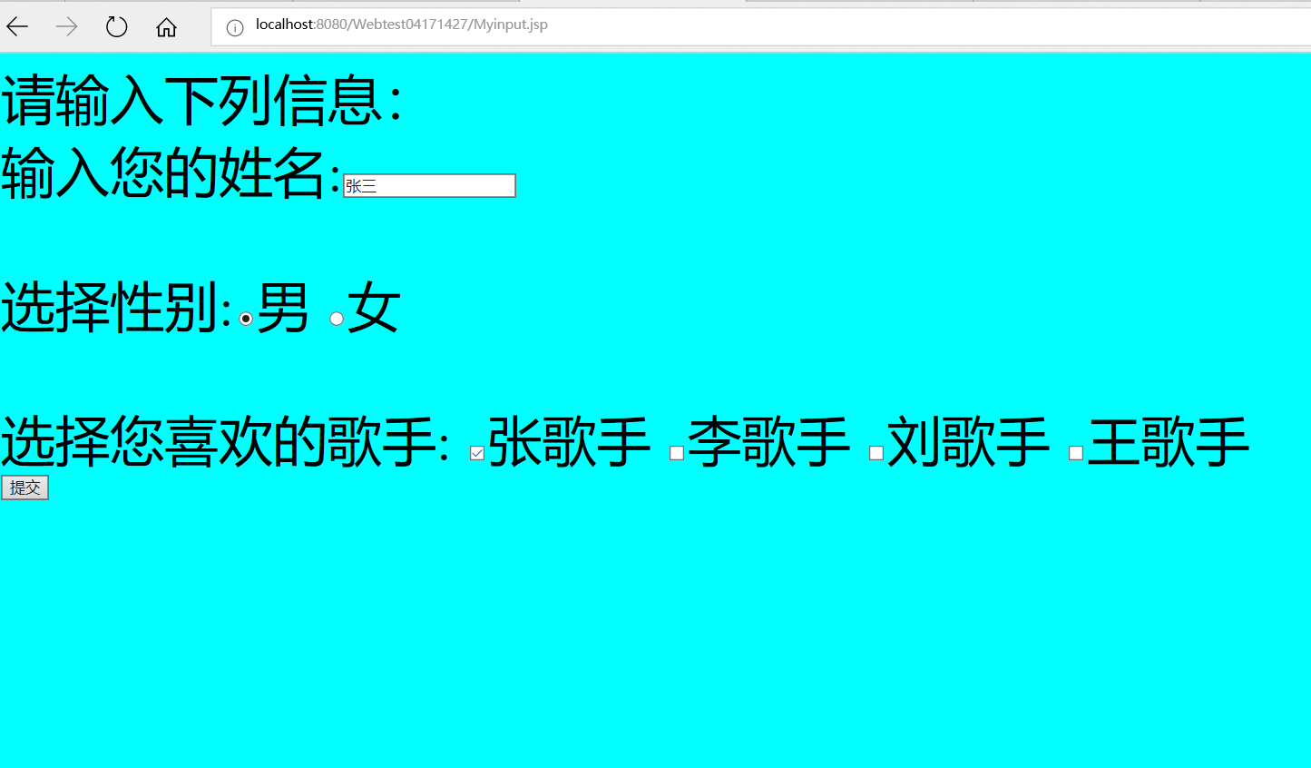

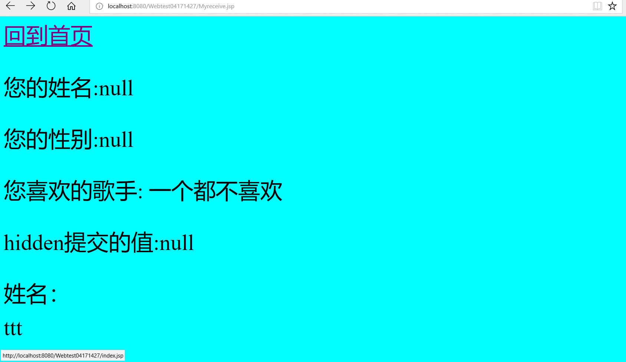

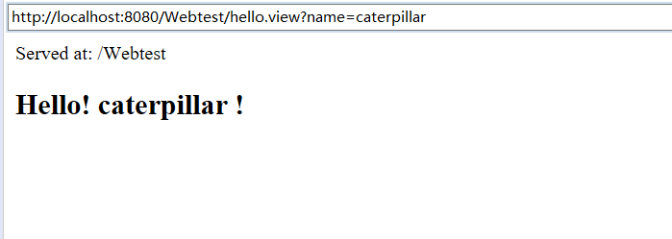

# 收获与问题

下载过程中遇见的问题挺多的，确实很麻烦好在成功解决；在程序实现过程中，遇到过很多次有问题的地方，无数次百度加问他人，逐渐熟悉整个运行环境了。该次实验还是很多地方不足，有待提升。