实验1

--------------------------------------------------------index(默认)---------------------------------------------------------

<%@ page language=*"java"* import=*"java.util.*"* pageEncoding=*"UTF-8"*%>

<%

String path = request.getContextPath();

String basePath = request.getScheme()+"://"+request.getServerName()+":"+request.getServerPort()+path+"/";

%>

<!DOCTYPE HTML PUBLIC "-//W3C//DTD HTML 4.01 Transitional//EN">

<html>

<head>

<base href=*"*<%=basePath%>*"*>

<title>My JSP 'index.jsp' starting page</title>

<meta http-equiv=*"pragma"* content=*"no-cache"*>

<meta http-equiv=*"cache-control"* content=*"no-cache"*>

<meta http-equiv=*"expires"* content=*"0"*>

<meta http-equiv=*"keywords"* content=*"keyword1,keyword2,keyword3"*>

<meta http-equiv=*"description"* content=*"This is my page"*>

<!--

<link rel="stylesheet" type="text/css" href="styles.css">

-->

</head>

<body>

This is my JSP page. <br>

</body>

</html>

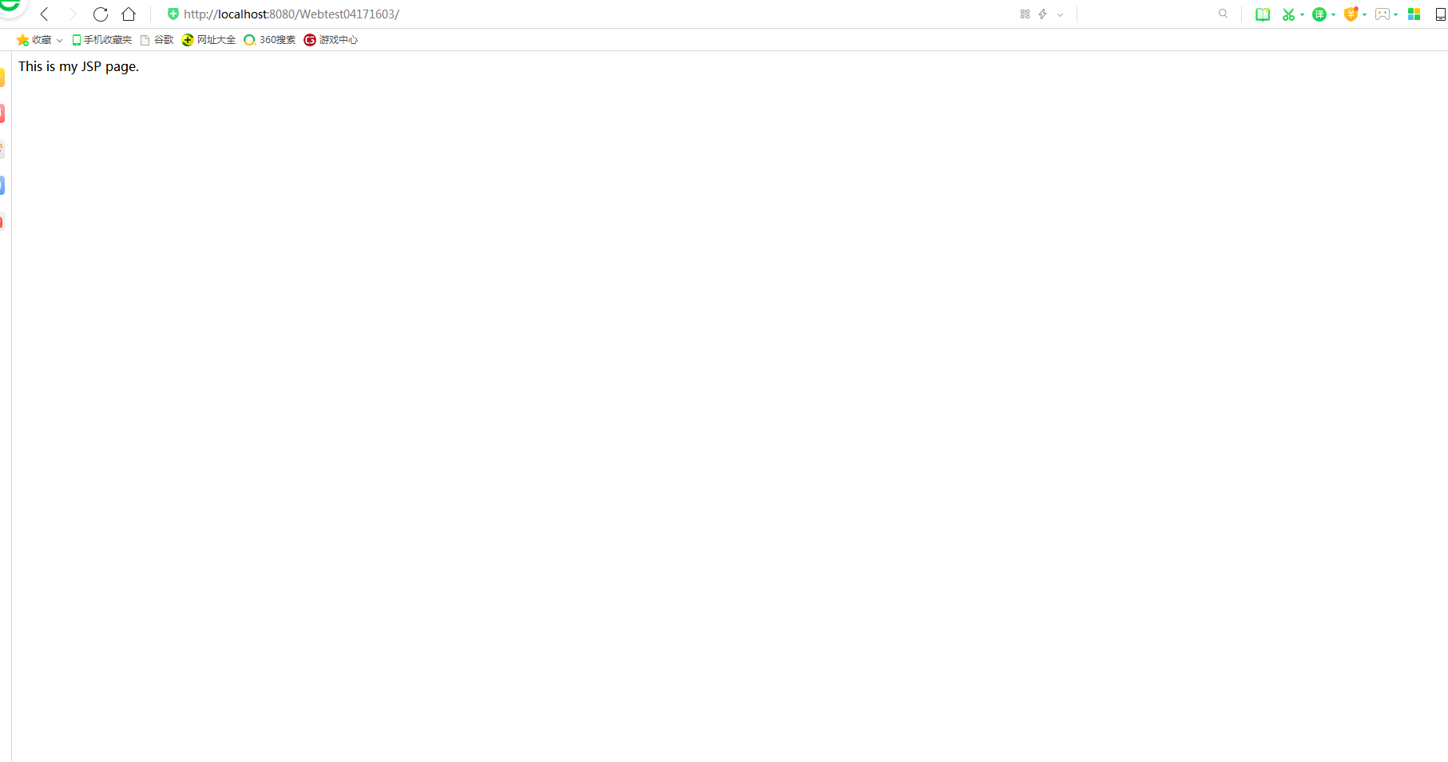

--------------------------------------------------------input-----------------------------------------------------------------

<%@ page language=*"java"* contentType=*"text/html; charset=UTF-8"*

pageEncoding=*"UTF-8"*%>

<html>

<head>

<title>input.jsp</title>

</head>

<body bgcolor=*#591*><font size=*8*>

<form action=*"receive.jsp"* method=*post* name=*form*>

<p>请输入以下信息：</p>

<br>请输入您的姓名：<input type = *"text"* name =*"name"* value=*"张三"*></br>

<br>选择性别：<input type = *"radio"* name=*"sexwh"* value=*"男"* ><font size=*4*>男</font>

<input type=*"radio"* name=*"sexwh"* value=*"女"*><font size=*4*>女</font>

</br>

<br>选择您喜欢的歌手：

<input type=*"checkbox"* name=*"superstar"* value=*"张歌手"*><font size=*4*>张歌手</font>

<input type=*"checkbox"* name=*"superstar"* value=*"李歌手"*><font size=*4*>李歌手</font>

<input type=*"checkbox"* name=*"superstar"* value=*"王歌手"*><font size=*4*>王歌手</font>

<input type=*"checkbox"* name=*"superstar"* value=*"刘歌手"*><font size=*4*>刘歌手</font>

</br>

<input type=*"hidden"* value=*"这是隐藏信息"* name=*"secert"* style="height: *61px*; width: *51px*; ">

<input type=*"submit"* value=*"提交"* name=*"submit"*>

</form>

</font>

</body>

</html>

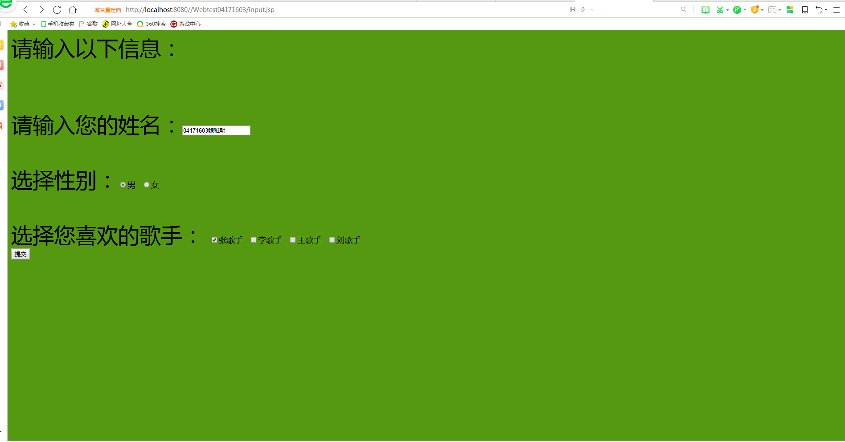

----------------------------------------------------------receive-------------------------------------------------------------

<%@ page contentType =*"text/html;charset=utf-8"*%>

<html>

<body bgcolor=*cyan*>

<font size=*7*> <a href=*"index.jsp"*>回到首页</a>

<%request.setCharacterEncoding("utf-8");

String yourName=request.getParameter("name");

String yourSex=request.getParameter("sexwh");

String secretMess=request.getParameter("secert");

String []personName=request.getParameterValues("superstar");

out.println("<P> 您的姓名:"+yourName+"</p>");

out.println("<P> 您的性别:"+yourSex+"</P>");

**if**(personName==**null**)

out.println("<p>您一个歌手都不喜欢</p>");

**else**

{

out.println("<P> 您喜欢的歌手:");

**for**(**int** i=0;i<personName.length;i++)

out.println(" "+personName[i]);

out.println("</p>");

}

out.println("<p>hidden提交的值:"+secretMess); %>

<p>姓名:${param.name }</font></body></html>

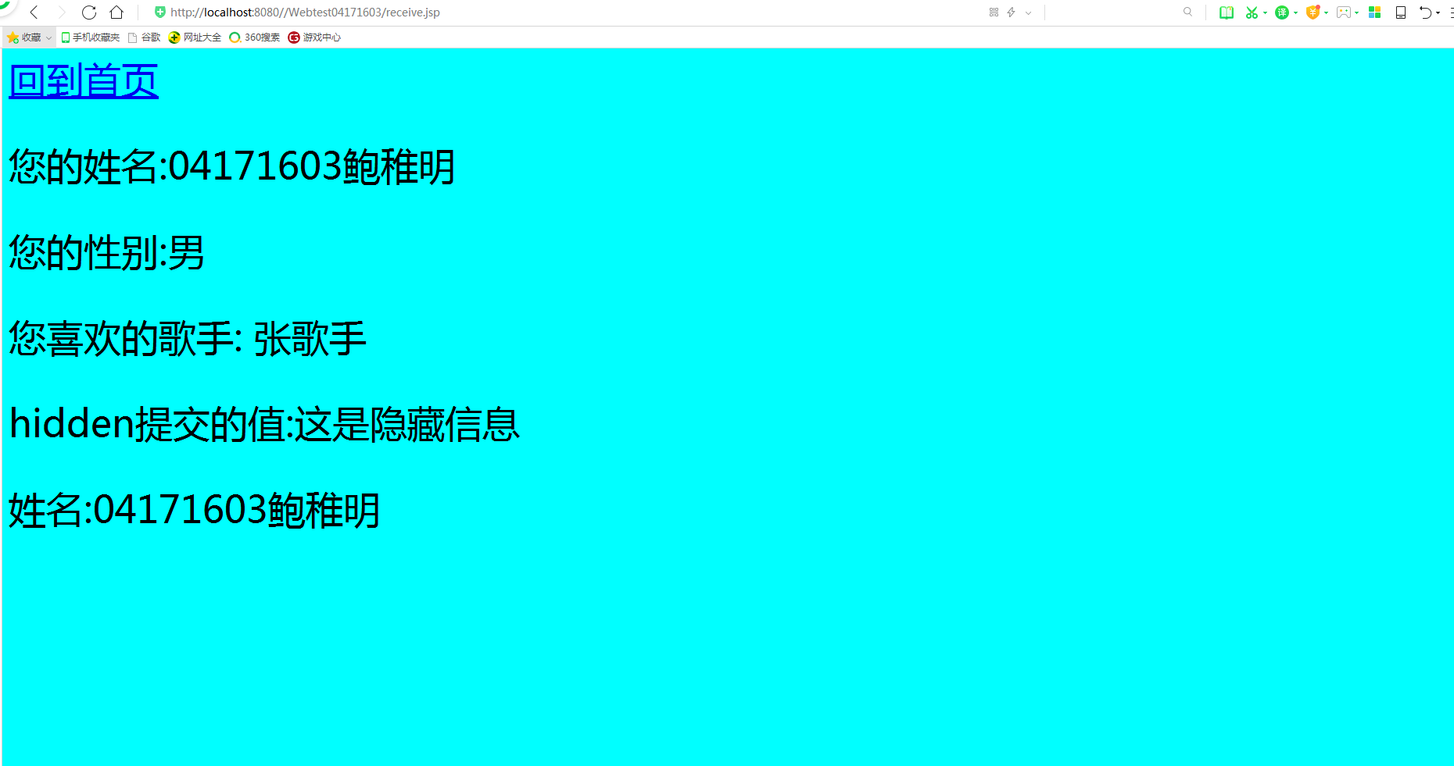

-------------------------------------------------HelloServlet----------------------------------------------------------------

**import** java.io.IOException;

**import** java.io.PrintWriter;

**import** java.io.UnsupportedEncodingException;

**import** javax.servlet.ServletException;

**import** javax.servlet.http.HttpServlet;

**import** javax.servlet.http.HttpServletRequest;

**import** javax.servlet.http.HttpServletResponse;

**public** **class** HelloServlet **extends** HttpServlet {

**protected** **void** doGet (HttpServletRequest request,

HttpServletResponse response)

**throws** ServletException, IOException {

response . setContentType ("text/html; charset UTF-8");

PrintWriter out = response . getWriter (); String name = **new** String(request . getParameter ("name").getBytes("iso-8859-1"),"UTF-8") ;

out. println ("<html>"); out . println ("<head>") ;

out .println ("<title>Hello Servlet</title>") ;out .println ("</head>");out.println ("<body>");

out.println("<h1> Hello! "+ name +"!</h1>"); out.println ("</body>");out . println ("</html>");

out.close() ;}

}

